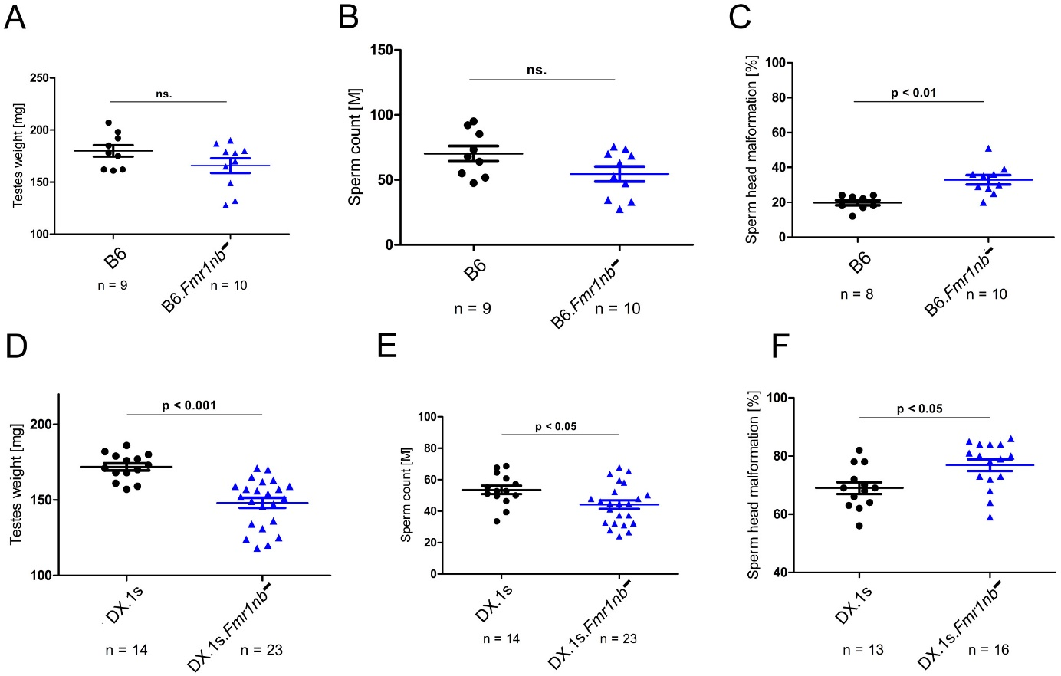

Figure S5 Fertility parameters of B6.Fmr1nb⁻ and B6.DX.1s.Fmr1nb⁻ males compared to the B6 and B6.DX.1s control counterparts. (A, B, C) Fmr1nb^{B6} null allele; testes weight (weight of pair of wet testes in mg), sperm count (number of sperms in millions per pair of epididymis) and frequency of malformed sperm heads (in per cent) are shown as mean (± SD) for the B6.Fmr1nb⁻ and B6 males. (D, E, F) Fmr1nb^{PWD} null allele; Fertility parameters are plotted for the B6.DX.1s.Fmr1nb⁻ and B6.DX.1s males. Data are presented as mean (±SD); n, number of males analyzed for the specific genotype.

