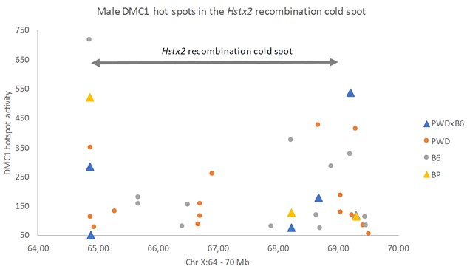

Figure S1 Activity of male DMC1 hotspots in the Hstx2 recombination cold spot. The activity of DMC1 hotspots in the Hstx2 region of the (PWD x B6) F1 and (B6 x PWD)F1 hybrid males was suppressed compared to PWD and B6 strains. Data extracted from (DAVIES et al. 2016); visualized are hotspots with activity > 50.

