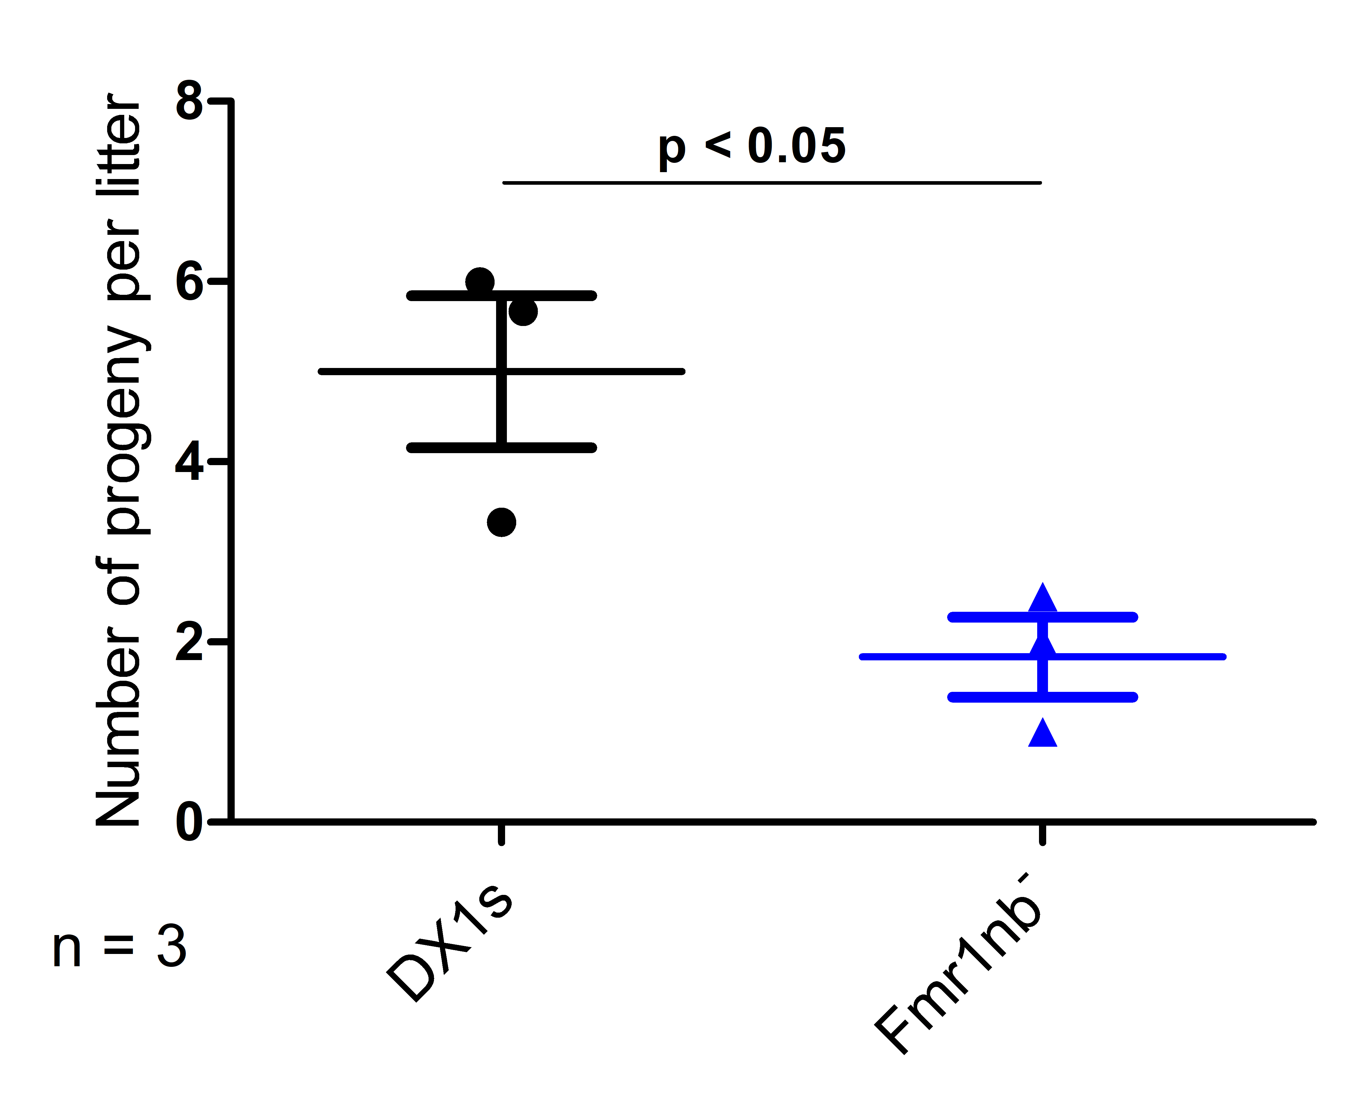
Figure S4 Reproductive performance of B6.DX1s and B6.DX1s.Fmr1nb⁻ males. Mean values (± SD) of litter size sired by B6.DX.1s or B6.DX.1s.Fmr1nb⁻ males (p < 0.05, t-test). The number of sired offspring was counted per each male caged individually with B6 female for three months of mating period.

