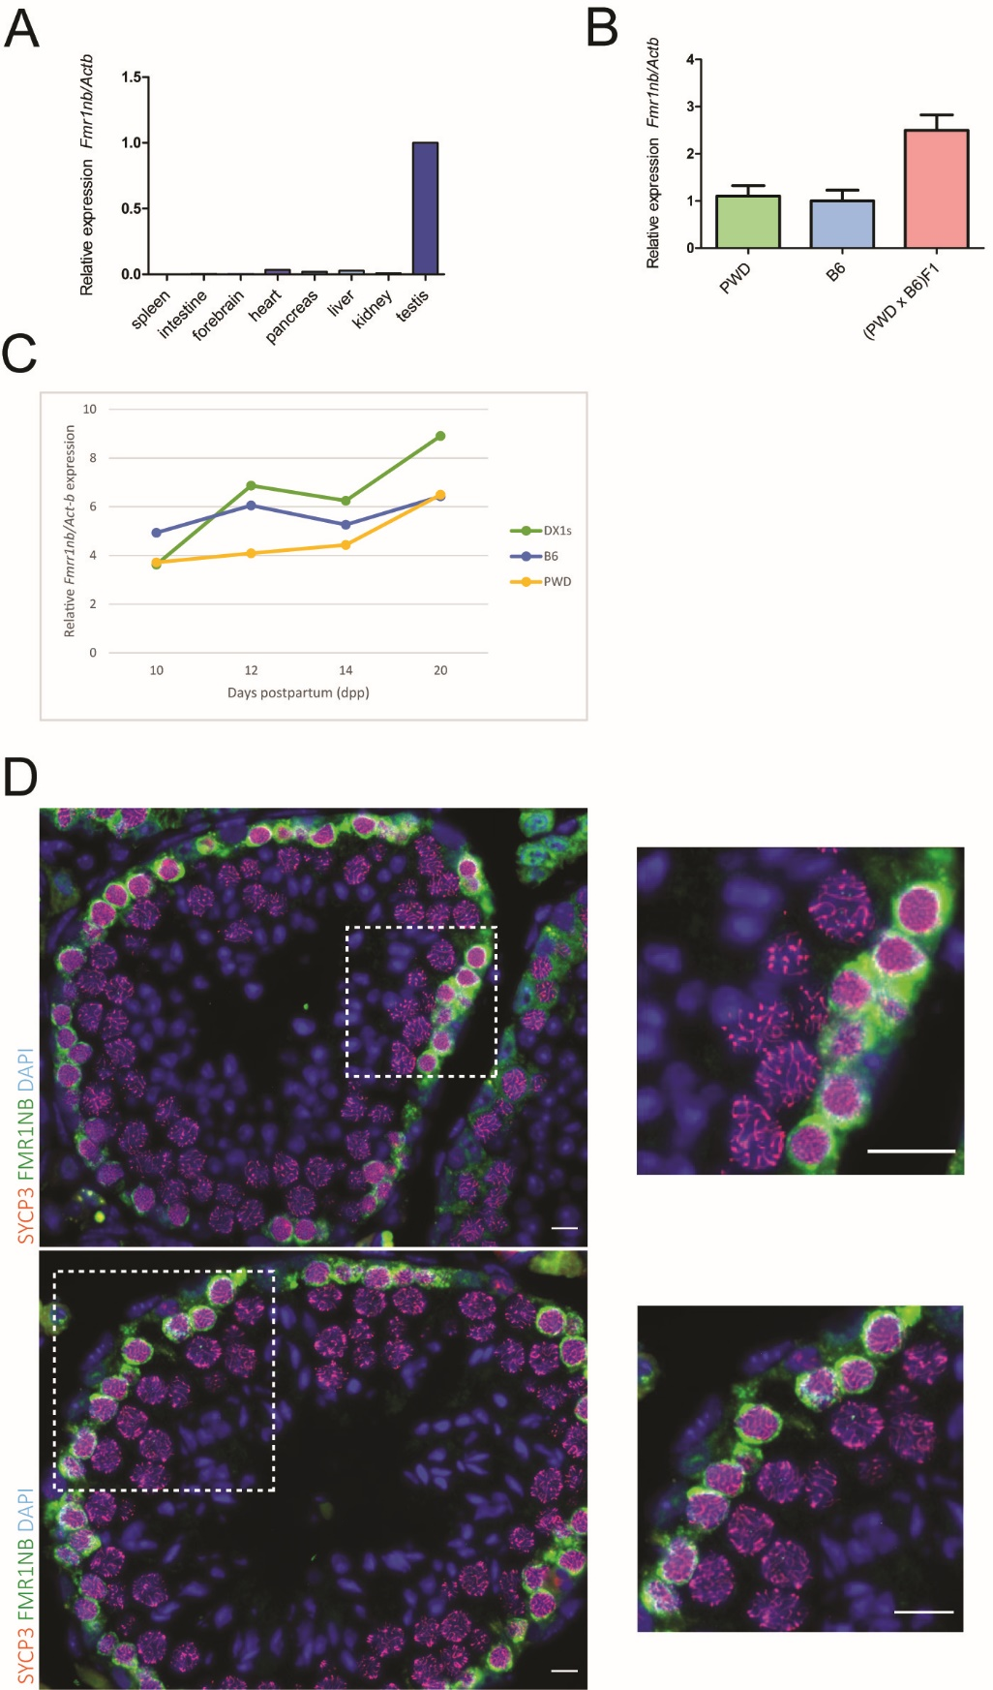

Figure S2 Expression of the Fmr1nb gene. (A) Tissue-specific expression of Fmr1nb mRNA. Relative expression of Fmr1nb to Actin-b measured by RT-qPCR and plotted for the spleen, intestine, brain, pancreas, liver, kidney and testis. (B) Expression of Fmr1nb determined by RT-qPCR in adult testis of PWD, B6 and (PWD x B6)F1 sterile hybrids. (C) Profiles of Fmr1nb mRNA in the first wave of spermatogenesis in the testis of juvenile males B6.DX.1s, PWD and B6 determined by RT-qPCR. (D) Immunohistochemical detection of FMR1NB and SYCP3 proteins in the histological section of testis of the B6.DX.1s mouse. FMR1NB expression appears in early stages of meiotic prophase I but not in the pachytene spermatocytes. The pachytene spermatocytes, determined by typical SYCP3 staining pattern, are shown at higher magnification. Data in B and C are presented as a mean of three independent biological replicates (±SD). FMR1NB, green; SYCP3, violet; DAPI, blue. Scale bar, 10 μm (D).

