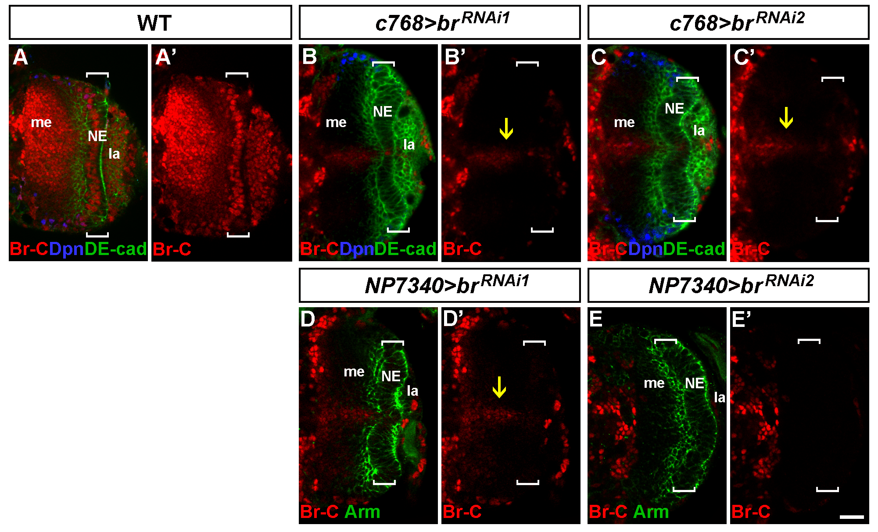

Figure S2 broad RNAi knockdown in the optic lobe. Late-third instar larval brains stained for Broad-core (Br-C, red), DE-Cad (green) and Dpn (blue). (A, A’) A wild-type brain. Broad is expressed in the NEs, lamina and medulla. (B, B’) A c768-Gal4/UAS-br^{RNAi1} brain. Broad is eliminated from the NEs and is also largely eliminated from the medulla cortex except for a strip of cells (arrow). (C, C’) A c768-Gal4/UAS-br^{RNAi2} brain. Broad is eliminated from the NEs and is also largely eliminated from the medulla cortex except for a strip of cells (arrow). (D, D’) An NP7340-Gal4/UAS-br^{RNAi1} brain. Broad is eliminated from the NEs and is also largely eliminated from the medulla cortex except for a strip of cells (arrow). (E, E’) an NP7340-Gal4/UAS-br^{RNAi2} brain. Broad expression is eliminated from the NEs and the medulla cortex. Brackets indicate the OPC NEs. me: medulla, la: lamina. Lateral is to the right. Scale bar: 20 μm.

