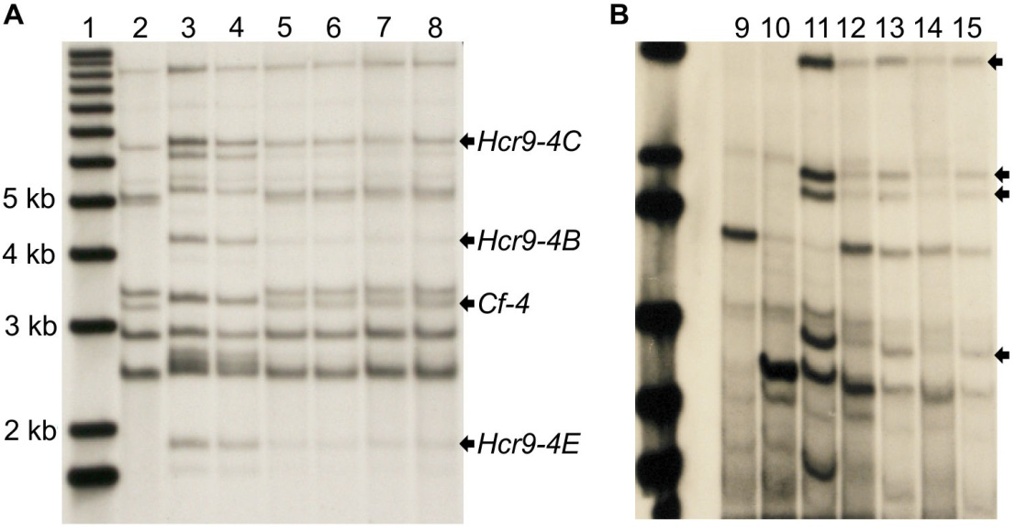
FIGURE S4 | DNA gel blot analysis of Ont7716 with Hcr9- and Hcr2-specific probes. (A) DNA gel blot showing (1) 1kb-plus DNA ladder, (2) Cf0, (3) Cf4, (4) Cf11, (5) 105R, (6) 105S, (7) 106R, and (8) 106S genomic DNA probed with a Hcr9-specific probe. The genomic DNA samples were digested with BglII and probed using a fragment derived from the Hcr9-9C (Cf-9) gene. (B) DNA gel blot showing (9) Cf0, (10) Cf2, (11) Cf11, (12) 105R, (13) 105S, (14) 106R, and (15) 106S. Genomic DNA was digested with EcoRV and probed with a PCR product derived from the Cf-2 gene. Bulked segregant DNA pools were prepared from the resistant and susceptible plants of segregating F₂ families 105 and 106 from a Cf2 x Cf11 cross (designated 105R, 105S, 106R and 106S respectively). The Hcr9 sequences originating from the Cf4 haplotype were present in both resistant and susceptible bulks, and hence not suitable for generating a mapping population for Ont7716. The Hcr2 sequences from Cf2 haplotype were linked to resistance and suitable for further analysis to identify molecular markers linked to the Cf-11 locus. Black arrows show (A) specific Hcr9s and (B) sequence bands linked to Cf-11-induced resistance.

