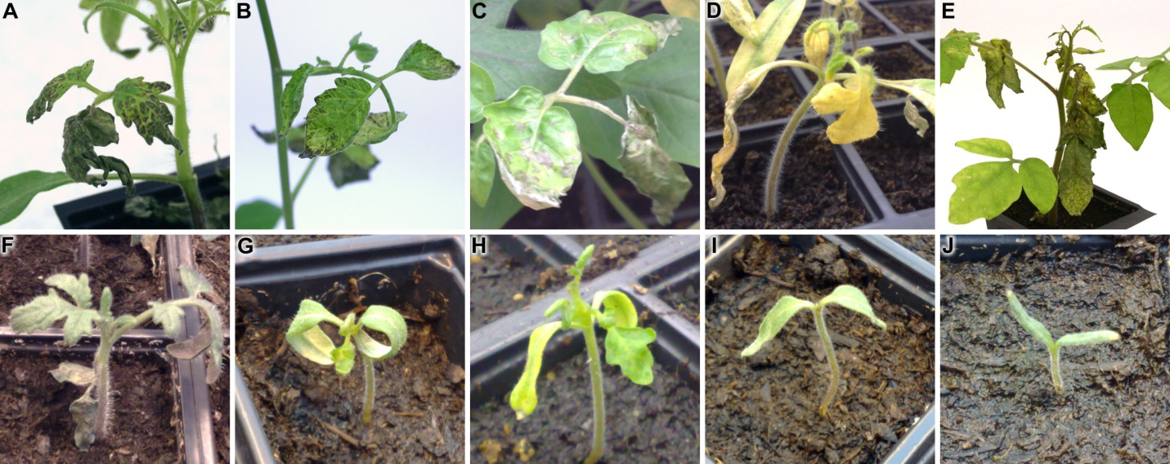
FIGURE S3 | Differences in strength of Ecp5-dependent HR symptoms in Cf-Ecp5-carrying tomato accessions. Representative phenotypes of five accessions for systemic HR following PVX:Ecp5 agro-infiltration (A-E) and for seedling lethal phenotypes from crosses to a Cf0:Ecp5 transgenic plant (F-J). Accessions shown: (A, F) G1.1161, (B, G) LA0722, (C, H) LA1689, (D, I) Ont7522, (E, J) LA2852. Pictures were taken at 14 dpi for PVX:Ecp5 agro-infiltrations or 14 days post-germination for the seedling lethal phenotype. The strongest symptoms from agro-infiltration were observed in Ont7522 (D) and LA2852 (E), where there is an apparent stunting of growth and cell death proceeds into the meristem. For G1.1161 (A), LA0722 (B), and LA1689 (C), agro-infiltration had similar effects with cell death symptoms emerging on older leaves only, without exhibiting arrested development. For seedling lethal phenotype, the strongest response was again observed in crosses to Ont7522 (I) and LA2852 (J) with no true leaves developing. Progeny of LA0722 (G) and LA1689 (H) developed some true leaves, with their cotyledons curled, while progeny of G1.1161 (F) developed several true leaves before necrotic lesions started to appear, similar to its PVX:Ecp5 phenotype.

