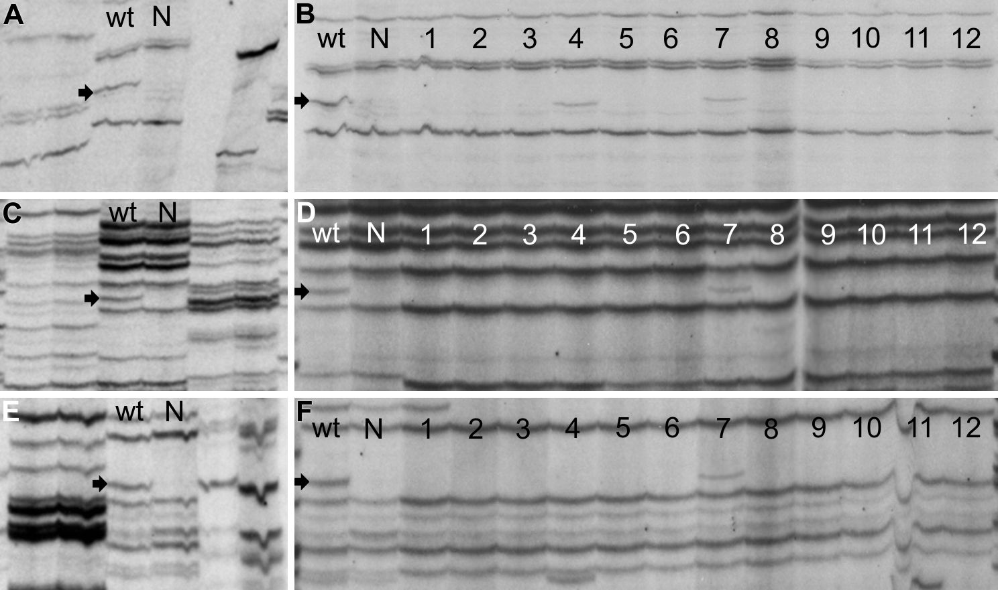
FIGURE S2 | Mapping of Cf-Ecp5 in LA0722 on tomato chromosome 7 by AFLP analysis. (A, C, E) Identification of S. pennellii AFLP markers linked in trans with Cf-Ecp5 in Ont7522. Primer combinations: (A) 91R30-M84, (C) 91R30-M88, (E) 91R30-M93. (B, D, F) Mapping of AFLP markers alongside bulks of ILs that represent entire tomato chromosomes (B, D, and F primer combinations correspond to A, C, and E respectively). Each primer combination is shown as a pair of lanes (A-F) for each phenotypic bulk under the “wt” and “N” labels (“wt” = wild type, “N” = Necrotic). Tomato chromosome numbers (1-12) for IL bulks are shown for each lane (B, D, F). Arrows indicate AFLP markers linked in trans to Cf-Ecp5 in LA0722.

