Supplemental Material

Supplemental Figures

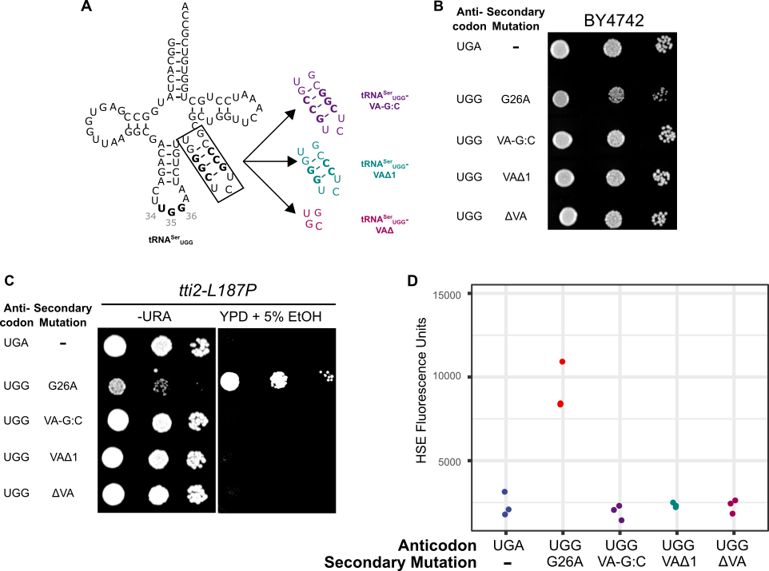

Figure S1. Targeted mutations to the variable arm of tRNA^{Ser} do not mistranslate. (A) Structures of tRNA^{Ser}_{UGG}-VA-G:C, tRNA^{Ser}_{UGG}-VAΔ1 and tRNA^{Ser}_{UGG}-VAΔ. (B) Wild-type strain (BY4742) containing either a wild-type tRNA^{Ser}_{UGA}, tRNA^{Ser}_{UGG}-G26A or the tRNA^{Ser}_{UGG} alleles described in (A) were grown to saturation in media lacking uracil and spotted in 10-fold serial dilutions on the same media. (C) Yeast strains containing tti2-L187P (CY7020) and expressing one of the tRNAs described in (B) were grown to saturation in media lacking uracil and spotted in 10-fold serial dilutions on media lacking uracil or YPD containing 5% ethanol. (D) Wild-type strains containing a variant tRNA^{Ser}_{UGG} described in (B) and a fluorescent heat shock reporter were grown in media lacking uracil and histidine. Cells were diluted 1:20 in the same media and grown for 6 hours. Cell densities were normalized and fluorescence measured. Each point represents one biological replicate.

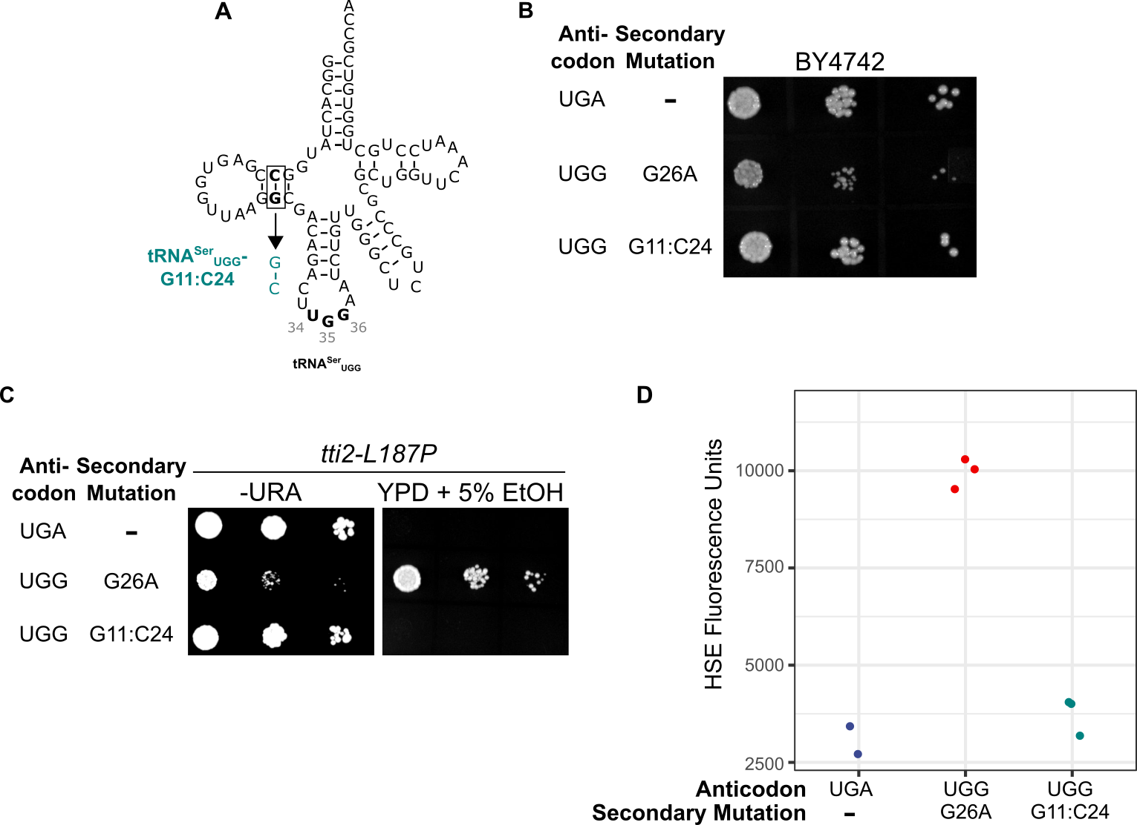

Figure S2. The C11:G24 base pair in the D-stem is required for tRNA^{Ser} function. (A) Structure of tRNA^{Ser}_{UGG}-G11:C24. (B) Wild-type strain (BY4742) containing either wild-type tRNA^{Ser}_{UGA}, tRNA^{Ser}_{UGG}-G26A or tRNA^{Ser}_{UGG}-G11:C24 were grown to saturation in media lacking uracil and spotted in 10-fold serial dilutions on media lacking uracil. (C) Yeast strains containing tti2-L187P (CY7020) and expressing one of the tRNAs described in (B) were grown to saturation in media lacking uracil and spotted in 10-fold serial dilutions on media lacking uracil or complete media containing 5% ethanol. (D) Wild-type strains containing a variant tRNA^{Ser}_{UGG} described in (B) and an HSE-GFP reporter were grown in media lacking uracil and histidine. Cells were diluted 1:20 in the same media and grown for 6 hours. Cell densities were normalized and fluorescence measured. Each point represents one biological replicate.

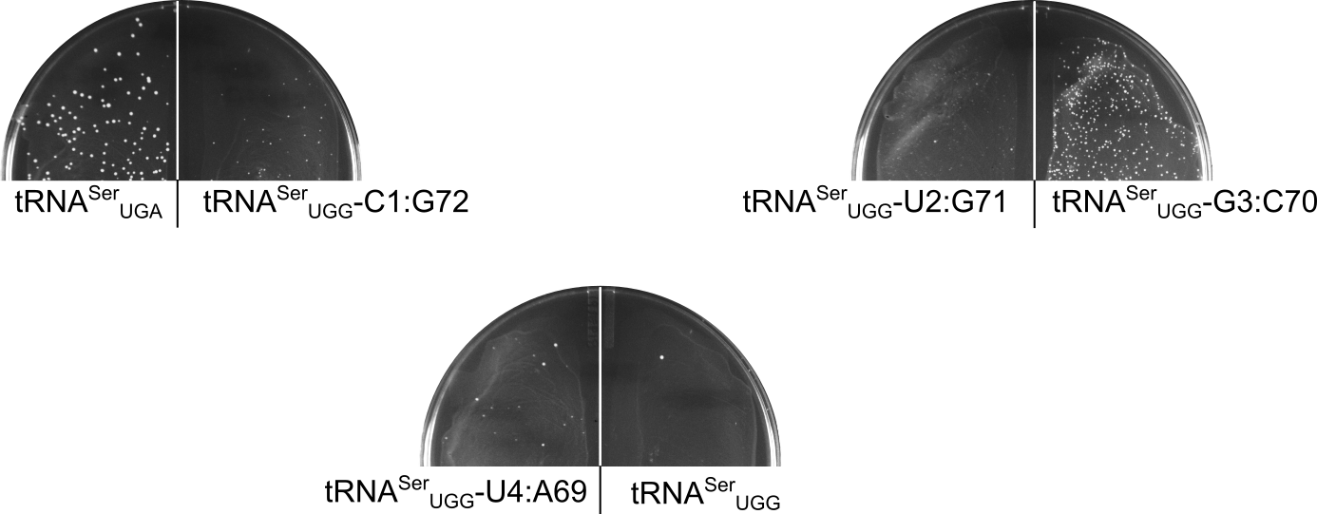

Figure S3. Transformation of 100 ng of URA3⁺ centromeric plasmids expressing tRNA^{Ser}_{UGA}, tRNA^{Ser}_{UGG}, or tRNA^{Ser}_{UGG} variants with mutations in the acceptor stem into a wild-type yeast strain (BY4742). Transformations were plated on media lacking uracil and grown for two days at 30°.

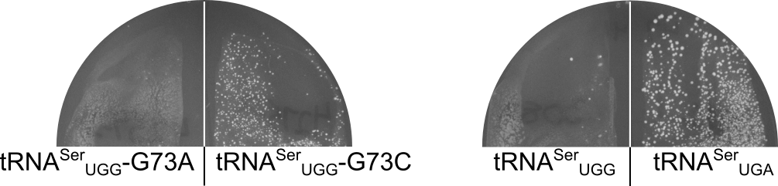

Figure S4. Transformation of 100 ng of URA3⁺ centromeric plasmids expressing tRNA^{Ser}_{UGA}, tRNA^{Ser}_{UGG} or variants of tRNA^{Ser}_{UGG} with mutations (G73A or G73C) at the discriminator base into a wild-type yeast strain (BY4742). Transformations were plated on media lacking uracil and grown for two days at 30°.

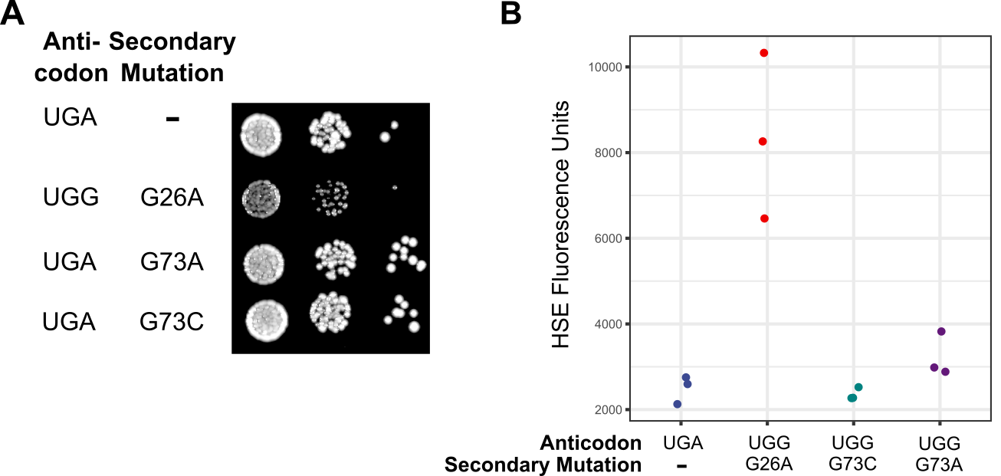

Figure S5. (A) Wild-type strain (BY4742) containing either wild-type tRNA^{Ser}_{UGA}, tRNA^{Ser}_{UGG}-G26A, tRNA^{Ser}_{UGA}-G73A or tRNA^{Ser}_{UGA}-G73C were grown to saturation in media lacking uracil and spotted in 10-fold serial dilutions on media lacking uracil. (B) Strains described in (A) containing an HSE-GFP reporter were grown in media lacking uracil and histidine. Cells were diluted 1:20 in the same media and grown for 6 hours. Cell densities were normalized and fluorescence measured. Each point represents one biological replicate.

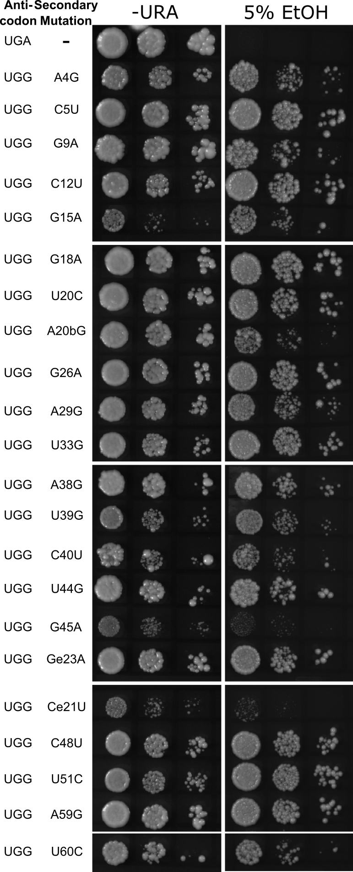

Figure S6. tti2-L187P suppression by randomly selected tRNA^{Ser}_{UGG} variants. Strains containing tti2-L187P (CY7020) and tRNA^{Ser}_{UGA} or a randomly selected tRNA^{Ser}_{UGG} variants were grown to saturation in media lacking uracil and spotted in 10-fold serial dilutions on media lacking uracil or complete media containing 5% ethanol.

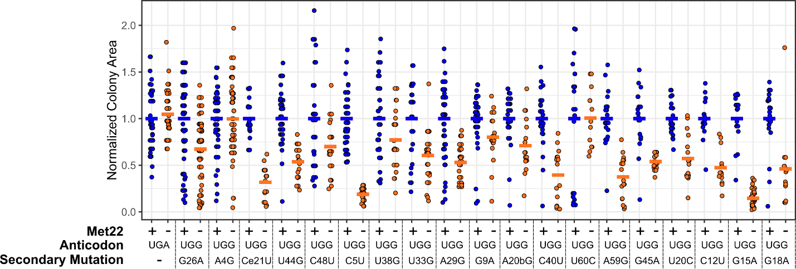
Figure S7. Colony sizes for tRNA^{Ser}_{UGG} variants in MET22 and met22 strains. Strains were grown in media lack uracil, diluted 1:10,000, plated for single colonies on media lacking uracil and allowed to grow for two days at 30°. Colony area was measured using ImageJ.

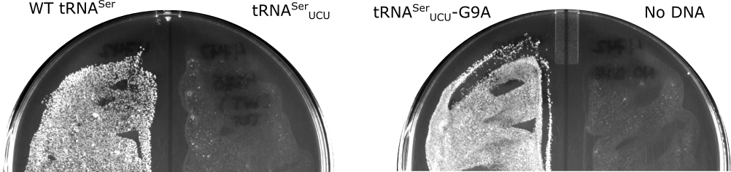

Figure S8. Transformation of 100 ng of HIS3⁺ centromeric plasmids expressing tRNA^{Ser}_{UGA}, tRNA^{Ser}_{UCU}, or tRNA^{Ser}_{UCU}-G9A into a wild-type yeast strain (BY4742). Transformations were plated on media lacking histidine and grown for two days at 30°.

Supplemental Tables

Table S1. Yeast strains used in this study
Strain | Genotype/Parent | Plasmid(s) | Reference
BY4741 | MATa his3∆0 leu2∆0 met15∆0 ura3∆0 |  | Winzeler and Davis, 1997
BY4742 | MATα his3∆0 leu2∆0 lys2∆0 ura3∆0 |  | Winzeler and Davis, 1997
CY6963 | MATα his3Δ1 leu2Δ0 lys2Δ0 met15Δ0  ura3Δ0 tti2Δ-met5Δ-mTn10luk | YCplac33-DED1pr-TTI2 | Hoffman et al., 2016
CY6874 | CY6963 | YCplac111-DED1pr-tti2_{Q276TAA} | Hoffman et al., 2016
CY7020 | CY6963 | YCplac111-DED1pr-tti2_{L187P} | Hoffman et al., 2016
CY8150 | CY6963 | pRS303-sup17(UCU)-G9A and  YCplac111-DED1pr-tti2_{L187R} | This work
CY8588 | MATa his3∆0 leu2∆0 ura3∆0 met22::KanMX |  | Tong et al. 2001
CY8589 | MATa his3∆0 leu2∆0 ura3∆0 MET22 |  | Tong et al. 2001

Table S2. Oligonucleotides used in this study
Name | Sequence | Description
VI1382 | aatctgttgcgcgctggttcaaatcctgc | sup17(UGG)-VAΔ
VI1383 | gaaccagcgcgcaacagattccaagtctgtcg | sup17(UGG)-VAΔ
UG5953 | TCTAAGCTTCGGACGATTGCCAACCGCCGAA | SUP17
UG5954 | CTGCAGAATTCCGCGGAAATTAGCACGGCC | SUP17
VJ2697 | atggGcgagtggttaagCcgacagactTGGA | sup17(UGG)-G11:C24
VJ2698 | gtcgGcttaaccactcgCccatagtGCCtaa | sup17(UGG)-G11:C24
VJ2766 | CTGTTGccgTCTcggCGCGCTGGttcaaatcctg | sup17(UGG)-VA-G:C
VJ2767 | GCGCCccgAGAcggCAACAGATTCCAagtctgt | sup17(UGG)- VA-G:C
WA5536 | caaatcctgctggtgtcAttatttttttatttttatttttt | sup17(UGG)-G73A
WA5537 | taaaaaaataaTgacaccagcaggatttgaaccagcg | sup17(UGG)-G73A
WA6571 | caaatcctgctggtgtcCttatttttttatttttatttttt | sup17(UGG)-G73C
WA6572 | taaaaaaataaGgacaccagcaggatttgaaccagcg | sup17(UGG)-G73C
VK4593 | AATCTGTTGGCTCTGCCGCGCTGGTTcaaatcc | sup17(UGG)-VAΔ1
VK4394 | GCGCGGCAGAGCCAACAgATTCCAAgtctgtc | sup17(UGG)-VAΔ1
VL5002 | AAATCCTGCTGGTCTCGTTATTTTTTTATTTTTAT | sup17(UGG)-G70C
VL5003 | AAATAACGAGACCAGCAGGATTTGAACCAGCG | sup17(UGG)-G70C
VF8661 | tgttttagggactatggccgagtggttaa | sup17(UGG)-C3G
VF8662 | cggccatagtccctaaaacaatgtaggtta | sup17(UGG)-C3G
WC8504 | CAACAGACTGAAAATCTGTTGGGCTCTGCC | sup17(GAA)-G26A
WC8505 | CCCAACAGATTTTCAGTCTGTTGCCTTAACC | sup17(GAA)-G26A
WF1163 | attgttttaGGCTCTATGGCCGAGTGGTT | sup17(UGG)-A4T
WF1164 | GGCCATAGAGCCTAAAACAATGTAGGTTATTT | sup17(UGG)-A4T
WF1165 | AATCCTGCTGGAGTCGTTATTTTTTTATTTTTATTT | sup17(UGG)-T69A
WF1166 | TAAAAAAATAACGACTCCAGCAGGATTTGAACCAG | sup17(UGG)-T69A
VJ2409 | CGACAGACTTCTAATCTGTTGGGCTCTGCC | sup17(UCU)
VJ2410 | CCCAACAGATTAGAAGTCTGTCGCCTTAACC | sup17(UCU)
VK4595 | GCGACAGACTttaAATCTGTTGGGctctgcc | sup17(UUA)
VK4596 | CCAACAGATTtaaAGTCTGTCGCCTTAACcac | sup17(UUA)
VF7765 | TGGTTAAGGCAACAGACTCTGAATCTGTTGGGC | sup17(CUG)-G26A
VF7766 | TTCAGAGTCTGTTGCCTTAACCACTCGGCCAT | sup17(CUG)-G26A
VL4943 | ACAGACTTctAATCTGTTGGGCTCTGCCC | sup17(UCU)-G26A
VL4945 | CCCAACAGATTagAAGTCTGTTGCCTTAACCACT | sup17(UCU)-G26A
5693-1 | ataagaatgcggccgcaatgacggccgtaactgatatc | TTI2
5693-2 | atacgagctctgcatttgtctgtgtctgtgt | TTI2
6856-1 | ttctgctcagacagacgctattaaatcatacc | tti2-L187R
6856-2 | tagcgtctgtctgagcagaacaccacgaagttta | tti2-L187R

Table S3. Number of peptides identified in mass spectrometry based analysis of mistranslation rates.
tRNA Variant | Replicate | # of wild-type peptides containing proline |  | # peptides with Pro to Ser substitutions | % mistranslated  peptides
tRNA^{Ser}_{UGA} | 1 | 5985 | 7 |  | 0.1
tRNA^{Ser}_{UGA} | 2 | 5241 | 5 |  | 0.1
tRNA^{Ser}_{UGA} | 3 | 5238 | 5 |  | 0.1
tRNA^{Ser}_{UGG}-G9A | 1 | 5767 | 24 |  | 0.4
tRNA^{Ser}_{UGG}-G9A | 2 | 5363 | 33 |  | 0.6
tRNA^{Ser}_{UGG}-G9A | 3 | 5287 | 34 |  | 0.6
tRNA^{Ser}_{UGG}-G26A | 1 | 5516 | 285 |  | 5.2
tRNA^{Ser}_{UGG}-G26A | 2 | 5068 | 222 |  | 4.4
tRNA^{Ser}_{UGG}-G26A | 3 | 5225 | 234 |  | 4.5
tRNA^{Ser}_{UGG}-U44G | 1 | 5327 | 19 |  | 0.4
tRNA^{Ser}_{UGG}-U44G | 2 | 5376 | 12 |  | 0.2
tRNA^{Ser}_{UGG}-U44G | 3 | 4575 | 9 |  | 0.2
tRNA^{Ser}_{UGG}-U33G | 1 | 5085 | 147 |  | 2.9
tRNA^{Ser}_{UGG}-U33G | 2 | 5408 | 180 |  | 3.3
tRNA^{Ser}_{UGG}-U33G | 3 | 4483 | 125 |  | 2.8
tRNA^{Ser}_{UGG}-U39G | 1 | 5166 | 205 |  | 4.0
tRNA^{Ser}_{UGG}-U39G | 2 | 5134 | 200 |  | 3.9
tRNA^{Ser}_{UGG}-U39G | 3 | 5023 | 215 |  | 4.3

Table S4. Eufind and Infernal tRNA score for tRNA^{Ser} variants analyzed in this paper.
tRNA Variant | Eufind Score | ΔEufind Score
tRNA^{Ser}_{UGA} | -15.97 | 0
VA-G:C | -15.97 | 0
VAΔ1 | -15.97 | 0
VAΔ | -14.6 | 1.37
G11:C24 | -22.32 | -6.35
G73C | -15.97 | 0
G73A | -15.97 | 0
G1:C70 | -15.97 | 0
U2:G71 | -15.97 | 0
C3:G70 | -15.97 | 0
U4:A69 | -15.97 | 0
A4G | -15.97 | 0
C5T | -15.97 | 0
G9A | -16.27 | -0.3
C12T | -16.02 | -0.05
G15A | -17.79 | -1.82
G18A | -26.48 | -10.51
T20C | -18.74 | -2.77
A20bG | -19.43 | -3.46
G26A | -15.97 | 0
A29G | -15.97 | 0
T33G | -15.97 | 0
A38G | -15.97 | 0
T39G | -15.97 | 0
C40T | -15.97 | 0
T44G | -15.97 | 0
G45A | -15.97 | 0
Ge23A | -15.97 | 0
Ce21T | -15.97 | 0
C48T | -15.97 | 0
T51C | -15.97 | 0
A59G | -17.32 | -1.35
T60C | -17.01 | -1.04

Table S5. tRNA^{Ser}_{UGG} mistranslating tRNA variants investigated in this study. All have the UGG anticodon, except for the wild-type tRNA^{Ser}_{UGA}.
Mutation | Lethal | Suppresses tti2-L187P | Doubling Time (min) | Heat Shock relative to tRNA^{Ser}_{UGA}ª
tRNA^{Ser}_{UGA} | NA | NA | 65.5 | 1
Engineered Variants
VA-G:C^{b} | No | No | n.d. | 1.0
VAΔ1^{c} | No | No | n.d. | 1.0
VAΔ^{d} | No | No | n.d. | 0.8
G11:C24 | No | No | n.d. | 1.2
C1:G72 | No | Yes | n.d. | 3.6
U2:G71 | Yes | NA | NA | NA
G3:C70 | No | Yes | n.d. | 1.8
U4:A69 | Yes | NA | NA | NA
G73C | Yes | n.d. | n.d. | 2.8
G73A | Yes | NA | NA | NA
Genetically Selected Variants
A4G | No | Yes | 77.9 | 1.7
C5T | No | Yes | 75.5 | 1.9
G9A | No | Yes | 68.3 | 1.2
C12T | No | Yes | 105 | 2.8
G15A | No | Yes | 107 | 2.9
G17A | No | Yes | 102 | 2.5
T19C | No | Yes | 85.3 | 3.4
A20bG | No | Yes | 67.4 | 1.6
G26A | No | Yes | 88.9 | 3.2
A29G | No | Yes | 81.6 | 3.3
T33G | No | Yes | 98.0 | 2.8
A38G | No | Yes | 80.4 | 2.2
T39G | No | Yes | 129 | 2.4
C40T | No | Yes | 116 | 3.8
T44G | No | Yes | 71.6 | 2.4
G45A | No | Yes | 79.4 | 2.3
Ge23A | No | Yes | 105 | 4.2
Ce21T | No | Yes | 77.7 | 1.4
C48T | No | Yes | 109 | 6.5
T51C | No | Yes | 101 | 3.8
A59C | No | Yes | 127 | 2.3
A59G | No | Yes | 85.4 | 2.7
T60C | No | Yes | 113 | 1.7
ª as determined with HSE-eGFP
^{b} switches the G:C base pairs in the variable arm to C:G
^{c} deletes one G:C base pair from the variable arm
^{d} deletes three G:C base pairs from the variable arm

