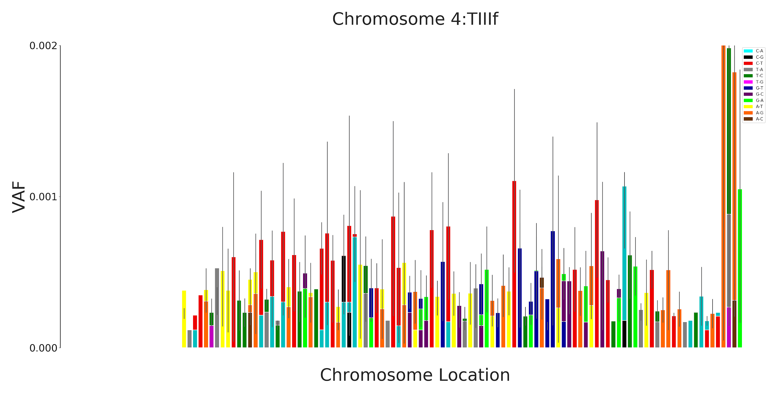

Figure S1
Sperm gDNA shows similar background to blood samples.
Use of FERMI to sequence 12 samples of sperm gDNA shows a significant signal within uncorrected consensus reads. Work from other groups robustly shows that any given sperm cell should contain about 100 mutations, confirming the presence of a widespread background signal within our uncorrected consensus reads (Lynch 2016).

