Table S1
Trinucleotide context is not sufficient to predict base mutability.
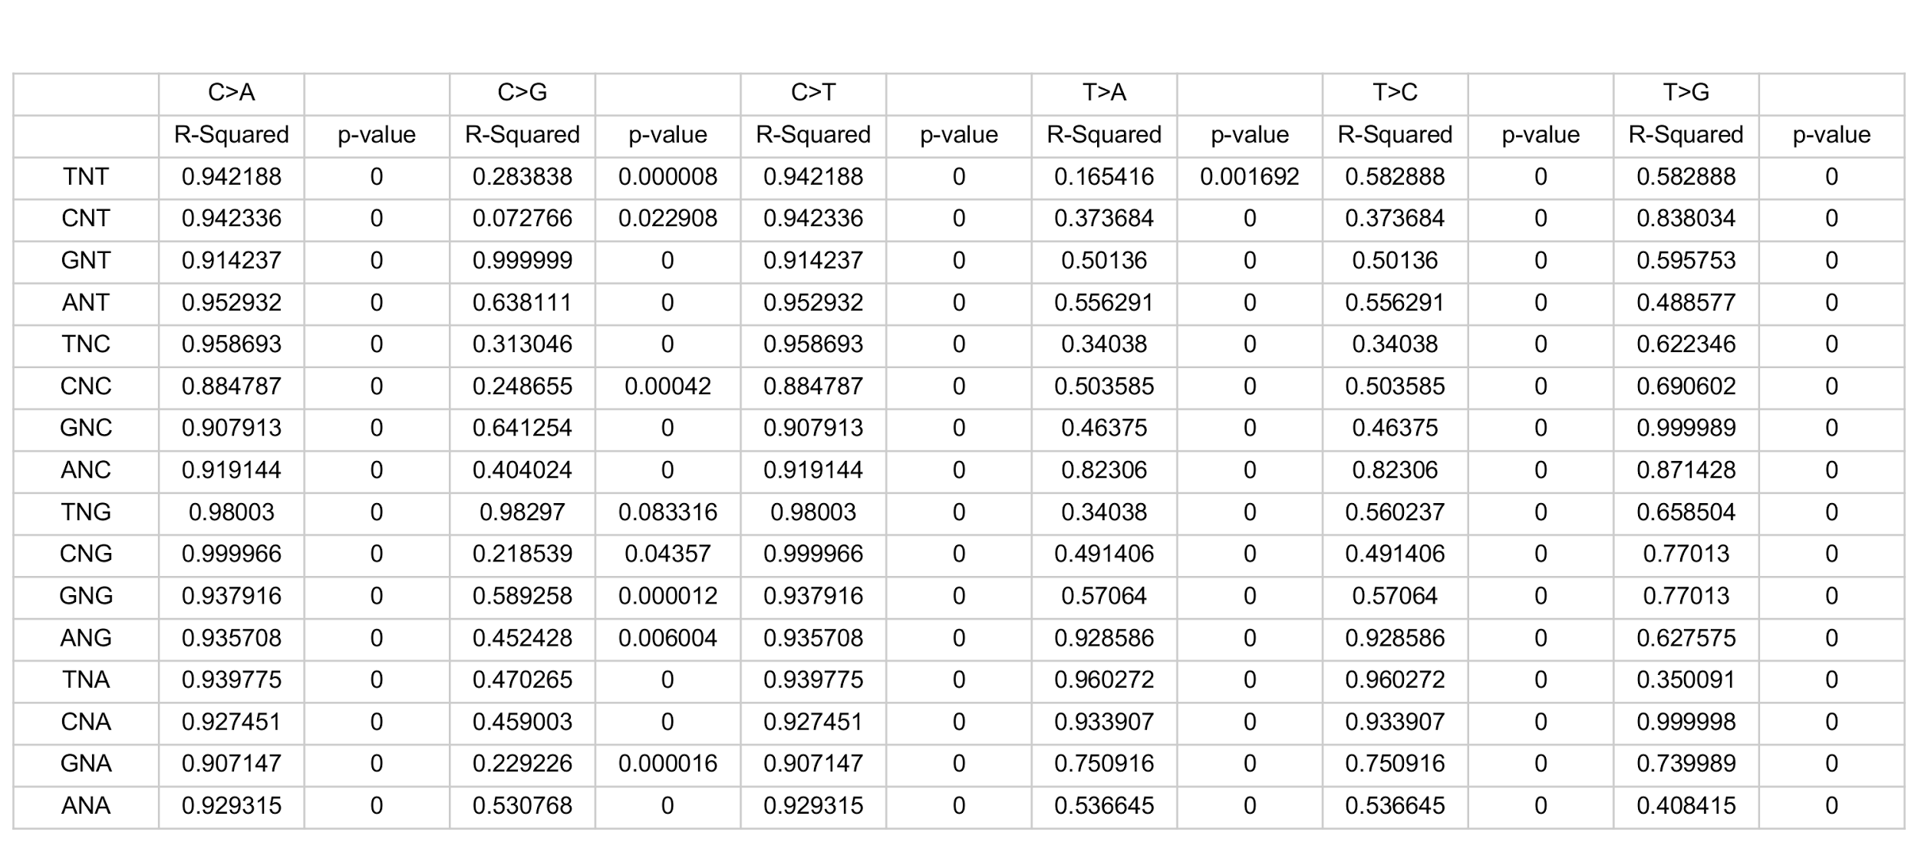
To understand how well the trinucleotide context of each unique nucleotide substitution predicts base mutability, all biopsied individuals were split into two groups (Group 1 and Group 2), which were similar in ages. Within these groups, each substitution was sorted by nucleotide and trinucleotide identity. Sorted substitutions were then plotted by their VAF and compared between Group 1 and Group 2. If trinucleotide context is sufficient to predict how often and to what a nucleotide mutates, it would be expected that the comparison between Groups 1 and 2 would result in a uniformly clustered set of variants. If this were the case, the R-squared value would be small as the variant population would not fit a line (for example, the distribution could reflect a round cluster, if substitution frequencies are not correlated in the different sample sets but driven by chance). Alternatively, if factors other than just trinucleotide context were important in determining the mutability of a particular context, it would be expected that variant comparisons between Groups 1 and 2 would strongly adhere to a y=x line and therefore have a high R-squared value. For each context, the R-squared values are shown for the comparisons between Groups 1 and 2. With most comparisons showing a high R-squared value, it is clear that trinucleotide context is not sufficient to predict base mutability.

