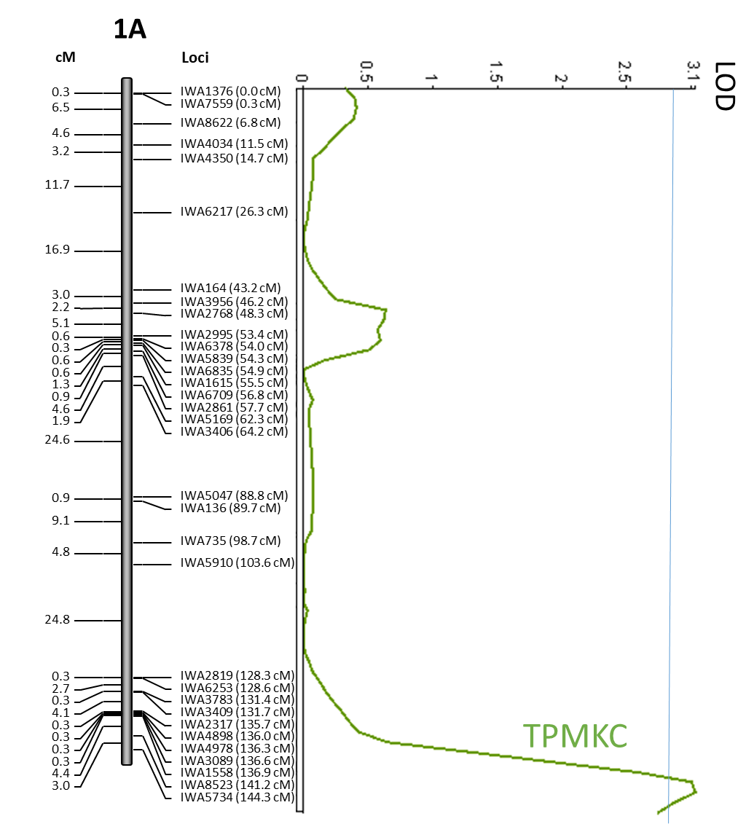

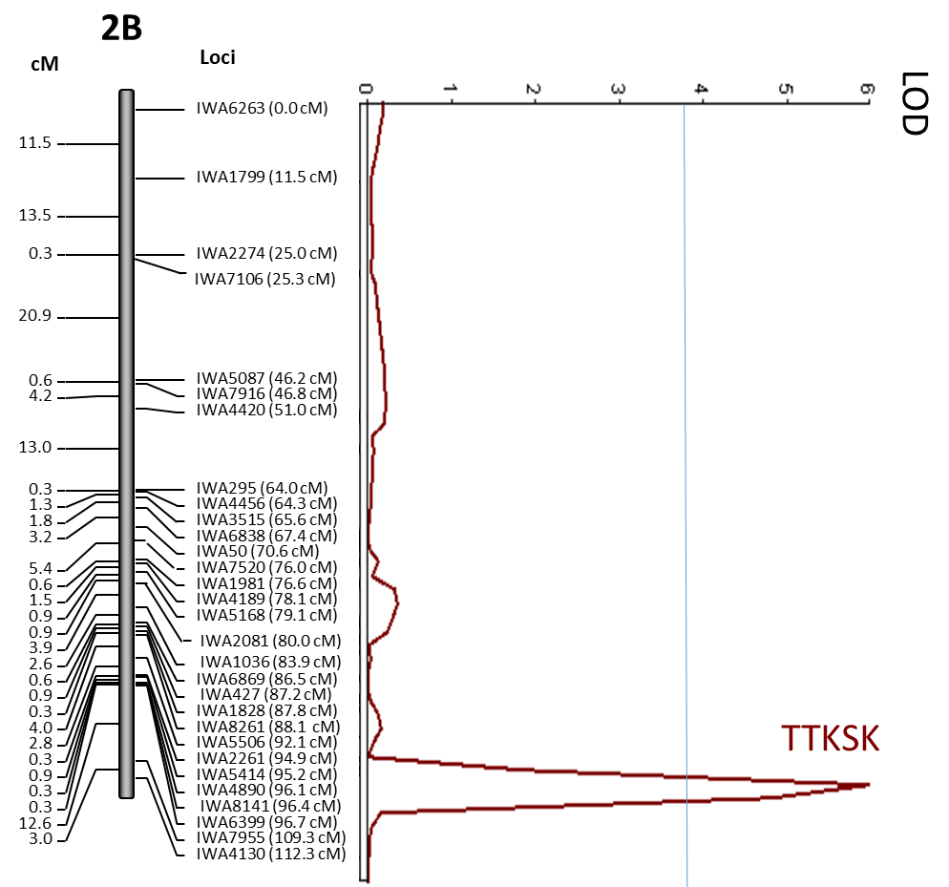

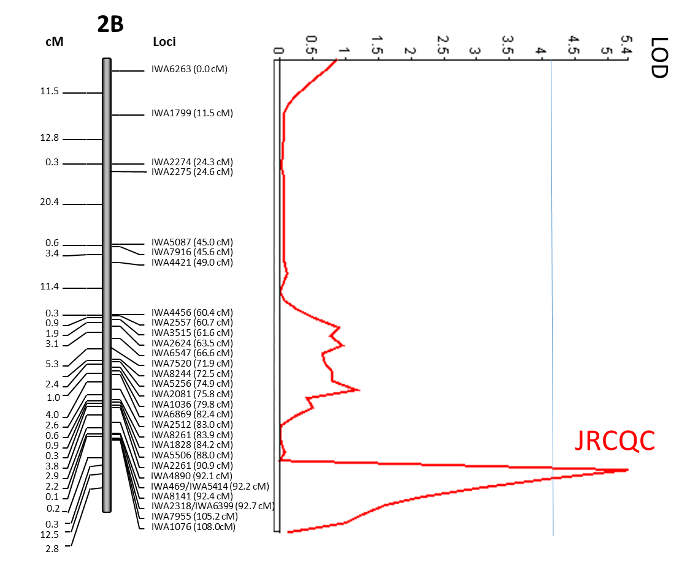

Figure S3. Mapping of stem rust resistance minor QTL: QSr.ace-1A to race TPMKC and QSr.ace-2B to races JRCQC and TTKSK) in the population Rusty × PI 192051-1. QSr.ace-1A was identified using composite interval mapping while QSr.ace-2B was mapped using multiple interval mapping (MIM) and MIM-based on a general linearized framework (MIM-GLZ) for race TTKSK and JRCQC, respectively. The QTL analysis LOD threshold is shown with the blue horizontal line. Co-segregating markers were excluded from these maps. SNPs and their co-segregating markers are presented in Figure S2.

