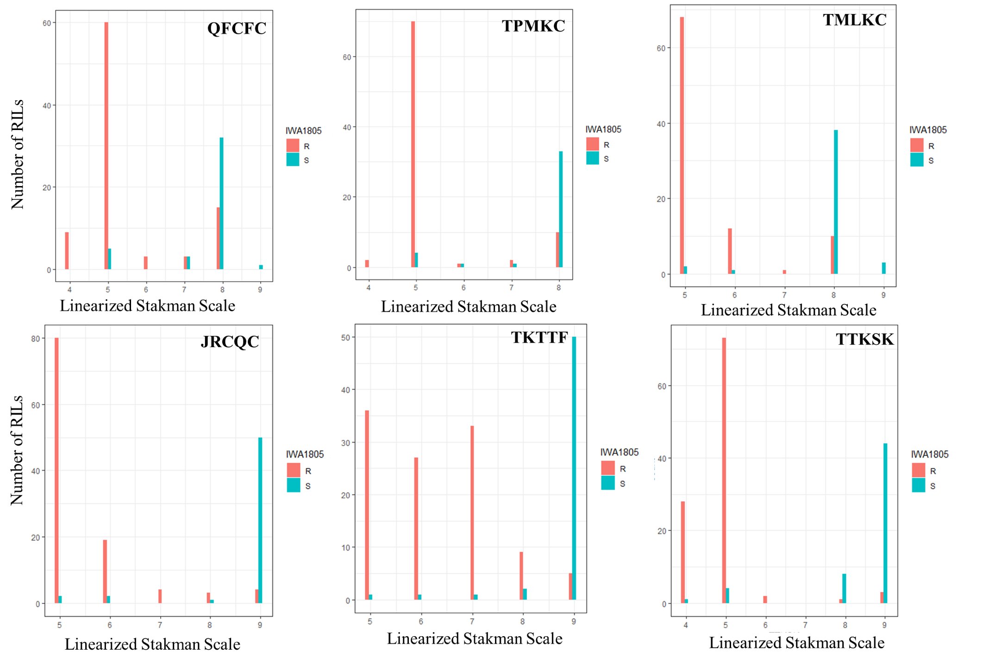
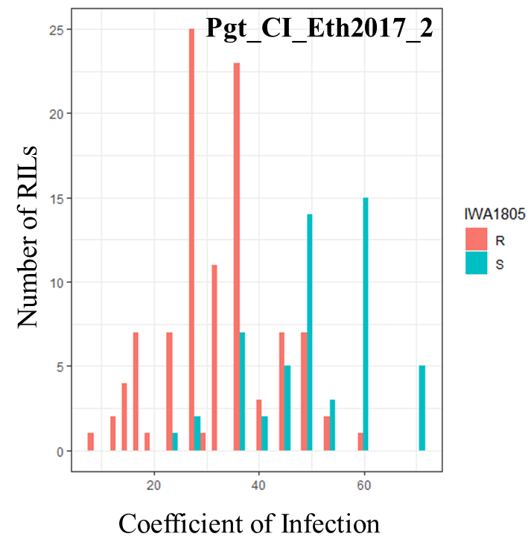
Figure S3.1 Frequency distributions of Rusty × PI192051-1 recombinant inbred lines (RILs) for stem rust infection types at seedling stage and coefficient of infections at adult plant stage in Ethiopia based on segregation at the flanking marker of QSr.ace.7A IWA1805. RILs are segregating for the ‘G’ allele associated with resistance from PI 192051-1 and the ‘A’ allele associated with susceptibility from Rusty.

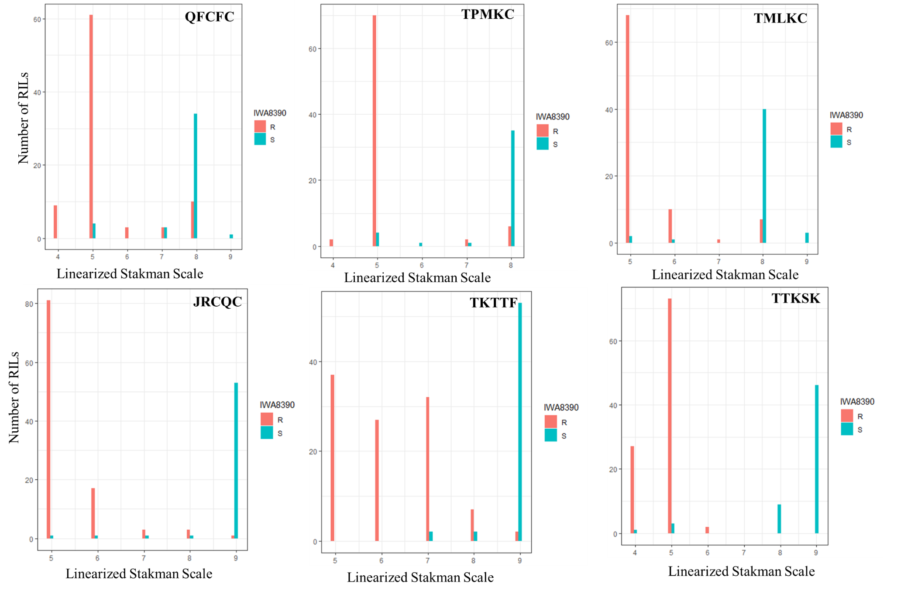

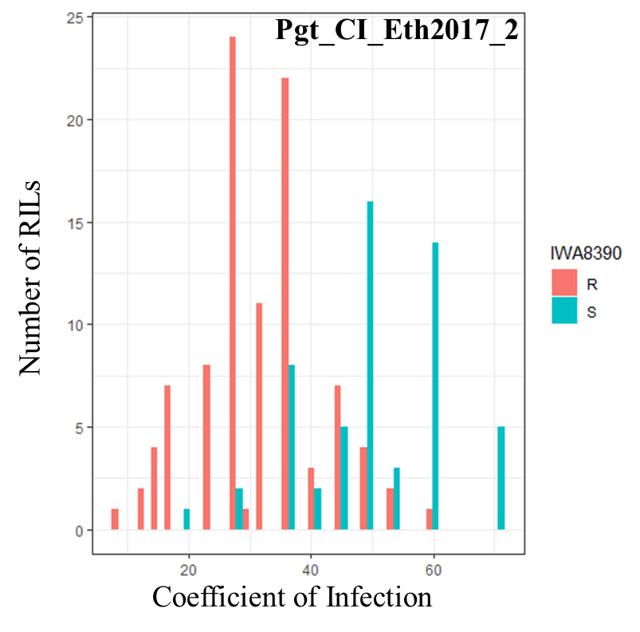

Figure S3.2 Frequency distributions of Rusty × PI192051-1 recombinant inbred lines (RILs) for stem rust infection types at seedling stage and coefficient of infections at adult plant stage in Ethiopia based on segregation at the flanking marker of QSr.ace.7A IWA8390. RILs are segregating for the ‘C’ allele associated with resistance from PI 192051-1 and the ‘T’ allele associated with susceptibility from Rusty.

