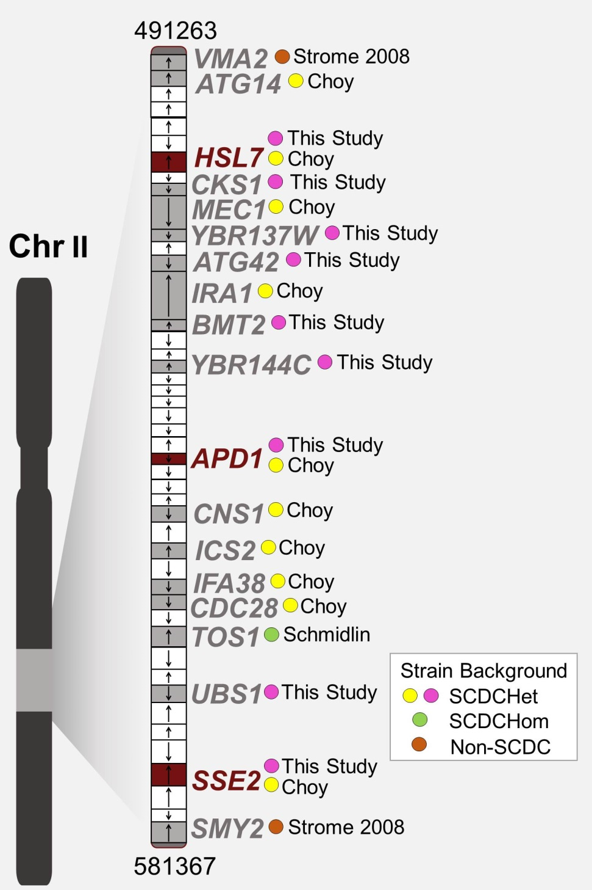

Figure S1. Positional Gene Enrichment example figure Chr II Visual representation of the data of chromosome II PGE analysis including gene name, study which identified the gene, and type of screen/analysis performed (SCDChet, SCDChom, non-SCDC). The majority of genes representing the enriched region of chromosome II come from heterozygous screens, and most of these are found utilizing SCDChet.

