**SUPPLEMENTARY INFORMATION**

**MATERIALS AND METHODS**

**Mice**

Figure 1 in the main part of the manuscript provides a schematic for mouse breeding. *Cyfip1*+/- mice were re-derived using sperm from *Cyfip1*+/- mice on the BE-prone C57BL/6N background (Kirkpatrick *et al*. 2017) that were generated by the International Knockout Mouse Consortium (Skarnes *et al*. 2011) from ES cells containing the “knockout first” allele C57BL/6N-Atm1Brd Cyfip1tm2a (EUCOMM)Wtsi/Wtsi; *Cyfip1*N/-; MGI: 5002986). Sperm was obtained from The Jackson Laboratory (JAX; Bar Harbor, ME USA). *Cyfip1*+/- mice were bred to C57BL/6NJ mice to produce haploinsufficient mice (*Cyfip1*N/-) and wild-type littermates (*Cyfip*N/N). Equal numbers of maternal (*Cyfip1*N/- (m) and paternal deletion families (*Cyfip1*N/- (p)) were paired with wild-type C57BL/6NJ males or wild-type C57BL/6NJ females, respectively. Mice homozygous for the null *Cyfip1* mutation are embryonic lethal (Bozdagi *et al*. 2012; Pathania *et al*. 2014).

Because the C57BL/6N-derived missense mutation (S968F) in the gene homolog *Cyfip2* was associated with increased PF consumption (Kirkpatrick *et al*. 2017; Kumar *et al*. 2013), we generated a second group of mice where we replaced the N alleles with C57BL/6J (J) alleles at the *Cyfip2* locus via backcrossing to the C57BL/6J strain for three and four generations. This approach was designed to reduce the background level of PF intake and to avoid a possible ceiling effect that could prevent detection of the hypothesized increase in PF intake in *Cyfip1*+/- mice. New C57BL/6J breeders were ordered from JAX at each generation of backcrossing. N1 offspring were first generated that were heterozygous for the *Cyfip1* J allele and null (-) allele and were heterozygous for the *Cyfip2* J allele and *Cyfip2* N allele. N1 mice were backcrossed to new C57BL/6J mice (JAX) to produce N2 mice. We picked an equal number of female (maternal; m) and male (paternal; p) N2 mice that were haploinsufficient for *Cyfip1* (*Cyfip1*J/-) and homozygous for the J allele at *Cyfip2* (*Cyfip2*J/J) and again backcrossed these mice to C57BL/6J mice (JAX) to propagate a large colony of N3 mice that were either *Cyfip1*J/- (~50%; one-half the offspring were derived from maternal and one-half of the offspring derived from paternal deletion) or wild-type *Cyfip1*J/J (~50%; one-half of the offspring were derived from maternal deletion and one-half of the offspring were derived from paternal deletion) and all mice were homozygous J/J at *Cyfip2*. A final cohort of N4 mice comprising *Cyfip1* J/J (m), *Cyfip1* J/- (m), *Cyfip1* J/J (p), and *Cyfip1* J/- (p) were produced and phenotyped and were expected to harbor additional loci that were homozygous for the J allele. Mice were housed in the vivarium adjacent to the testing room with *ad libitum* access to chow (Harlan® 2918) and water in the home cage. Behavioral testing was performed between 0730 h and 1300 h, during the light phase of a 12 h light/dark cycle (lights on at 0630). Cage mates were all assigned to the same treatment group within a cage (PF or Chow).

**Power analysis**

To determine an appropriate sample size for the behavioral studies, we used the effect size from a previous publication of summed % body weight (BW) consumed of PF in *Cyfip2*N/N F2 mice vs. *Cyfip2*J/J F2 mice (Cohen’s d = 0.93). A sample size of N = 20 was required to achieve 80% power (p<0.05; two-tailed test) (Kirkpatrick *et al*. 2017). Therefore, we employed a minimum sample size of N = 20 per *Cyfip1* genotype. While we achieved this sample size across *Cyfip1* genotypes, we were also interested in the effect of parental origin (**PO**) of *Cyfip1* deletion on PF consumption in light of a recent report demonstrating an effect of PO of *Cyfip1* deletion on emotional learning (Chung *et al*. 2015). Adding PO as an additional factor for analysis would necessitate doubling the sample size per Genotype to N = 40 [N = 20 per *Cyfip1* Genotype (+/+, +/-) per PO (Maternal, Paternal)]. At the same time, we were cognizant in our attempt to generate equally balanced cohorts across Genotype and PO for each cohort while avoiding generating too many additional mice of a particular PO and introducing potential batch effects that could confound PO effects. While we did not always achieve the target sample size per PO for mice on the *Cyfip2*N/N background (N = 13-31 per Genotype per PO; **Supplementary Table 1**), we did achieve the minimum N = 20 per Genotype per PO for the *Cyfip2*J/J background (N = 23-31 per Genotype per PO) which were the more striking results of the manuscript, thus ensuring their reliability.

**Behavioral battery of anxiety-like and compulsive-like behaviors**

Two cohorts of mice from the *Cyfip1,2*N/N background and three cohorts of mice from the *Cyfip1,2*J/J background were tested in the behavioral battery. The results that drove the main effects and interactions were qualitatively similar across each cohort.

**1) *Open field test***: The open field test is a measure of anxiety-like behavior whereby a reduction in time spent in the inner/central zone of the arena is considered anxiety-like behavior that reflects an avoidance for the more exposed and thus the more dangerous part of the arena (Prut and Belzung. 2003). Experimentally naïve mice were placed in a 46 cm tall testing chamber (total area: 20 cm wide x 43 cm long; inner/central zone area: 10 cm wide x 22 cm long; outer zone: total area minus the inner/central zone area) in a lit room and allowed to move freely for five min. Behaviors were video recorded for five min for tracking analysis (AnyMaze, Stoelting Co., Wood Dale, IL USA) whereby the chamber was divided into four equal outer zones and four equal inner zones. Analyses were conducted on the amount of time spent in any of the inner zones, the number of times that all four inner zones were visited without entering an outer zone (center sequences), and the number of times that all four outer zones were visited without entering an inner zone (perimeter sequences).

**2) *Elevated plus maze (EPM)***: The elevated plus maze is a second test of anxiety-like behavior whereby mice can choose to whether reside in the safer, “closed” arms of an elevated chamber or to enter the more exposed and thus, more aversive and dangerous “open” arms that lack side walls. Less time spent or entries into the open arms is thought to reflect anxiety-like behavior (Kulkarni and Sharma. 1991). Mice were allowed to acclimate to the dark testing room (illuminated by a dim red light) for one h. Mice were then placed into the center of the EPM (Stoelting Co.) and video recorded for five min. We examined the percent time spent in the closed arms, the open arms, the outer half of the open arms, the center, and the distance traveled.

**3) *Marble burying***: Digging, burrowing, and burying of objects with bedding are highly correlated behaviors associated with survival. Inherent burying of non-aversive stimuli can be distinguished from defensive burying of aversive, noxious stimuli (De Boer and Koolhaas. 2003) and can be dissociated from other anxiety-like behaviors, response to novelty, and levels of locomotor activity. Rather, inherent marble burying is an indirect measure of the natural tendency to dig (Gyertyan. 1995; Njung'e and Handley. 1991; Thomas *et al*. 2009) and represents a persistent, repetitive behavior that is resistant to habituation and is proposed to be relevant to obsessive/compulsive behavior (Deacon. 2006; Thomas *et al*. 2009). Marble burying is used to screen pharmacotherapeutics for OCD (Hoffman and Cano-Ramirez. 2017). Genetic variance in marble burying among inbred mouse strains is heritable but is not genetically correlated with anxiety-like behaviors and thus, is mediated by distinct genetic factors (Thomas *et al*. 2009).

The testing chamber (20 cm x 43 cm x 46 cm) was filled to a depth of five cm with wood chip bedding material that was tamped to make a flat, even surface (Deacon. 2006). Six marbles (2.54 cm by 2.54 cm by 1.27 cm) were evenly spaced on top of the bedding in a 2 x 3 pattern, approximately 8 cm apart. Mice were then placed in the chamber and video recorded for five min. At the end of this period, mice were returned to the home cage, and each marble was scored based on percent surface covered (0, 25, 50, 75, or 100%) (Angoa-Perez *et al*. 2013). The number of marbles with greater than 50% coverage was recorded as well as the average % burial across the total six marbles (each marble was scored as 25%, 50%, 75%, or 100% covered) for each individual mouse. The experimenter was always blinded to Genotype.

**4) *Hole board test***: The hole board test is commonly used to assess anxiety-like (do-Rego *et al*. 2006), novelty-seeking (Arenas *et al*. 2014), and repetitive behaviors (Moy *et al*. 2008). Moreover, head-dipping activity in the hole board test has been shown to be a valid predictor of reward-associated behaviors such as nicotine self-administration (Abreu-Villaca *et al*. 2006), and cocaine-induced conditioned place preference (Arenas *et al*. 2014).

A solid platform was placed into the testing chamber (20 cm x 43 cm x 46 cm) and elevated to a height of 20 cm above the chamber floor. The platform contained eight, evenly-spaced holes (2 x 4 pattern; hole diameter: 2.54 cm; hole spacing: 10.16 cm) positioned directly above an instrument that generated a grid of infrared beams (MotorMonitor, Kinder Scientific, Poway, CA USA). Each mouse was placed individually on the platform and video recorded for five min. Each time the mouse inserted its head into any hole, the infrared beams were broken, and the head dip was recorded. We then analyzed the total number of head dips over five min.

**5) *Mist-induced grooming***: Mist spray-induced grooming has been used to model compulsive-like behavior (Hill *et al*. 2007; Maravet Baig *et al*. 2018). The mist spray serves as a stimulus that induces grooming response in order to detect whether experimental factors (here, Genotype) promote or reduce excessive grooming. Excessive (or, i.e., perseverative, repetitive) grooming is considered an OC-related behavior in rodents and humans (Kalueff *et al*. 2016).

Mice were placed onto a table and gently lifted by the tail to minimize avoidance. The mouse was turned to face a spray bottle filled with room-temperature tap water, and mist-sprayed twice to adequately coat the animal with mist. The mice were then placed in the observation chamber for 10 min and grooming behavior was recorded. The experimental chamber was cleaned extensively with 20% ethanol after each 10 min period and with 70% ethanol after completion of the experiments. Behaviors quantified included the number of bouts of grooming, the time spent grooming (s), and the average duration of the grooming bouts (s) (Hill *et al*. 2007; Maravet Baig *et al*. 2018).

**Locomotor activity on Day 1 (D1) in the conditioned place preference (CPP) chambers, prior to BE training**

The locomotor data in **Supplementary Figure 5** illustrate total distance traveled on D1 during open access to both sides of the CPP apparatus prior to BE training. Total distance traveled over 30 min (both the left and right sides combined) was quantified via video recording and AnyMaze tracking software (Stoelting Co.). Mixed effects ANOVAs were conducted separately for females and males with Genotype and PO as factors and Time as the repeated measure. Results are presented in **Supplementary Figure 5.**

**Binge eating (BE) procedure**

We used a two-chambered conditioned place preference (**CPP**) apparatus, with differently textured floors in each chamber. The right and left sides were designated the food-paired (**FP**) and no-food-paired sides (**NFP**), respectively. Mice were trained and video recorded in unlit sound-attenuating chambers (MedAssociates, St. Albans, VT USA). On Day (D)1, initial side preference was determined by placing each mouse on the NFP side with the divider containing an open entryway that provided free access to the both sides for 30 min. Clean, empty food bowls were placed in the far corners of each side. On D2, D4, D9, D11, D16, and D18, mice were confined to the FP side with a closed divider that prevented access to the NFP side. Mice were provided either forty, 20 mg sweetened palatable food pellets (**PF**; TestDiet 5-TUL, St. Louis, MO USA) or home cage chow-like pellets (Chow; TestDiet 5BR3) in a non-porous porcelain dish in the far corner of the chamber. On D3, D5, D10, D12, D17, and D19, mice were confined to the NFP side with no access to the FP side. A clean, empty, and non-porous porcelain dish was placed in the far corner of the chamber during this time. On D22, side preference was again assessed with open access to both sides. No food was present in either bowl at this time. Mice were assigned to either the PF or Chow group in a counterbalanced design in order to ensure equal distribution across Sex, Genotype, Treatment, and PO. The experimenter who ran the mice through the behavioral studies as well as the experimenters who scored or analyzed the data were blinded to Genotype and PO throughout data collection and analysis for each cohort. Four cohorts of *Cyfip2*N/N and three cohorts of *Cyfip2*J/J mice were tested in the BE procedure. The results that drove the main effects and interactions were qualitatively similar across each cohort.

PF pellets were obtained from TestDiet (20 mg each; 5TUL diet; MO, USA). The 5TUL contains a metabolizable energy density of 3.4 kcal/g (21% from protein, 13% from fat, and 67% from carbohydrates). Chow pellets were custom-made in the same, 20 mg size by Purina LabDiet and were similar to the home cage diet in the vivarium (Teklad 18% Protein Diet). They comprise the LabDiet 5V75 formulation which has a metabolizable energy density of 3.26 kcal/g (calories provided: 23% from protein, 13% from fat, and 64% from carbohydrates). Additional literature on the 5TUL and 5V75 diets can be found online at the TestDiet website (<https://www.testdiet.com/>) and the LabDiet website (<https://www.labdiet.com/>), respectively.

**Light/dark conflict test of compulsive-like eating**

In addition to premorbid anxiety- and compulsive-like behaviors, we also assessed post-training, compulsive-like eating and concomitant behaviors in the anxiety-provoking light/dark conflict test where rodents will avoid the aversive, light side of the box (Moore *et al*. 2017) . On Day 23, mice were assessed for behaviors as described (Babbs *et al*. 2018; Kirkpatrick *et al*. 2017). The light/dark box consists of a dark side, which was a black, opaque Plexiglas chamber and a light side which was a clear Plexiglas chamber. An open doorway allowed free access to both sides. A non-porous ceramic bowl containing forty, 20 mg PF pellets was placed in the center of the light side. Mice were initially placed on the light side facing both the food and the doorway and were video recorded for 30 min. Because the light side is aversive, increased behaviors in this environment were operationalized as compulsive-like, including compulsive-like eating (Babbs *et al*. 2018; Kirkpatrick *et al*. 2017). Four cohorts of *Cyfip2*N/N and three cohorts of *Cyfip2*J/J mice were tested in the BE procedure. The results were qualitatively similar across each cohort for each genetic background.

***Cyfip1* and *Cyfip2* genotyping**

*Cyfip1*+/- mice were genotyped using DNA extraction from tail biopsy, PCR, and gel electrophoresis. Separate PCR reactions were used to detect the wild-type and mutant alleles. The forward primer sequence for *Cyfip1* was 5'-TGGAAGTAATGGAACCGAACA- 3'. The reverse wild-type *Cyfip1* primer sequence was 5’-GTAACTACCTATAATGCAGACCTGAAG-3' and together with the forward primer yielded an amplicon size of 259 bp. The mutant reverse primer sequence was 5'-TCGTGGTATCGTTATGCGCC-3' and together with the forward primer yielded an amplicon size of 182 bp. *Cyfip1*+/- samples show both bands. Primers were purchased from Integrated DNA Technologies (**IDT**; Coralville, IA USA).

*Cyfip2* was genotyped for the N-derived S968F missense mutation (chromosome 11: 46,222,615 bp; mm10) vs. the alternate J allele using a primer set obtained from IDT that targeted the mutation (rs240617401; chromosome 11: 46,222,615 bp; mm10) (Kirkpatrick *et al*. 2017; Kumar *et al*. 2013). The forward primer sequence was 5’-TACAGGCACAGCCAGAGATG-3’ and the reverse primer sequence was 5’- TCCTGCAGTACGTGAAGACG-3’, yielding an amplicon size of 185 bp. Sequencing was conducted by IDT. Sequence results were determined using Sequence Scanner Software v2.0 (Applied Biosystems, Foster City, CA, USA).

**Primer sequences for qPCR**

***Cyfip1*:** Forward: CTAACGCACAGCCCCAGTAT (exon 23, UCSC Genome Browser); Reverse: CAAGTAGCCGGCAGATGACT (exon 24, UCSC)

***Cyfip2*** (Kirkpatrick *et al*. 2017)**:** Forward: ACTGTATCCCTGTGGGGACC (exon 29, UCSC); Reverse: AAGACAATGATGGAGCAGCC (exon 30, UCSC)

***Magel2*** (Kamaludin *et al*. 2016)**:** Forward: GGCTGCACTCTACGAGAACC; Reverse: GGCATTTGCGTCCTTGTATT (exon 1, UCSC)

***Hprt*** (housekeeping gene for *Cyfip1*, *Cyfip2*, and *Magel2*):Forward: GCTGGTGAAAAGGACCTCT; Reverse: CACAGGACTAGAACA CCTGC

**Western blot procedure**

Tissues were homogenized in RIPA buffer (Thermo Scientific, Waltham, MA, USA) containing 1x HALT protease/phosphatase inhibitor cocktail (Thermo Scientific) with 3 s burst from an ultrasonic homogenizer. Samples were spun at 17200 RCF for 20 min at 4ºC. Supernatants were collected, and protein concentrations were determined via BCA protein estimation (Thermo Scientific). 30 µg of sample protein and loading buffer (BioRad, Hercules, CA, USA) was loaded into 4-15% Criterion TGX gels (BioRad) and run at 200 V for 50 min. Gels were transferred onto nitrocellulose membranes (GE Healthcare, Chicago, IL, USA) overnight in Towbins buffer containing 20% methanol at 25V at 4ºC. Blots were then blocked with 5% milk for 1 h.

**CYFIP1:** Hypothalamic immunoblots were blocked in 5% milk in tris-buffered saline containing 0.5% Tween 20 (**TBST**) for 1 h, incubated in a 1:50,000 dilution of Beta-actin antibody (Sigma Aldrich, St. Louis, MO, USA; cat. # A2228) in 5% BSA in TBST overnight at 4ºC, and a 1:10,000 dilution of peroxidase conjugated donkey anti mouse antibody (Jackson Immunoresearch, West Grove, PA, USA; cat. # 715-035-151) for 1 h. Following application of stripping buffer (Thermo Scientific) at 55ºC for 30 min, the immunoblot was blocked again in 5% milk, incubated in a 1:50,000 dilution of CYFIP1 antibody (Abcam, Cambridge, UK; cat. # Ab108220) in 5% BSA in TBST overnight at 4ºC, and a 1:10,000 dilution of peroxidase conjugated donkey anti rabbit antibody (Jackson Immunoresearch; cat. # 711-035-152) for 1 h. All imaging was conducted using radiological film (Denville Scientific, Holliston, MA, USA). Immunoblots for nucleus accumbens tissue were blocked in 5% BSA in TBST, incubated in a 1:50,000 dilution of Beta-actin antibody in 5% BSA in TBST overnight at 4ºC, and a 1:10,000 dilution of peroxidase conjugated donkey anti mouse antibody for 1 h. Following application of stripping buffer at 55ºC for 30 min, the blot was blocked in 5% BSA in TBST, incubated in a 1:50,000 dilution of CYFIP1 antibody in 5% BSA in TBST overnight at 4ºC, and a 1:10,000 dilution of peroxidase conjugated donkey anti-rabbit antibody for 1 h. Imaging of beta-actin was conducted using a ChemiDoc XRS+ imager (BioRad), CYFIP1 imaging was conducted using radiological film.

**FMRP:** FMR1 immunoblots were blocked in 5% BSA in TBST, incubated in a 1:2,500 dilution of FMR-1 antibody (EMD Millipore, MAB2160) in 5% BSA in TBST overnight at 4C and a 1:10,000 dilution of peroxidase conjugated donkey anti mouse antibody (Jackson Immunoresearch, #715-035-151) for 1 h and then imaged. All imaging was conducted using radiological film (Denville Scientific, #E3018) and Clarity Western ECL substrate (BioRad, #170-5061). Following imaging, blots were stripped with stripping buffer (Thermo Scientific, 46430) at 55°C for 30 min, blocked in 5% BSA in TBST. in a 1:50,000 dilution of Beta-actin antibody (Sigma Aldrich, #A2228) in 5% BSA for 1 h, then a 1:10,000 dilution of peroxidase conjugated donkey anti mouse antibody for 1 h, and then imaged.

**Analysis.** Immunoblot bands were quantified using densitometry analysis in NIH ImageJ. Raw densitometry values for each lane were first normalized to the corresponding beta actin value. Next, to control for blot effects, densitometry values for each band were subsequently normalized to the average wild-type value for that blot. These values were then compiled into groups that were used in the statistical analysis.

**SUPPLEMENTARY RESULTS**

The samples sizes for each study are listed in **Supplementary Table 1.** The mean and S.E.M. values of the phenotypes from the battery of premorbid anxiety-like and compulsive-like behaviors are listed in **Supplementary Table 2.** The qPCR results are presented in **Supplementary Table 3.**

**Verification of key findings influencing our conclusions with non-parametric tests**

To verify key differences between groups on PF intake on individual days identified via ANOVA and post-hoc t-tests, we implemented a series of Mann-Whitney U (**MWU**) and Welch’s t-tests (**WTT**). For PF intake on the *Cyfip1*,2N/N background, to follow up on the effect of Genotype [F(1,464) = 12.3; p = 0.0005], PO [F(1,464) = 9.0; p = 0.003], and Day [F(1,464) = 20.8, p = 6.5 x 10-6**; Fig.5A**]., we compared PF intake on D4 between maternally deleted *Cyfip1*N/- (m) and their wild-type *Cyfip1* N/N (m) counterparts (**Fig.5A**) and verified greater consumption in *Cyfip1*N/- with WTT [t(29) = 2.3; p = 0.03] and with MWU [U(29) = 66; p = 0.04].

For the *Cyfip1*,2J/J genetic background (**Fig.5D**), to follow up on the effect of Genotype [F(1,600) = 5.2; p = 0.02], the Genotype x PO interaction [F(1,600) = 9.3; p = 0.002], the effect of Day [F(5,600) = 4.4; p = 0.0006], we verified that there was significantly greater PF intake on D9 in wild-type *Cyfip1*J/J (m) mice vs. their mutant *Cyfip1*J/- (m) counterparts with WTT [t(59) = 2.9; **\***p=0.005; **Fig.5D**] and with MWU [U(59) = 286; **\***p = 0.009; **Fig.5D**]. Similarly, for D18, we also verified that there was significantly greater intake in wild-type *Cyfip1*J/J (m) mice vs. their mutant *Cyfip1*J/J (m) counterparts with WTT [t(59) = 2.2; **\***p = 0.03; **Fig.5D**] and with MWU [U(59) = 316; **\***p = 0.03; **Fig.5D**].

For the *Cyfip1*,2 J/J genetic background (**Fig.5D-L**), to follow up on the effect of Sex [F(1,600) = 14.1; p = 0.0002], Day [F(5,600) = 4.4; p = 0.0006], and Genotype x Sex interaction [F(1,600) = 10.8; p = 0.001] on PF intake, we verified that there was significantly less intake on D9 in male maternally deleted *Cyfip1*J/- (m) mice vs. their male wild-type *Cyfip1*J/J (m) counterparts with WTT [t(29) = 2.2; **\***p = 0.04] and with MWU [U(29) = 42; **\***p = 0.004]. For PF intake on D16, we identified trends for less PF intake in maternally deleted male *Cyfip1*J/- (m) mice vs. their male wild-type *Cyfip1*J/J (m) counterparts with MWU [U(29) = 29; p = 0.053; **Fig.5J**] and WTT [t(29) = 1.7; p = 0.09; **Fig.5J**]. And finally, for PF intake on D18, we again verified that there was significantly less PF intake in maternally deleted male *Cyfip1*J/- (m) mice vs. their male wild-type *Cyfip1*J/J (m) counterparts with MWU [U(29) = 58; p = 0.03] and a trend with WTT [t(29) = 1.8; p = 0.09; **Fig.5J**].

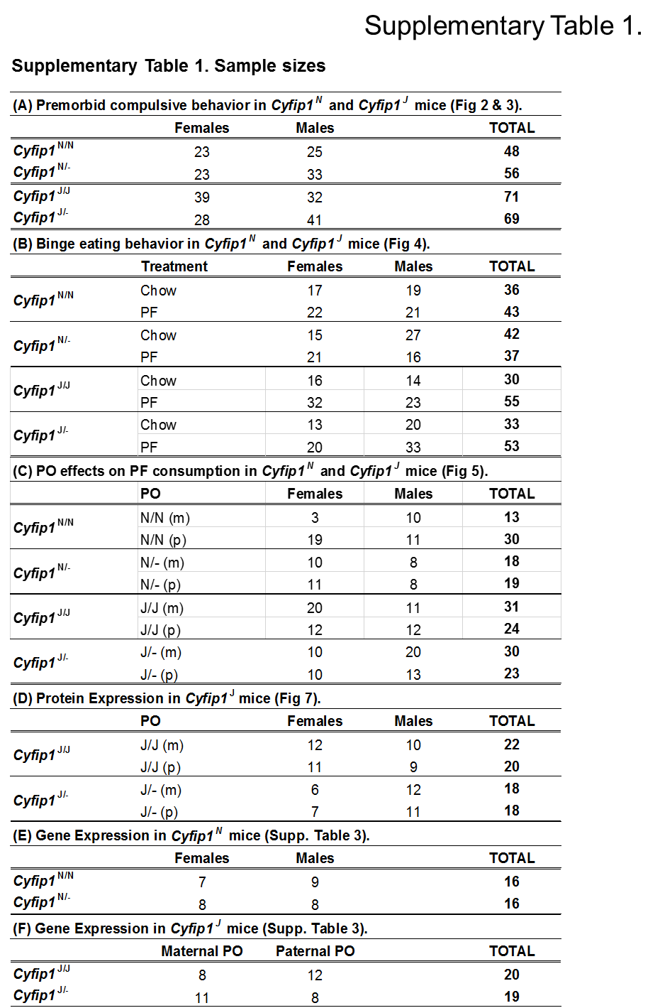

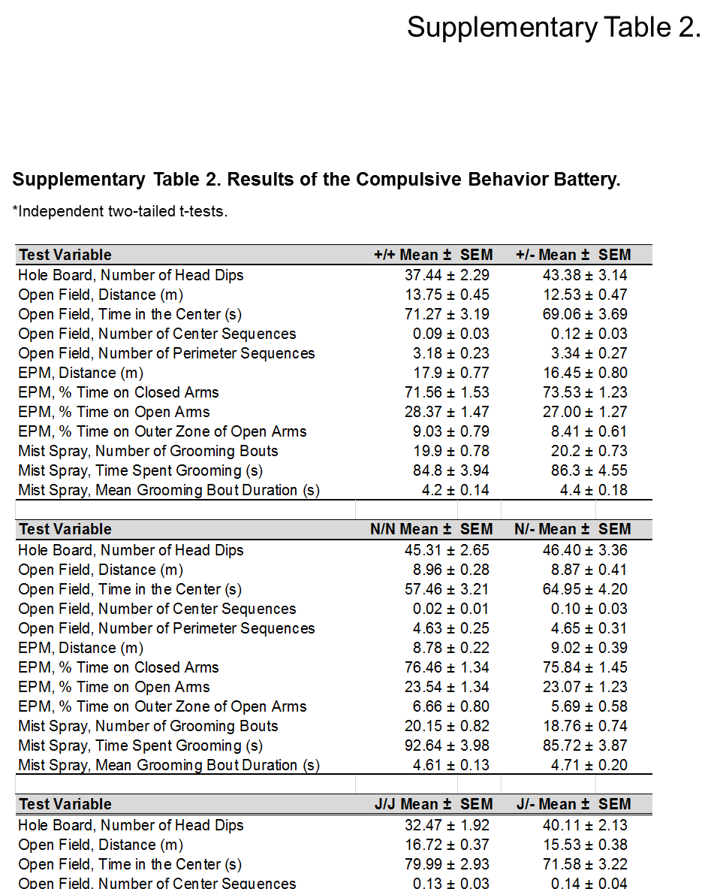



For the qPCR samples from the *Cyfip1*,2N/N genetic background (panel A), all mice were Chow-trained with no history of training in the five-day behavioral battery. For the qPCR samples from the *Cyfip1*,2J/J genetic background (panel B), all mice were experimentally naïve with no prior history of training in either the five-day behavioral battery or in BE training. Bold = significantly different from wild-type. Data are shown as mean ± S.E.M. (in parentheses) for fold-change in expression relative to wild-type mice using the 2-∆∆CTmethod. Bolded results indicate values that were significantly decreased relative to wild-type (p < 0.05; unpaired t-test). **(A):** Results are shown for *Cyfip1*N/- mice on a *Cyfip1,2*N/N background. Samples were balanced across experimental cohorts and qPCR plates (n = 14-16 per Genotype; 7-9 per Genotype per PO). **(B):** Results are shown for *Cyfip1*J/- n = 8-12 per Genotype per PO) versus *Cyfip1* J/J mice (n = 19-20) on the *Cyfip1,2* J/J background. * indicates a significant difference in **Maternal (m)** versus **Paternal (p)** fold change in *Cyfip1*J/- mice (p<0.05; unpaired t-test).

**Supplementary Table 3. Changes in hypothalamic *Cyfip1*, *Cyfip2*, and *Magel2* expression in *Cyfip*+/-mice as a function of PO on either the *Cyfip1,2*N/N or *Cyfip1,2*J/J genetic background.**

**Supplementary Figure 1: Change in body weight across training days in female and male *Cyfip1*+/- mice and in maternally vs. paternally deleted *Cyfip1*+/- mice.** The following analyses for body weight represent the results of mixed-effects ANOVAs containing either Genotype and Sex as factors (panels A and B) or Genotype and PO as factors (panels C and D) and in all cases, Day as the repeated measure. **(A,B):** While we did not identify any effect of *Cyfip1* Genotype or interaction with Sex on body weight in mice with a *Cyfip2*N/N background, we did identify the expected main effect of Sex (females < males) [**A;** F(1,300) = 460.3; **\***p = 2 x 10-16]. We also detected a similar Sex effect for mice on the *Cyfip2*J/J background [**B**: F(1,326) = 997; **\***p = 2 x 10-16]. Additionally, Chow-trained mice weighed more compared to PF-trained mice on the *Cyfip1,2*J/J genetic background [F(1,326) = 11.4; p = 0.0008] (data not shown) and *Cyfip1*J/- mice weighed less than *Cyfip1*J/J mice [F(1,326) = 18.0; p = 2.8 x 10-5]. We also observed a Sex x Treatment interaction [F(1,326) = 15.6; p = 9.5 x 10-5], driven primarily by differences between Chow-trained and PF-trained males (data not shown). **(C,D):** In examining the effects of PO in mice on the *Cyfip2*N/N background, there was no effect of Genotype, PO, Day, or any interactions (**C**: all ps > 0.15). However, for mice on the *Cyfip2*J/J background there was again, a main effect of Genotype [**D**: F(1,334) = 4.8; p = 0.03] as well as a small effect of PO [**D**: F(1,334) = 5.2; p = 0.02].

**Supplementary Figure 2: PF-CPP in *Cyfip1*N/- and *Cyfip1* J/- mice. (A):** In examining CPP via change in time spent on the food-paired side between Day 1 (**D1**) and Day 22 (**D22**), we used two-way ANOVA with Genotype and Treatment as factors. For the *Cyfip1,2*N/N genetic background, there was no effect of Genotype [F(1,148) = 2.4; p = 0.13], Treatment [F(1,148) = 1.2; p = 0.27], or interaction [F(1,148) = 0.58; p = 0.45]. However, when considering the PF data alone (as we also did in analysis of PF intake; **Fig.5A-C**), PF-trained *Cyfip1*N/- mice showed greater CPP than *Cyfip1*N/N mice [t(77) = 2.19; **\***p = 0.03], thus indicating greater PF reward which is in line with the greater, preceding PF intake in *Cyfip1*N/- mice. **(B):** In considering *Cyfip1*J/- mice on the *Cyfip2*J/J background, there was no effect of Genotype [F(1,167) = 0.7; p = 0.41], Treatment [F(1,167) = 1.1; p = 0.3], or interaction [F(1,167) = 0.001; p = 0.97] and no difference in PF-CPP (p > 0.05).

**Supplementary Figure 3. Compulsive-like PF consumption in the light/dark conflict test in *Cyfip1*N/- and *Cyfip1*J/- mice. (A):** An illustration of the light/dark box is shown. All mice were provided 30 min access to PF. The PF was placed in a bowl located in the center of the light side. In examining compulsive-like PF intake in the light/dark test, we ran two-way ANOVAs with Genotype and PO as factors for mice on either the *Cyfip1*,2 N/N or *Cyfip1*,2J/J backgrounds (**B,C**). For the *Cyfip1*,2J/J background, because of the Sex-dependent PO effects on PF intake during training (**Fig.5**), we also ran separate two-way ANOVAs for females and males with Genotype and PO as factors (**D,E**). **(B):** In considering PF-trained mice on the *Cyfip2*N/N background, there was no effect of Genotype or interaction with PO in the Sex-collapsed dataset (all ps > 0.28). **(C):** For *Cyfip1*J/- mice on the *Cyfip1*J/J background, there was a main effect of Genotype [F(1,104) = 7.4; p = 0.008] that was explained by a reduction in PF consumption in *Cyfip1*J/- relative to *Cyfip1*J/J mice that was significant for paternally deleted *Cyfip1* J/- (p) vs. their wild-type *Cyfip1* J/J (p) counterparts [left two bars: t(49) = 2.4; **†**p = 0.02]. **(D,E):** For females on the *Cyfip1*,2J/J background, there was no effect of Genotype or PO [**D**: ps > 0.39]. For males on the *Cyfip1*,2J/J background, there was an effect of Genotype **[E:** F(1,52) = 7.2; p = 0.01] that was explained in part by paternally deleted male *Cyfip1*J/- (p) mice showed a significant reduction in PF intake relative to their wild-type *Cyfip1*J/J (p) counterparts [**E:** **‡** t(23) = 2.2; p = 0.035].

**Supplementary Figure 4: Immunoblots for CYFIP1.** Western blot images show the density of CYFIP1 and β-actin staining. J/J = *Cyfip1*J/J; J/- = *Cyfip1*J/-; m = maternal deletion family; p = paternal deletion family (see annotations in Fig.1D).

**Supplementary Figure 5: Maternal but not paternal deletion of *Cyfip1* induces locomotor hyperactivity on Day 1 in male but not female *Cyfip1*J/- mice.** We first ran a mixed effects ANOVA (factors: Genotype, Sex, PO; repeated measure: Time) for distance traveled. We then ran subsequent mixed effects ANOVAs separately for females and males (factors: Genotype, PO; repeated measure: Time). In considering distance traveled on Day 1 (D1) of training, there was a main effect of Genotype [F(1,984) = 31.0; p = 3 x 10-8], Time [F(5,984) = 244.9; p = 2 x 10-16], a Genotype x PO interaction [F(1,984) = 4.8; p = 0.03], a PO x Sex interaction [F(1,984) = 4.2; p = 0.04], and a Genotype x PO x Sex interaction [F(1,984) = 7.1; p = 0.008]. To determine the source of these interactions, we broke down the data by PO separately for females and males. **(A).** Maternally deleted *Cyfip1*J/- (m) mice showed significant locomotor hyperactivity at 10-30 min (* all ps < 0.04, unpaired t-tests). **(B):** Paternally deleted *Cyfip1*J/- (p) did not show a genotypic difference in locomotor activity (all ps > 0.09). **(C,D):** In considering females only, there was a main effect of Genotype [F(1,462) = 13.8; p = 0.0002], PO [F(1,462) = 5.5; p =0.02] and Time [F(5,462) = 127; p = 2 x 10-16]. There was no genotypic difference in females, regardless of whether there was maternal *Cyfip1*J/- (m) deletion (**C**; all p’s > 0.11) or paternal *Cyfip1*J/- (p) deletion (**D**; all p’s > 0.14, unpaired t-tests). **(E,F):** In considering males only, there was a main effect of Genotype [F(1,522) = 15.2; p = 0.0001], Time [F(5,522) = 120.2; p = 2 x 10-16], and a Genotype x PO interaction [F(1,522) = 9.2, p = 0.002]. Maternally deleted *Cyfip1*J/- (m) males showed significant locomotor hyperactivity compared to their male wild-type *Cyfip1*J/J (m) counterparts at 10, 20, and 30 min (**E**: * all ps < 0.04, unpaired t-tests). Paternally deleted *Cyfip1*J/- (p) mice did not show any difference in locomotor activity compared to their male wild-type *Cyfip1*J/J (p) counterparts (**F**: all p’s > 0.3).

**Supplementary Figure 6: Immunoblots for FMRP.** Western blot images show the density of FMRP and β-actin staining. J/J = *Cyfip1*J/J; J/- = *Cyfip1*J/-; m = maternal deletion family; p = paternal deletion family (see annotations in Fig.1D).

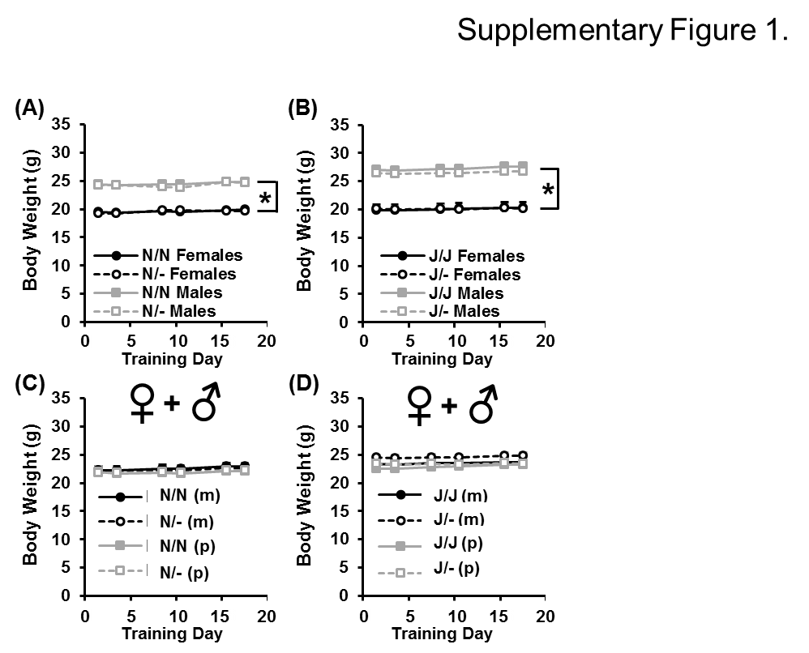

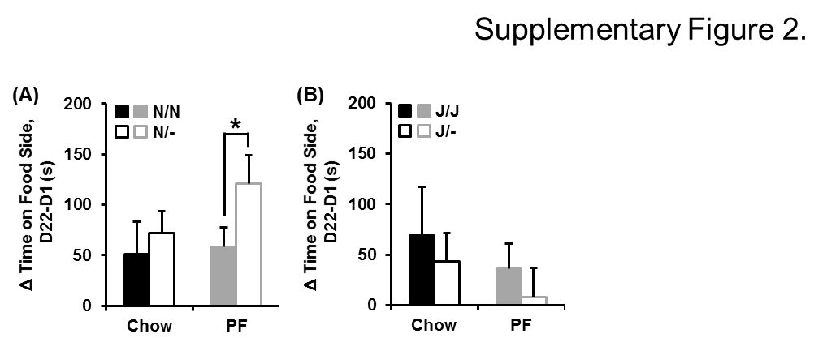

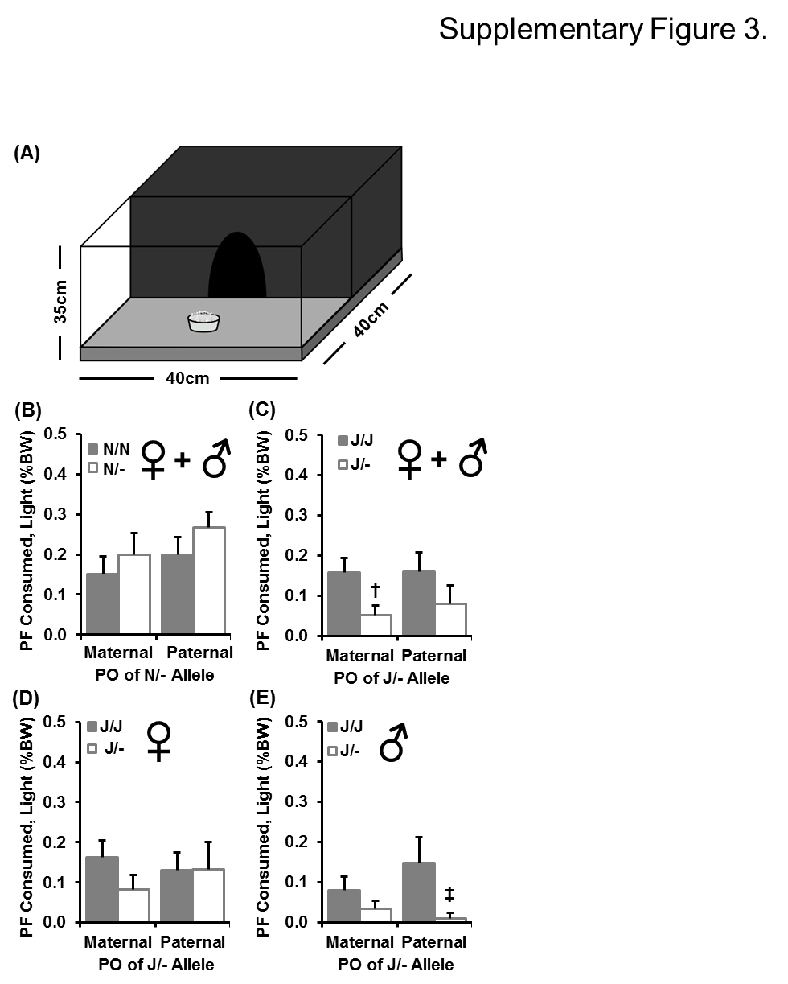

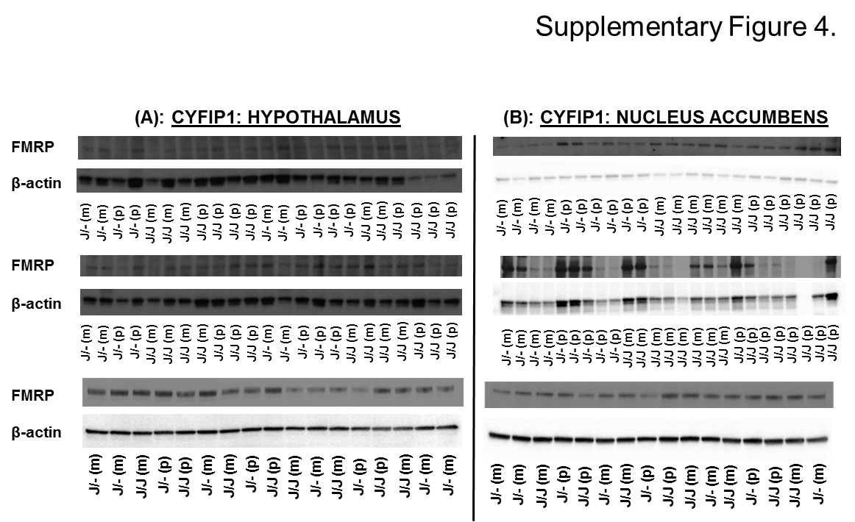

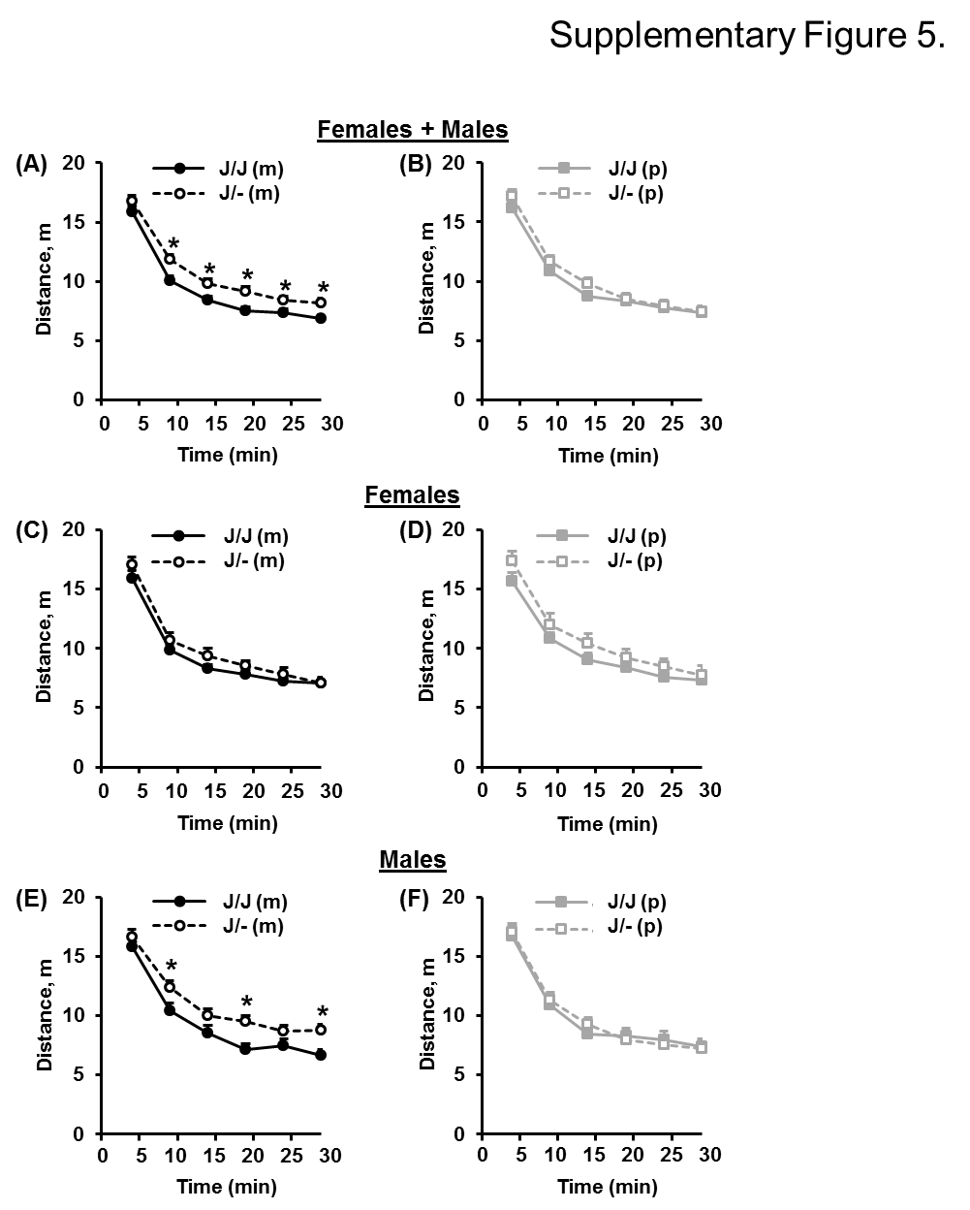

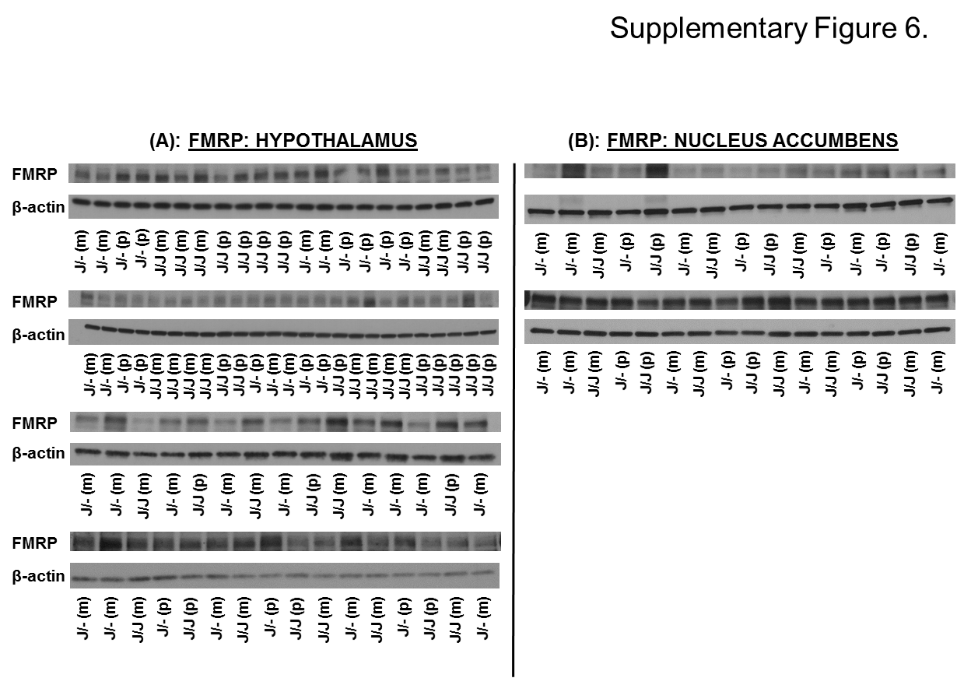

LITERATURE CITED

Abreu-Villaca, Y., E. Queiroz-Gomes Fdo, A. P. Dal Monte, C. C. Filgueiras and A. C. Manhaes, 2006 Individual differences in novelty-seeking behavior but not in anxiety response to a new environment can predict nicotine consumption in adolescent C57BL/6 mice. Behav. Brain Res. **167:** 175-182.

Angoa-Perez, M., M. J. Kane, D. I. Briggs, D. M. Francescutti and D. M. Kuhn, 2013 Marble burying and nestlet shredding as tests of repetitive, compulsive-like behaviors in mice. J. Vis. Exp. **(82):50978. doi:** 50978.

Arenas, M. C., M. Daza-Losada, A. Vidal-Infer, M. A. Aguilar, J. Minarro *et al*, 2014 Capacity of novelty-induced locomotor activity and the hole-board test to predict sensitivity to the conditioned rewarding effects of cocaine. Physiol. Behav. **133:** 152-160.

Babbs, R. K., J. C. Kelliher, J. L. Scotellaro, K. P. Luttik, M. K. Mulligan *et al*, 2018 Genetic differences in the behavioral organization of binge eating, conditioned food reward, and compulsive-like eating in C57BL/6J and DBA/2J strains. Physiol. Behav. **197:** 51-66.

Bozdagi, O., T. Sakurai, N. Dorr, M. Pilorge, N. Takahashi *et al*, 2012 Haploinsufficiency of Cyfip1 produces fragile X-like phenotypes in mice. PLoS One **7:** e42422.

Chung, L., X. Wang, L. Zhu, A. J. Towers, X. Cao *et al*, 2015 Parental origin impairment of synaptic functions and behaviors in cytoplasmic FMRP interacting protein 1 (Cyfip1) deficient mice. Brain Res. **1629:** 340-350.

De Boer, S. F., and J. M. Koolhaas, 2003 Defensive burying in rodents: Ethology, neurobiology and psychopharmacology. Eur. J. Pharmacol. **463:** 145-161.

Deacon, R. M., 2006 Digging and marble burying in mice: Simple methods for in vivo identification of biological impacts. Nat. Protoc. **1:** 122-124.

do-Rego, J. C., A. F. Viana, E. Le Maitre, A. Deniel, S. M. Rates *et al*, 2006 Comparisons between anxiety tests for selection of anxious and non anxious mice. Behav. Brain Res. **169:** 282-288.

Gyertyan, I., 1995 Analysis of the marble burying response: Marbles serve to measure digging rather than evoke burying. Behav. Pharmacol. **6:** 24-31.

Hill, R. A., K. J. McInnes, E. C. Gong, M. E. Jones, E. R. Simpson *et al*, 2007 Estrogen deficient male mice develop compulsive behavior. Biol. Psychiatry **61:** 359-366.

Hoffman, K. L., and H. Cano-Ramirez, 2017 Lost in translation? A critical look at the role that animal models of obsessive compulsive disorder play in current drug discovery strategies. Expert Opin. Drug Discov. 1-10.

Kalueff, A. V., A. M. Stewart, C. Song, K. C. Berridge, A. M. Graybiel *et al*, 2016 Neurobiology of rodent self-grooming and its value for translational neuroscience. Nat. Rev. Neurosci. **17:** 45-59.

Kamaludin, A. A., C. Smolarchuk, J. M. Bischof, R. Eggert, J. J. Greer *et al*, 2016 Muscle dysfunction caused by loss of Magel2 in a mouse model of prader-willi and schaaf-yang syndromes. Hum. Mol. Genet. **25:** 3798-3809.

Kirkpatrick, S. L., L. R. Goldberg, N. Yazdani, R. K. Babbs, J. Wu *et al*, 2017 Cytoplasmic FMR1-interacting protein 2 is a major genetic factor underlying binge eating. Biol. Psychiatry **81:** 757-769.

Kulkarni, S. K., and A. C. Sharma, 1991 Elevated plus-maze: A novel psychobehavioral tool to measure anxiety in rodents. Methods Find. Exp. Clin. Pharmacol. **13:** 573-577.

Kumar, V., K. Kim, C. Joseph, S. Kourrich, S. H. Yoo *et al*, 2013 C57BL/6N mutation in cytoplasmic FMRP interacting protein 2 regulates cocaine response. Science **342:** 1508-1512.

Maravet Baig, K., S. C. Su, S. L. Mumford, E. Giuliani, S. S. M. Ng *et al*, 2018 Mice deficient in AKAP13 (BRX) develop compulsive-like behavior and increased body weight. Brain Res. Bull. **140:** 72-79.

Moore, C. F., V. Sabino, G. F. Koob and P. Cottone, 2017 Pathological overeating: Emerging evidence for a compulsivity construct. Neuropsychopharmacology **42:** 1375-1389.

Moy, S. S., J. J. Nadler, M. D. Poe, R. J. Nonneman, N. B. Young *et al*, 2008 Development of a mouse test for repetitive, restricted behaviors: Relevance to autism. Behav. Brain Res. **188:** 178-194.

Njung'e, K., and S. L. Handley, 1991 Evaluation of marble-burying behavior as a model of anxiety. Pharmacol. Biochem. Behav. **38:** 63-67.

Pathania, M., E. C. Davenport, J. Muir, D. F. Sheehan, G. Lopez-Domenech *et al*, 2014 The autism and schizophrenia associated gene CYFIP1 is critical for the maintenance of dendritic complexity and the stabilization of mature spines. Transl. Psychiatry. **4:** e374.

Prut, L., and C. Belzung, 2003 The open field as a paradigm to measure the effects of drugs on anxiety-like behaviors: A review. Eur. J. Pharmacol. **463:** 3-33.

Skarnes, W. C., B. Rosen, A. P. West, M. Koutsourakis, W. Bushell *et al*, 2011 A conditional knockout resource for the genome-wide study of mouse gene function. Nature **474:** 337-342.

Thomas, A., A. Burant, N. Bui, D. Graham, L. A. Yuva-Paylor *et al*, 2009 Marble burying reflects a repetitive and perseverative behavior more than novelty-induced anxiety. Psychopharmacology (Berl) **204:** 361-373.