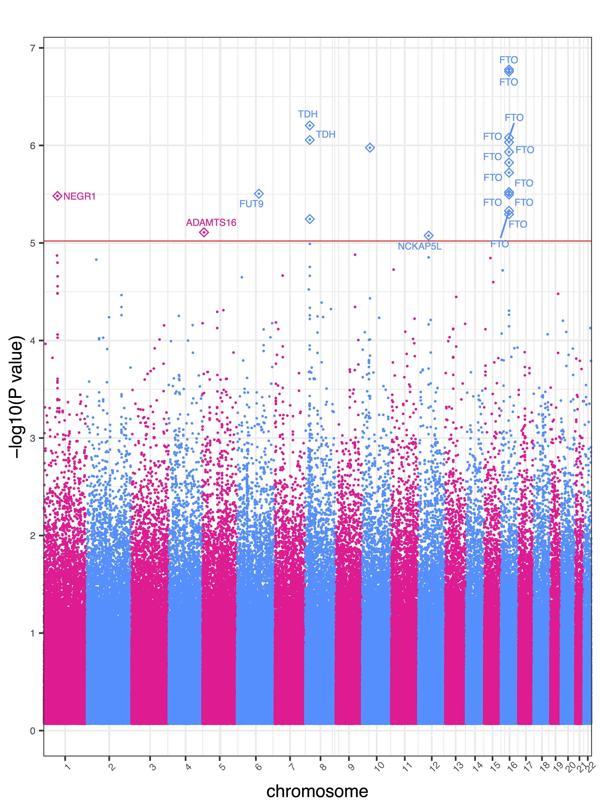

Supplementary Figure S2: Manhattan plot of GWAS results of BMI with DM2-diagnosed individuals removed
Genome-wide association study results for BMI. This study excludes DM2-diagnosed individuals. The x-axis represents the genomic position of 500,508 SNPs. The y-axis represents -log₁₀-transformed raw p-values of each genotypic association. The red horizontal line indicates the significance level 1x10⁻⁵.

