Quantification of beak and leg coloration from pictures

Pictures of individual beak and leg skin were taken against a light brown background. To normalize colors of pictures taken under slightly different light conditions color values obtained from photographs, an X-rite color checker chart, including pure white and yellow colored squares, was placed on the brown background, next to the subjects. We measured overall yellow intensity in Adobe Photoshop CS6 by selecting an area ,varying from approximately 0.5 cm² (~7000 pixels) to 4 cm² (increasing with age), i.e. that included shaft and the entire upper beak. Using the color histogram function, we then recorded the median value from the yellow CYMK channel. This value was then normalized over the yellowness value measured from the ‘true’ white standard on the color chart, to control any difference in lighting conditions (Figure S1).
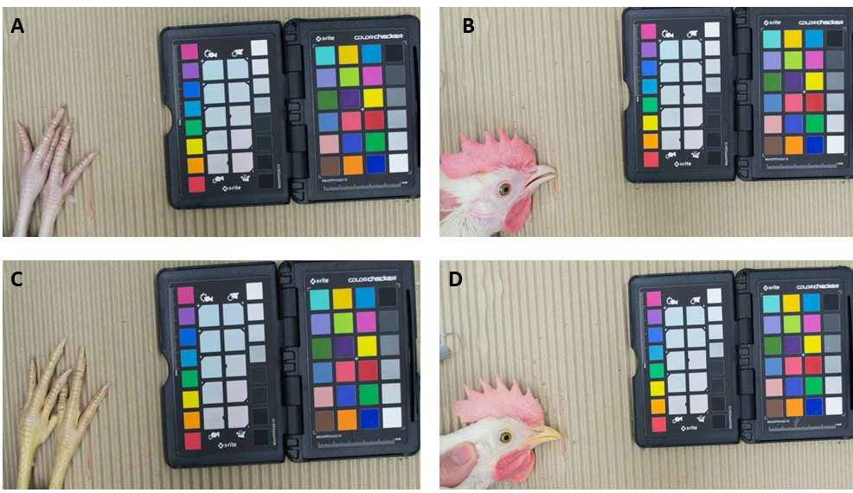
Figure S1. Measuring yellow color intensity in leg and beak. Figures A and B show chickens with the ancestral genotype in the BCO2 gene, while figure C and D show chickens with the derived BCO2 allele.

Quantification of egg coloration using digital YolkFan

The digital YolkFan uses the LAB (1) color system (combination of A and B) with a D50 illumination to find the corresponding DSM number. The L represents lightness (0 = black, 100 = white), A is redness (-100 = green, 100 = red), and B reflects yellowness (-100 = blue, 100 = yellow). Digital DSM scoring is a standard and objective method to measure yellow and red color intensity of egg yolk, which is highly correlated with carotenoid deposition (2). The values from digital Yolkfan are expressed in a DSM scale of 1 to 16 and higher values are associated with higher yellow intensity (Figure S2).
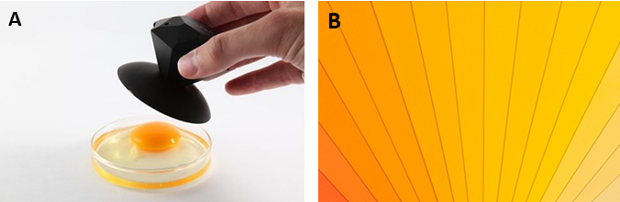

Figure S2. Measuring yellow intensity of egg yolk. A. Digital Yolk fan was used to objectively measure intensity of yellow colour in egg yolk. B. Shows the colouring scale that represent DSM score of 1 (the most right) to 16 (the most left).
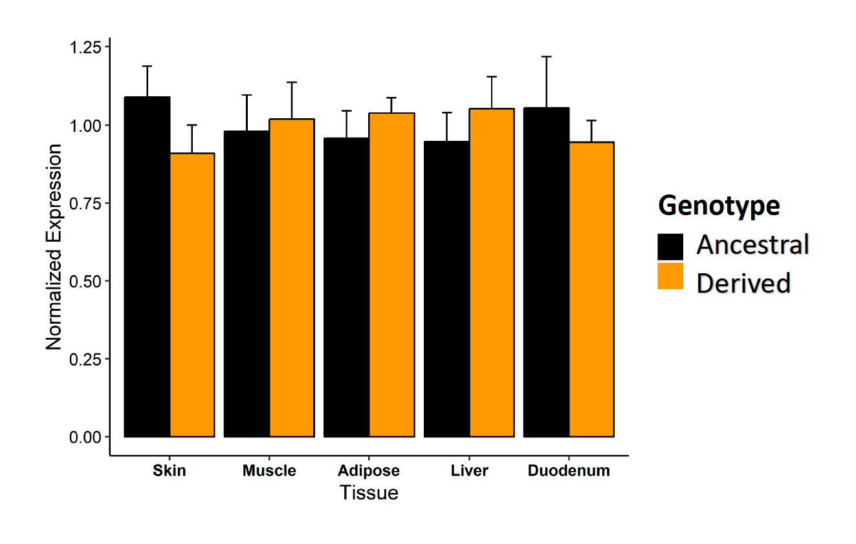

Figure S3. Relative expression of BCO1. Gene expression is measured in skin, muscle, adipose, liver, and duodenum. Derived represent White Leghorn genotype and ancestral represents red junglefowl genotype.

Table S1. The list and sequence of used primers for qPCR and genotyping.
qPCR primers:
BCO1
Forward primer TTACCTCCATCCCAACCTGC
Reverse primer CGAGGCAGTTCTATCCCTTCAC
BCO2
Forward primer TGCAATTCGTCCCAGGTCTA
Reverse primer ACTCAAATTTCCCAGGGCCA

Table S2. Statistics for the intensity of yellow color in beak and leg skin using linear regression model with color intensity as response variable and genotype, sex and interaction between genotype and sex as predictors. All p values are adjusted for false discovery rate (FDR).

Organ | Age (week) | Genotype |  |  | Sex |  |  | Genotype by sex Interaction
 |  | Estimate | std | FDR-adj P | Estimate | std | FDR-adj P | Estimate | std | FDR-adj P
Skin | 1 | -0.13 | 0.03 | 2.05E-03 | -0.0004 | 0.04 | ns | -0.004 | 0.06 | ns
 | 2 | -0.28 | 0.04 | 9.26E-07 | -0.02 | 0.04 | ns | 0.08 | 0.06 | ns
 | 4 | -0.98 | 0.077 | 7.62E-14 | -0.068 | 0.08 | ns | -0.001 | 0.11 | ns
 | 8 | -1.75 | 0.19 | 1.21E-08 | 0.27 | 0.22 | ns | -0.34 | 0.4 | ns
 | 18 | -1.83 | 0.12 | 2.57E-13 | 0.08 | 0.15 | ns | 0.07 | 0.26 | ns
 | 26 | -0.31 | 0.056 | 1.13E-05 | 0.75 | 0.07 | 6.96E-11 | -0.838 | 0.12 | 2.23e-06
Beak | 1 | 0.02 | 0.059 | ns | -0.02 | 0.06 | ns | -0.1 | 0.086 | ns
 | 2 | -0.118 | 0.088 | ns | 0.025 | 0.0956 | ns | -0.068 | 0.13 | ns
 | 4 | -0.32 | 0.11 | 1.74E-02 | 0.14 | 0.12 | ns | -0.32 | 0.176 | ns
 | 8 | -1.639 | 0.21 | 3.57E-07 | 0.027 | 0.25 | ns | 0.178 | 0.43 | ns
 | 18 | -1.545 | 0.22 | 9.30E-07 | 0.37 | 0.267 | ns | -0.4049 | 0.47 | ns
 | 26 | -0.209 | 0.086 | 3.41E-02 | 1.3 | 0.11 | 1.16E-11 | -1.33 | 0.187 | 1.3e-06

- International Color Consortium, Specification ICC.1:2004-10 (Profile version 4.2.0.0) Image technology colour management — Architecture, profile format, and data structure, (2006)

- Hammershøj, M., Kidmose, U., & Steenfeldt, S. (2010). Deposition of carotenoids in egg yolk by short‐term supplement of coloured carrot (Daucus carota) varieties as forage material for egg‐laying hens. Journal of the Science of Food and Agriculture, 90(7), 1163-1171.

