Female genetic contributions to sperm competition in Drosophila melanogaster

Supplementary tables and figures

Dawn S. Chen*, Sofie Y.N. Delbare*, Simone L. White*, Jessica Sitnik , Martik Chatterjee, Elizabeth DoBell, Orli Weiss, Andrew G. Clark†, Mariana F. Wolfner†.

Department of Molecular Biology and Genetics, Cornell University, Ithaca NY, USA

*Co-first authors, in alphabetical order
†Co-corresponding authors, in alphabetical order
Table S1. Summary of candidate genes tested, VDRC lines used, the approximate level of gene knockdown relative to genetically matched controls, and primer sequences used for RT-PCR.

Table S2. Summary statistics and sample sizes (n) for remating rate, fertility and P1. KD = knockdown; sd = standard deviation; TG4 = Tubulin-GAL4/TM3, Sb; TG80 = Tubulin-GAL80^{ts}; Tubulin-GAL4/TM3, Sb. Q-values were obtained using Benjamini-Hochberg correction.

Table S3. Nominal p-values and Benjamini-Hochberg adjusted p-values by vial for the temporal analysis of P1, for all driver-gene combinations tested. TG4 = Tubulin-GAL4/TM3, Sb; TG80 = Tubulin-GAL80^{ts}; Tubulin-GAL4/TM3, Sb.
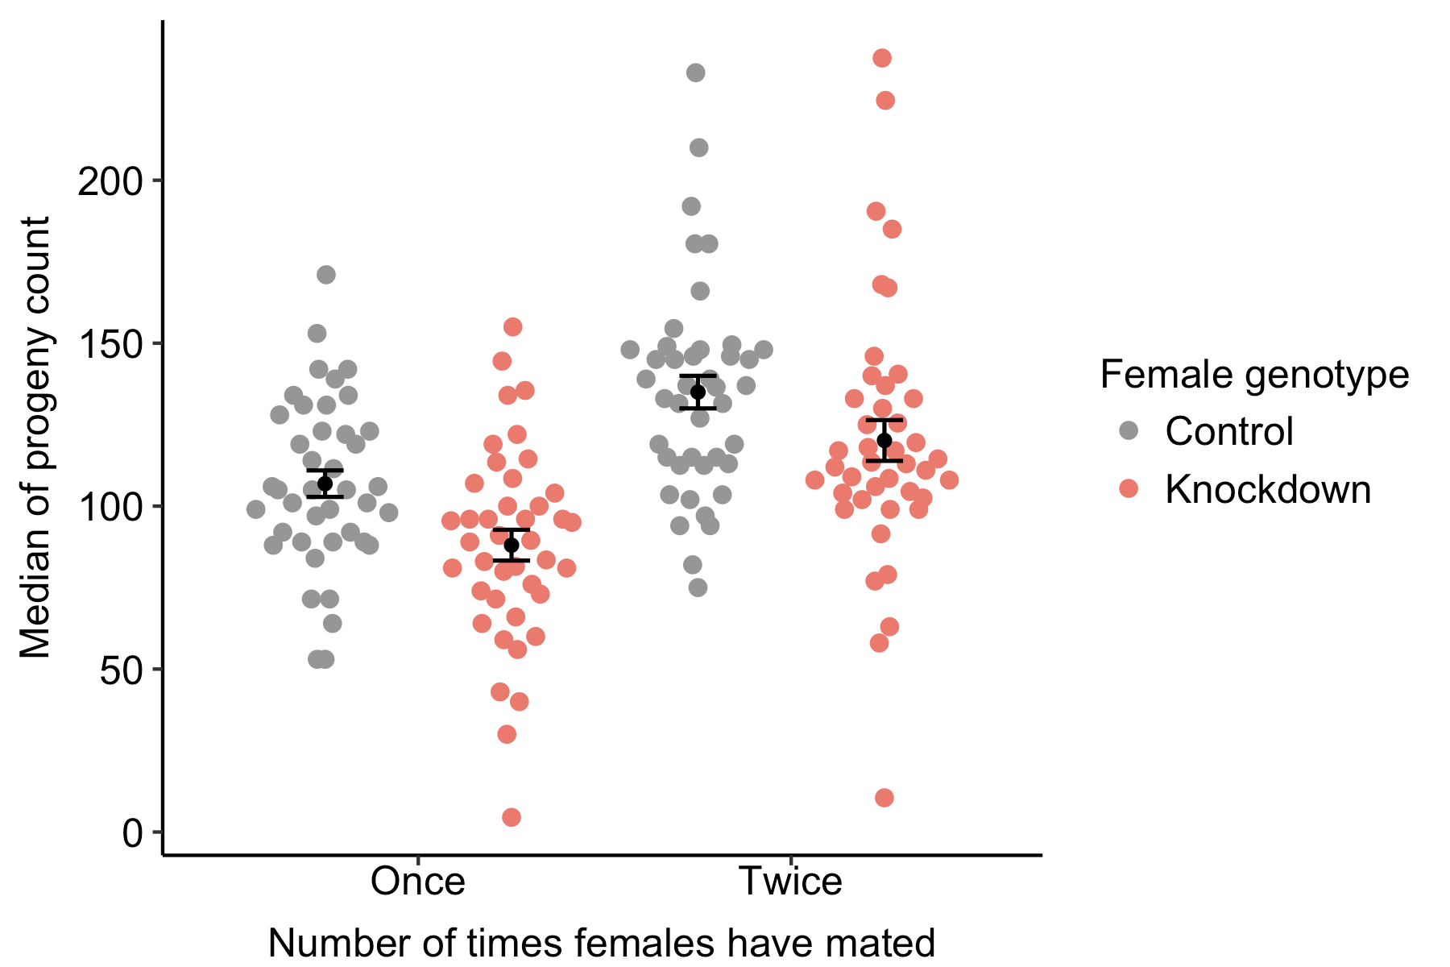

Figure S1. Doubly mated females have higher fertility than singly mated females. Fertility of each female was calculated as the total number of progeny she produced over the course of the sperm competition assay. Each dot represents the median fertility of all females used in one experiment, with females grouped by genotype (control and knockdown) and by the number of times they have mated. Error bars represent mean ± standard error. ANOVA revealed significant differences in fertility based on female mating status (F=34.959, p=1.93×10⁻⁸) and genotype (F=10.918, p=0.00117) but not their interaction (F=0.158, p=0.692). In a separate analysis, when we grouped singly mated females by the identity of the males they mated with (first male or second male), we found that there was no significant difference in the fertility of singly mated females depending on the identity of the male they mated with (data not shown).
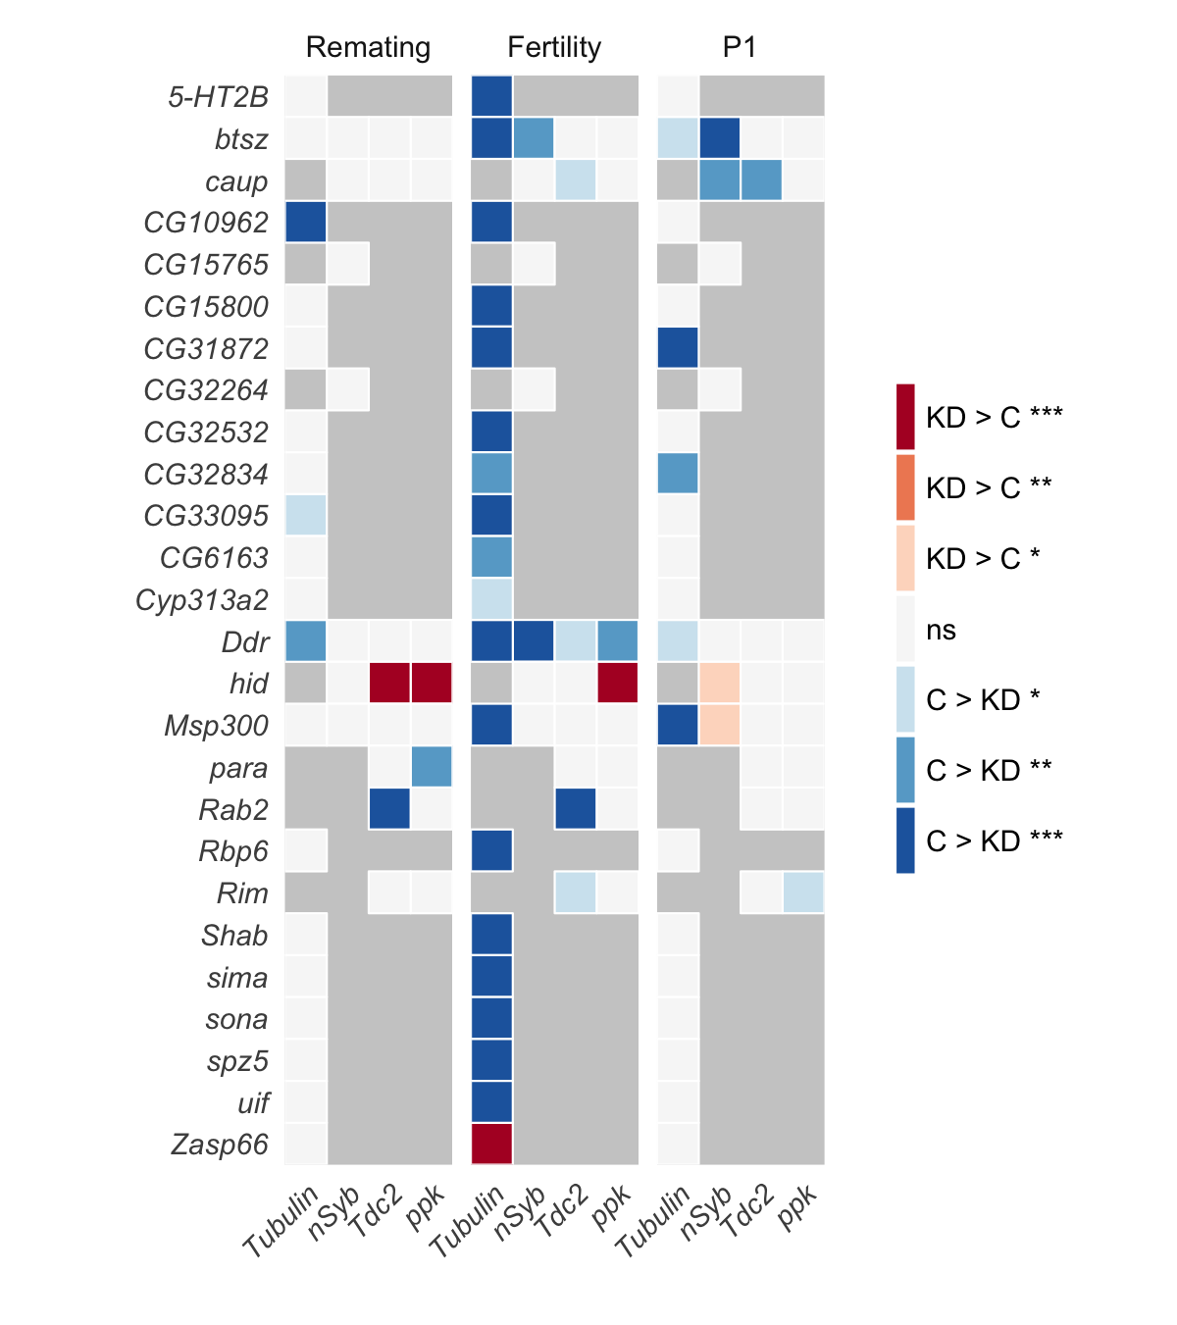
Figure S2. Summary of the effects of ubiquitous and tissue-specific gene knockdown on female remating rate, fertility and P1. Each row represents one gene and each column represents one tissue in which the gene is knocked down. Remating rate was measured as the proportion of doubly mated females among females who mated with the first male. Fertility was measured as the total number of offspring produced by a doubly mated female. P1 was measured as the proportion of offspring sired by the first male (P1) upon ubiquitous (Tubulin-GAL4) or neuronal knockdown (nSyb-GAL4, Tdc2-GAL4, ppk-GAL4). Colors represent the direction of changes and their significance levels (C: control, KD: knockdown, ns: not significant, dark gray: not tested). Asterisks indicate p < 0.05 (*), p < 0.01 (**) or p < 0.001 (***).
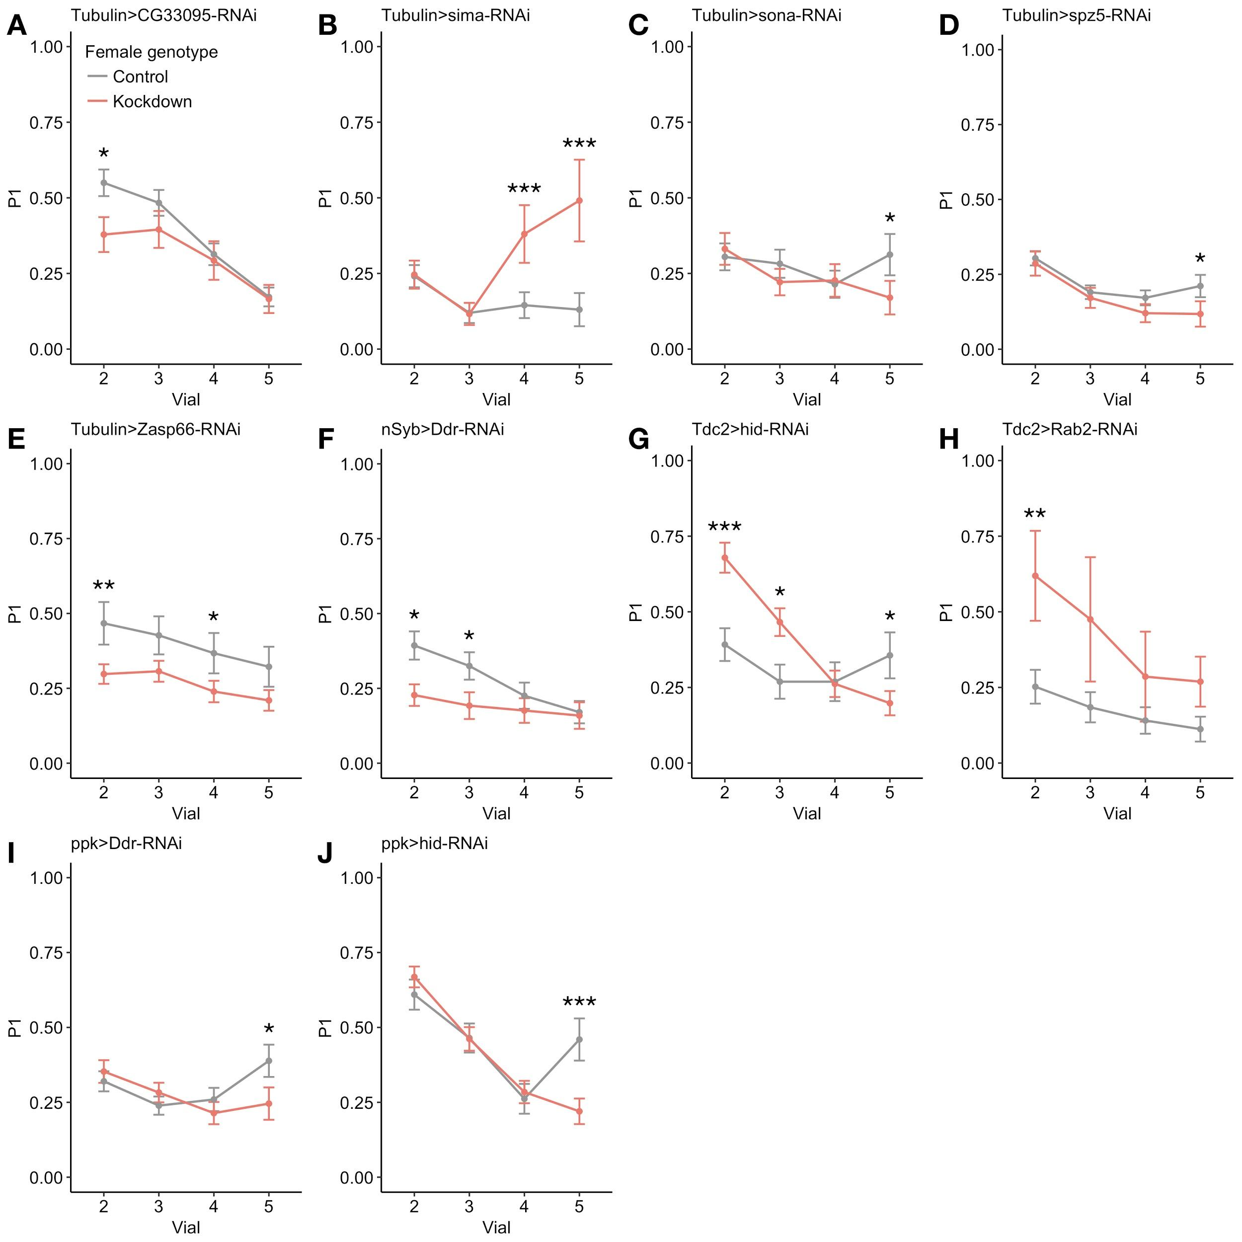

Figure S3: Knockdown of eight candidate genes mediated temporal, but not overall, differences in P1. The line plots represent the average relative success of the first male to mate (P1), for knockdown and control females, across vials 2-5. Error bars represent the standard error of the mean. Asterisks (*) indicate p < 0.05 (*), p < 0.01 (**) or p < 0.001 (***). A-E: Significant temporal effects due to ubiquitous knockdown (Tubulin-GAL4). F: Effects of pan-neuronal knockdown (nSyb-GAL4). G-J: Changes in P1 mediated by Tdc2⁺ neuron- (G, H) or ppk⁺ neuron-specific knockdown (I, J).

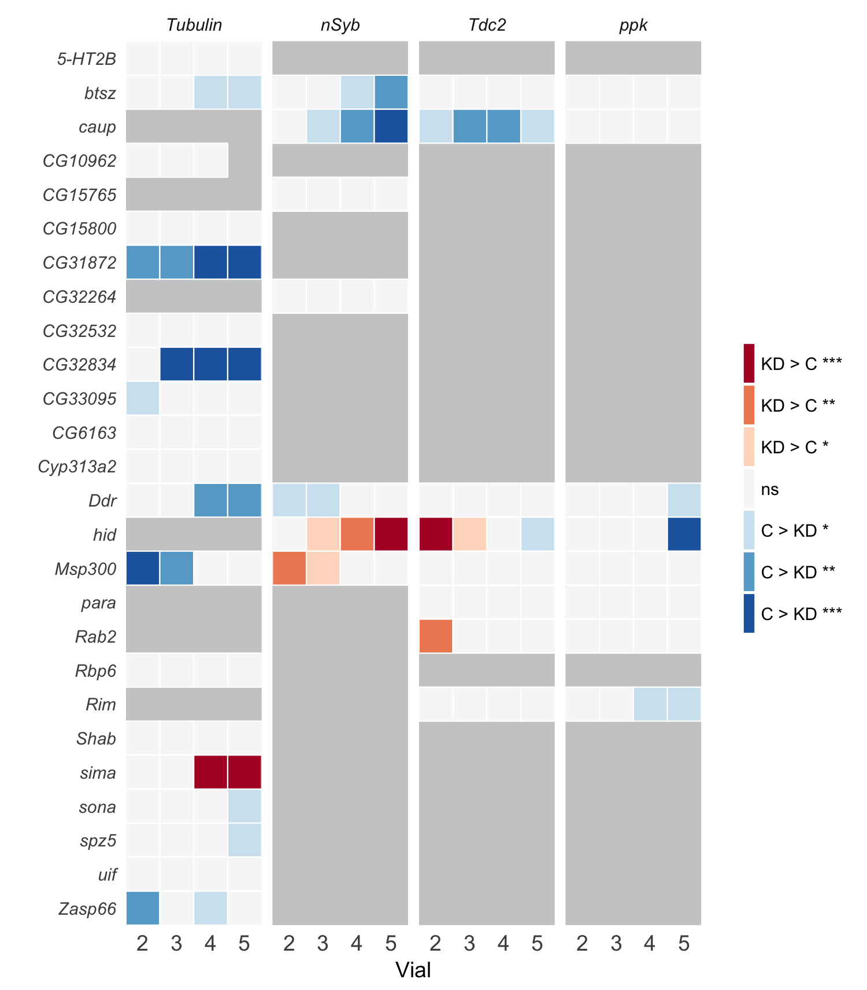
Figure S4. Summary of temporal effects of ubiquitous and tissue-specific gene knockdown on P1. Each row represents one gene, each facet represents one tissue in which the gene is knocked down, and each column within each facet represents one vial (range 2-5). Colors represent the direction of changes and their significance levels (C: control, KD: knockdown, ns: not significant, dark gray: not tested). Asterisks (*) indicate p < 0.05 (*), p < 0.01 (**) or p < 0.001 (***).
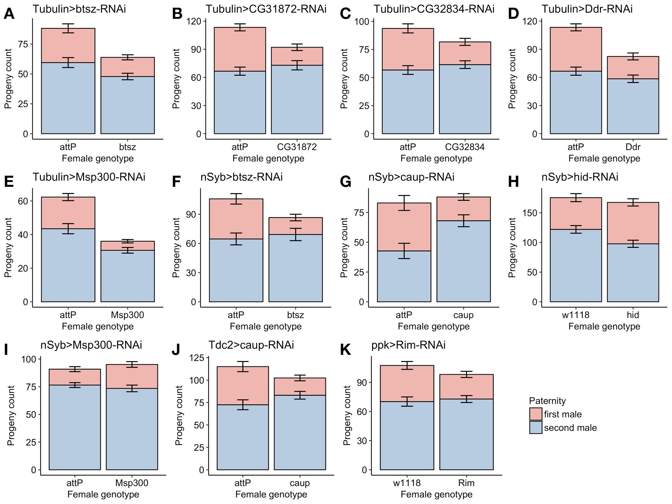

Figure S5. Knockdown of 8 genes that affect sperm competition outcome upon ubiquitous or tissue-specific knockdown has different effects on absolute numbers of first- versus second-male progeny. Bar graphs represent the mean progeny count of knockdown and control females in vials 2-5, with colors indicating the paternity of their progeny (red: first male progeny; blue: second male progeny). Vial 1 was excluded in these graphs (and in the calculation of P1) because both matings took place in vial 1, and with our experimental setup, it was not possible to determine which progeny were produced before or after the second mating. Error bars represent mean ± standard error.

