High quality draft genome of Arogyapacha (Trichopus zeylanicus), an important medicinal plant endemic to Western Ghats of India

Biju Vadakkemukadiyil Chellappan, Shidhi PR, Sheethal Vijayan, Veena S Rajan, Anu Sasi, Achuthsankar S. Nair
Department of Computational Biology and Bioinformatics, University of Kerala, Thiruvananthapuram, Kerala, India

Supplementary Figures

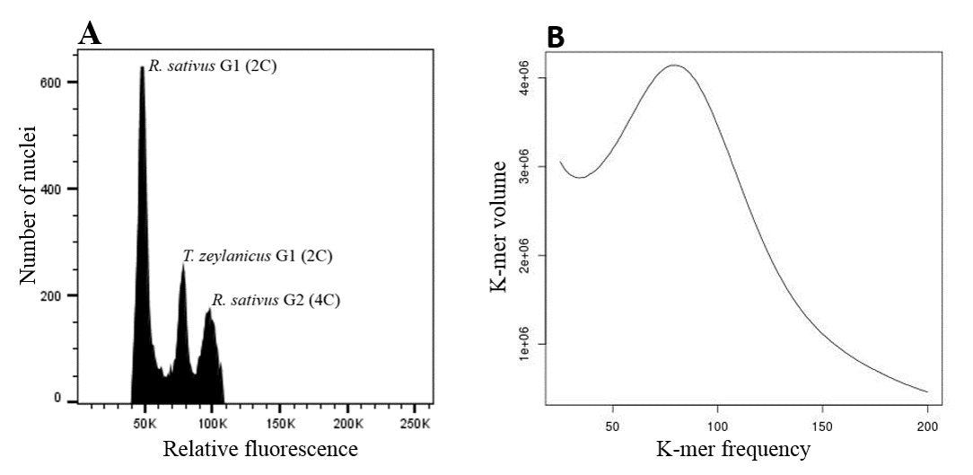
Figure S1. Estimation of absolute nuclear DNA amount (genome size) in T. zeylanicus. A. Flow cytometry method. B. K-mer frequency method

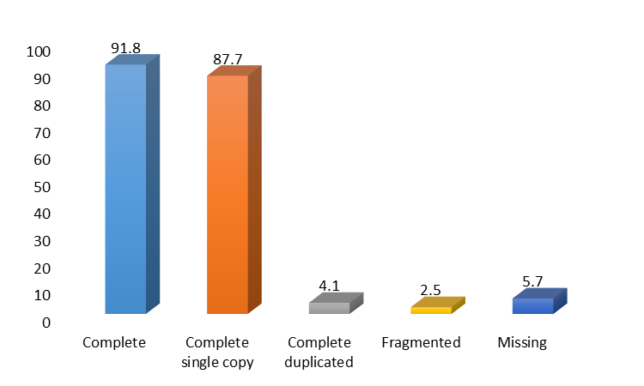
Figure S2. BUSCO Analysis of T. zeylanicus genome assembly. 1440 conserved orthologous gene sets were searched against the genome assembly. The number above each bar indicates the percentage of buscos.

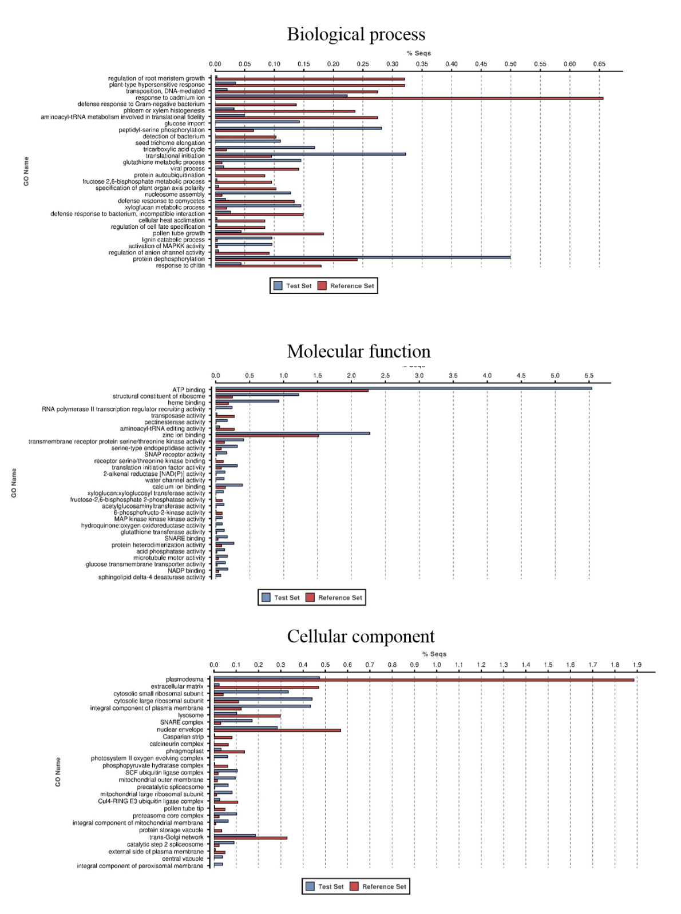
Figure S3. Gene ontology enrichment in T. zeylanicus complete gene set. GO enrichment analysis of complete gene set in T. zeylanicus was performed using two tailed Fisher's exact test (P value < 0.001). Percentage of enriched GO terms statistically significant with respect to a reference set of D. rotundata complete gene set are shown.

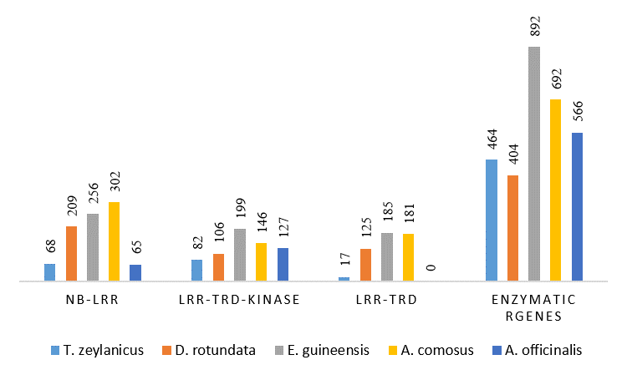
Figure S4. Comparison of the number of disease resistance gene families in T. zeylanicus to its closely related species.

Figure S5 –S8 legends (because of the large size these figures uploaded separately)
Figure S5. Dot plot showing the collinearity between T. zeylanicus and E. Guineensis. Each dot represents collinear pair
Figure S6. Dot plot showing the collinearity between T. zeylanicus and A. comosus. Each dot represents collinear pair
Figure S7. Dot plot showing the collinearity between T. zeylanicus and A. officinalis. Each dot represents collinear pair
Figure S8. Dot plot showing the collinearity between T. zeylanicus and D. rotundata. Each dot represents collinear pair

