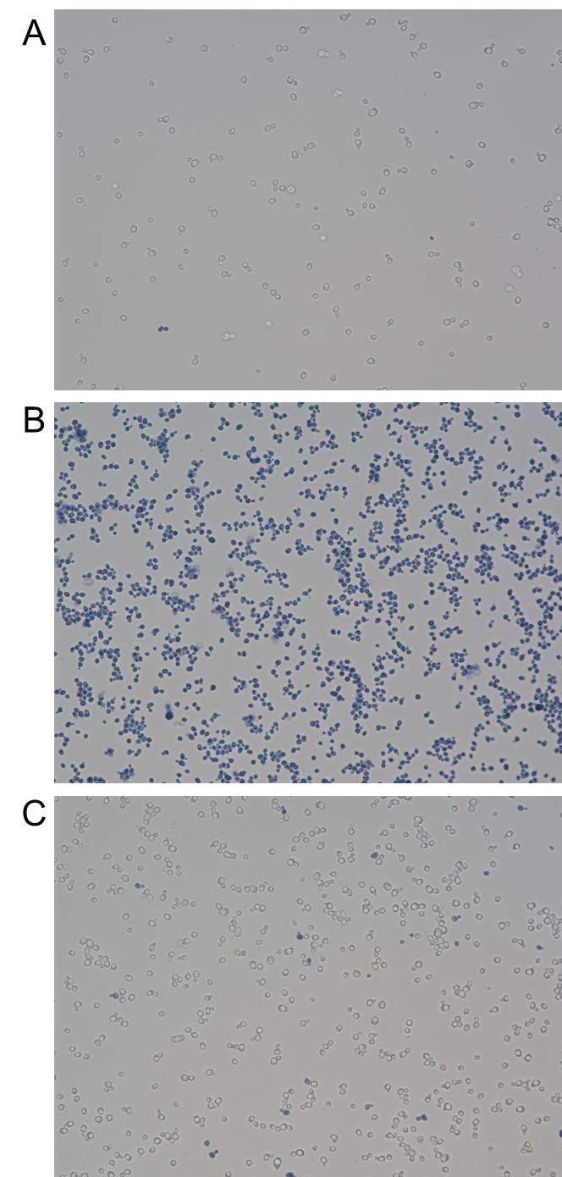
Figure S1. Trypan blue exclusion stain of (A) non-irradiated, (B) heat-killed, and (C) laser-irradiated cells. Live cells exclude the blue dye. The images are representative of 9 fields collected for each condition.

