**Little evidence of antagonistic selection in the evolutionary strata of fungal mating-type chromosomes (*Microbotryum lychnidis-dioicae)***

Anna Liza Bazzicalupo*1,2, Fantin Carpentier†2, Sarah Perin Otto‡ and Tatiana Giraud† §

*Department of Botany, 3200-6270 University Blvd., University of British Columbia, Vancouver, BC V6T 1Z4, Canada

†Ecologie Systématique Evolution, Univ. Paris-Sud, CNRS, AgroParisTech, Université Paris-Saclay, 91400 Orsay, France

‡ Department of Zoology & Biodiversity Research Centre, 6270 University Blvd., University of British Columbia, Vancouver, BC V6T 1Z4, Canada

§ Corresponding author: [tatiana.giraud@u-psud.fr](mailto:tatiana.giraud@u-psud.fr); Phone: +33 6 34644514

1 Present address: Department of Microbiology and Immunology, Montana State University, Leon Johnson Hall, Bozeman, MT 59715, United States of America

2 These authors equally contributed to this work

**Short title:** Antagonistic selection and mating types

**Keywords:** antagonistic selection, fungi, mating-type chromosomes, evolutionary strata, expression, sex chromosomes, sexual antagonism, haploid selection

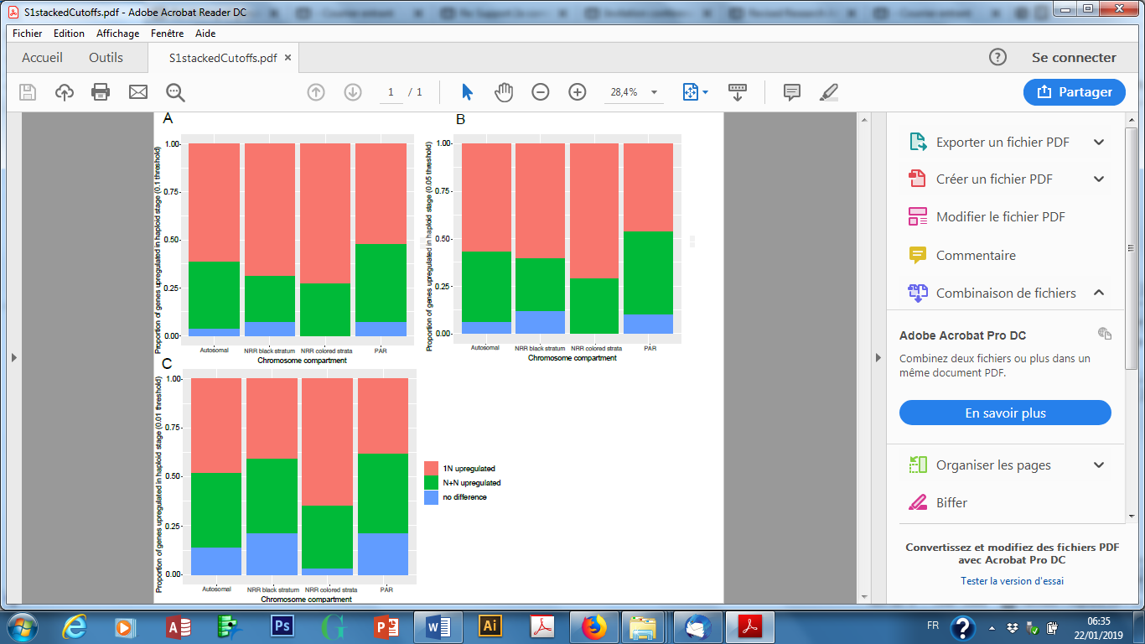

**Supplementary Figure 1:** Proportions of *Microbotryum lychnidis-dioicae* genes upregulated in at least one haploid stage/mating type (in red, 1N upregulated), upregulated at the dikaryotic stage (in green, N+N upregulated) or showing no differential expression (in blue). Expression level was considered significantly different at the 0.1 (A), 0.05 (B) or 0.01 (C) threshold. Genes are separated according to their genomic compartment: autosomes, pseudoautosomal regions (PARs) of the mating-type chromosome, non-recombining region (NRR) of the mating-type chromosome, and into the black versus color evolutionary strata (blue, purple, black, orange, red and green).



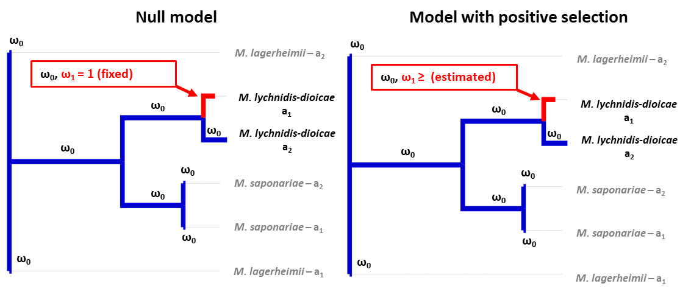**Supplementary Figure S2: Illustration of the positive selection “test 2” from codeml.** We performed branch-site tests of positive selection in *Microbotryum lychnidis-dioicae*, by performing a ratio test between the maximum likelihood values of two models of sequence evolution with different values of ω=dN/dS (the ratio between the number of non-synonymous over synonymous substitutions). Each model assumes a single ω value (ω0) for the background branches (in blue) and two ω values (ω0 and ω1) for the foreground branch (the focal branch in which we test the occurrence of positive selection, in red, the sequence association to either the a1 or a2 mating type in *M. lychnidis-dioicae*). The null model (left) allows three classes of sites (the classes 1 and 2b being equivalent in this model) while the model with positive selection (right) allows a fourth site class with ω estimates being allowed to be higher than one.