**Additional Files**

**Supplemental Figures**

**Supplementary Figure 1**: The extent of missing data points reintroduced by filtering for Beagle posterior genotype probabilities greater than 0.45 and 0.9. A mild filter of GP > 0.45 keeps missing data below 5%, while missing data greatly inflates to over 20% at 0.1X with a filter of GP > 0.9.

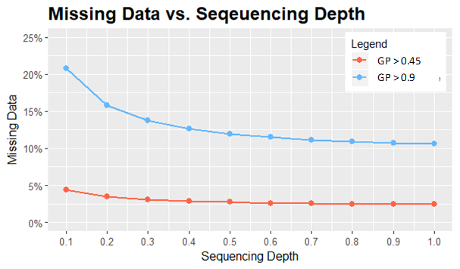

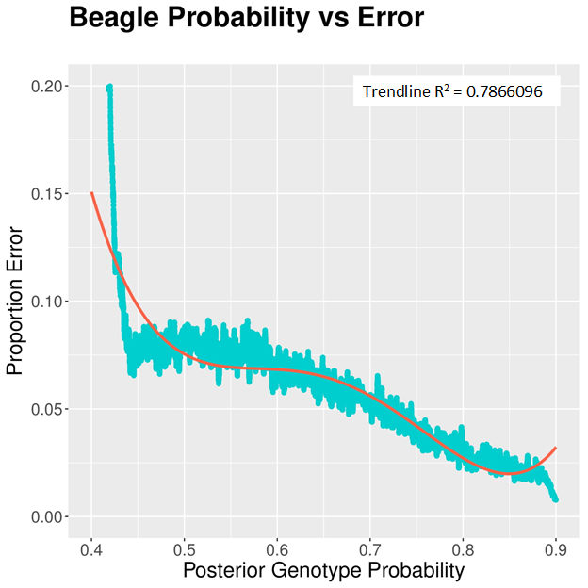

**Supplementary Figure 2:** Comparing the frequency of error at individual sites across sequencing depths with the assigned genotype probability for imputed values by Beagle demonstrates a strong correlation, making the posterior genotype probability a useful metric for post imputation filtering for data improvement.

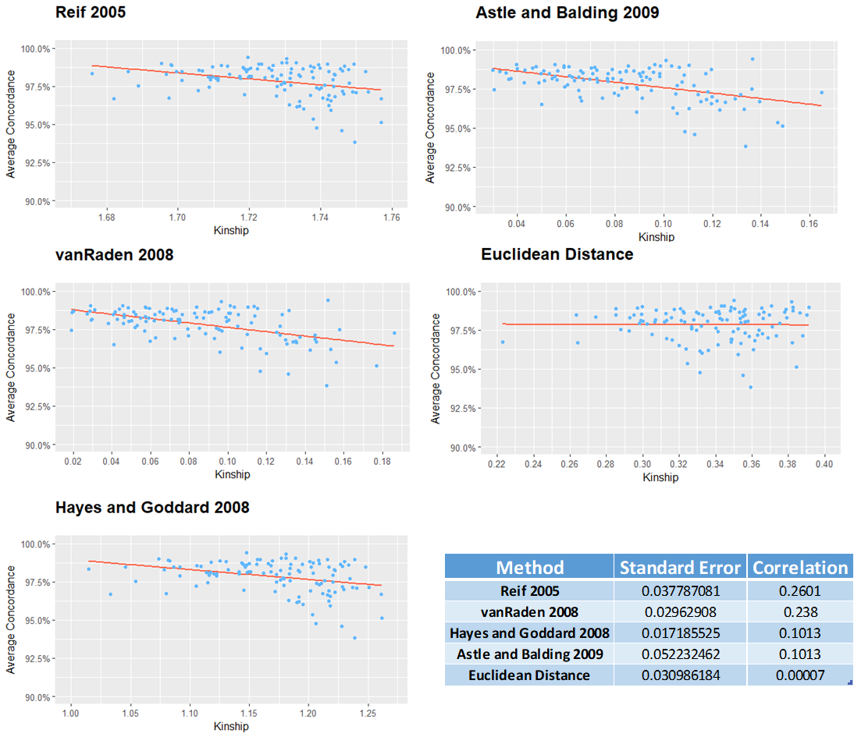

**Supplementary Figure 3:** The average of the top five scores for five relatedness metrics are plotted against the average concordance across depths for that genotype. Correlations and standard errors reported in the bottom right hand corner reveal no strong relationship for any metric, which may be explained by the low level variation within our study panel in terms of degree of kinship to the reference panel and overall weak kinship.

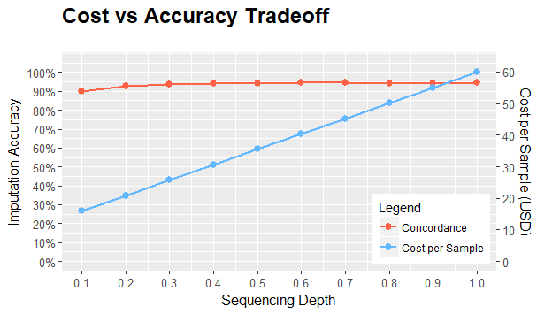

**Supplementary Figure 4:** The proportion of accuracy retained relative to 1X from raw imputed values vs the retained cost per sample. Decreasing coverage from 1X to 0.3X results in a nearly negligible loss in accuracy of 0.85%, while decreasing per sample costs by 57.04%

**Supplemental Tables**

Supplemental Table 1: Sequencing depth of individual genotypes used in the generation of the reference and study panels. Samples with text struck through were dropped from final reference panel due to suspected contamination.

|  |  |  |
| --- | --- | --- |
| Genotype | Panel | Mean Depth |
| G100540 | Study | 1 |
| G100534 | Study | 1.01 |
| G100585 | Study | 1.02 |
| G100613 | Study | 1.02 |
| G100538 | Study | 1.04 |
| G100579 | Study | 1.04 |
| G100555 | Study | 1.05 |
| G100565 | Study | 1.05 |
| G100526 | Study | 1.06 |
| G100600 | Study | 1.07 |
| G100573 | Study | 1.08 |
| G100553 | Study | 1.09 |
| G100602 | Study | 1.09 |
| G100545 | Study | 1.11 |
| G100561 | Study | 1.12 |
| G100582 | Study | 1.13 |
| G100562 | Study | 1.14 |
| G100605 | Study | 1.15 |
| G100506 | Study | 1.17 |
| G100529 | Study | 1.17 |
| G100535 | Study | 1.17 |
| G100541 | Study | 1.17 |
| G100583 | Study | 1.19 |
| G100591 | Study | 1.19 |
| G100536 | Study | 1.2 |
| G100559 | Study | 1.21 |
| G100574 | Study | 1.22 |
| G100576 | Study | 1.25 |
| G100504 | Study | 1.26 |
| G100554 | Study | 1.26 |
| G100601 | Study | 1.26 |
| G100508 | Study | 1.29 |
| G100515 | Study | 1.3 |
| G100532 | Study | 1.3 |
| G100569 | Study | 1.3 |
| G100596 | Study | 1.3 |
| G100516 | Study | 1.31 |
| G100595 | Study | 1.31 |
| G100537 | Study | 1.32 |
| G100548 | Study | 1.32 |
| G100531 | Study | 1.34 |
| G100566 | Study | 1.36 |
| G100599 | Study | 1.36 |
| G100597 | Study | 1.37 |
| G100606 | Study | 1.37 |
| G100575 | Study | 1.38 |
| G100503 | Study | 1.4 |
| G100517 | Study | 1.4 |
| G100547 | Study | 1.4 |
| G100523 | Study | 1.44 |
| G100519 | Study | 1.51 |
| G100552 | Study | 1.52 |
| G100507 | Study | 1.55 |
| G100581 | Study | 1.55 |
| G100513 | Study | 1.57 |
| G100578 | Study | 1.59 |
| G100592 | Study | 1.61 |
| G100510 | Study | 1.64 |
| G100607 | Study | 1.65 |
| G100590 | Study | 1.69 |
| G100593 | Study | 1.69 |
| G100550 | Study | 1.71 |
| G100563 | Study | 1.75 |
| G100521 | Study | 1.82 |
| G100560 | Study | 1.84 |
| G100522 | Study | 1.85 |
| G100557 | Study | 1.86 |
| G100527 | Study | 1.87 |
| G100568 | Study | 1.9 |
| G100570 | Study | 1.91 |
| G100501 | Study | 1.99 |
| G100514 | Study | 1.99 |
| G100588 | Study | 2 |
| G100524 | Study | 2.04 |
| G100587 | Study | 2.04 |
| G100544 | Study | 2.05 |
| G100511 | Study | 2.1 |
| G100528 | Study | 2.15 |
| G100610 | Study | 2.16 |
| G100546 | Study | 2.17 |
| G100584 | Study | 2.17 |
| G100509 | Study | 2.21 |
| G100577 | Study | 2.27 |
| G100551 | Study | 2.28 |
| G100580 | Study | 2.3 |
| G100608 | Study | 2.32 |
| G100539 | Study | 2.36 |
| G100571 | Study | 2.36 |
| G100549 | Study | 2.38 |
| G100589 | Study | 2.44 |
| G100609 | Study | 2.44 |
| G100525 | Study | 2.52 |
| G100604 | Study | 2.59 |
| G100594 | Study | 2.64 |
| G100530 | Study | 2.74 |
| G100586 | Study | 2.87 |
| G100564 | Study | 2.91 |
| G100603 | Study | 2.91 |
| G100518 | Study | 2.93 |
| G100543 | Study | 3.06 |
| G100611 | Study | 3.11 |
| G100502 | Study | 3.3 |
| G100572 | Study | 3.66 |
| G100598 | Study | 4.2 |
| G100505 | Study | 4.25 |
| G100558 | Study | 4.47 |
| G100556 | Study | 4.58 |
| G100512 | Study | 6.78 |
| G100614 | Study | 7.43 |
| G100542 | Study | 9.15 |
| G100612 | Study | 14.65 |
| G100533 | Study | 14.78 |
| G100567 | Study | 16.65 |
| G100520 | Study | 36.47 |
| PI_518664 | Reference | 14.8 |
| Peking | Reference | 15.68 |
| PI_089772 | Reference | 16.3 |
| PI_090763 | Reference | 14.28 |
| PI_404166 | Reference | 16.58 |
| PI_407788A | Reference | 15.5 |
| PI_424298 | Reference | 16.18 |
| PI_437655 | Reference | 13.37 |
| PI_495017C | Reference | 15.6 |
| PI_468915 | Reference | 12.51 |
| PI_507354 | Reference | 13.29 |
| PI_567305 | Reference | 13.39 |
| S05-11482 | Reference | 15.76 |
| PI_548667 | Reference | 13.64 |
| PI_437654 | Reference | 15.77 |
| PI_567387 | Reference | 20.48 |
| PI_437725 | Reference | 19.8 |
| PI_437690 | Reference | 14.15 |
| PI_548402 | Reference | 18.37 |
| PI_088788 | Reference | 12 |
| PI_209332 | Reference | 15.82 |
| PI_404198B | Reference | 14.84 |
| PI_424608A | Reference | 12.58 |
| PI_548316 | Reference | 17.68 |
| PI_567516C | Reference | 13.22 |
| PI_612611 | Reference | 14.9 |
| S10-11227 | Reference | 17.17 |
| Holladay | Reference | 17.6 |
| IA3023 | Reference | 16.27 |
| Maverick | Reference | 16.34 |
| PI_079691-4 | Reference | 15.08 |
| PI_086006 | Reference | 19.54 |
| PI_087617 | Reference | 19.64 |
| PI_087631-1 | Reference | 16.36 |
| PI_196175 | Reference | 18.59 |
| PI_200508 | Reference | 14.84 |
| ~~PI_248515~~ | ~~Reference~~ | ~~12.67~~ |
| ~~PI_366121~~ | ~~Reference~~ | ~~16.97~~ |
| PI_378702 | Reference | 14.29 |
| PI_398593 | Reference | 18.63 |
| PI_398595 | Reference | 19.64 |
| PI_398610 | Reference | 19.95 |
| PI_398614 | Reference | 16.93 |
| PI_407162 | Reference | 19.51 |
| PI_407184 | Reference | 18.81 |
| PI_407729 | Reference | 17.84 |
| PI_407965 | Reference | 20.48 |
| PI_408105A | Reference | 17.38 |
| PI_416937 | Reference | 19.48 |
| PI_424078 | Reference | 18.29 |
| PI_424079 | Reference | 18.4 |
| PI_424088 | Reference | 17.93 |
| PI_437169B | Reference | 19.19 |
| PI_437679 | Reference | 17.68 |
| PI_437863A | Reference | 19.3 |
| ~~PI_438258~~ | ~~Reference~~ | ~~17.98~~ |
| ~~PI_458515~~ | ~~Reference~~ | ~~14.3~~ |
| PI_464920B | Reference | 20.7 |
| PI_467312 | Reference | 17.78 |
| PI_471938 | Reference | 16.82 |
| PI_475783B | Reference | 15.31 |
| PI_483463 | Reference | 14.96 |
| PI_518751 | Reference | 14.69 |
| PI_542044 | Reference | 22.72 |
| PI_547862 | Reference | 20.43 |
| PI_548317 | Reference | 18.84 |
| PI_548349 | Reference | 20.39 |
| PI_548415 | Reference | 16.23 |
| PI_548511 | Reference | 16.39 |
| PI_548657 | Reference | 16.94 |
| PI_549031 | Reference | 15.95 |
| PI_552538 | Reference | 17.52 |
| PI_561271 | Reference | 17.65 |
| PI_567230 | Reference | 17.4 |
| PI_567336B | Reference | 17.94 |
| PI_567343 | Reference | 14.6 |
| PI_567354 | Reference | 17.61 |
| PI_567357 | Reference | 15.85 |
| PI_567383 | Reference | 18.44 |
| ~~PI_567519~~ | ~~Reference~~ | ~~17.33~~ |
| PI_567611 | Reference | 18.14 |
| PI_567651 | Reference | 15.03 |
| PI_567690 | Reference | 17.16 |
| PI_567719 | Reference | 15.11 |
| PI_567731 | Reference | 15.6 |
| PI_591539 | Reference | 19.09 |
| PI_593258 | Reference | 17.8 |
| PI_594012 | Reference | 18.38 |
| PI_594512A | Reference | 20.49 |
| ~~PI_594599~~ | ~~Reference~~ | ~~14.87~~ |
| ~~PI_597387~~ | ~~Reference~~ | ~~17.35~~ |
| PI_603154 | Reference | 17.62 |
| PI_603170 | Reference | 17.44 |
| PI_603175 | Reference | 24.6 |
| PI_603176A | Reference | 18.92 |
| PI_603497 | Reference | 15.56 |
| PI_605869A | Reference | 15.96 |
| PI_639740 | Reference | 13.69 |
| PI_647086 | Reference | 18.2 |
| PI_658519 | Reference | 18.71 |
| S07-5049 | Reference | 20.88 |
| V71-370 | Reference | 20.88 |
| FC_31721 | Reference | 20.2 |
| PI_438471 | Reference | 24.01 |
| PI_417091 | Reference | 22.45 |
| PI_417015 | Reference | 16.22 |

|  |  |  |  |  |  |
| --- | --- | --- | --- | --- | --- |
| **Depth** | **Unfiltered Accuracy** | **GP > 0.45 Accuracy** | **Improvement** | **GP > 0.9 Accuracy** | **Improvement** |
| 0.1 | 89.70% | 92.70% | 3.00% | 94.80% | 5.10% |
| 0.2 | 92.80% | 95.60% | 2.80% | 97.20% | 4.40% |
| 0.3 | 93.60% | 96.30% | 2.70% | 97.80% | 4.20% |
| 0.4 | 94.20% | 96.60% | 2.40% | 98.10% | 3.90% |
| 0.5 | 94.20% | 96.70% | 2.50% | 98.40% | 4.20% |
| 0.6 | 94.40% | 96.70% | 2.30% | 98.40% | 4.00% |
| 0.7 | 94.50% | 96.70% | 2.20% | 98.50% | 4.00% |
| 0.8 | 94.30% | 96.70% | 2.40% | 98.60% | 4.30% |
| 0.9 | 94.30% | 96.70% | 2.40% | 98.60% | 4.30% |
| 1 | 94.40% | 96.70% | 2.30% | 98.60% | 4.20% |
| **Averages** | **93.64%** | **96.14%** | **2.50%** | **97.90%** | **4.26%** |

Supplementary Table 2: Accuracy improvement as a results of filtering on Beagle’s genotype posterior probability after imputation.



Supplementary Table 3: A breakdown of the per item costs involved in the DNA extraction, sample library preparation, and sequencing of genotypes from 0.1X – 1X sequencing depths in USD.