SUPPLEMENTAL INFORMATION

Roth et al., GENETICS/2019/302056
Article doi: 10.1534/genetics.119.302056

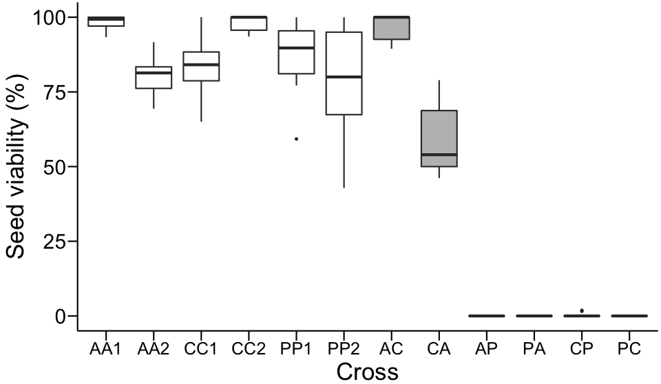

Figure S1 Box plot representing the distribution of seed viability in all crosses used in this study. Assessment of seed viability was performed visually at fruit maturity 60 days after pollination (data source: Roth et al. 2018a). Open boxes, intraspecific crosses; grey boxes, hybrid crosses. A, S. arcanum var. marañón; C, S. chilense; P, S. peruvianum. AA1, LA2185A × LA1626B; AA2, LA1626B × LA2185A; CC1, LA4329B × LA2748B; CC2, LA2748B × LA4329B; PP1, LA2744B × LA2964A; PP2, LA2964A × LA2744B; AC, LA2185A × LA4329B; CA, LA4329B × LA2185A; AP, LA2185A × LA2744B; PA, LA2744B × LA2185A; CP, LA4329B × LA2744B; PC, LA2744B × LA4329B. Cross specifications
are identical in all other display items.

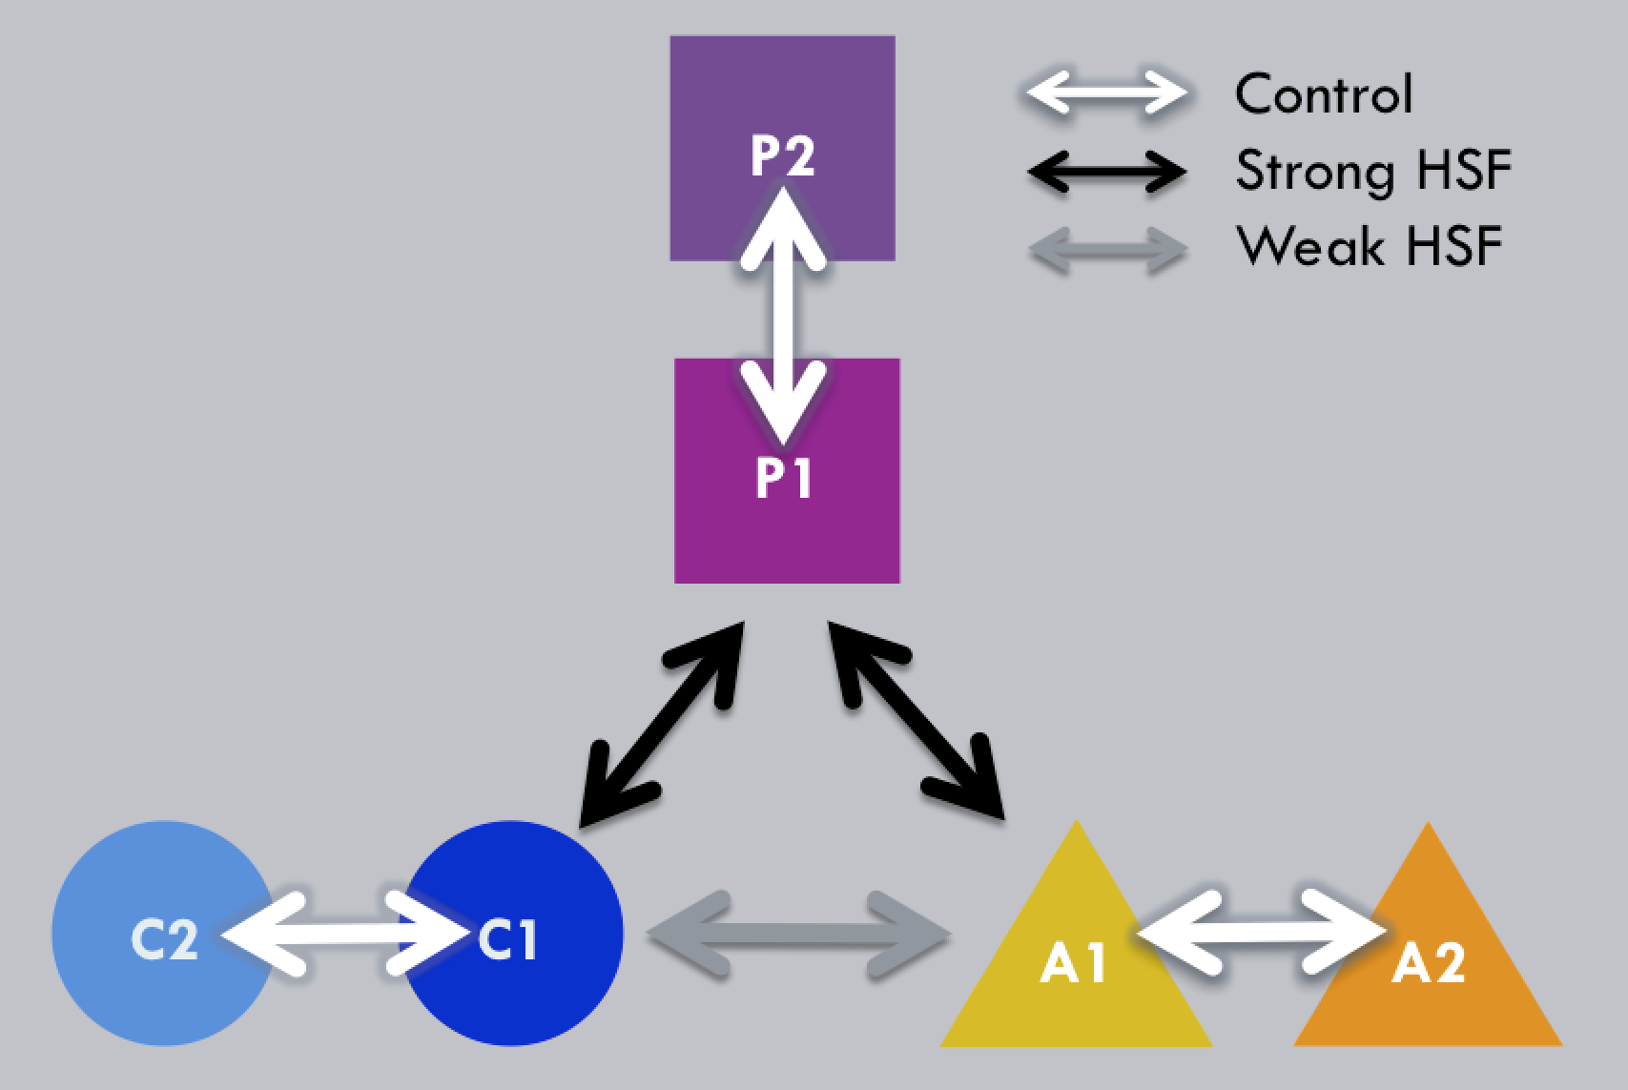

Figure S2 Crossing design representing the six reciprocal crosses used for our endosperm RNA-Seq experiment. Arrows represent reciprocal crosses (white, intraspecific; black, hybrid crosses resulting in strong hybrid seed failure (HSF); grey, hybrid crosses resulting in ‘weak’ (partial) HSF). Each shape represents one wild tomato genotype sampled from separate populations in species A (S. arcanum var. marañón; triangles), C (S. chilense; circles) and
P (S. peruvianum; squares). A1, LA2185A; A2, LA1626B; C1, LA4329B; C2, LA2748B;
P1, LA2744B; P2, LA2964A.

The following SI Tables are available as a separate Excel file:

Table S1 Target table used in EdgeR describing all samples and categories used for cross comparisons.
Table S2 Specific contrasts used in EdgeR for each differential gene expression analysis.
Table S3 Differential gene expression results for 17 contrasts (cross comparisons).
Table S4 GO term enrichment for differentially expressed genes using TopGO.
Table S5 Differential gene expression results in 15 contrasts (cross comparisons) for 58 candidate imprinted genes in wild tomatoes (Roth et al. 2018b).

