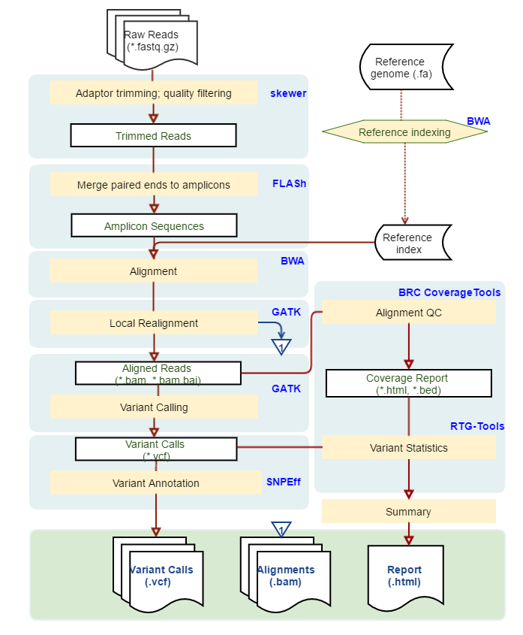

Figure S1. Workflow for analysis of sequencing data from the yeast spliceosome targeted sequencing panel. Kindly provided by University of Wisconsin Bioinformatic Resource Center. See Materials and Methods section for a detailed explanation.

