File S2: Computing the expected distribution of locus effects

Considering that the change of distribution parameters for locus effect sizes (log-normal) and MAF (normal) were found to fit well to an exponential model (Figure 1 of the main text and Table S6[D-G]), we were able to predict them for any given number of loci, and thus infer the corresponding expected distribution of locus effect sizes and MAF. An illustration of this procedure is shown next for the trait HDL (Figure S1).

Figs. S1A,B below give the observed mean and standard deviation parameters of the log-normal distribution of effects (dots) for HDL loci as these are found and accumulated, and their expected projections under the exponential model fitted up to a number of loci which could explain the familial heritability. The same process is done in parallel for inferring the normal distribution of MAF. Fig. S1C shows the observed distribution of effects with the current number of loci found by GWAS, and the corresponding expected distribution with a number of loci which would theoretically explain the familial heritability for this trait. In this example, the heritability currently explained with 137 already found loci is 0.23, whereas the averaged familial heritability reported in the Literature, $h_{fam}^{2}$ = 0.335, would be obtained with a range of 234-362 loci with a 95% confidence interval. This means that, if the familial heritability of the trait HDL were explained by the additive contribution of single loci, between 97 and 225 new loci should be yet found. Note that the observed distribution shows a deficit of loci of small effect, but some of moderate effect are also missing.

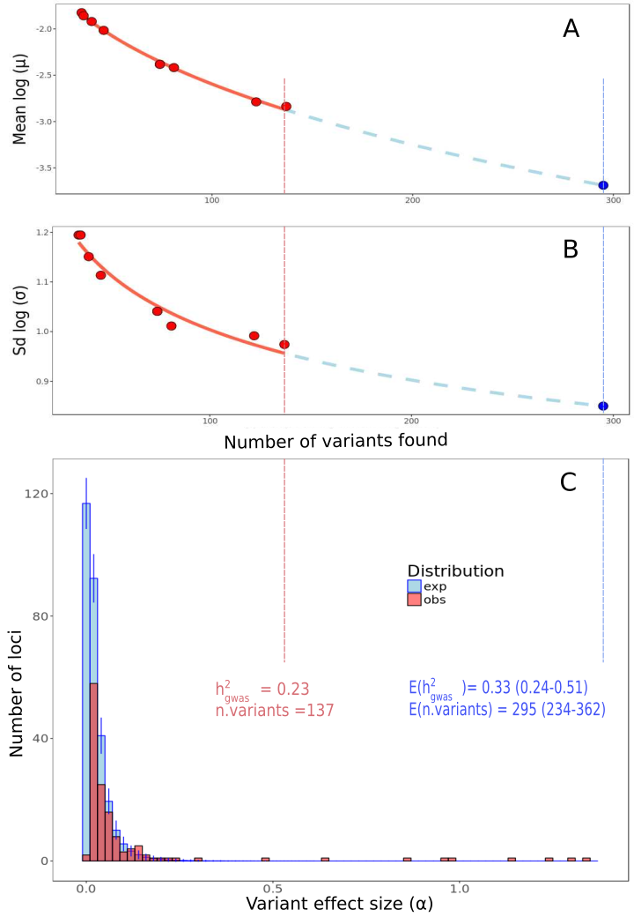
Figure S1. Illustration of the expected distribution inference process for trait HDL.
Observed values are presented in red, and expectations in blue. Plots A and B show the change in the parameters of the log-normal distribution of effect sizes as new loci are being found: the mean parameter (A) and the standard deviation parameter (B). The blue point corresponds to the expected value of these parameters for the number of variants sampled from the expected distribution which gives the best approach to the familial heritability. Plot C shows the distribution of locus effect sizes, as well as the corresponding values of heritability and numbers of loci. Two vertical dashed lines connect observed (red) and expected (blue) distribution parameters with their corresponding values of heritability and number of loci.

The above prediction method was carried out for all 16 traits under study. A two-parameter exponential model was used to predict the change in the parameters of the log-normal distribution of effect sizes, as well as the parameters of the normal distribution of MAFs, as new loci are found.

