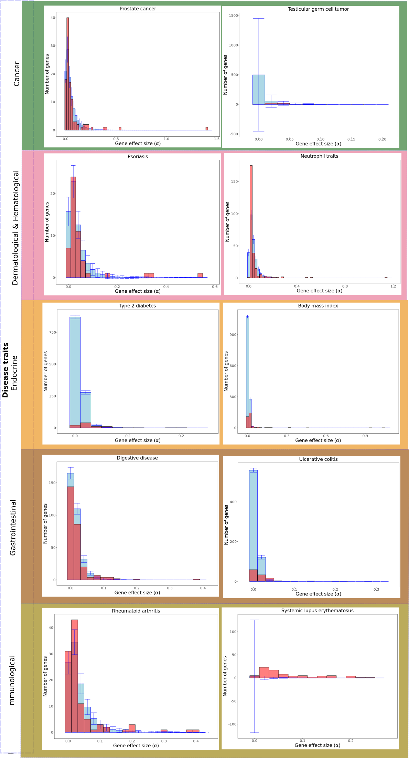
Figure S3. Distribution of locus effect sizes for disease traits. In red it is shown the expected distribution. In blue, the inferred expected distribution with returns a heritability value that approaches the most to the familial value.

