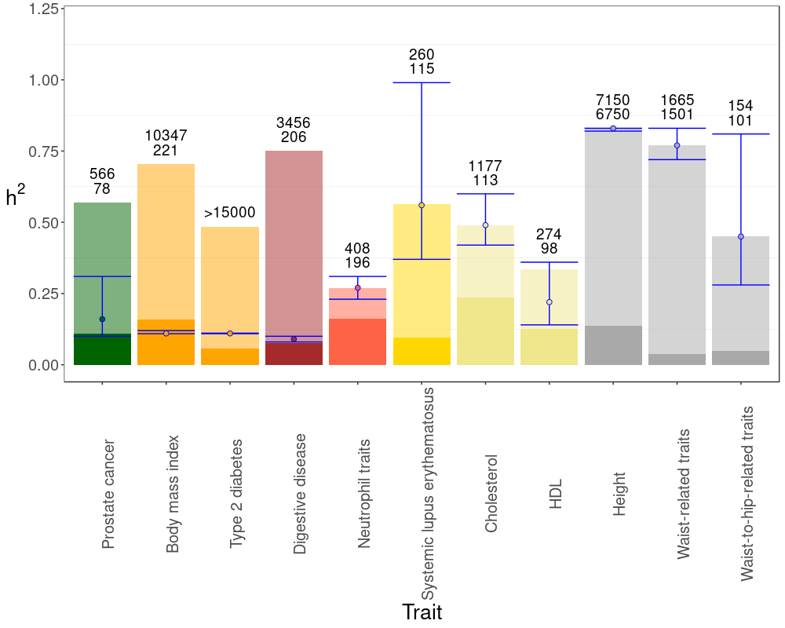

Figure S5. Observed and expected values of heritability. This Figure is analogue to Figure 4 in the main text, but inferences are based on a dataset where loci were pruned by using a 1-MB window (see Table S7). The full length of bars indicate the mean familial heritability ($h_{fam}^{2}$) for the studied traits. In solid color it is shown the heritability explained by the loci already found and available from the Catalog ($h_{gwas}^{2}$). The blue error bar gives the inferred value of heritability (the dot corresponds to the median value) that approaches most to the familial heritability with a 95% confidence interval, using data from the expected distribution of locus effects. The expected number of loci for each trait required to produce the expected heritabilities within the error bars are given over the bars. Traits are colored depending on the functional domain they belong: Cancer (green), endocrine (orange), gastrointestinal (brown), hematological (red), immunological (yellow), metabolic (beige), skeletal (grey).

