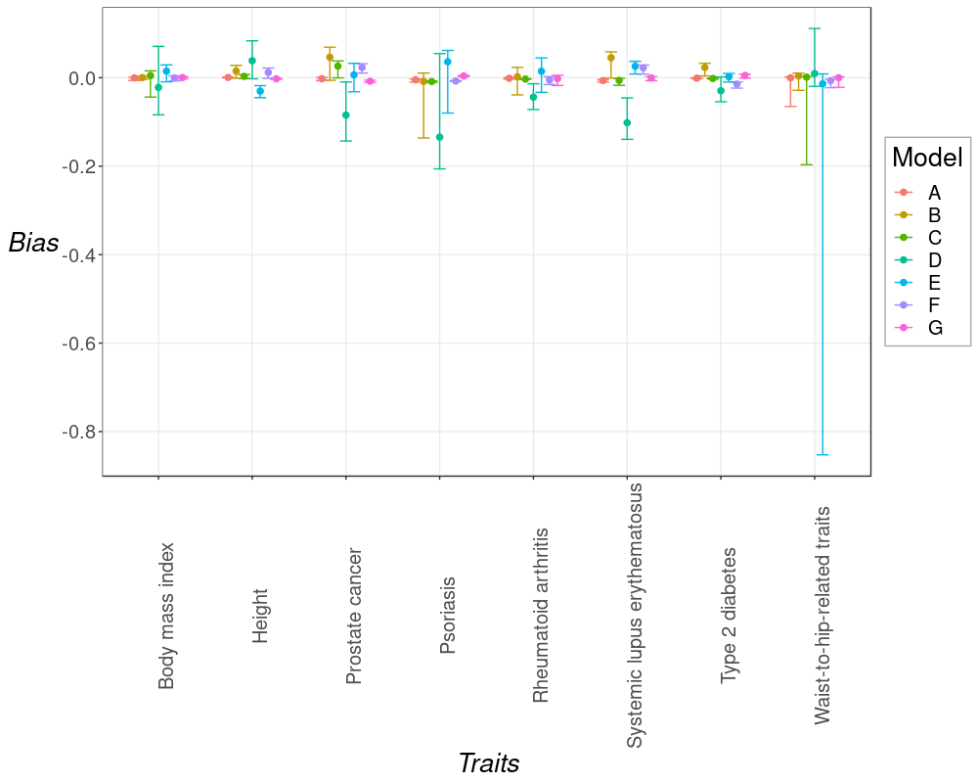

Figure S4. Prediction bias over the observed parameters calculated for the cumulated number of loci as independent variable. Models are named as in Table S6 depending on the dependent variable used: mean locus effect size (A) or frequency (B), heritability (C), the mean and standard deviation parameters of the log-normal distribution of effect sizes (D and E respectively) or the mean and standard deviation parameters of the normal distribution of MAF (F and G respectively).

