Genomic prediction of autotetraploids; influence of relationship matrices, allele dosage, and continuous genotyping calls in phenotype prediction
Ivone de Bem Oliveira*, †, Marcio F. R. Resende Jr.‡, Luis Felipe V. Ferrão*, Rodrigo R. Amadeu*, Jeffrey B. Endelman§, Matias Kirst††, Alexandre S. G. Coelho†, and Patricio R. Munoz*

*Blueberry Breeding and Genomics Lab, Horticultural Sciences Department, University of Florida, Gainesville, FL, USA, 32611
†Plant Genetics and Genomics Lab, Agronomy College, Federal University of Goias, GO, Brazil, 74690-900
‡Sweet Corn Genomics and Breeding, Horticultural Sciences Department, University of Florida, Gainesville, FL, USA, 32611

§Department of Horticulture, University of Wisconsin, Madison, WI, USA, 53706
††Forest Genomics Lab, School of Forestry Resources and Conservation, University of Florida, Gainesville, FL, USA, 32610
Corresponding author:

Patricio Ricardo Muñoz (p.munoz@ufl.edu)

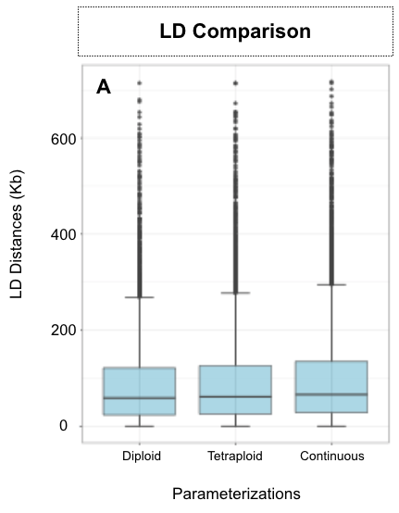
Figure S2 Distribution of linkage disequilibrium distances at the empirical threshold r²=0.2 for the diploid, tetraploid and continuous parameterizations

