Identification and expression analysis of long noncoding RNAs in fat-tail of sheep breeds
Mohammad Reza Bakhtiarizadehª*, Seyed Alireza Salami^{b}
ª Department of Animal and Poultry Science, College of Aburaihan, University of Tehran, Tehran, Iran
^{b} University of Tehran, Tehran, Iran
* Corresponding author. E-mail address: mrbakhtiari@ut.ac.ir

Supplementary Information I1

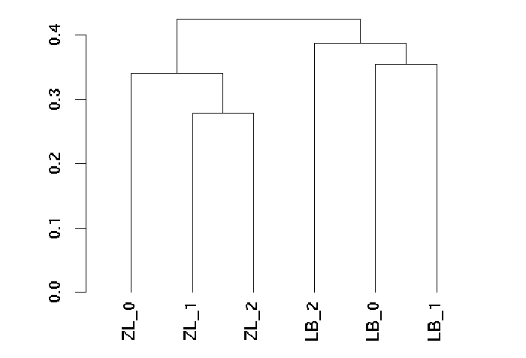
Figure I1 A hierarchical clustering analysis of all the biological samples. LB and ZL denotes Lori-Bakhtiari and Zel sheep breeds.
Distance

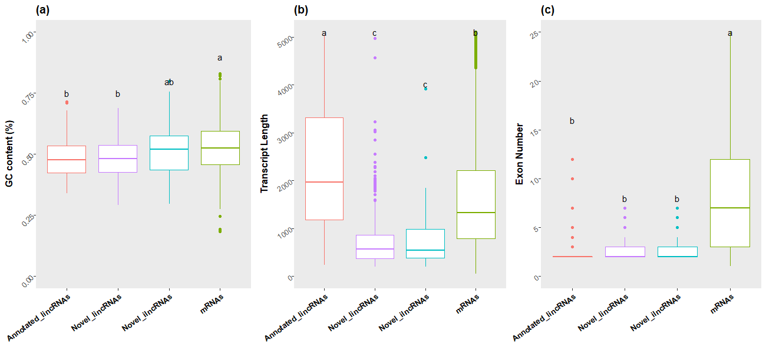
Figure I2 Comparisons of GC content (a), transcript length (b) and exon number (c) among novel and annotated transcripts. In all figures, a, b, c and d denote the results of statistical analysis and the boxes sharing a common letter are not significantly different (p<0.05).

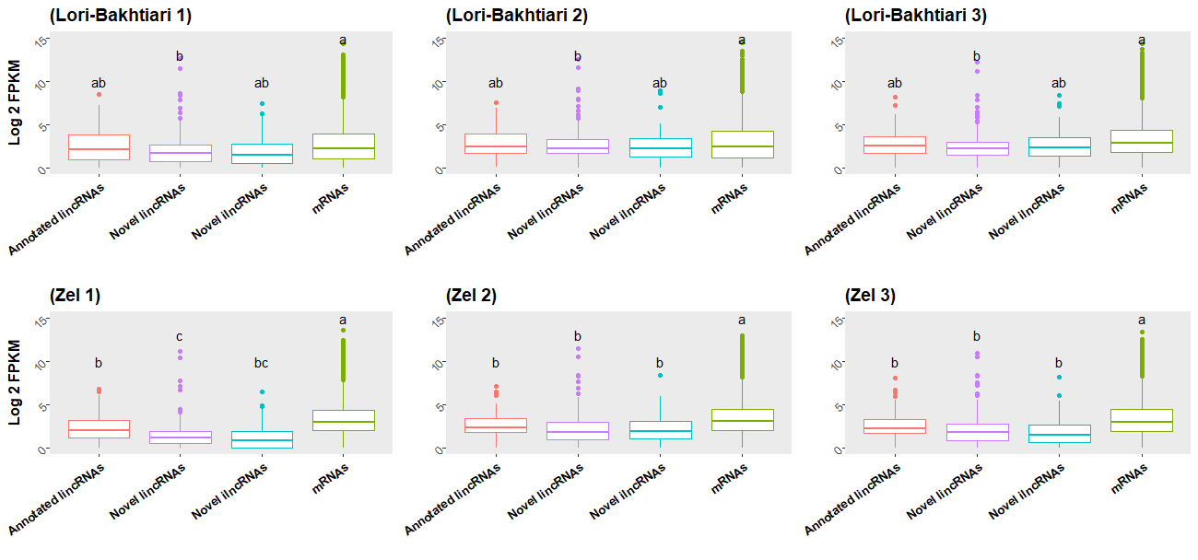
Figure I3 Gene expression patterns of different genes in different samples. In all figures, a, b, c and d denote the results of statistical analysis and the boxes sharing a common letter are not significantly different (p<0.05).

