Fig. S1. Confirmation of transposon integration in PGPR2 mutant library. (A) Integration of mariner transposon was confirmed with PCR to amplify the transposon. Lane M, 1-kb molecular weight DNA marker (Thermo Fisher Scientific, USA); “-”, negative control (gDNA from P. aeruginosa PGPR2); “+”, positive control (pSAM_BT plasmid DNA); lane 3-14, PCR amplification of Gm^{R} antibiotic cassette from gDNA of individual mutants of P. aeruginosa PGPR2. (B) PCR for the same samples using himar transposase gene primers should be lost in mutants upon proper integration of transposon.
Fig. S2. Southern blot analysis of PGPR2 INSeq library mutants. Genomic DNA of wild type PGPR2 (WT) and 13 INSeq mutants were digested with HindIII restriction enzyme and resolved on an 0.8% agarose gel. A gentamicin resistance gene used as a probe revealed a single insertion and random integration of the transposon.
Fig. S3. Genome map of P. aeruginosa PGPR2 showing transposon insertion sites. The outer circle represents the forward strand (red), the inner circle represents the reverse strand (blue), and the purple bars represent the transposon insertion sites.
Fig. S4. Functional categorization of essential genes responsible for growth of PGPR2. The functional classification was done according to protein annotation by COG database using WebMGA.
Fig. S5. Functional categorization of genes responsible for the fitness of PGPR2 during corn root colonization. The functional classification was done according to protein annotation by COG database using WebMGA.

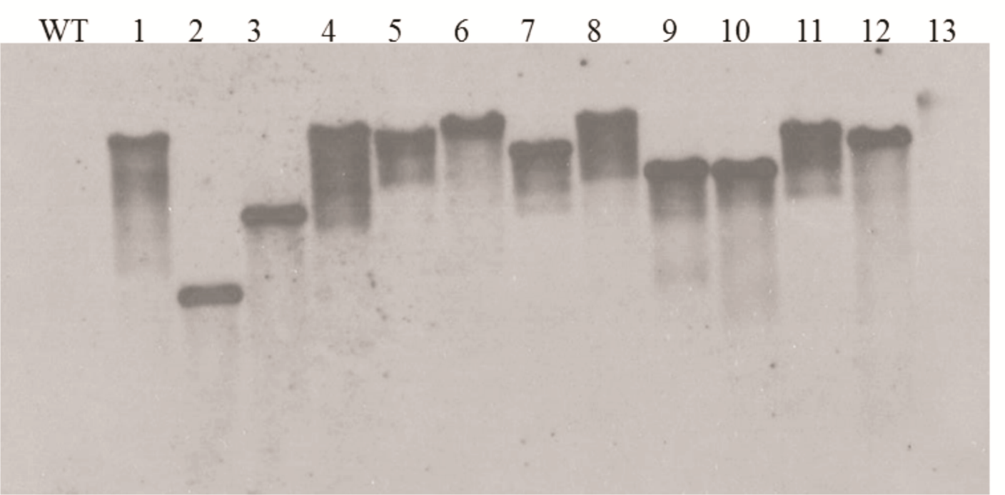
Fig. S2

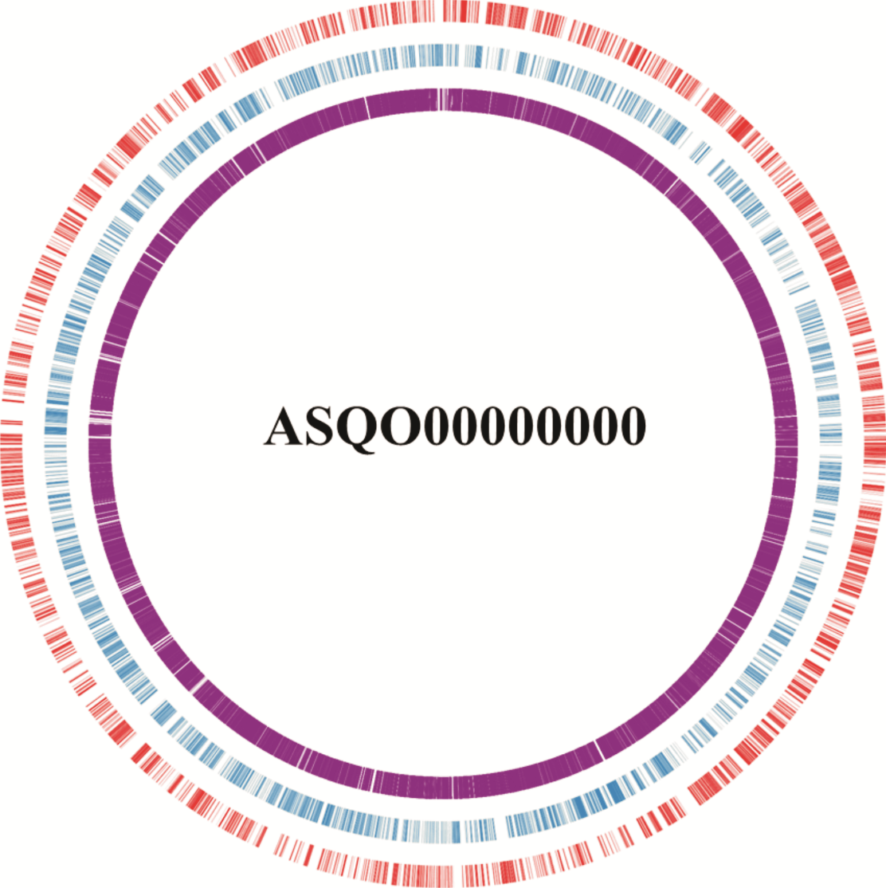
Fig. S3

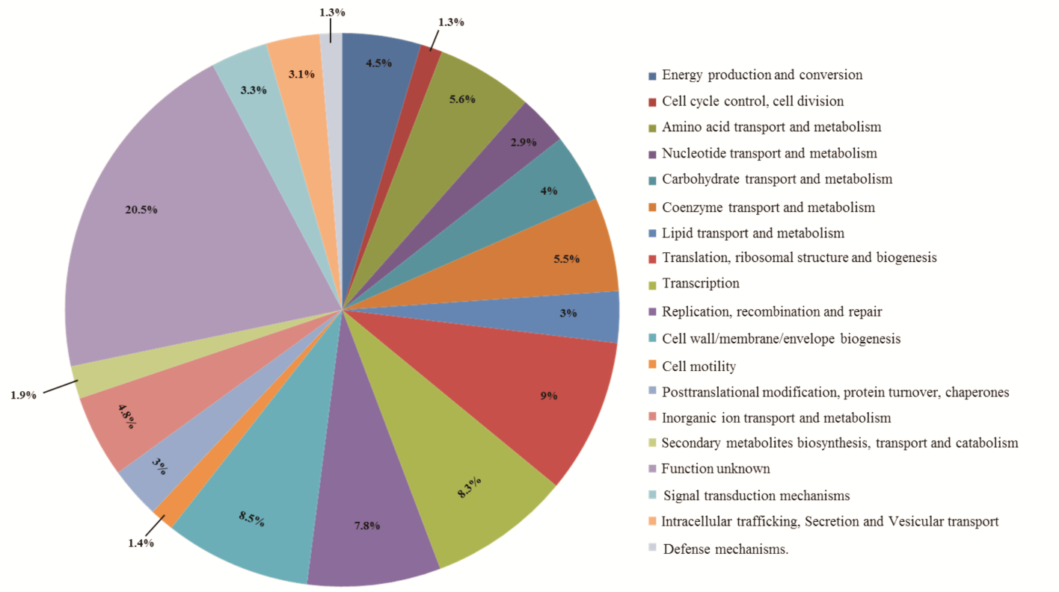
Fig. S4

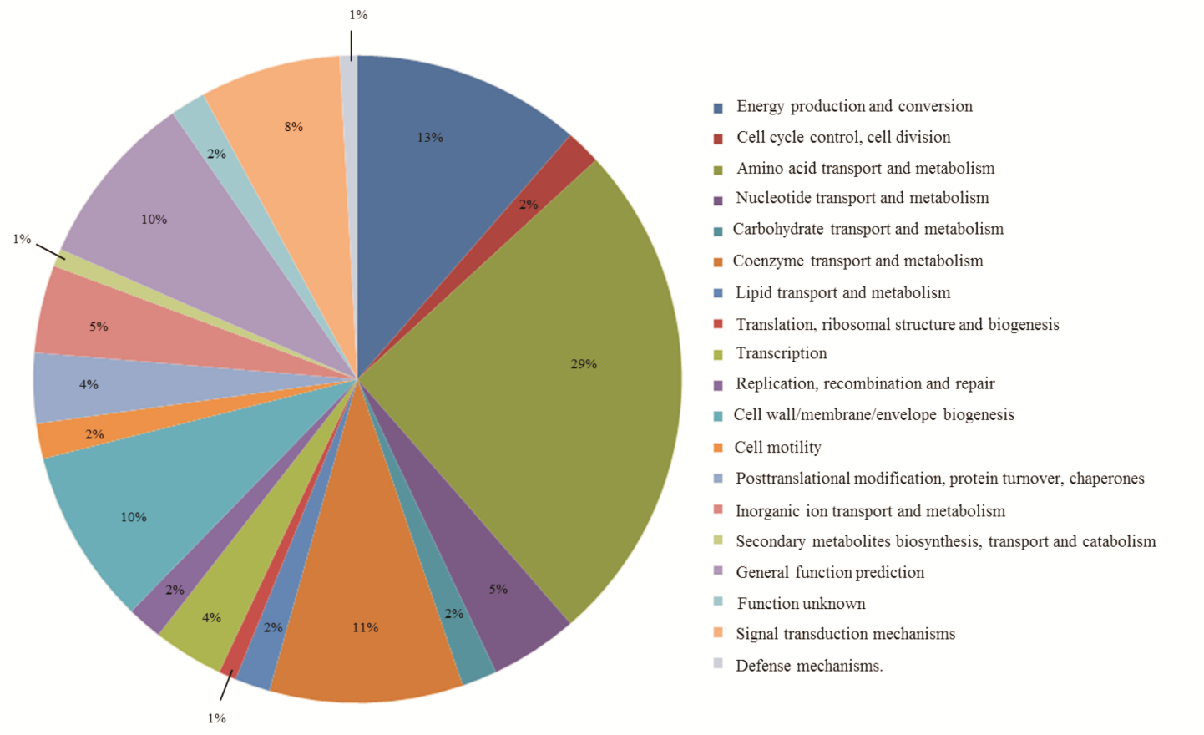
Fig. S5
Table S1 List of primers used in this study
Primer | Sequence (5’-3’)ª | Purpose
Gen F | TACTCGAGCGCGTCAATTCTCGAATTGACA | Gm^{R} PCR
Gen R | CAGCGGCCGCAGGGTTTTCCCAGTCAC | Gm^{R} PCR
Trans F | CACCGGATCCCAGTGTGATGGATTGACACATAG | Transposase PCR
Trans R | TAGCGGCCGCAGGGTTTTCCCAGTCACG | Transposase PCR
trpD F | GAACTCGAGATGGATATCAAGGGAGCCCTC | TrpD deletion
trpD R1 | TATAAGCTTCACGAAGGACGCCGCCGAGGA | TrpD deletion
trpD F1 | GTTAAGCTTGAAGTGCGTCCCGAGGACTTC | TrpD deletion
trpD R | ATTCTCGAGTCACTGTGCGTTCTCCTCTCT | TrpD deletion
hom F | GAACTCGAGGTGAAACCGGTCAAAGTAGGC | Hom deletion
hom R1 | CATAAGCTTGCCTTGGCGAAGATCTCGTTG | Hom deletion
hom F1 | GTTAAGCTTTGACCTCCGATCCGGAGAACC | Hom deletion
hom R | GCGCTCGAGTCAATTCAGTTGTTCGACACG | Hom deletion
oprF F | GCGCTCGAGATGAAACTGAAGAACACCTTA | OprF deletion
oprF R1 | AATAAGCTTGTGGTAGATGGCGTCCAGAGA | OprF deletion
oprF F1 | GCTAAGCTTAAAGAGAACAGCTACGCTGAC | OprF deletion
oprF R | GCGCTCGAGTTACTTGGCTTCAGCTTCTAC | OprF deletion
cbrA F | TAACTCGAGATGCTGACGAGCTTTAGCCTG | CbrA deletion
cbrA R1 | ATTAAGCTTCGAGCATCACCAGCTTGACCA | CbrA deletion
cbrA F1 | ATTAAGCTTGAACGCGAAGGCGACGGCGAG | CbrA deletion
cbrA R | ATTCTCGAGCTACAGCTCGGCCGTCGGGCC | CbrA deletion

ª Relevant restriction sites are given in bold letters.

