Supplementary Materials

Tissue-specific transcriptome analysis reveals candidate genes for terpenoid and phenylpropanoid metabolism in the medicinal plant Ferula assafoetida
Hajar Amini,∗,† Mohammad Reza Naghavi,†, Tong Shen,‡ Yanhong Wang,§ Jaber Nasiri,† Ikhlas A. Khan,§ Oliver Fiehn,‡,** Philipp Zerbe,∗ and Julin N. Maloof*,1

∗Department of Plant Biology, University of California, Davis, CA, USA, 95616
†Department of Agronomy and Plant Breeding, Agricultural and Natural Resources College, University of Tehran, Iran, 77871-31587
‡West Coast Metabolomics Center, University of California, Davis, CA, USA, 95616
§National Center for Natural Products Research, Research Institute of Pharmaceutical Sciences, University of Mississippi, Oxford, MS, USA, 38677
**Department of Biochemistry, Faculty of Sciences, King Abdulaziz University, Jeddah, Saudi-Arabia

MATERIAL AND METHODS
Metabolite analysis
GC-MS analyses were performed on an Agilent GC model 5977A equipped with a MD800 selective mass detector. Analyses were performed with electron ionization (EI) at 70 eV, an ion-source temperature of 200°C and an interface temperature of 280°C using split-splitless injection (split ratio 1:10) with a 280°C injector temperature and a 1 μl injection volume. Separation was achieved using a fused silica column 5% phenyl-poly-dimethyl-siloxane (Chrompack CP-Sil 8 CB 50 m x 250 µm x 0.12 µm) and the following GC parameters: 50°C for 2 min, 4°C/min to 120°C, 2°C/min to 200 °C, 25°C/min to 280°C with hold for 8 min. Data acquisition was performed with Mass Lab software for the mass ranges 30-600 u with a scan speed of 1 scan/sec. Identification of compounds was based on Kovats retention indices as calculated using n-alkanes C₁₁-C₂₈ as reference compounds using three replicated measurements, as well as comparison to reference mass spectral libraries, including Adams (Robert Adams, 2012), US National Institute of Standards and Technology (NIST, USA), WILEY 1996 Ed. mass spectra library, and an in-house library of 600 mass spectra.
For ultra-high-performance liquid chromatography-quadrupole time-of-flight mass spectrometry (UHPLC-QToF-MS) studies, dry plant material was ground to a fine powder. Plant samples (0.5 g) were weighed in a centrifuge tube and 3.5 mL of methanol added before sonication in a water bath for 30 min and centrifugation at 959 ×g for 15 min. The supernatant was transferred to a 10 mL flask. The extraction procedure was repeated twice and supernatants combined. The final volume was adjusted to 10 mL with methanol and mixed thoroughly. Prior to injection, an adequate sample volume was passed through a 0.45 µm PTFE filter and collected in a LC sample vial. All samples were analyzed on a Waters Acquity UPLC™ system including binary solvent manager, sampler manager, column compartment and a photodiode array (PDA) detector (Waters Acquity model code UPD). Data were acquired and interpreted using MassLynxTM NT 4.1 software. The separation was carried out on a Waters Acquity UPLC™ BEH Shield RP18 column (100 mm × 2.1mm i.d., 1.7 µm) which was equipped with a guard column (Vanguard 2.1 × 5 mm). The sample temperature and column temperature were maintained at 15°C and 35°C, respectively. The mobile phase consisted of water containing 0.05% formic acid (v/v) (A) and acetonitrile with 0.05% formic acid (B). The analysis was performed using the following gradient elution at a flow rate of 0.30 mL/min: 0-11 min, 30% B to 70% B and 11-15 min, 70% B to 100% B. The column was washed with 100% B for 3 min and re-equilibrated for 3.5 min between runs using the initial conditions. The strong needle wash (90/10; acetonitrile/water, v/v) and weak needle wash solution (10/90; acetonitrile/water, v/v) were used. The total run time for analysis was 15 min. Mass spectrometric analyses were performed using electrospray ionization (ESI) on a Waters ACQUITY™ Xevo QToF G2-S mass spectrometer (Waters Corporation, Manchester, UK). The ESI source was operated under the positive ionization mode in the following conditions: capillary of 0.65 kV, cone of 25 V, source temperature of 80°C, desolvation temperature 500°C, desolvation gas flow of 900 L/h, cone gas flow of 50 L/h, and collision energy of 6 eV. Leucine-enkephalin was used for the lock mass at a concentration of 5 ng/mL and flow rate of 5 µL/min. Ions [M+H]⁺ (m/z 556.2771 Da) and fragment ion (m/z 278.1141 Da) of leucine-enkephalin were employed to ensure mass accuracy during the MS analysis. The lock spray interval was set at 30 s, and the data were averaged over three scans. The mass spectrometer was programmed to step between low (6 eV) and elevated (10-30 eV) collision energies on the gas cell, using a scan time of 0.5 s per function over a mass range of 50–1200 m/z. When data were acquired with MS^{E}, two interleaved scan functions were used. The first scan function acquired a wide mass range using low collision energy. This scan function collected precursor ion information for the sample. The second scan function acquired data over the same mass range; however, the collision energy was ramped from low to high. This scan function allowed for the collection of a full-scan accurate mass of fragments along with precursor ion information. An individual stock solution of standard compounds (umbelliferone, luteolin, and umbelliprenin) was prepared at a concentration of 1.0 mg/mL in methanol. The calibration curves were prepared at seven different concentration levels and listed in Supplementary Table S1.

De novo transcriptome assembly and evaluation
We utilized four different de novo transcriptome assembly pipelines to ensure a high quality reference transcriptome was assembled.
First pipeline: Reads from all organs were combined and assembled with Trinity v2.4.0 with kmer = 25 (Grabherr et al. 2011). We refer to this pipeline as “Trinity” pipeline.
Second pipeline: The Khmer v2.0 tools (Crusoe et al. 2015) was applied to variable kmer coverage abundance trimming to the reads prior to Trinity assembly. This reduces the computational cost of assembly without negatively affecting the quality of the assembly. We refer to this pipeline as the “Khmer_Trinity” pipeline.
Third pipeline: The Drap v1.91 was applied as a post processing step after using Trinity to compact and correct the assembled transcriptome (Cabau et al. 2017). We refer to this pipeline as the “Trinity_DRAP” pipeline.
Fourth pipeline: The Drap v1.91 was applied as a post processing step after using Oases v0.2.06 with kmer 25, 31,37, 43, 49 (Zerbino and Birney 2008; Schulz et al. 2012). We refer to this pipeline as the “Oases_DRAP” pipeline.

Tissue-specific differential expression analysis
The differentially expressed genes of the assembled transcriptome were investigated using the edgeR package in the R statistical environment (FDR <0.05) (Robinson et al. 2010b; R Core Team 2016) as follows: The differential expression analysis was calculated from 12 samples from the UC Davis facility (3 samples from 4 different organs) to avoid the possibility of a batch effect altering the expression analysis. We filtered to remove genes with low expression, only retaining genes with more than 10 reads in more than three samples. After this filtering, sample libraries were normalized by calculating the effective library size and normalization factor using the TMM method on counts data (Robinson and Oshlack, 2010a). The model was calculated based on “model.matrix (~organs, data=data)” formula. Organs refer to four organs including roots, flowers, leaves and stems for designing this model. We then identified genes differentially expressed among plant organs using a generalized linear model (glm) in edgeR and multiple-testing correction via the Benjamini and Hochberg (BH) procedure (Benjamini and Hochberg, 1995).

RESULTS AND DISCUSSION
De novo transcriptome assembly and evaluation
By using the Illumina HiSeq platform, the libraries were sequenced, and then after removing low quality reads and adaptor sequences, approximately 218 million reads from roots, 190 million reads from flowers, 123 million reads from stems, and 91 million reads from leaves were generated (Supplemental Table S2). To obtain high quality assemblies, we compared results from four different de novo assembly pipelines including Trinity (Grabherr et al. 2011), Khmer_Trinity (Crusoe et al. 2015), Trinity_DRAP, and Oases_DRAP (Cabau et al. 2017) (Supplemental Table S3). The Oases assemblies after DRAP correction produced the longest contigs (N50) in comparison to other pipelines (Supplemental Table S3).
To investigate the quality of the transcriptome assembly we determined the percentage of reads mapping and the completeness of universal single copy orthologs. Using the STAR aligner, we found that over 65% of the reads mapped uniquely to the transcripts produced by Oases_DRAP (Figure S2). High quality assemblies should have a high representation of universally conserved single copy orthologs; we assessed this metric using BUSCO v3 (Simão et al. 2015). The universal single-copy orthologs used were from the OrthoDB database (Zdobnov et al. 2016). The transcriptome assembly produced by Oases and further corrected by DRAP contained complete assemblies of over 90% of these genes and more than 80% were present as single copy (Table S4), confirming that this assembled transcriptome was of high quality.

Supplementary Figures and Tables

Supplementary Table
Supplementary Table S1. The calibration curves for umbelliferone, luteolin, umbelliprenin.
Compound Name | Calibration Curve | R² | Linearity Range  (ng/mL)
umbelliferone | Y = 24.673 * X – 125.505 | 0.999 | 20-20,000
luteolin | Y = 58.4144 * X -761.246 | 0.996 | 20-20,000
umbelliprenin | Y = 4.5332 * X – 26.2643 | 0.994 | 20-20,000

Supplementary Table S2. RNAseq data obtained from different organs of F. assafoetida.
Facility for Sequencing | No. of Plants | Organ | Total No. of Reads after Quality Control | Average Read Length (bp)
UC Davis | 3 | Root | 91735578 | 149.31
UC Davis | 3 | Stem | 123539018 | 149.33
UC Davis | 3 | Leaf | 91321958 | 149.41
UC Davis | 3 | Flower | 60283346 | 149.47
Novogene | 2 | Root | 93100182 | 150
Novogene | 2 | Flower | 95622730 | 150
BGI | 1 | Root | 33877268 | 150
BGI | 1 | Flower | 34402438 | 150
Supplemental Table S3. Summary statistics on de novo assembly of F. assafoetida.
 | Trinity | Khmer_Trinity | Trinity_DRAP | Oases_DRAP
Total transcripts | 329131 | 273777 | 81327 | 60134
Contig N50 (bp) | 1464 | 1250 | 1559 | 1888
Average contig (bp) | 841.37 | 728.51 | 1102.25 | 1241.3
Supplementary Table S4. Summary evaluation of F. assafoetida transcriptome assemblies.
 | Trinity | Khmer_Trinity | Trinity_ DRAP | Oases_DRAP
Complete BUSCOs (C) | 1272 (88.4%) | 1281 (88.9%) | 1303 (90.5%) | 1315 (91.4%)
Complete and single-copy BUSCOs (S) | 482 (33.5%) | 503 (43.9%) | 1114 (77.4%) | 1176 (81.7%)
Complete and duplicated BUSCOs (D) | 790 (54.9%) | 778 (54.0%) | 189 (13.1%) | 139 (9.7%)
Fragmented BUSCOs (F) | 87 (6.0%) | 89 (6.2%) | 47 (3.3%) | 34 (2.4%)
Missing BUSCOs (M) | 81 (5.6%) | 70 (4.9%) | 90 (6.2%) | 91 (6.2%)
Total BUSCO groups searched | 1440 | 1440 | 1440 | 1440

Supplementary Table S5. Putative annotation and transcript identities of candidate genes of terpenoid biosynthesis.

Name in F. assafoetida | Abbreviation
TRINITY_DN26504_c0_g1_i1 | Ferula assafoetida CPS
oases3_k43_Locus_5220_Transcript_5_1 | Ferula assafoetida EKS
oases3_k31_Locus_43830_Transcript_3_1 | Ferula assafoetida TPS1
oases3_k49_Locus_2046_Transcript_4_1 | Ferula assafoetida TPS2
oases3_k49_Locus_48413_Transcript_4_1 | Ferula assafoetida TPS3
oases6_k49_Locus_56686_Transcript_2_1 | Ferula assafoetida TPS4
TRINITY_DN40361_c0_g4_i2 | Ferula assafoetida TPS5
oases3_k49_Locus_1839_Transcript_5_2 | Ferula assafoetida TTS1
oases6_CL5040Contig1_1 | Ferula assafoetida TTS2
oases6_k25_Locus_16826_Transcript_4_1 | Ferula assafoetida TTS3
oases6_k37_Locus_1803_Transcript_51_1 | Ferula assafoetida TTS4
oases2_k31_Locus_1021_Transcript_15_1 | Ferula assafoetida TTS5
oases6_k49_Locus_1643_Transcript_11_1 | Ferula assafoetida TTS6
oases6_k49_Locus_26372_Transcript_1_1 | Ferula assafoetida TTS7
oases3_CL17600Contig1_1 | Ferula assafoetida TTS8
oases2_CL309Contig1_2 | Ferula assafoetida TTS9

Supplementary Table S6. Putative annotation and transcript identities of candidate genes of coumarin-type phenylpropanoid biosynthesis.

Name in F. assafoetida | Abbreviation
oases3_k25_Locus_11029_Transcript_9_1 | Ferula assafoetida 4CL-like1
oases3_k25_Locus_4163_Transcript_5_1 | Ferula assafoetida 4CL-like2
oases3_k37_Locus_4395_Transcript_4_1 | Ferula assafoetida 4CL-like3
oases3_k43_Locus_7570_Transcript_3_1 | Ferula assafoetida 4CL-like4
oases6_k25_Locus_30933_Transcript_3_1 | Ferula assafoetida 4CL-like5
TRINITY_DN75605_c0_g1_i1 | Ferula assafoetida 4CL-like6
oases6_k37_Locus_13492_Transcript_4_1 | Ferula assafoetida C2'H
oases2_k37_Locus_48872_Transcript_1_1 | Ferula assafoetida CHI-like1
oases3_CL10153Contig1_2 | Ferula assafoetida CHI-like2
oases3_k49_Locus_9379_Transcript_12_1 | Ferula assafoetida CHI-like3
oases6_k25_Locus_14487_Transcript_14_1 | Ferula assafoetida CHI-like4
oases6_k37_Locus_61759_Transcript_1_1 | Ferula assafoetida CHI-like5
oases2_k25_Locus_50568_Transcript_1_1 | Ferula assafoetida CHS-like1
oases3_k25_Locus_15765_Transcript_6_1 | Ferula assafoetida CHS-like2
oases2_k25_Locus_16219_Transcript_3_1 | Ferula assafoetida FH-like1
oases3_k43_Locus_8457_Transcript_7_1 | Ferula assafoetida FH-like2
oases6_k37_Locus_57857_Transcript_1_1 | Ferula assafoetida FH-like3
oases6_k49_Locus_12143_Transcript_7_2 | Ferula assafoetida FNS
oases2_k31_Locus_1941_Transcript_18_1 | Ferula assafoetida PAL-like1
oases3_k43_Locus_21058_Transcript_1_1 | Ferula assafoetida PAL-like2
TRINITY_DN121792_c0_g1_i1 | Ferula assafoetida PAL-like3
TRINITY_DN38110_c0_g8_i1 | Ferula assafoetida PAL-like4
oases2_k25_Locus_8995_Transcript_3_1 | Ferula assafoetida PAL-like5
Supplementary Table S7. Genes upregulated in sesqui- and tri-terpenoid biosynthesis with ko00909.
Name in F. assafoetida | KO | EC | Definition
oases3_CL17600Contig1_1 | K15813 | EC:5.4.99.39 | β-Amyrin
oases3_k49_Locus_48413_Transcript_4_1 | K15803 | EC:4.2.3.75 | (-)-germacrene D
oases6_k25_Locus_6897_Transcript_5_2 | K15803 | EC:4.2.3.75 | (-)-germacrene D
oases6_k31_Locus_55853_Transcript_2_1 | K00801 | EC:2.5.1.21 | farnesyl-diphosphate farnesyltransferase
oases6_k37_Locus_56543_Transcript_8_1 | K00801 | EC:2.5.1.21 | farnesyl-diphosphate farnesyltransferase
oases6_k49_Locus_18297_Transcript_7_1 | K00801 | EC:2.5.1.21 | farnesyl-diphosphate farnesyltransferase

Supplementary Table S8. Genes upregulated in flavonoid biosynthesis with ko00941.
Name in F. assafoetida | KO | EC | Definition
oases2_k25_Locus_16219_Transcript_3_1 | K05280 | EC:1.14.13.21 | flavonoid 3'-monooxygenase
oases2_k25_Locus_50568_Transcript_1_1 | K00660 | EC:2.3.1.74 | chalcone synthase
oases2_k37_Locus_48872_Transcript_1_1 | K01859 | EC:5.5.1.6 | chalcone isomerase
oases3_CL10153Contig1_2 | K01859 | EC:5.5.1.6 | chalcone isomerase
oases3_k25_Locus_52353_Transcript_5_1 | K05278 | EC:1.14.20.6 | flavonol synthase
oases3_k31_Locus_19023_Transcript_5_1 | K00475 | EC:1.14.11.9 | naringenin 3-dioxygenase
oases3_k31_Locus_19023_Transcript_5_2 | K00475 | EC:1.14.11.9 | naringenin 3-dioxygenase
oases3_k37_Locus_50451_Transcript_6_1 | K13082 | EC:1.1.1.219/ EC:1.1.1.234 | bifunctional dihydroflavonol 4 reductase/  flavanone 4-reductase
oases6_k25_Locus_14487_Transcript_14_1 | K01859 | EC:5.5.1.6 | chalcone isomerase
oases6_k49_Locus_12143_Transcript_7_2 | K00475 | EC:1.14.11.9 | naringenin 3-dioxygenase

1.2 Supplementary Figures

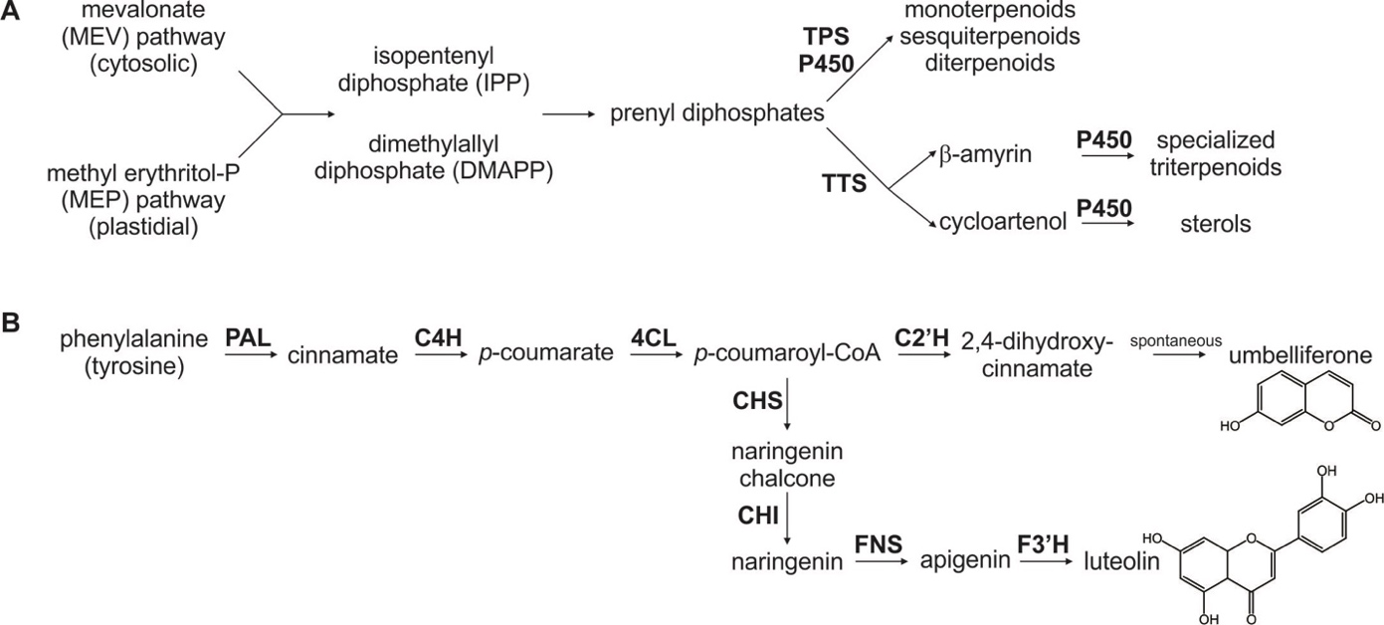

Supplementary Figure S1. Schematic overview of core pathway reactions in the biosynthesis of terpenoids (A) and phenylpropanoids (B) targeted in this study as relevant bioactive constituents in Ferula assafoetida. Key enzymes are highlighted in bold: TPS, terpene synthase; TTS, triterpene synthase; P450, cytochrome P450-dependent monooxygenase; PAL, phenylalanine ammonia-lyase; C4H, cinnamate 4-hydroxylase; 4CL, 4-coumarate:CoA-ligase; C2′H, p‐coumaroyl-CoA 2′‐hydroxylase; CHS, chalcone synthases; CHI, chalcone isomerases; FNS, flavone synthases; F3’H, flavanone 3-hydroxylase.

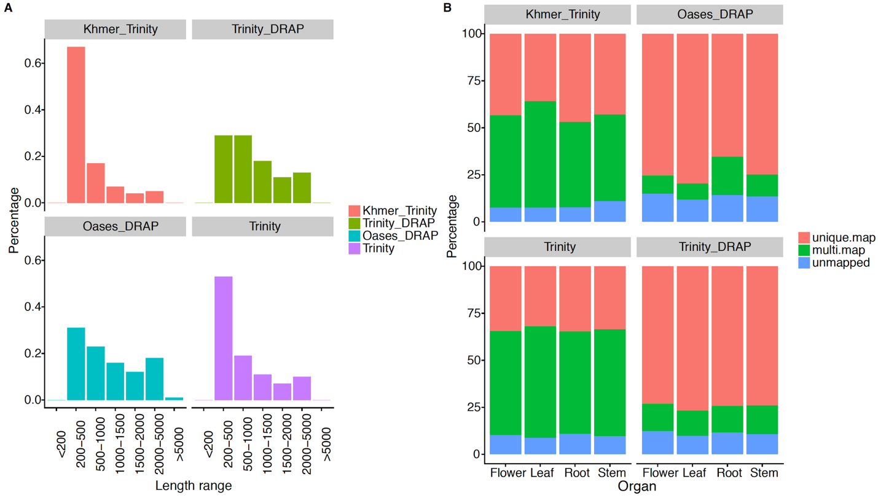Supplementary Figure S2. Length distribution of transcripts of assembled transcriptomes (A) and fraction of the RNAseq reads uniquely mapped to the assembled transcriptome by STAR 2.5.2b (B).

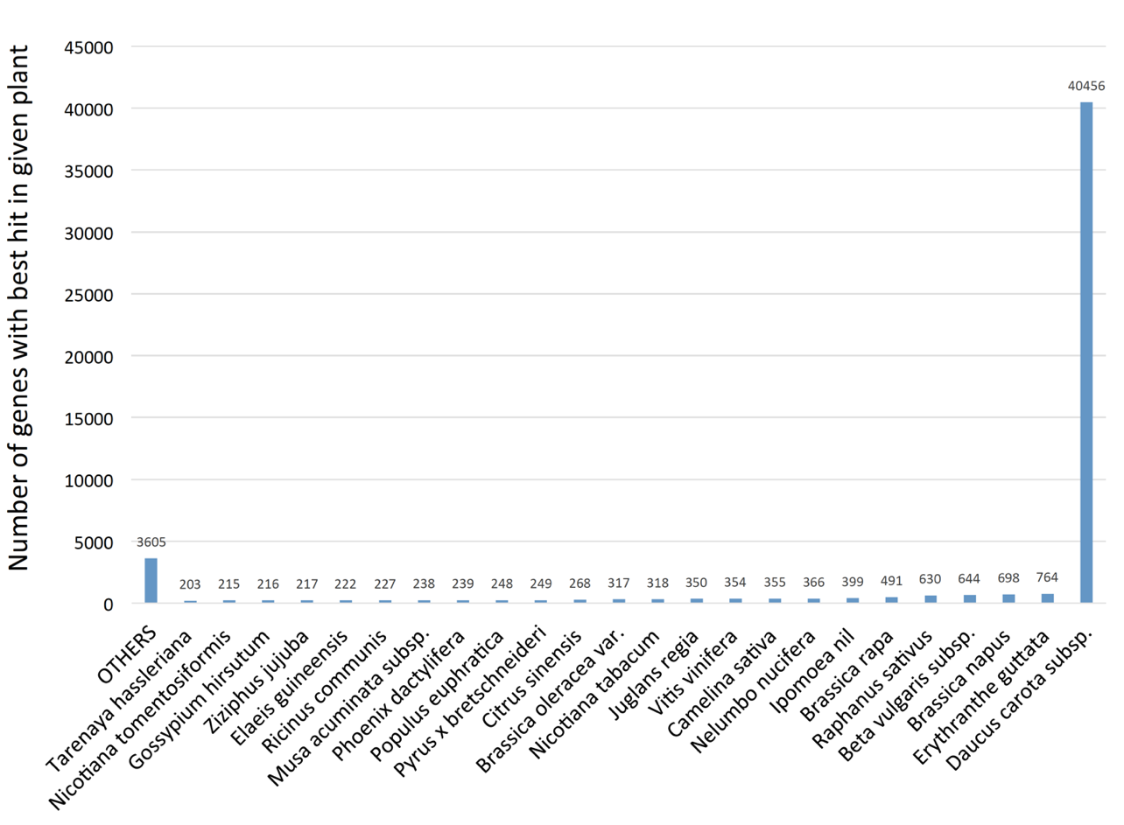
Supplementary Figure S3. Distribution of assembled transcriptome best hits to different plants as a result of blastx against all RefSeq plant databases.

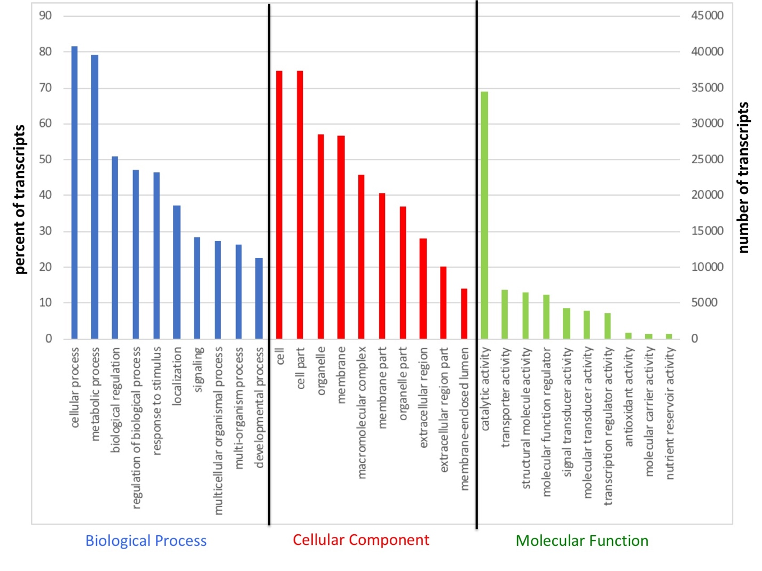
Supplementary Figure S4. Gene ontology (GO) classification of the transcripts derived from F. assafoetida.

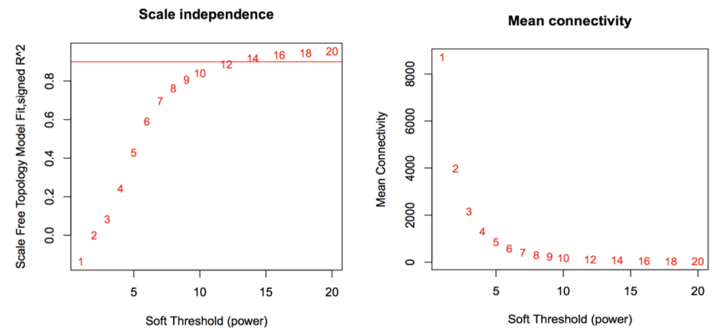Supplementary Figure S5. Determination of soft threshold (power) for network construction.

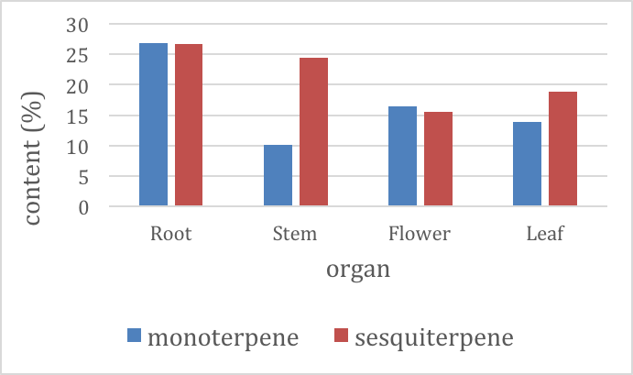
Supplementary Figure S6. Relative terpenoid composition in the essential oils of different organs.

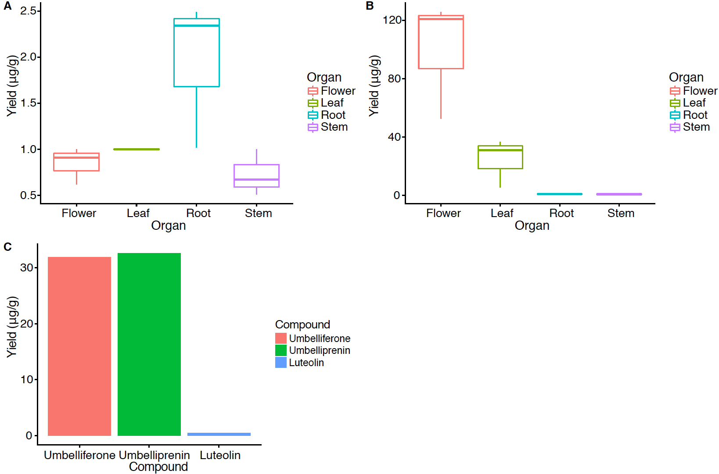

Supplementary Figure S7. Quantification of the amount of umbelliferone (A) and luteolin (B) among different organs. Quantification of the amount of umbelliferone, umbelliprenin and luteolin (C) in oleo-gum-resin. The yield was microgram per gram dry weight (µg/g) of these compounds for each sample. Each value represents the average of two injections for each sample by LOD (limits of detection) at 10 ng/ml and LOD at 20 ng/ml.

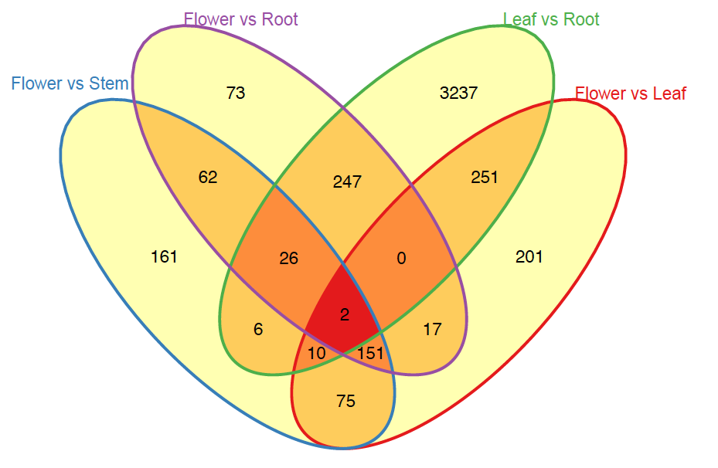

Supplementary Figure S8. Venn diagram of differentially expressed genes used in pairwise statistical tests and contrast matrix of different organs (Significance level: FDR <0.05).

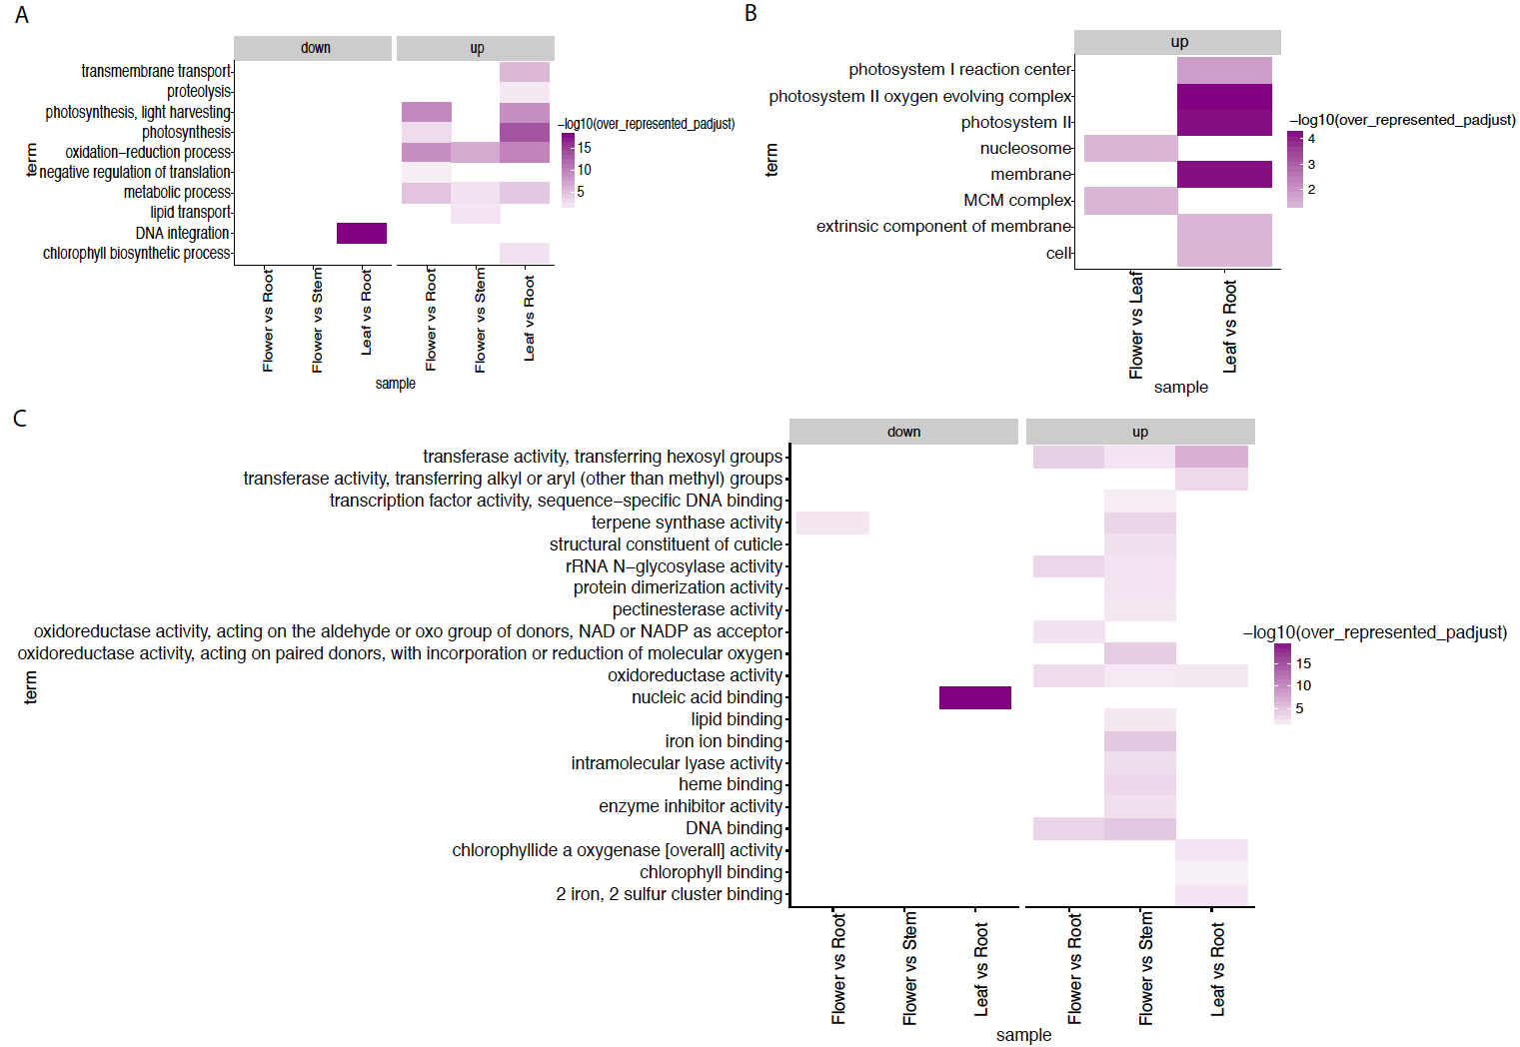

Supplementary Figure S9. Over-represented GO terms in differential expressed genes between pairwise comparison organs for three ontologies biological process (A), cellular component (B) and molecular function (C). “down” in Flower vs Root means higher expression in Root; “down” in Flower vs Stem means higher expression in Stem; “down” in Leaf vs Root means higher expression in Root.
“up” in Flower vs Root indicates higher expression in Flower; “up” in Flower vs Stem indicates higher expression in Flower; “up” in Leaf vs Root indicates higher expression in Leaf; “up” in Flower vs Leaf indicates higher expression in Flower; “up” in Leaf vs Root means higher expression in Leaf.
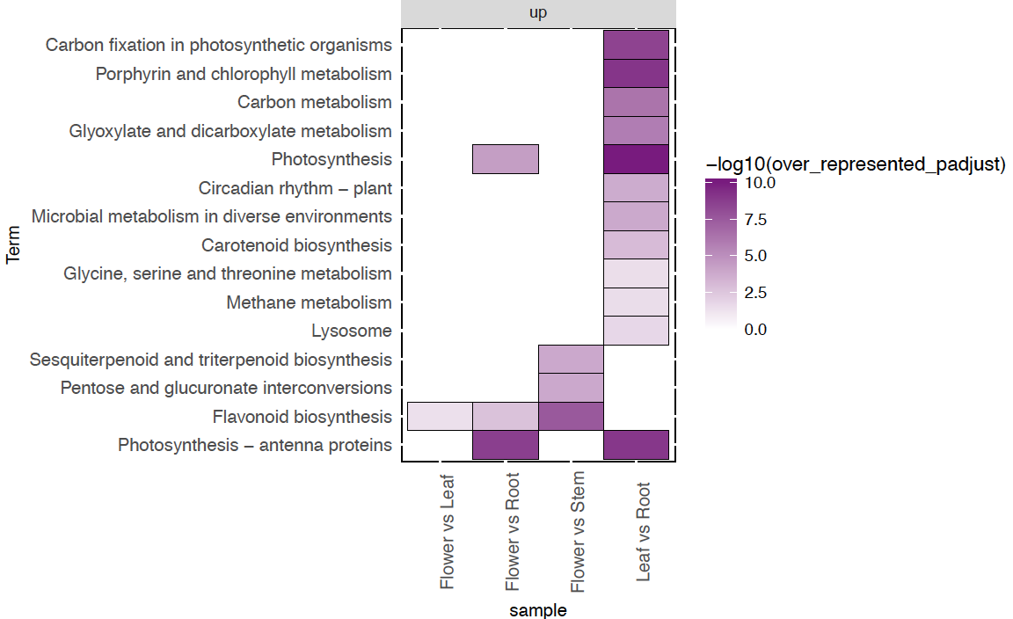
Supplementary Figure S10. Pathway analysis result for finding over-represented KEGG orthology by using the KEGG database. “up” in Flower vs Leaf indicates higher expression in Flower; “up” in Flower vs Root indicates higher expression in Flower; “up” in Flower vs Stem indicates higher expression in Flower; “up” in Leaf vs Root indicates higher expression in Leaf.

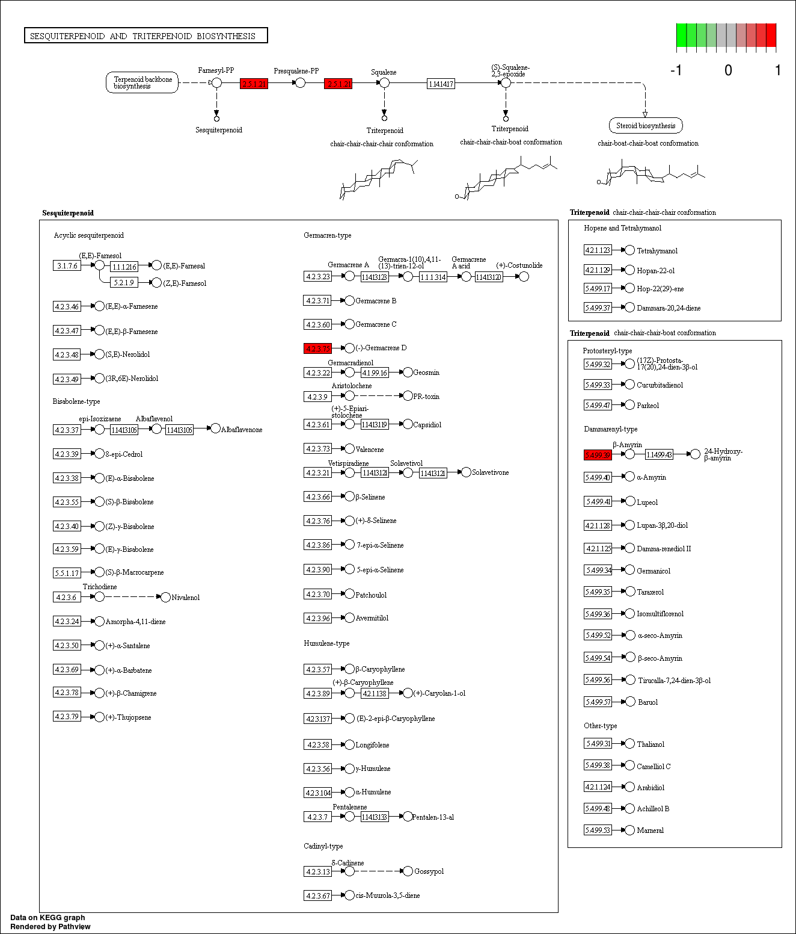

Supplementary Figure S11. Visualization of terpenoid pathway branches that were identified as significantly enriched in flowers versus stems of F. assafoetida. F. assafoetida transcripts significantly mapped to sesquiterpenoid biosynthesis are highlighted in red.

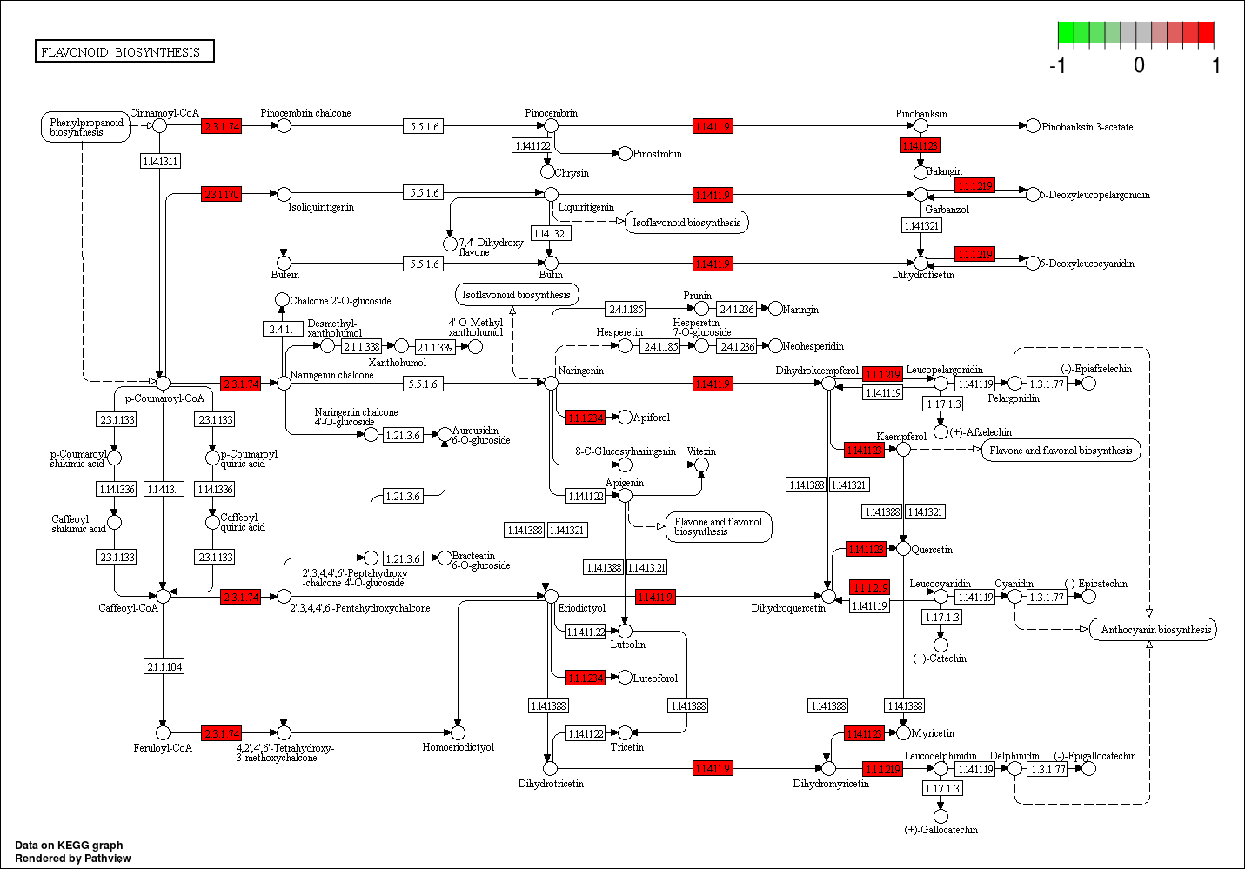Supplementary Figure S12. Visualization of phenylpropanoid pathway branches that were identified as significantly enriched in flowers versus stems of F. assafoetida. F. assafoetida transcripts significantly mapped to phenylpropanoid and flavonoid biosynthesis are highlighted in red.

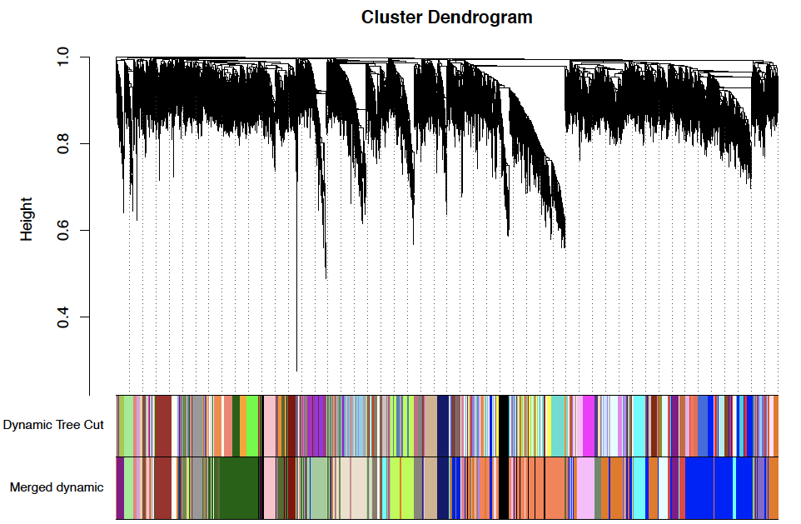

Supplementary Figure S13. Gene network of F. assafoetida was constructed using WGCNA by setting the soft power to 12, type to signed hybrid, minModuleSize to 30, dissimilarity threshold to 0.2, and deepslit to 2.

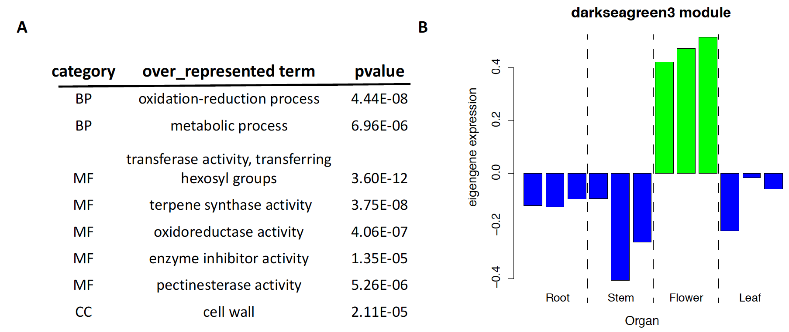
Supplementary Figure S14. Over-representation analysis (ORA) of darkseagreen3 module (A). The eigengenes expression value of darkseagreen3 module across different organs (B).

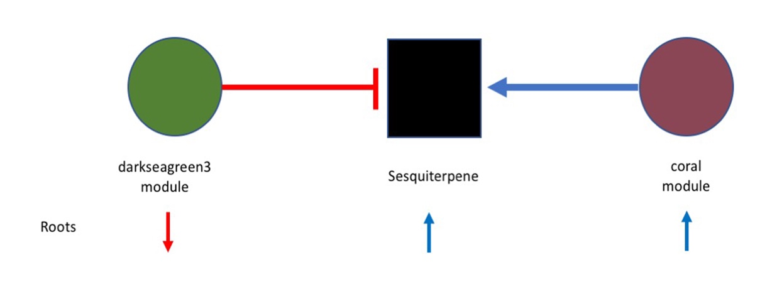
Supplementary Figure S15. The contribution of the darkseagreen3 and coral modules in sesquiterpene biosynthesis. The co-expression analysis indicates that the darksagreen3 module is negatively correlated with production of sesquiterpene in roots while the coral module is positively correlated with production of sesquiterpene.

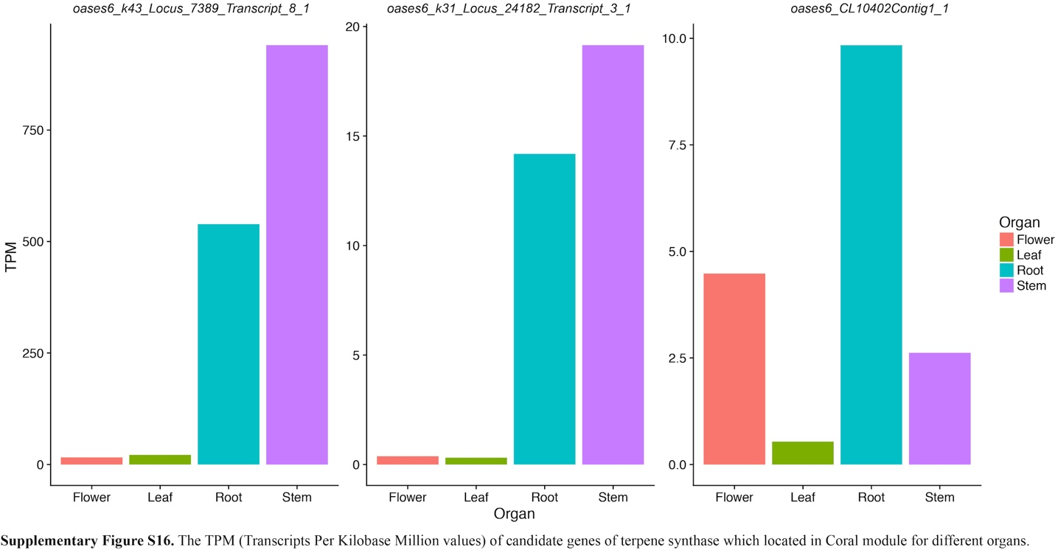
Supplementary Figure S16. The TPM (Transcripts Per Kilobase Million values) of terpene synthase candidate genes located in the coral module for different organs.

REFERENCES
Adams, R. P., 2012 Identification of Essential Oils by Ion trap Mass Spectroscopy. Academic Press Available at: https://www.elsevier.com/books/identification-of-essential-oils-by-ion-trap-mass-spectroscopy/adams/978-0-12-044230-0.
Benjamini, Y., and Y. Hochberg, 1995 Controlling the false discovery rate - a practical and powerful approach to multiple testing. J. R. Stat. Soc. Series B. Stat. Methodol. 57: 289–300. Available at: ://A1995QE45300017.
Cabau, C., F. Escudié, A. Djari, Y. Guiguen, J. Bobe et al., 2017 Compacting and correcting Trinity and Oases RNA-Seq de novo assemblies. PeerJ 5: doi:10.7717/peerj.2988.
Crusoe, M. R., H. F. Alameldin, S. Awad, E. Boucher, A. Caldwell et al., 2015 The khmer software package: enabling efficient nucleotide sequence analysis. F1000Res 4. doi:10.12688/f1000research.6924.1.
Grabherr, M. G., B. J. Haas, M. Yassour, J. Z. Levin, D. A. Thompson et al., 2011 Full-length transcriptome assembly from RNA-Seq data without a reference genome. Nature Biotech. 29: 644–652. doi:10.1038/nbt.1883.
R Core Team, 2016 R: A language and environment for statistical computing. R Foundation for Statistical Computing. Available at: https://www.R-project.org/.
Robinson, M. D., and A. Oshlack, 2010a A scaling normalization method for differential expression analysis of RNA-seq data. Genome biol. 11: R25. doi:10.1186/gb-2010-11-3-r25.
Robinson, M. D., D. J. McCarthy, and G. K. Smyth, 2010b edgeR: a Bioconductor package for differential expression analysis of digital gene expression data. Bioinformatics 26: 139–140. doi:10.1093/bioinformatics/btp616.
Schulz, M. H., D. R. Zerbino, M. Vingron, and E. Birney, 2012 Oases: robust de novo RNA-seq assembly across the dynamic range of expression levels. Bioinformatics 28: 1086–1092. doi:10.1093/bioinformatics/bts094.
Simão, F. A., R. M. Waterhouse, P. Ioannidis, E. V. Kriventseva, and E. M. Zdobnov, 2015 BUSCO: assessing genome assembly and annotation completeness with single-copy orthologs. Bioinformatics 31: 3210–3212. doi:10.1093/bioinformatics/btv351.
Zdobnov, E. M., F. Tegenfeldt, D. Kuznetsov, R. M. Waterhouse, F. A. Simão et al., 2016 OrthoDB v9.1: cataloging evolutionary and functional annotations for animal, fungal, plant, archaeal, bacterial and viral orthologs. Nucleic Acids Res. 45: D744–D749. doi:10.1093/nar/gkw1119.
Zerbino, D. R., and E. Birney, 2008 Velvet: Algorithms for de novo short read assembly using de Bruijn graphs. Genome Res. 18: 821–829. doi:10.1101/gr.074492.107.

Corresponding authors: Email; jnmaloof@ucdavis.edu; mnaghavi@ut.ac.ir

