

**Figure S1:** Estimation of $ψ$ by MMC-ABC for three different sets of sampling timepoints, indicated by color. $ψ$ was calculated for 100 unique populations under each condition, with an average number of 487.7 sites and a diploid population of *N =* 1000. For each of the three sets of estimates at each level of $ψ$, the number of timepoints spread over 100 generations of simulation were, from left to right, 5, 11, and 21. Red circles indicate the true value of $ψ$, and blue triangles indicate the sample mean. It is clear that in most cases, five time-points is sufficient to obtain a reasonably accurate estimate of $ψ$, with 11 timepoints always providing an accurate estimate.



**Figure S2:** Estimation of $ψ$ by MMC-ABC for three different sample sizes, indicated by color. $ψ$ was calculated for 100 unique populations under each condition, with an average number of 287.6 sites. For each of the three sets of estimates at each level of $ψ$, the sample sizes were, from left to right, 25, 100, and 250. All simulated populations were sampled at 21 timepoints over 100 generations. Red circles indicate the true value of $ψ$, and blue triangles indicate the sample mean. It is clear that in most cases, a sample size of 25 is sufficient to achieve an accurate estimate of $ψ$.



**Figure S3:** Boxplot depicting the variation in estimates of $ψ$ for 500 populations. Each population was represented by a group of modern samples (simulated with ten time points spaced ten generations apart) and a single ancient DNA sample (a single time point 500 generations prior to the next time point). The true value of $ψ$ for all populations was 0.1. The average number of sites across all populations was 252, and the average number of sites with non-zero frequencies in the initial, ancient time point was 78.



**Figure S4:** Comparison of the estimation of *s* by WF-ABC and MMC-ABC for $ψ$ ranging from 0 to 0.2 for populations with 1,000 sites sampled over 21 time points spanning 100 generations and a population size of 1,000. Each panel indicates a different true value of *s* indicated by the bold horizontal line, with $s=$ 0, 0.1 0.2, 0.3, and 0.4. The true values of $ψ$ and *N* were provided to MMC-ABC, and the true value of *N* was provided to WF-ABC, as both programs rely upon the majority of sites being neutral, which is not the case in this test. All alleles began at an initial frequency of 0.1.



**Figure S5:** Boxplot for the estimation of *s* by MMC-ABC for three different sets of sampling timepoints, indicated by color, with *s* being estimated for 1,000 sites of equal selection coefficients and the true values of $ψ=0.1$ and $N=1000$ provided to MMC-ABC (as accurate estimation of $ψ$ relies upon the majority of sites being selectively neutral). For each of the three sets of estimates at each level of $s$, the number of timepoints spread over 100 generations of simulation were, from left to right, 5, 11, and 21. Red circles indicate the true value of $s$, and blue triangles indicate the sample mean. It is clear that in most cases, five timepoints is sufficient to get a reasonably accurate estimate of $s$, with 11 timepoints always providing a reasonably accurate estimate.



**Figure S6:** Boxplot for estimation of $s$ from MMC-ABC for three different sample sizes, indicated by color, with *s* estimated for 1,000 sites of equal selection coefficients and the true values of $ψ=0.1$ and $N=1000$ being provided to MMC-ABC (as accurate estimation of $ψ$ relies upon the majority of sites being selectively neutral). For each of the three sets of estimates at each level of $s$, the sample sizes were, from left to right, 25, 100, and 250. All simulated populations were sampled at 21 timepoints over 100 generations. Red circles indicate the true value of $s$, and blue triangles indicate the sample mean.

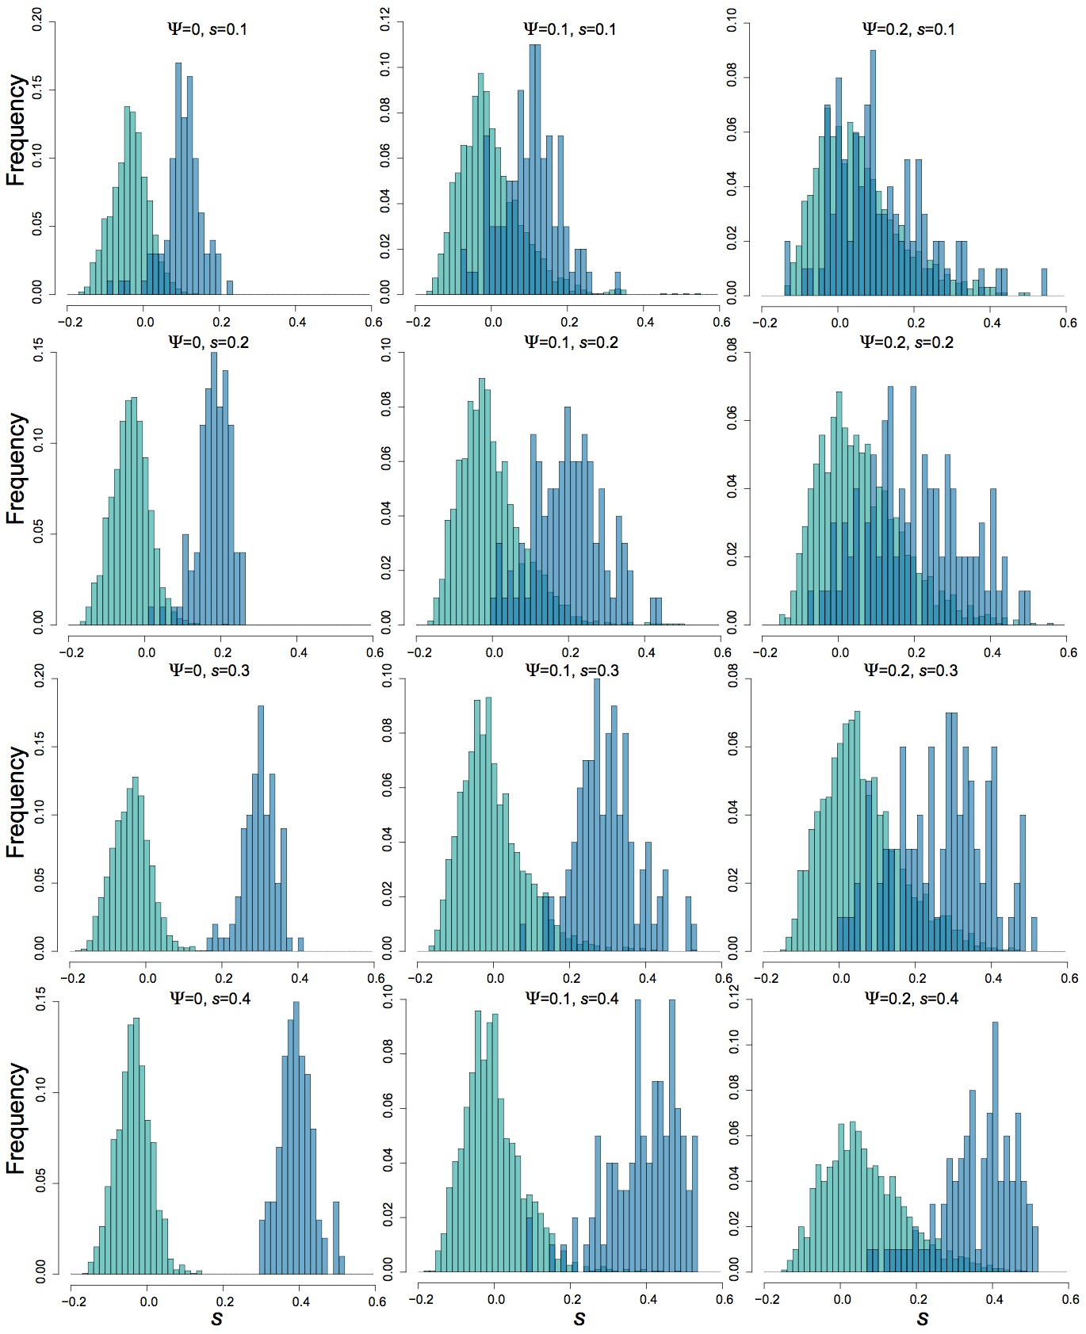

**Figure S7:** Each panel depicts the estimates of *s* by MMC-ABC for a single population with 1900 neutral sites and 100 sites under selection with *s =* 0.1, 0.2, 0.3, or 0.4, with $ψ$ = 0, 0.1, or 0.2 (indicated at the top of each panel), and with *N* = 1,000. *N* was estimated over a uniform prior ~U[250,2,000], $ψ$ was estimated over a uniform prior ~U[0,0.3], and *s* was estimated over a uniform prior ~U[-0.2,0.6]. Note that we display the relative frequencies for estimated values of *s* for each class of mutation, for which there are unequal numbers of total sites. These results can be directly compared with the estimation of *s* for the same populations by WF-ABC in Fig. S8.

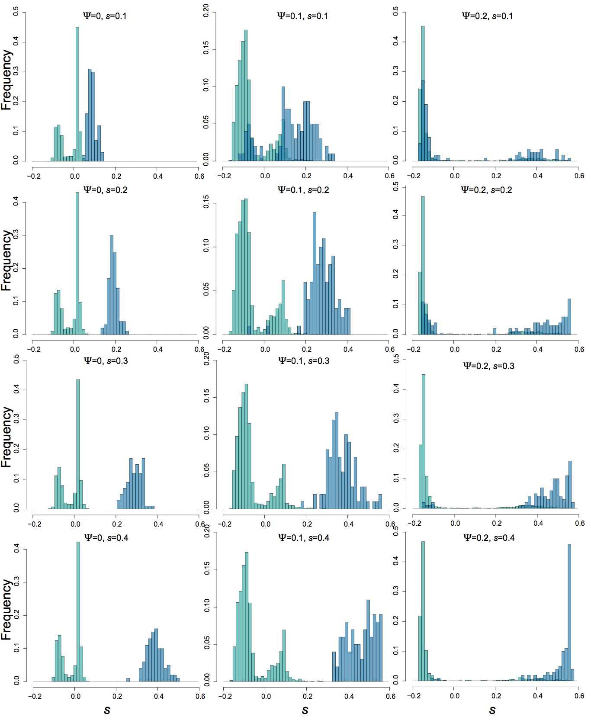

**Figure S8:** Each panel depicts the estimates of *s* by WF-ABC for a single population with 1900 neutral sites and 100 sites under selection with *s =* 0.1, 0.2, 0.3, or 0.4, with $ψ$ = 0, 0.1, or 0.2 (indicated at the top of each panel), and with *N* = 1,000. *s* was estimated over a uniform prior ~U[-0.2,0.6]. Note that we display the relative frequencies for estimated values of *s* for each class of mutation, for which there are unequal numbers of total sites. These results can be directly compared with the estimation of *s* for the same populations by MMC-ABC in Fig. S7.

**Table S1:** Summary of all beneficial mutations identified with WF-ABC by Foll *et al*. 2014a, with mutations also identified as beneficial by MMC-ABC in bold.

|  |  |  |  |  |  |  |  |
| --- | --- | --- | --- | --- | --- | --- | --- |
|  | Seg. | Pos. | Substitution-type | Initial frequency | Final frequency | WF-ABC *s* estimates  (99% HPDIs) | MMC-ABC *s* estimates  (99% HPDIs) |
| Control 1 | PB1 | 1119 | Syn. | 0.01% | 38.8% | 0.06 (0.01,0.11) | 0.04 (-0.15,0.38) |
|  | **HA** | **1395** | **Non-syn.** | **0.03%** | **92.5%** | **0.12 (0.05,0.19)** | **0.14 (0.06,0.21)** |
|  | NP | 1104 | Syn. | 0.02% | 81.1% | 0.05 (0.00,0.11) | 0.12 (-0.06,0.3) |
|  | NP | 1396 | Non-syn. | 0.03% | 56.1% | 0.09 (0.03,0.15) | 0.05 (-0.1,0.22) |
| Control 2 | **HA** | **1211** | **Non-syn.** | **0.04%** | **100.0%** | **0.20 (0.08,0.35)** | **0.23 (0.15,0.32)** |
|  | NS | 820 | Syn. | 0.08% | 59.5% | 0.06 (0.01,0.12) | 0.11 (0.0,0.19) |
| Osel 1 | PB1 | 33 | Syn. | 0.03% | 39.6% | 0.14 (0.06,0.25) | 0.11 (-0.04,0.23) |
|  | **PA** | **2194** | **Syn.** | **1.4%** | **36.7%** | **0.09 (0.02,0.17)** | **0.11 (0.05,0.18)** |
|  | **HA** | **48** | **Syn.** | **0.1%** | **92.3%** | **0.14 (0.06,0.27)** | **0.16 (0.05,0.24)** |
|  | **HA** | **1395** | **Non-syn.** | **0.06%** | **99.9%** | **0.22 (0.08,0.34)** | **0.27 (0.13,0.42)** |
|  | **NA** | **582** | **Syn.** | **0.02%** | **98.3%** | **0.29 (0.15,0.45)** | **0.43 (0.28,0.56)** |
|  | **NA** | **823** | **Non-syn.** | **0.04%** | **99.5%** | **0.15 (0.06,0.24)** | **0.18 (0.08,0.28)** |
|  | M | 147 | Non-syn. | 0.04% | 84.2% | 0.08 (0.01,0.15) | 0.05 (-0.1,0.15) |
|  | NS | 820 | Syn. | 0.03% | 51.7% | 0.12 (0.04,0.20) | 0.03 (-0.2,0.37) |
| Osel 2 | PB1 | 326 | Non-syn. | 0.02% | 27.3% | 0.06 (0.01,0.12) | 0.04 (-0.2,0.34) |
|  | PA | 2194 | Non-syn. | 1.4% | 37.4% | 0.07 (0.01,0.13) | 0.06 (-0.11,0.41) |
|  | HA | 1211 | Non-syn. | 0.04% | 87.6% | 0.12 (0.05,0.20) | 0.06 (-0.13,0.24) |
|  | NP | 301 | Non-syn. | 3.8% | 92.9% | 0.06 (0.01,0.12) | -0.02 (-0.19,0.51) |
|  | **NA** | **823** | **Non-syn.** | **0.04%** | **90.3%** | **0.27 (0.12,0.48)** | **0.26 (0.13,0.42)** |
|  | M | 92 | Non-syn. | 4.0% | 96.8% | 0.06 (0.01,0.12) | 0.05 (-0.18,0.42) |

**Table S2:** Comparison of *s* estimation for WF-ABC and MMC-ABC under skewed offspring distributions. The column on the left details the parameters for the simulated data. The first number gives the selection coefficients for 1,000 simulated trajectories. The second number gives the number of time points of data for each trajectory, evenly spaced over 100 total generations. The final number gives the sample size for each site at each time point. Sites were classified as being significantly beneficial or deleterious at the level *p* = 0.01 if the equal-tailed 100(1-*p*) posterior interval excluded zero, with all either sites being classified as neutral. $ψ$ = 0.1 for all simulations. When offspring skew is moderately strong, WF-ABC classifies a large proportion of neutral mutations as being beneficial or deleterious.

|  |  |  |  |  |  |  |
| --- | --- | --- | --- | --- | --- | --- |
|  | WF-ABC | | | MMC-ABC | | |
|  | Deleterious | Neutral | Beneficial | Deleterious | Neutral | Beneficial |
| [0.0, 5, 250] | 397 | 428 | 175 | 0 | 980 | 20 |
| [0.0, 11, 250] | 386 | 467 | 147 | 0 | 995 | 5 |
| [0.0, 21, 25] | 3 | 987 | 10 | 0 | 992 | 8 |
| [0.0, 21, 100] | 65 | 880 | 55 | 0 | 989 | 11 |
| [0.0, 21, 250] | 269 | 619 | 121 | 1 | 995 | 4 |
| [0.2, 5, 250] | 0 | 4 | 996 | 0 | 81 | 919 |
| [0.2, 11, 250] | 0 | 6 | 994 | 0 | 241 | 759 |
| [0.2, 21, 25] | 0 | 195 | 805 | 0 | 771 | 229 |
| [0.2, 21, 100] | 0 | 13 | 987 | 0 | 609 | 391 |
| [0.2, 21, 250] | 0 | 12 | 988 | 0 | 522 | 478 |