Supplementary Information
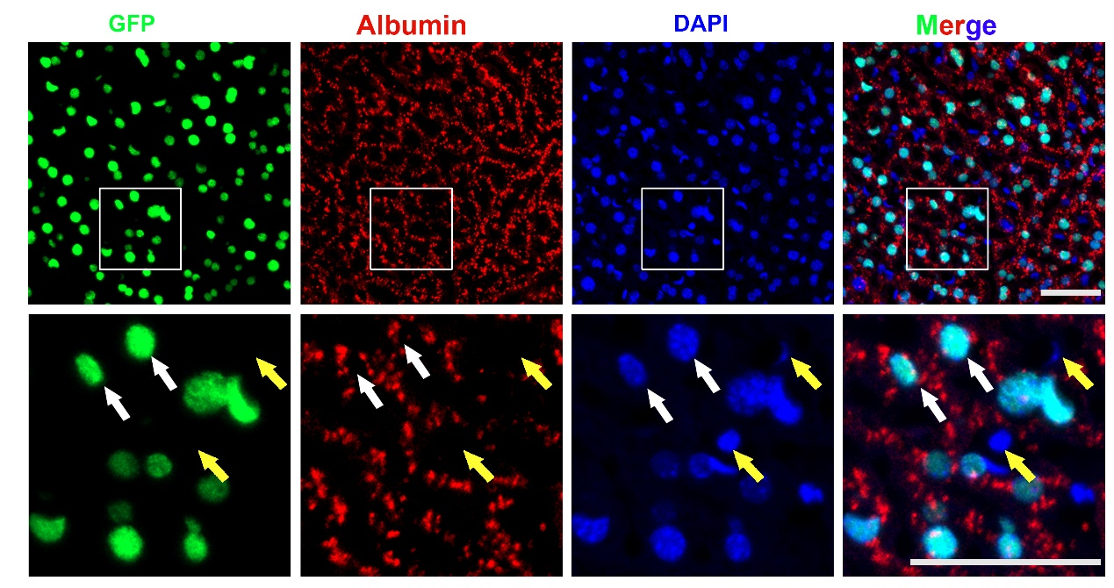
Figure S1. Double immunostaining for H2BGFP and albumin in the livers of H11-albumin-rtTA/TetO-H2BGFP transgenic mice that were treated with 1 mg/ml Dox for two days. Enlarged images in boxed areas are shown below the original images. White arrows show representative GFP and albumin double staining positive cells; yellow arrows show representative GFP and albumin negative cells. GFP staining (green); albumin staining (red); DAPI nuclear counterstaining of DNA (blue). Scale bar: 50 μm.
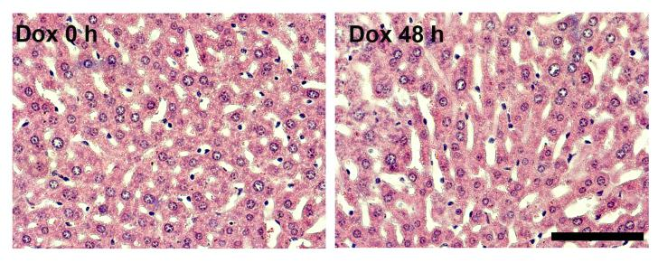
Figure S2. Liver dissected from H11 albumin-rtTA/TetOH2BGFP double-transgenic mice treated for 0 h (left panel) or 48 h with 1 mg/ml Dox (right panel) were analyzed by HE staining. Scale bar: 20 μm.
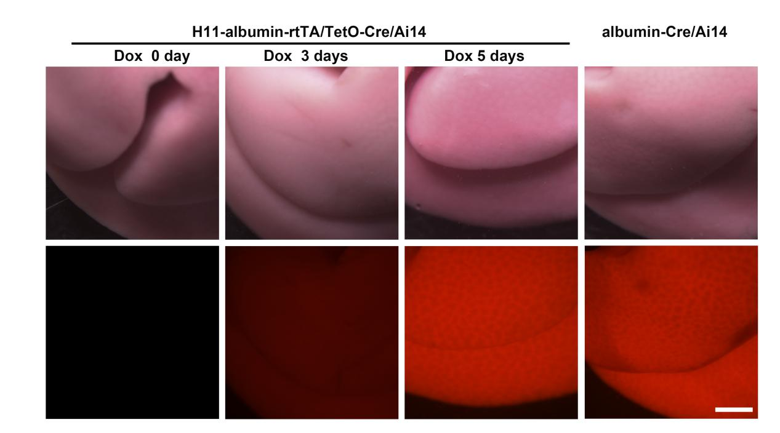
Figure S3. Light images (top panels) and whole mount fluorescence microscopy (bottom panels) images of the tdTomato protein in the H11-albumin-rtTA/TetO-Cre/Ai14 triple-transgenic mice that were treated for 0, 3, or 5 days with 1 mg/ml Dox, as well as in the albumin-Cre/A14 mice. Scale bar: 2 mm.

Plasmid element | Primer sequence 5’ -3’ | Amplicon
H11 left HR-F | TACGACTCACTATAGGGCGAATTGTGGGCCTTGCCAAATGGTTT | 1371bp
H11 left HR-R | GAAAACTGAGAGAAGCAGAAGCTGATAAGTGCACTAGTGTTCCT
albumin-F | AAGGAACACTAGTGCACTTATCAGCTTCTGCTTCTCTCAGTTTTC | 2241bp
albumin-R | TTGCTCTTGTCCAGTCTAGACATCCCGGGGTTGATAGGAAAGGT
rtTA-advanced-F | CACCTTTCCTATCAACCCCGGGATGTCTAGACTGGACAAGAGCAA | 747bp
rtTA-advanced-R | TGGCTGGCAACTAGAAGGCACAGTTACCCGGGGAGCATGTCAAG
BGH-polyA-F | F:CCTTGACATGCTCCCCGGGTAACTGTGCCTTCTAGTTGCCAGCCA | 225bp
BGH-polyA-R | ACCACTGTTGGCTCAGCAGACACCCATAGAGCCCACCGCATCCCC
H11 right HR-F | GGGGATGCGGTGGGCTCTATGGGTGTCTGCTGAGCCAACAGTGG | 1377bp
H11 right HR-R | ACTAAAGGGAACAAAAGCTGGCTTACAGCCAAAGACTTTTTCTCC
sgRNA | GAACACTAGTGCACTTATCCTGG
Table S1.Sequences of donor plasmid H11-albumin-rtTA construction primers

Name | Primer Sequence 5’ -3’ | Amplicon
Up-F1 | CGTACCAGCCAAAGGAGCAGC | 1484bp
Up-R1 | GTGGAGCAATGTTGGTAGGG
Down-F2 | GCCTTCCTTTTCGGCCTG | 1891bp
Down-R2 | GGCATAGTCTACCACATCCACTGAGG
Table S2. Sequences of H11-albumin-rtTA transgenic mouse genotyping primers
Mice genotyping | Primer sequence 5’ -3’
Albumin-Cre-F | GATGGCAAACATACGCAAGGGAT
Albumin-Cre-R | TTCTTGCGAACCTCATCACTC
TetO-Cre-F | TGCTGTTTCACTGGTTATGCGG
TetO-Cre-R | TTGCCCCTGTTTCACTATCCAG
TetO-H2BGFP-F | AAGTTCATCTGCACCACCG
TetO-H2BGFP-R | TCCTTGAAGAAGATGGTGCG
Ai14-F | GGCATTAAAGCAGCGTATCC
Ai14-R | CTGTTCCTGTACGGCATGG
H11-albumin-rtTA-F | CAGCCTTCCTTTTCGGCCTG
H11-albumin-rtTA-R | GGCATAGTCTACCACATCCACTGAGG
Table S3. Sequences of transgenic mouse genotyping primers

qPCR | Primer sequence 5’ -3’
H2BGFP-F | AGTGCTTCAGCCGCTACC
H2BGFP-R | GAAGATGGTGCGCTCCTG
Gapdh-F | AAGCCCATCACCATCTTCCAG
Gapdh-R | AGGGGCCATCCACAGTCTTCT

Table S4. Sequences of qRT-PCR primers

