Supplementary Information

**This section includes:**

Supplementary text

Figs. S1 to S7

Tables S1 to S2

Captions for movies S1 S2

References for SI reference citations

**Other supplementary materials for this manuscript include the following:**

Movies S1 to S2

Supplementary Information Text

*Quantification of nuclear localization*

Nuclear localization has been quantified using various heuristics: pairwise spatial distance summed over the top 10 brightest pixels in individual cells (Lin *et al.* 2015) or using the median intensity of the 10 (or 15 for diploids) brightest pixels in the cell (Hansen *et al.* 2015). We found that the values of nuclear fluorescence obtained using these approaches were sensitive number of pixels chosen and was not comparable between cells in the same confocal field, due in part to spatial variation in image signal. Another approach to quantify pulses is using a two-state HMM (Corrigan *et al.* 2016), but because our model makes qualitative predictions about the shapes of pulses, we did not want to introduce assumptions about the distribution of intensities in the nuclear pulses.

We therefore developed a new generative model to quantify nuclear localization by fitting a mixture of a Gaussian (to model background cytoplasm) and a uniform (to model the distribution of pixel intensity in the nucleus). In using a uniform distribution to model the nuclear intensities, we are assuming that they are different that the cytoplasm, but we make no assumptions about the shape of the distribution. Because the nucleus is not visible in every cell, (when there is no localization pulse) we use a hidden indicator variable to represent this uncertainty, and weight each pixel both by the posterior probability that it is a nuclear pixel, and whether the nucleus is actually visible in the cell image.

More formally, we model the pixel intensities, X, as having been generated from the model

$$P\left(X\right)=P\left(Y=1\right)\prod_{i}{P\left(X_{i} | Y=1\right)}+P\left(Y=0\right)\prod_{i}{P\left(X_{i} | Y=0\right)}$$

Where i indexes the pixels within a cell and Y is a hidden variable that represents whether the nucleus is visible (Y = 1) or invisible (Y = 0) in a particular single cell image. $P\left(Y=1\right)$ and $P\left(Y=0\right)$ are prior probabilities summarizing our beliefs about how often the nucleus will be visible. Since we had no specific prior information, we set these to be ½. In the case where the nucleus is visible, the probability of a pixel’s intensity is given by a two-component mixture model

$$P\left(X_{i} | Y=1\right)=P\left(X_{i} | Z=1,Y=1\right)P\left(Z=1\right)+P\left(X_{i} | Z=0,Y=1\right)P\left(Z=0\right)$$

$$P\left(X_{i} | Y=1\right)=U(X_{i})0.2+N\left(X_{i} | μ,σ\right)0.8$$

This corresponds to the assumption that if the nucleus is visible, the pixels are modeled as a mixture of a Uniform distribution, $U\left(X_{i}\right)= 1/(\max\left(X\right)-min⁡(X))$, for the nuclear pixels (Z=1) and a Gaussian distribution, $N\left(X_{i} | μ,σ\right)$, for the cytoplasmic pixels (Z=0). $P\left(Z=1\right)$ and $P\left(Z=0\right)$ are priors on the hidden indicator variable Z, which determines if a pixel is nuclear or cytoplasmic. Since the cells in our images have approximately 20% of their area taken up by the nucleus, we set the prior probability of being a nuclear pixel to 0.2, while the prior probability of being a cytoplasmic pixel is 0.8. In the case where the nucleus is not visible, we assume that all pixel intensities are drawn from the same Gaussian distribution $P\left(X_{i} | Y=0\right)=N\left(X_{i} | μ,σ\right)0.2+N\left(X_{i} | μ,σ\right)0.8=N\left(X_{i} | μ,σ\right)$. We note that our model does not assign any pixel to the cytoplasm or nucleus, nor does it require that exactly 20% of pixels reside in the nucleus. These types of “soft” assignments allow us to include prior biological knowledge, but develop a method that is insensitive to the exact choice of 20% or assignments of pixels to variable cell compartments.

To quantify nuclear localization, we use the expected nuclear intensity, which is the average intensity of pixels weighted by the (posterior) probability of whether the nucleus is actually visible in that particular image P(Y=1), whether they are actually in the nucleus P(Z=1|Y,X).

$$E\left[nuc. int.\right]=P\left(Y=1 | X\right)×\frac{\sum_{i}{P\left(Z_{i}=1 | Y=1,X_{i}\right)X_{i}}}{\sum_{i}{P\left(Z_{i}=1 | Y=1,X_{i}\right)}}+P\left(Y=0 | X\right)×\frac{\sum_{i}{P\left(Z_{i}=1 | Y=0,X_{i}\right)X_{i}}}{\sum_{i}{P\left(Z_{i}=1 | Y=0,X_{i}\right)}}$$

To compute the posterior probabilities, we use Bayes Theorem to obtain

$P\left(Y | X\right)=\frac{P(X|Y)P(Y)}{P(X)}=\frac{P(X|Y)\frac{1}{2}}{\sum_{Y∈\left\{0,1\right\}}{P\left(X | Y\right)\frac{1}{2}}}=\frac{\prod_{i}{P(X_{i}|Y)}}{\sum_{Y∈\left\{0,1\right\}}{\prod_{i}{P(X_{i}|Y)}}}$ and $P\left(Z_{i}=1 | Y,X_{i}\right)=\frac{P\left(X_{i} | Y,Z_{i}=1\right)P(Z=1)}{P(X_{i}|Y)}$

Where $P\left(X_{i} | Y\right)$ s are given above. We note that when the nucleus is not actually visible,

$P\left(Z=1 | Y=0,X_{i}\right)=\frac{N\left(X_{i} | μ,σ\right)0.2}{N\left(X_{i} | μ,σ\right)}=0.2$, such that data doesn’t tell us anything about which pixels are in the nucleus and the posterior is equal to the prior. Therefore,

$$E\left[nuc. int.\right]=P\left(Y=1 | X\right)×\frac{\sum_{i}{P\left(Z_{i}=1 | Y=1,X_{i}\right)X_{i}}}{\sum_{i}{P\left(Z_{i}=1 | Y=1,X_{i}\right)}}+P\left(Y=0 | X\right)×\frac{\sum_{i}{X_{i}}}{\sum_{i}{1}}$$

Thus, our measure smoothly varies between the average intensity of all the pixels in the image and the average of the pixels that deviate strongly from the cytoplasmic distribution. The unknown parameters of the model are $μ,σ$ which we estimate for each cell for each image using Expectation-Maximization, which, in practice, converges within 10 iterations for typical images. Using the posterior probabilities for the hidden variables computed above, the update equations for the M-step are (See Appendix for derivation):

$$μ= \frac{\sum_{i}{X_{i}\left(1-P\left(Y=1 | X\right)P\left(Z=1 | Y=1,X_{i}\right)\right)}}{\sum_{i}{\left(1-P\left(Y=1 | X\right)P\left(Z=1 | Y=1,X_{i}\right)\right)}}$$

$$σ=\sqrt{\frac{\sum_{i}{{(X_{i}-μ)}^{2}(1-P\left(Y=1 | X\right)P\left(Z=1 | Y=1,X_{i}\right))}}{\sum_{i}{(1-P\left(Y=1 | X\right)P\left(Z=1 | Y=1,X_{i}\right))}}}$$

*Derivation of M-step*

To derive the update equations for the M-step, we use the complete likelihood of the pixel intensities X, which is the likelihood of intensities if we knew whether each pixel $X_{i}$ is nuclear ($Z_{i}=1$) or cytoplasmic ($Z_{i}=0$) and whether the nucleus is visible (Y=1) or invisible (Y=0),

$$CL={(\frac{1}{2}P(X|Y=1))}^{Y}{(\frac{1}{2}P(X|Y=0))}^{1-Y}$$

$$CL={(\prod_{i}{{(U(X_{i})0.2)}^{Z_{i}}{(N\left(X_{i} | μ,σ\right)0.8)}^{1-Z_{i}}})}^{Y}{(\prod_{i}{N\left(X_{i} | μ,σ\right)})}^{1-Y}$$

We can take the complete likelihood logarithm and expectation over the hidden indicator variables

$$E[logCL]=E[Y]\sum_{i}{(E[Z_{i}]\log\left(0.2U\left(X_{i}\right)\right)+\left(1-E\left[Z_{i}\right]\right)\log{({0.8N\left(X_{i} | μ,σ\right)}}))+(1-E[Y])\sum_{i}{logN\left(X_{i} | μ,σ\right)}}$$

so we can solve $\frac{∂}{∂θ}E[logCL] =0$ and optimize the complete log-likelihood.

In the case $θ=μ$, we obtain

$$\frac{∂E[logCL]}{∂μ}=E\left[Y\right]\sum_{i}{\left(1-E\left[Z_{i}\right]\right)\frac{∂}{∂μ}(log{N\left(X_{i} | μ,σ\right)+log0.8)}+(1-E[Y])\sum_{i}{\frac{∂}{∂μ}logN\left(X_{i} | μ,σ\right)}}=0$$

Since $\frac{∂}{∂μ}logN\left(X_{i} | μ,σ\right)= \frac{X_{i}-μ}{σ}$,

$$\frac{∂E[logCL]}{∂μ}= E\left[Y\right]\sum_{i}{\left(1-E\left[Z_{i}\right]\right)\frac{X_{i}-μ}{σ}+(1-E[Y])\sum_{i}{\frac{X_{i}-μ}{σ}}}=0$$

So

$$μ=\frac{\sum_{i}{X_{i}(1-E[Y]E[Z_{i}])}}{\sum_{i}{(1-E[Y]E[Z_{i}])}}$$

Where $E\left[Y\right]=P\left(Y=1 | X\right)$ and $E\left[Z_{i}\right]= P\left(Z_{i}=1 | Y=1,X_{i}\right)$, which are the posterior probabilities given above.

In the case $θ=σ$, because $\frac{∂}{∂σ}logN\left(X_{i} | μ,σ\right)= \frac{{(X_{i}-μ)}^{2}-σ^{2}}{σ^{3}}$, we obtain

$$\frac{∂E[logCL]}{∂σ}= E\left[Y\right]\sum_{i}{\left(1-E\left[Z_{i}\right]\right)\frac{{(X_{i}-μ)}^{2}-σ^{2}}{σ^{3}}+(1-E[Y])\sum_{i}{\frac{{(X_{i}-μ)}^{2}-σ^{2}}{σ^{3}}}}=0$$

$$\frac{∂E[logCL]}{∂σ}= \sum_{i}{\left(1-E\left[Z_{i}\right]E\left[Y\right]\right)\frac{{(X_{i}-μ)}^{2}-σ^{2}}{σ^{3}}}=0$$

So

$$σ= \sqrt{\frac{\sum_{i}{{(X_{i}-μ)}^{2}\left(1-E\left[Z_{i}\right]E\left[Y\right]\right)}}{\sum_{i}{\left(1-E\left[Z_{i}\right]E\left[Y\right]\right)}}}$$

*Time delay model*

Crz1 State-transitions

To model Crz1 localization we suppose Crz1, which we denote as X, can exist in 4 states, either in the nucleus $X_{N}$, in the cytoplasm, $X_{C}$, during the process of nuclear export $T_{}^{e}$, or during the process of nuclear import $T_{}^{i}$. To model the relatively slow processes of export and import, the process of import is composed by *n* states $T_{1}^{i},T_{2}^{i} ,…,T_{n}^{i}$ and process of export is composed by *n* states $T_{1}^{e},T_{2}^{e} ,…,T_{n}^{e}$.

The processes when a Crz1 molecule is imported into the nucleus are $$X_{C}\underset{→}{R_{C}(Cn\left(t\right))}T_{1}^{i}, T_{j}^{i}\underset{→}{R_{T}}T_{j+1}^{i}, T_{n}^{i}\underset{→}{R_{T}}X_{N}, 1≤j<n$$ 
where $R_{C}(Cn\left(t\right))$ is the calcineurin dependent initiation rate of import, $R_{T}$ is the calcineurin independent rate of transport, and *n* is the total number of states in the process of transport.

The processes when a Crz1 molecule is being exported from the nucleus are $$X_{N}\underset{→}{R_{T}}T_{1}^{e}, T_{j}^{e}\underset{→}{R_{T}}T_{j+1}^{e},T_{n}^{e}\underset{→}{R_{T}}X_{C}, 1≤j<n$$  
where we parsimoniously assume the initiation rate of export have the same reaction rate of the rest of the states in export, $R_{T}$.

Since we treat the model in discrete time, the transition probabilities are the rates of each reaction. For example, $R_{T}$ is the probability of a transition between one transport state and the next, meaning a Crz1 molecule changes from $T_{j}^{i}$ to $T_{j+1}^{i}$, $i≤n-1$, with probability $R_{T}$ in each discrete timestep and the probability to remain in $T_{i}^{i}$ is ${1-R}_{T}$. $R_{C}$ is the initiation probability of import that depends on calcineurin activity. We assume $R_{C}(Cn\left(t\right))=d×min{[Cn\left(t\right),1]}$,where *d* is the probability for an active calcineurin to dephosphorylate Crz1 and is assumed as 1 for simplicity. In our simulations (see below) Cn(t) never exceeded 1.

The transition probability matrix of $2(n+1)×2(n+1)$ for the discrete time Markov chain at time *t* is

$$P\left(t\right)=\left[\begin{matrix}\begin{matrix}1-R_{C}\left(Cn\left(t\right)\right) & R_{C}\left(Cn\left(t\right)\right) & … \\ & {1-R}_{T} & \\ ⋮ & & ⋱\end{matrix} & \begin{matrix} \\ \\ ⋮\end{matrix} \\ R_{T} & \begin{matrix}… & {1-R}_{T}\end{matrix}\end{matrix}\right]$$

Stochastic Simulations

We simulate the states of 500 Crz1 molecules ($n_{Crz1}$ =500) and define the nuclear signal of Crz1at time *t, ${Cz}_{N}\left(t\right)$,* as the average over the simulations of Crz1 in the second half of import, in the nucleus, and in the first half of export, ${Cz}_{N}\left(t\right)≡average[{ X}_{N}+\sum_{j=\frac{n}{2}}^{n}{{T^{i}}_{j}}+ \sum_{j=1}^{\frac{n}{2}}{{T^{e}}_{j}}]$ 
.

All Crz1 molecules are in the state $X_{C}$ as the initial condition. The increment of time is defined as 1 second. Parameters of the model are given in table S2. A Crz1 pulse is defined as a peak with minimal prominence of 0.25.

*Logistic pulse fitting*

Current methods that quantify pulse width in time series data include: exponential regression on autocorrelation function (Cai *et al.* 2008), which does not quantify width at single pulse level; estimation of time difference between two data points that are at half of the pulse height (e.g., MATLAB function findpeaks), which provides single pulse quantification but presumes one pulse returns to the baseline before the next pulse; analytic solution of an exponential function to fit single pulse, which approach assumes asymmetrical pulse shapes(Neuert *et al.* 2013) and did not fit well to our Crz1 data. To estimate single pulse width when two symmetrical pulses may overlap each other, we developed a least squares method to fit an analytic pulse of the form: $X\left(t\right)= a\frac{{re}^{-r\left(t-t_{0}\right)}}{({1+e^{{-r(t-t}_{0})})}^{2}}$ 
 ,  
which we refer to as a “logistic pulse” because it corresponds to the derivative of the logistic function. The pulse is symmetric, as the increasing and decreasing part of *X* before and after time $t_{0}$ is identical.

The maximum of the logistic pulse is $\left(t_{0}\right)= \frac{ar}{4}$, and $t_{0}$ can be found with a peak-finding function. We estimate the two remaining free parameters *a* and *r* by minimizing sum of squared error, which is $sse= \sum_{t}{{(Z\left(t\right)-X(t))}^{2}}=\sum_{t}{{(Z\left(t\right)-a\frac{{re}^{-r\left(t-t_{0}\right)}}{({1+e^{{-r(t-t}_{0})})}^{2}})}^{2}}$ 
,  
where $Z\left(t\right)$ is the experimental data for, in our case, a Crz1 pulse. To minimize *sse*, we take the partial derivative with respect to *a* and solve $\frac{∂sse}{∂a}=0$. We obtain $\frac{∂sse}{∂a} = \sum_{t}{-2\frac{{re}^{-r\left(t-t_{0}\right)}}{({1+e^{{-r(t-t}_{0})})}^{2}}×(Z\left(t\right)-a\frac{{re}^{-r\left(t-t_{0}\right)}}{({1+e^{{-r(t-t}_{0})})}^{2}})}$  
 =0  
giving the function relating *r* to *a* as $a= \frac{\sum_{t}{Z\left(t\right)\frac{{re}^{-r\left(t-t_{0}\right)}}{({1+e^{{-r(t-t}_{0})})}^{2}}}}{\sum_{t}{{(\frac{{re}^{-r\left(t-t_{0}\right)}}{({1+e^{{-r(t-t}_{0})})}^{2}})}^{2}}}$ 
.   
By using this function to constrain *a*, parameter search needs to be only done for *r*, and we used MATLAB function fminsearch and initial value 1. Each Crz1 pulse was identified between two local minima and was required to contain at least 5 data points across the local maximum (2 minutes).



Fig. S1. Cross-correlation between cytoplasmic calcium and Crz1 nuclear localization under different external calcium concentration shows a correlation between the two dynamics. Solid lines are the mean unbiased correlation of Crz1 pulsing cells with calcium burst (red lines), Crz1 pulsing cells without calcium burst (blue lines), and cells without calcium burst and Crz1 pulse (yellow lines). Shaded area shows 95% CI under Normal distribution of the average trace. See methods for details of definition of pulses.

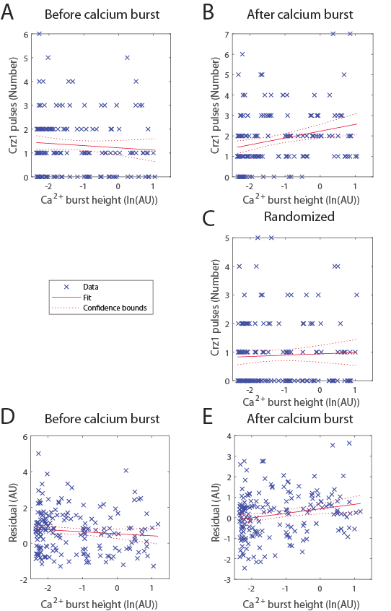

Fig. S2. Linear regression reveals a positive correlation between calcium burst height and number of Crz1 pulses after calcium bursts. A) Crz1 pulses counted before calcium bursts do not show correlation. R-squared = 0.0062, slope = -0.09, p > 0.3, n =135. B) Crz1 pulses counted after calcium bursts show positive correlation. R-squared = 0.0634, slope = 0.33, p= 0.0017, n =135. C) Crz1 pulses counted from randomized cells do not show correlation. R-squared = 0.0017, slope = 0.05, p > 0.6, n =135. The length of time between two calcium bursts is positively correlated to the number of observed Crz1 pulses with a slope, *st*, such that *st* = 0.00047 for Crz1 pulses before calcium bursts (p<10-3, n =135) and *st* = 0.0012 for Crz1 pulses after calcium bursts (p<10-11, n =135). In D) and E), residuals are calculated by reducing each number of Crz1 pulses by the product of *st* and the length of time between the two calcium bursts. D) No correlation between the residual of pulse number before calcium bursts and calcium burst height is observed. R-squared = 0.0101, slope = -0.112, p >0.1, n =135. E) The residual for pulse number after calcium bursts still shows positive correlation to calcium burst height. R-squared = 0.0438, slope = 0.22, p < 0.005, n =135.

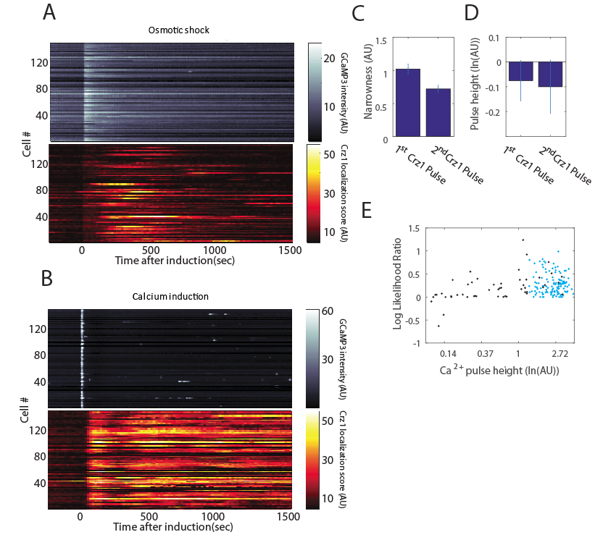

Fig. S3. Nifedipine treated cells responding to calcium shock show similar properties of Crz1 nuclear localization dynamics after calcium bursts to untreated cells at steady state. Heat maps in A) and B) show the dynamics of [Ca2+]­cyt (upper heat map)and Crz1 nuclear localization (lower heat map) when nifedipine is maintained at 200µm in the media. A) 0.4M sodium chloride was added into the media after 5 minutes to induce osmotic shock of approximately 6.1 Pa. A well-characterized increase in [Ca2+]cyt occurs (Denis and Cyert 2002) and the dynamics of [Ca2+]cyt and Crz1 nuclear localization return to baseline within 25 min. B) 0.2M calcium chloride is added to the media after 5 minutes. These cells had been previously incubated for 30 minutes in 0.4M sodium chloride so that osmolality is maintained after calcium addition (at approximately 6.5Pa). A synchronized calcium burst (white dots on the upper heat map where time is 0 sec) occurs in each cell, which is followed by a synchronized Crz1 nuclear localization (red/yellow pattern on the lower heat that initiates after 0 sec). Stochastic calcium bursts (white dots on the upper heat map where time is larger than 500 sec) are only found after the addition of calcium chloride, and not during the incubation with sodium chloride. The data from this experiment is used in the analysis reported in panels C-E. C) The second Crz1 pulse is less narrow than the first Crz1 pulse (paired t-test, p<10-13, n = 108, median R2 = 0.83 for logistic pulse fitting (see methods)). D) The second Crz1 pulse is not significantly shorter than the first Crz1 pulse (paired t-test, p>0.05, n = 108, median R2 = 0.83 for logistic pulse fitting (see methods)). E) The Crz1 dynamics after calcium bursts are better explained by a periodic Gaussian process model (mean LLR = 0.17, one-sample t-test, p<10-10, n = 108). Each blue/ black dot represents a Crz1 trajectory following a calcium burst from nifedipine treated/untreated cell, respectively.

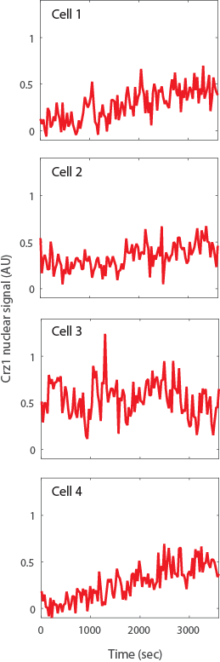

Fig. S4. Crz1 pulses are found when protein synthesis is inhibited. Four examples from an experiment where 0.2M CaCl2 and 0.05 µg/ml cycloheximide were added at t = -1800 sec.



Fig. S5. A conformational switch model predicts Crz1 pulses as a result of cytoplasmic calcium concentration crossing a threshold. The dynamics of cytoplasmic calcium concentration is provided as input. A large calcium burst is generated using $Ca\left(t\right)=0.1\cos\left(\frac{t-500}{2}\right)e^{-0.01\left(t-500\right)}+0.07, 500≤t<1000$ and a smaller one using $Ca\left(t\right)=0.035\cos\left(\frac{t-1000}{2}\right)e^{-0.01\left(t-1000\right)}+0.07, 1000≤t<1500$, and $Ca\left(t\right)=0.07, t<500$ for equilibrium before pulses. Calcineurin activity and Crz1 localization are simulated with an ODE model, where parameter values and initial condition provided in reference (Cui and Kaandorp 2006).

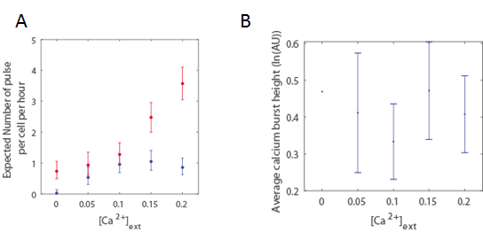

Fig. S6. Calcium burst size does not explain the increase of Crz1 pulse frequency when external calcium concentration is increased from 0.15 M to 0.2M. A) Markers represent average pulse frequency of calcium bursts (blue) and Crz1 pulses (red) with error bars show 95% CI under Poisson distribution. Frequencies of calcium bursts are not significantly different when cells are exposed to 0.15 M and 0.2 M external calcium concentrations; however, frequencies of Crz1 pulses are significantly increased (2-tailed t-test, p = 0.0025, n = 85, 56). B) Blue line shows the average size of calcium bursts under different levels of calcium stress. Error bars show 95% CI under Normal distribution (unable to estimate CI when [Ca2+]cyt = 0 because only 2 calcium bursts are found). No increase in calcium burst size is observed when the external calcium concentration is increased from 0.15M to 0.2M (2-tailed t-test, p > 0.7, n = 46, 53).

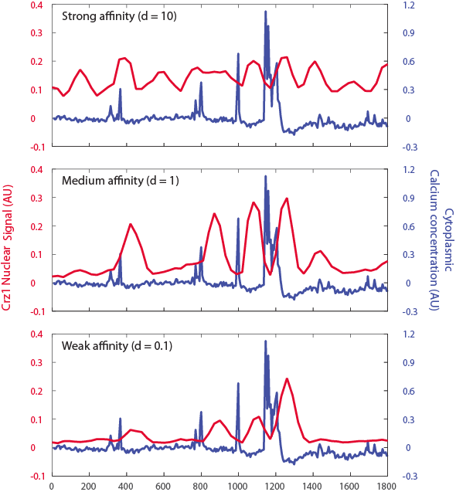

Fig. S7. Predicted Crz1 trajectories (red line) of different affinities of calcineurin binding site. The same experimental calcium trajectory (blue line) is used as the input of the time delay model, and the parameter d (see table S2) is varied to model changes in calcineurin binding affinity.

Table S1. *Statistical summaries of Crz1 pulse comparison*.

Null hypothesis is rejected only when P-value < 0.0031 to correct for multiple testing

|  |  |  |  |  |  |  |  |  |
| --- | --- | --- | --- | --- | --- | --- | --- | --- |
| Relative time to previous pulse comparing to random cell | Forward 1st Crz1 pulse (relative time to Ca2+ burst) | Forward 2nd Crz1 pulse | Forward 3rd Crz1 pulse | Forward 4th Crz1 pulse | Backward 1st Crz1 pulse (relative time to Ca2+ burst) | Backward 2nd Crz1 pulse | Backward 3rd Crz1 pulse | Backward 4th Crz1 pulse |
| t-test (means of non-random vs. random, sec) | 251.42  vs.  564.61,  p = 3.5956e-09 | 513.89  vs.  605.11,  p = 0.029374 | 474.59  vs.  528.75,  p = 0.77772 | 425.01  vs.  88.43,  p = 0.60816 | -542.97  vs.  -579.10,  p = 0.54368 | -528.63  vs.  -442.66,  p = 0.0905 | -417.30  vs.  -465.72,  p = 0.39533 | -408.02  vs.  -391.23,  p = 0.73897 |
| F-test (standard deviation of non-random vs. random, sec) | 389.02  vs.  586.64,  p = 4.5366e-08 | 384.88  vs.  649.91,  p = 2.6922e-06 | 336.79  vs.  626.08,  p = 0.0027746 | 290.21  vs.  682.29,  p = 0.032074 | 516.98  vs.  551.17,  p = 0.41689 | 438.36  vs.  338.17,  p = 0.0049406 | 318.17  vs.  406.66,  p = 0.028 | 301.84  vs.  249.99,  p = 0.14772 |
| Sample size (non-random vs. random) | 193,169 | 138,113 | 96,69 | 48,28 | 168,155 | 131,114 | 88,75 | 59,62 |

Table S2. *parameters of the time delay model*.

|  |  |  |
| --- | --- | --- |
| Parameter | Description | Value |
| $${Cn}_{base}$$ | Basal activity of phosphatase | 0.001 |
| $$D$$ | Decay rate of phosphatase activity | 0.003 |
| $$A$$ | Activation rate by calcium concentration | 0.1 |
| $$n$$ | Number of states in transport | 40 |
| $$R_{T}$$ | Probability to move into the next state in transport | 0.25 |
| $$d$$ | Probability for an active calcineurin to dephosphorylate Crz1 | 1 |
| $$n_{Crz1}$$ | Number of Crz1 molecules in transport | 500 |

Movie Captions:

Movie S1. Calcium bursts and Crz1 pulses

Movie S2. Synchronized calcium bursts and Crz1 pulses

**References**

Cai, L., C. K. Dalal, and M. B. Elowitz, 2008 Frequency-modulated nuclear localization bursts coordinate gene regulation. Nature 455: 485–490.

Corrigan, A. M., E. Tunnacliffe, D. Cannon, and J. R. Chubb, 2016 A continuum model of transcriptional bursting. eLife 5:.

Cui, J., and J. A. Kaandorp, 2006 Mathematical modeling of calcium homeostasis in yeast cells. Cell Calcium 39: 337–348.

Denis, V., and M. S. Cyert, 2002 Internal Ca(2+) release in yeast is triggered by hypertonic shock and mediated by a TRP channel homologue. J. Cell Biol. 156: 29–34.

Hansen, A. S., N. Hao, and E. K. O’Shea, 2015 High-throughput microfluidics to control and measure signaling dynamics in single yeast cells. Nat. Protoc. 10: 1181–1197.

Lin, Y., C. H. Sohn, C. K. Dalal, L. Cai, and M. B. Elowitz, 2015 Combinatorial gene regulation by modulation of relative pulse timing. Nature 527: 54–58.

Neuert, G., B. Munsky, R. Z. Tan, L. Teytelman, M. Khammash *et al.*, 2013 Systematic identification of signal-activated stochastic gene regulation. Science 339: 584–587.