Supplementary material
Fig. S1 Average genetic merit of commercial sires derived from the best performing surrogate sire strategy scenario and the conventional strategy (top 50, 200 and 500 males) for SmallScenario (a) and BigScenario(b) plotted against time

Fig. S1 Average genetic merit of commercial sires derived from the best performing surrogate sire strategy scenario and the conventional strategy (top 50, 200 and 500 males) for SmallScenario (a) and BigScenario(b) plotted against time
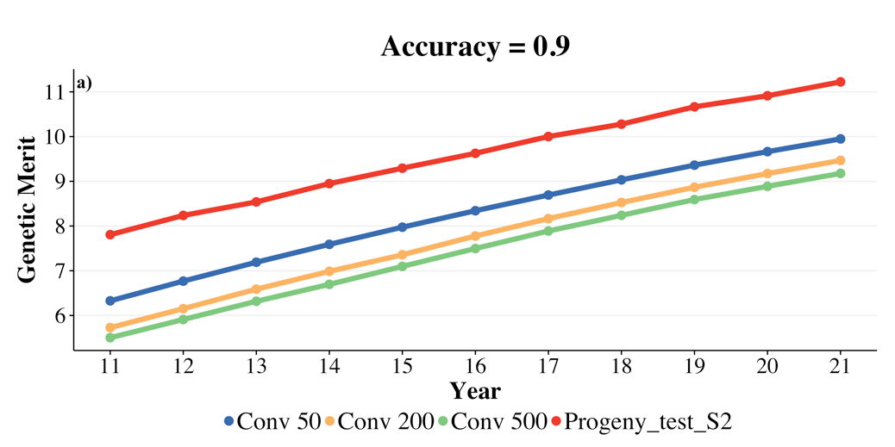 | 