SUPPLEMENTAL TABLE LEGENDS
Supplemental Table 1. Oligos. Oligos listed were used in the excecution of this paper, 5’-3’.
Primers (5' -- 3')
Forward | Reverse | Purpose
CGGAGCTGAACATCACGTTT | GTGGATTCTGTGCACGATGA | wnt4a fluorescent in situ
AGTGTTCCCCAAAAGCCTCT | GAGAAGCTGCGAGGACTCAT | uc55 and uc56 PCR ID
GCTGCAAGTTCCACTGGT | CTATGGGTGGGCGTGGTC | fh294 PCR ID
TCTGGAGGACTGTGTAAGAGGTATGC | AGACGCACAATCTTGAGAGCAG | rpl13a RT
TCTGAGTCCACACGTTTCCTG | TCTCATCCTGTGGAATTCTGTGAC | amh RT
CAGCCAGCAAGTTCAGTGAG | CGCACTTTACTCAGGCCAAT | Vasa RT
AGATGTCGAGTTAAAGATCCTGCA | CGACCGGGTGAAAACGTAGA | cyp19a1a RT
GCTCTTTCTAGCGCTCTTCTC | GTCACTGCAAATGCTACGCT | wnt4a RT-PCR
GTCAAGACCTGCTGGAAAGC | CTTGCGACACTGTTTGCATT | fh294 PCR ID
GCTGCAAGTTCCACTGGT | CTATGGGTGGGCGTGGTC | fh295 HRMA ID
CCGCAACCGCCGATGGAACT | ACCGGGCGTTCTGGGGTCAT | wnt4a color in situ
AAGGTCATGCCTCCATTCCG | AACCGCGAGGTTCCATTACA | wnt4b RT-PCR

Supplemental Table 2. Genotypic ratios of wnt4a mutants were normal. The ratio of wild-type : heterozygous : mutant was not significantly different from expected Mendelian ratios, 1:2:1, consistent with normal survival.
 | Number of Wild-types | Number of Heterozygotes | Number of Mutants | Resulting Ratio | Chi-square test
fh295 | 56 | 124 | 51 | 1 : 2.21 : 0.91 | P = 0.48
fh295 | 162 | 307 | 143 | 1 : 1.90 : 0.88 | P = 0.55
uc55 | 103 | 202 | 119 | 1 :1.96 : 1.16 | P = 0.34
uc56 | 109 | 208 | 79 | 1 : 1.91 : 0.72 | P = 0.06

SUPPLEMETNAL FIGURE LEGENDS
Supplemental Figure 1. In zebrafish gonads, wnt4a expression is female specific. RT-PCR analysis of gene expression in adult (90dpf) (A) and juvenile (30dpf) (B) gonads. The germ cell-specific gene vasa was detected in both ovaries and testes. The female-specific gene cyp19a1a was detected in only ovaries while the male-enriched gene amh was detected at slightly higher levels in testes compared to ovaries. Expression of wnt4a was only detected in ovaries, while wnt4b transcript appeared faintly in the testies. The ribosomal protein gene rpl13a is ubiquitously expressed used here as loading control. NRT, no reverse transcriptase control.

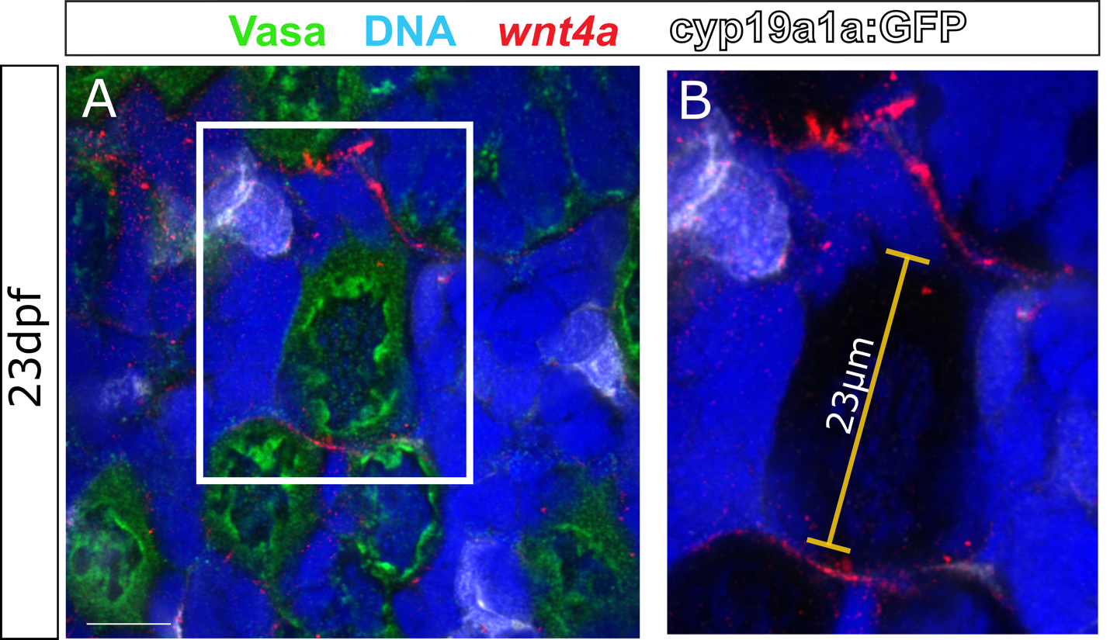
Supplemental Figure 2. wnt4a is expressed in somatic cells that surround stage IB oocytes in 23dpf female zebrafish. A. Confocal micrographs showing wnt4a RNA-expressing somatic gonadal cells (red) are closely associated with Vasa-expressing (green) oocytes. Wnt4a does not appear to be expressed in theca cells, which express Tg(cyp19a1a:egfp) (white, n=3). Red staining that overlaps with white was consistent with the background staining see throughout the tissue. B. In a simplified magnified view outlined in A, wnt4a localizes to the somatic cells adjacent to an oocyte with a diameter of 23µm. Expression of wnt4a is found consistently in somatic cells of stage IB oocytes that are >20µm in diameter. Nuclei are stained blue. Scale bar in A, 10µm).

Supplemental Figure 3. CRISPR/Cas9 mutant allele generation. wnt4a(uc55) and wnt4a(uc56) were both generated by targeting the highlighted sequence (red) of Exon two. Mutagenesis resulted in 17bp (uc55) or 23bp (uc56) insertions (bold), PAM sequence (underlined).

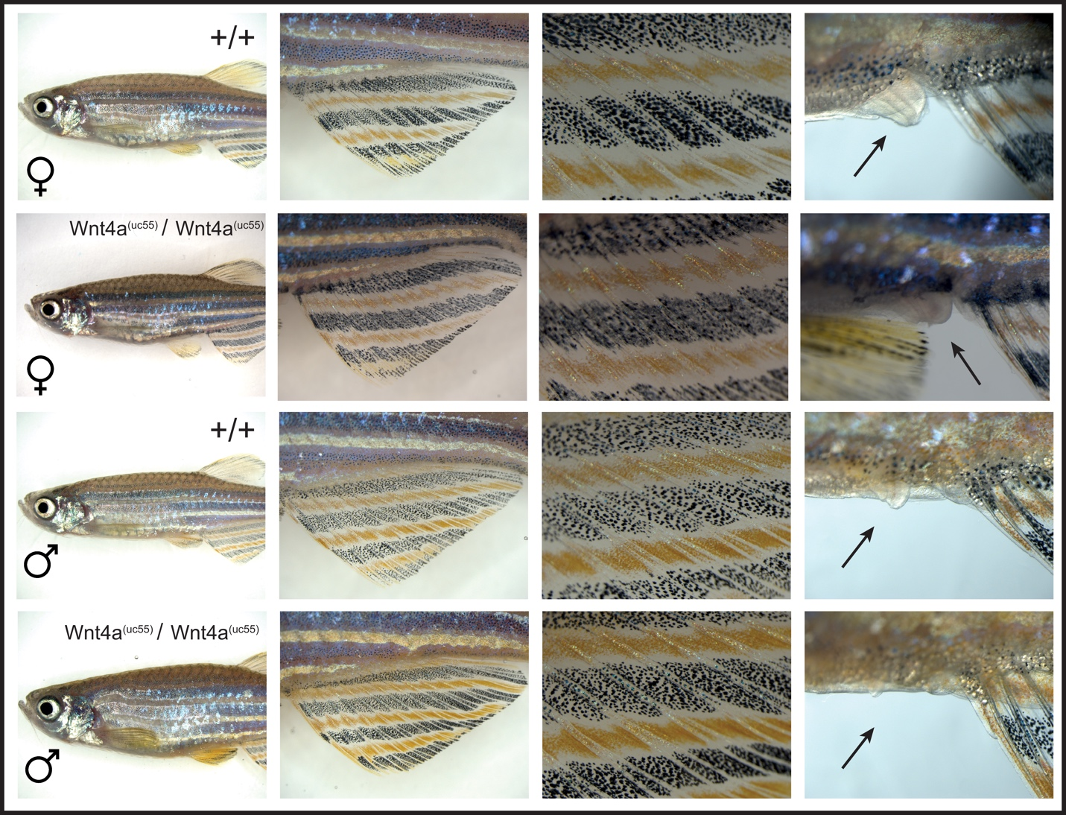
Supplemental Figure 4. wnt4a mutant fish have normal secondary sexual characteristics. Light micrograph pictures showing that the pigment patterns and body shapes of wnt4a(uc55) mutant females and males (B-B’” and D-D’”, respectively) are indistinguishable from their wild-type female and male siblings (A-A’” and C-C’”, respectively). Panels A-D compare of body shapes. B’-D’ and B”-D” are low and high magnification views, respectively, of anal fin pigmentation. Note that males have more yellow pigmentation than females. A’”-D’” show high magnification views of the genital orifice. Note that the genital orifice of females protrudes from the ventral body wall, while those of male do not (black arrow).

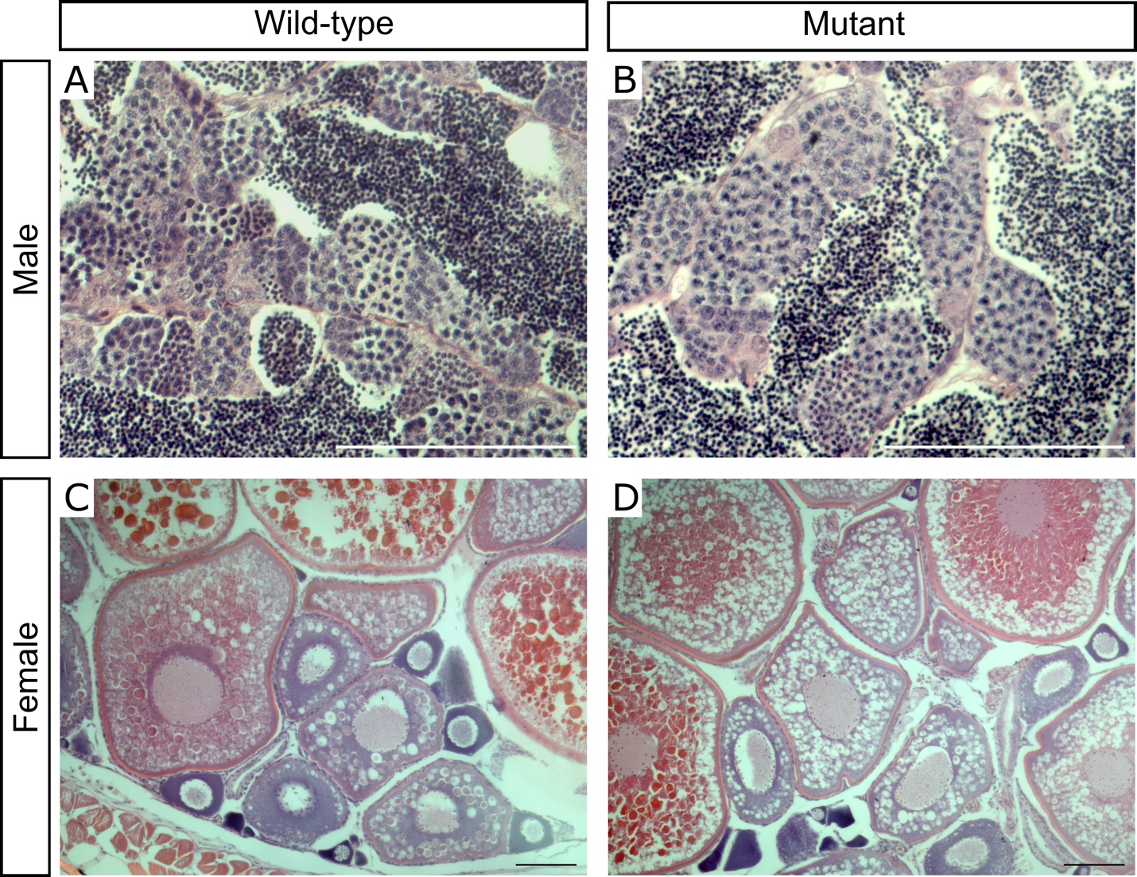
Supplemental Figure 5. wnt4a mutant zebrafish have normal mature gonads. Wild-type males (A) and wnt4a mutant males (B) at 90dpf both have all stages of spermatogenesis and are indistinguishable. Similarly, wild-type females (C) and wnt4a mutant females (D) have all stages of oogenesis and are indistinguishable. Scale: 1mm

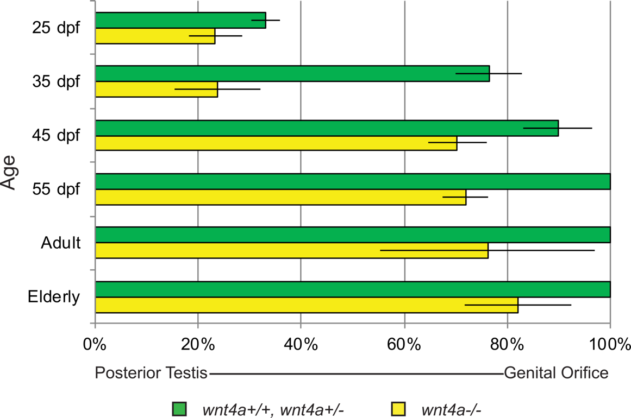
Supplemental Figure 6. Growth of the male zebrafish reproductive duct over time. Males were measured for duct elongation as a percentage of the distance between the posterior end of the testis and the genital orifice. Males were collected from 25dpf through 55dpf including adults and elderly (about 2 years old) for reference. Wild-type and wnt4a heterozygous males (green) had fully elongated reproductive ducts by 55dpf, while ducts in wnt4a mutants (yellow) never fully connected to the genital orifice.

Supplemental File 1. 3D renderings of the male reproductive ducts. WT male (left) develop a fused duct deferens which is absent in the mutant (right).

Supplemental File 2. 3D renderings of the female reproductive ducts. WT female (left) develop a complete oviduct which fails to connect to the genital orifice in the mutant (right).

