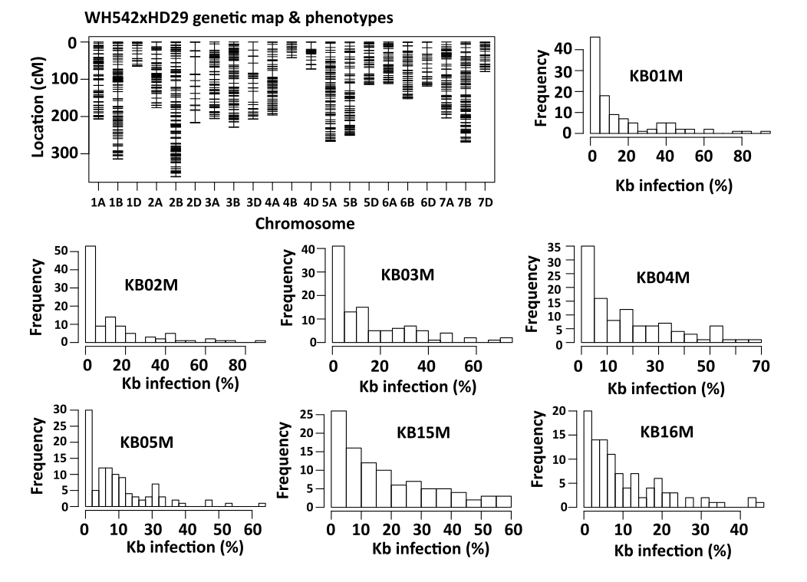
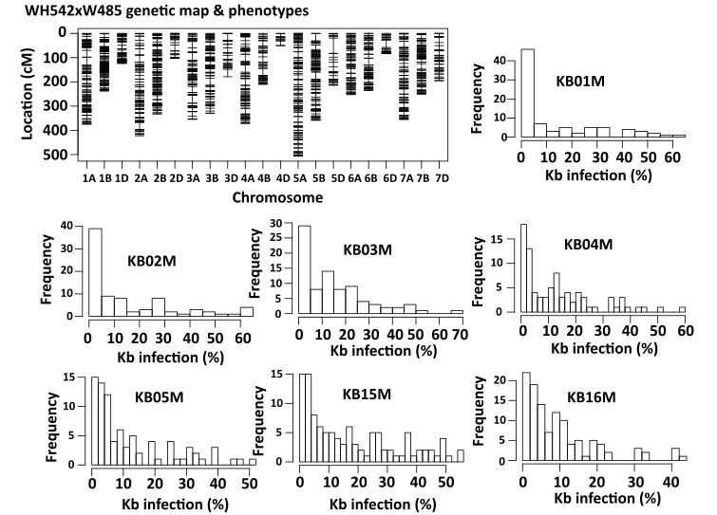

Fig. 1S. Genetic linkage map and phenotypic distribution of percent Karnal bunt infected grains in two wheat recombinant inbred line populations (WH542×HD29 and WH542×W485).

