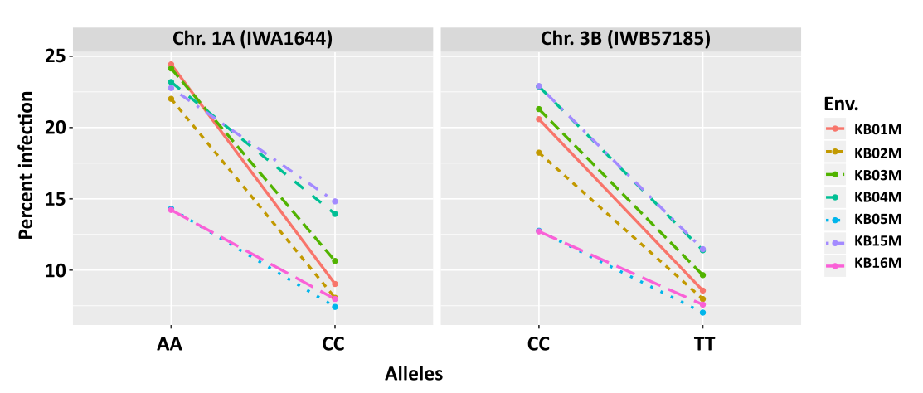

Fig. 2S. Allele effects of two QTL detected for Karnal bunt resistance in the WH542×HD29 population. Allele effects were analysed across seven environments.

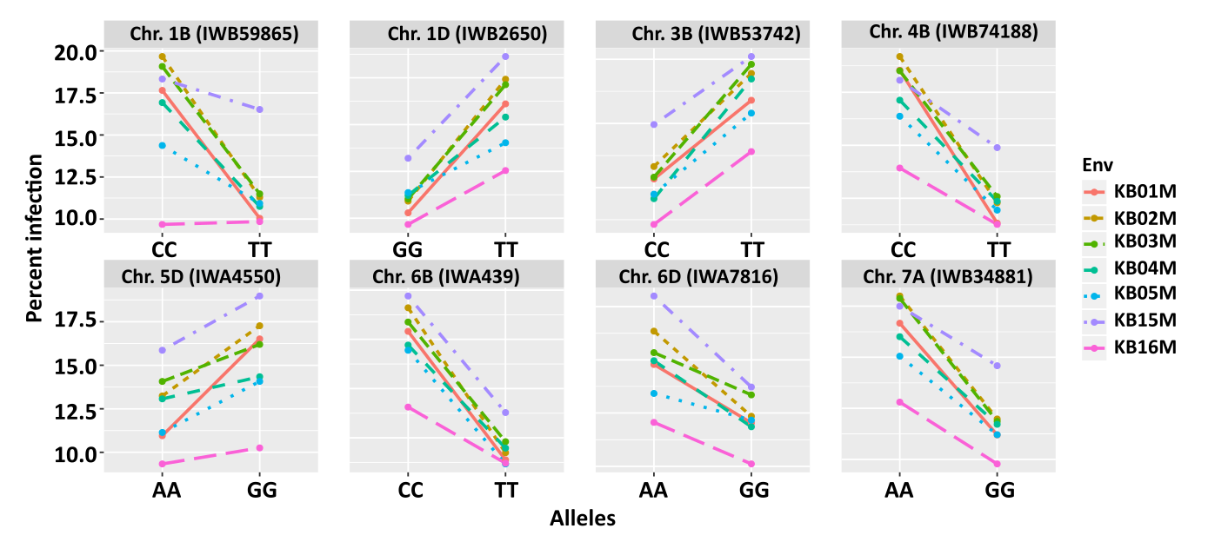

Fig. 3S Allele effects of eight QTL detected for Karnal bunt resistance in the WH542×W485 population. Allele effects were analysed across seven environments.

