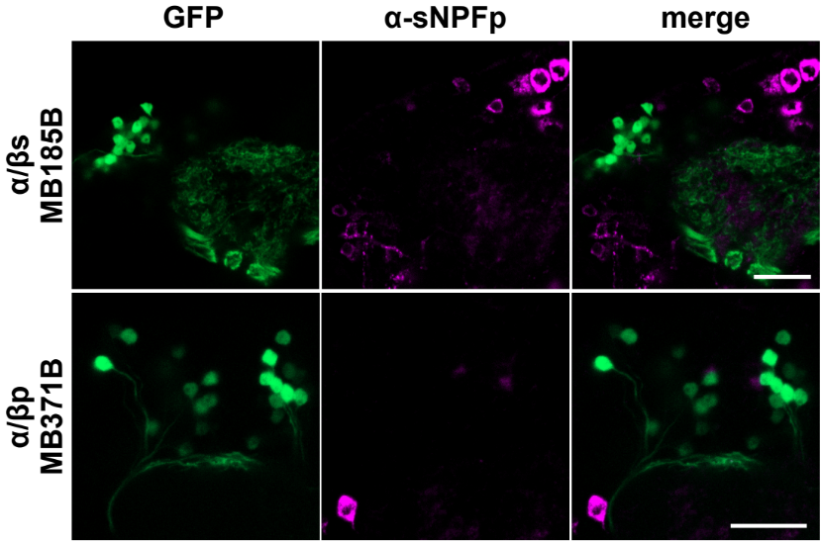
Figure S3. No detectable anti-sNPFp immunoreactivity in the cell bodies of either the MB α/βs or α/βp subtypes. Scale bars represent 20μm. Expression patterns of the split-GAL4 lines were reported by P{10XUAS-IVS-GFP-p10}attP2.

