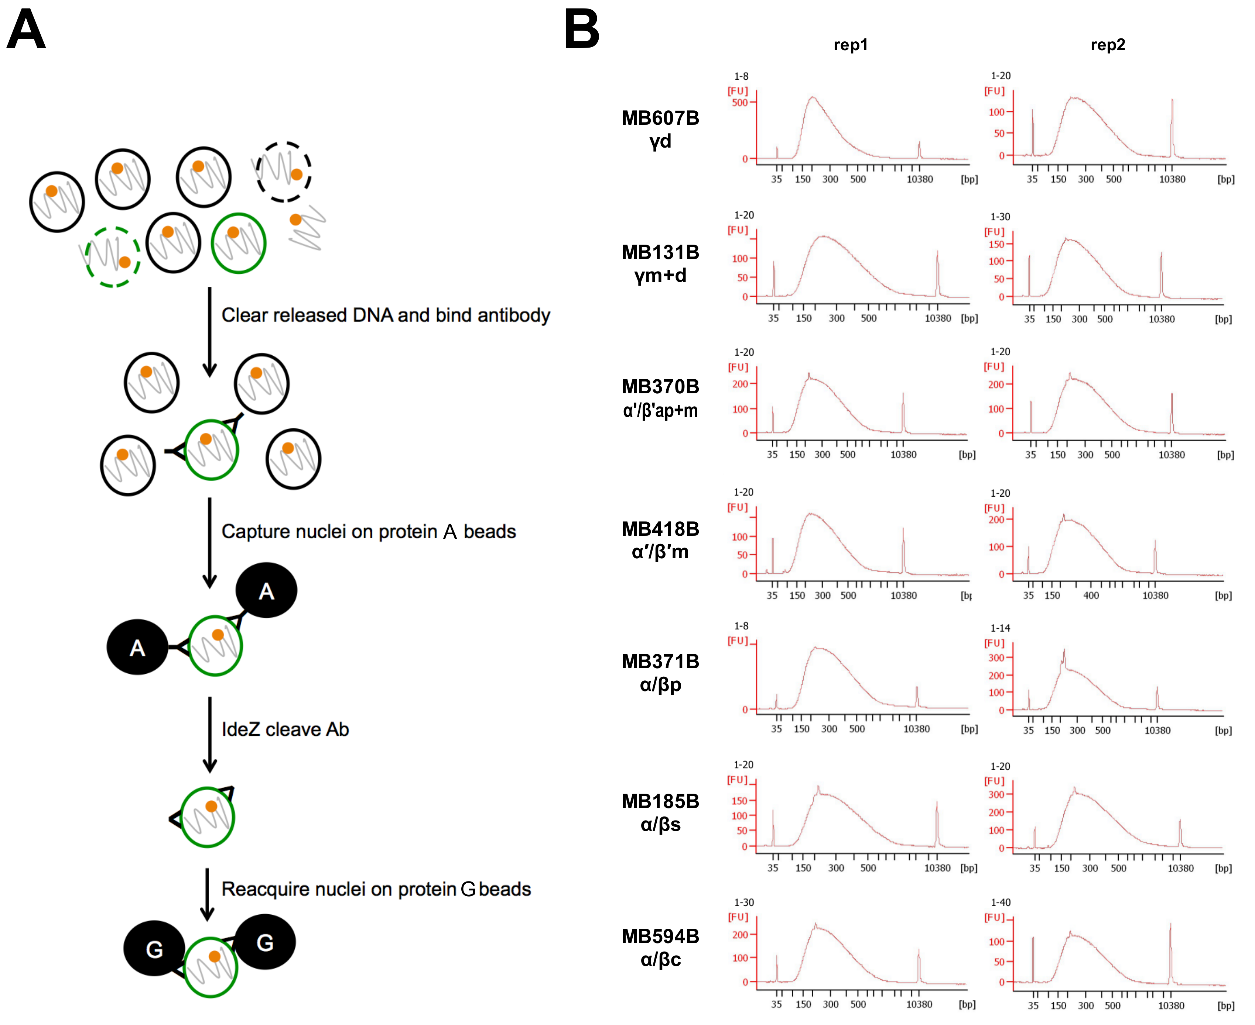
Figure S2. (A) Overview of the workflow of TAPIN purification of nuclei. (B) The molecular size distribution of amplified cDNA obtained from the 14 TAPIN-seq libraries.

