“IBD, source-sink population dynamics and dispersal facilitation by trade routes: impact on population genetic structure of a stored grain pest”

Supplementary material

Sequencing data
Table S1. Illumina HiSeq2000 output summary.
Library | Samples/lane | Density (K/mm²) | Cluster PF (%) | Phas/Prephas | Read (M) | Reads PF | % >=30 | Yield (G)
RD_5 | 80 | 846+63 | 88.12+8.87 | 0.128/0.051 | 233.94 | 205.52 | 92.3 | 20.6
RD_6 | 80 | 860+76 | 88.33+5.42 | 0.125/0.047 | 237.70 | 209.15 | 90.8 | 20.6
RD_7 | 96 | 815+50 | 85.42+6.44 | 0.138/0.041 | 225.19 | 191.71 | 90.3 | 19.2

SNP discovery and filtering strategies

Table S2. Filtering parameters used in population module of STACKS.
Input parameters | Parameter description
-min_maf 0.05 | Minimum minor allele frequency required to process a nucleotide site at a locus
--max_obs_het 0.5 | Maximum heterozygosity required to process a nucleotide site at a locus
-p 12 (100%) | Minimum number of populations a locus must be present in to process a locus
-r 0.85 (85%) | Minimum number of individuals in a population required to process a locus for that population
-m 3 | Minimum stack depth required for individuals at a locus

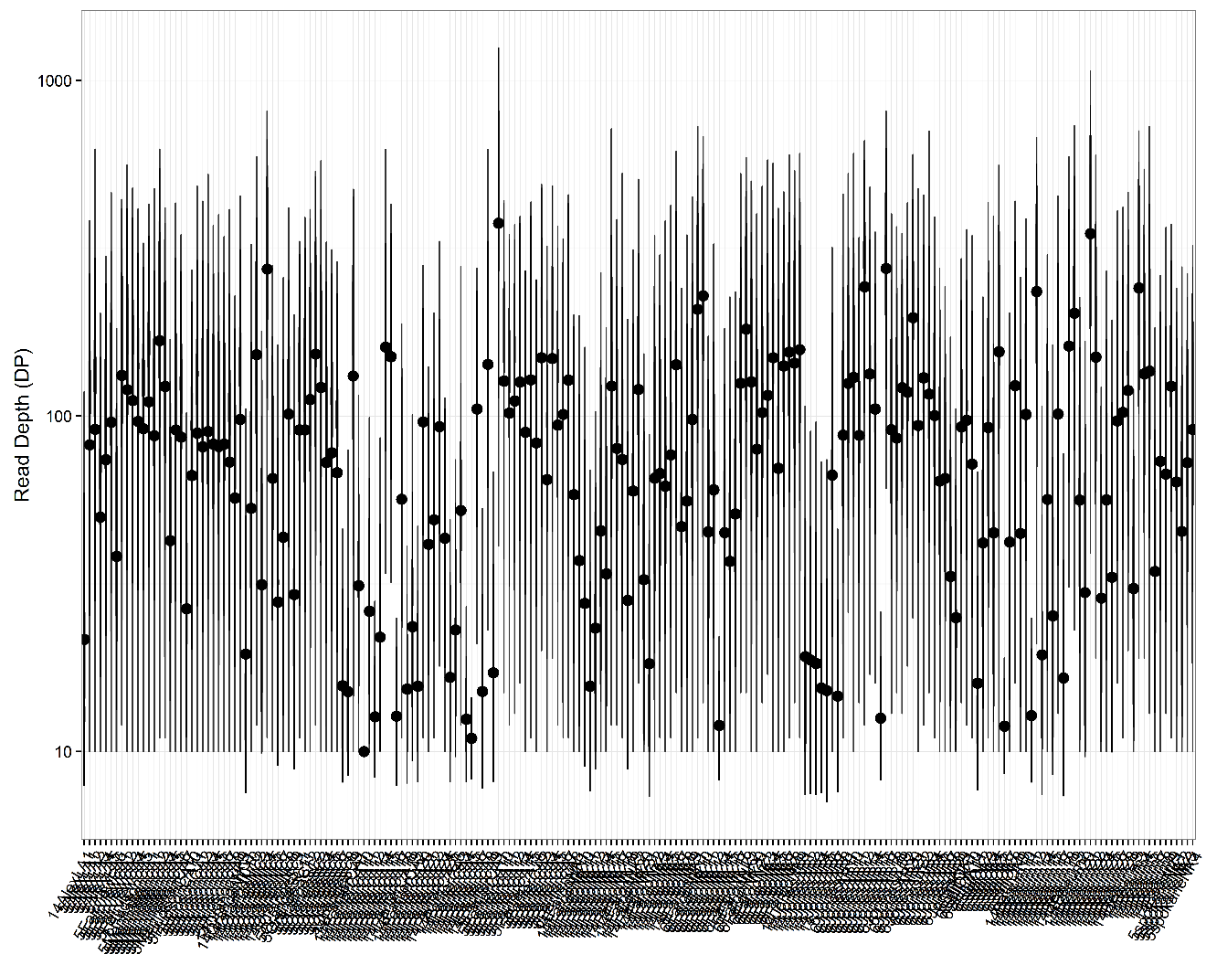
Figure S1. Depth of coverage (DP) per Rhyzopertha dominica beetle. Data refers to SNP coverage after STACKS population module filtered for minimum 10x coverage. Average coverage per individual (ID in the x axis) is 35x coverage.

Diversity

Table S3. STACKS summary statistics for each population. Variant sites are the number of sites across all population that are variant. Polymorphic sites are the number of variant sites in the current population. Parameters were calculated based on 209 beetles.
Population | Sites | Variant Sites | Polymorphic Sites | % Polymorphic Loci
LA | 95416 | 1156 | 894 | 0.9369
KS1 | 95416 | 1156 | 816 | 0.8552
KS2 | 95416 | 1156 | 895 | 0.938
KS3 | 95416 | 1156 | 1013 | 1.0617
OK | 95416 | 1156 | 1008 | 1.0564
TX | 95416 | 1156 | 1073 | 1.1245
AR | 95416 | 1156 | 1127 | 1.1811
SC | 95416 | 1156 | 1091 | 1.1434
CA | 95416 | 1156 | 1114 | 1.1675
WA | 95416 | 1156 | 681 | 0.7137
ND | 95416 | 1156 | 1137 | 1.1916

Table S4. STACKS summary statistics for each population. NI is the number of individuals sampled in this population at this site. P frequency of the most frequent allele; H₀ is the observed heterozygosity; H_{E} is the expected heterozygosity, π is an estimate of nucleotide diversity, and F_{IS} is the inbreeding coefficient of an individual (I) in relation to the subpopulation (S). Reported statistics were calculated taking in account all positions (variant and fixed) in each population. Parameters were calculated based on 209 beetles and 1156 variant sites (SUP2).
Population | NI | P | H_{O} | H_{E} | π | F_{IS}
LA | 6.9555±0.0007 | 0.9981±0.0001 | 0.0027±0.0001 | 0.0027±0.0001 | 0.0029±0.0001 | 0.0005±0.0007
KS1 | 5±0 | 0.9981±0.0001 | 0.0028±0.0001 | 0.0027±0.0001 | 0.003±0.0001 | 0.0004±0
KS2 | 6.9403±0.0008 | 0.998±0.0001 | 0.0026±0.0001 | 0.0028±0.0001 | 0.003±0.0001 | 0.001±0.0008
KS3 | 10.9443±0.0007 | 0.9979±0.0001 | 0.0028±0.0001 | 0.003±0.0001 | 0.0031±0.0001 | 0.0008±0.0007
OK | 10.2522±0.0014 | 0.998±0.0001 | 0.0027±0.0001 | 0.0029±0.0001 | 0.003±0.0001 | 0.0011±0.0014
TX | 27.4599±0.0032 | 0.998±0.0001 | 0.0026±0.0001 | 0.0028±0.0001 | 0.0029±0.0001 | 0.0008±0.0032
AR | 28.6641±0.0036 | 0.998±0.0001 | 0.0026±0.0001 | 0.003±0.0001 | 0.003±0.0001 | 0.0014±0.0036
SC | 20.3861±0.0025 | 0.998±0.0001 | 0.0029±0.0001 | 0.003±0.0001 | 0.003±0.0001 | 0.0006±0.0025
CA | 37.1424±0.0046 | 0.9981±0.0001 | 0.0024±0.0001 | 0.0029±0.0001 | 0.0029±0.0001 | 0.0019±0.0046
WA | 4±0 | 0.9981±0.0001 | 0.0027±0.0001 | 0.0025±0.0001 | 0.0029±0.0001 | 0.0003±0
ND | 40.8016±0.0034 | 0.998±0.0001 | 0.0028±0.0001 | 0.003±0.0001 | 0.0031±0.0001 | 0.0011±0.0034

Table S5. STACKS summary statistics for each population. NI is the number of individuals sampled in this population at this site. P frequency of the most frequent allele; H₀ is the observed heterozygosity; H_{E} is the expected heterozygosity, π is an estimate of nucleotide diversity, and F_{IS} is the inbreeding coefficient of an individual (I) in relation to the subpopulation (S). Reported statistics were calculated taking in account only variant positions in each population. Parameters were calculated based on 209 beetles and 1156 variant sites (SUP2).
Population | NI | P | H_{O} | H_{E} | π | F_{IS}
LA | 6.904±0.0087 | 0.8441±0.0041 | 0.2267±0.0057 | 0.2252±0.0049 | 0.2428±0.0053 | 0.0411±0.0087
KS1 | 5±0 | 0.8413±0.0043 | 0.2334±0.0064 | 0.2234±0.0052 | 0.2483±0.0058 | 0.0308±0
KS2 | 6.9083±0.0085 | 0.8358±0.0043 | 0.2171±0.0058 | 0.2327±0.0051 | 0.2509±0.0055 | 0.0823±0.0085
KS3 | 10.9144±0.0082 | 0.8291±0.004 | 0.2345±0.005 | 0.2468±0.0046 | 0.2587±0.0049 | 0.0653±0.0082
OK | 10.2327±0.0124 | 0.8375±0.0038 | 0.2188±0.005 | 0.2381±0.0046 | 0.2504±0.0048 | 0.0911±0.0124
TX | 27.2405±0.031 | 0.8389± 0.039 | 0.2186±0.0045 | 0.2345±0.0046 | 0.239±0.0047 | 0.0621±0.031
AR | 28.2128±0.0353 | 0.8348±0.0036 | 0.2177±0.0041 | 0.2461±0.0042 | 0.2506±0.0043 | 0.1141±0.0353
SC | 20.0865±0.026 | 0.8327±0.0038 | 0.2353±0.0048 | 0.2452±0.0044 | 0.2515±0.0045 | 0.0536±0.026
CA | 36.6384±0.0404 | 0.8411±0.0037 | 0.1954±0.0038 | 0.236±0.0044 | 0.2392±0.0044 | 0.1561±0.0404
WA | 4±0 | 0.8459±0.0048 | 0.2264±0.0076 | 0.2085±0.0057 | 0.2383±0.0065 | 0.028±0
ND | 40.3071±0.0358 | 0.8313±0.0036 | 0.228±0.004 | 0.2513±0.0041 | 0.2544±0.0041 | 0.0897±0.0358

Diversity differences, F_{ST} and effective migrant estimations
Table S6. Population average pairwise differences calculated in Arlequin 3.5.2.2. The above diagonal contains the average number of pairwise differences between populations (π_{XY}). The diagonal elements are the average number of pairwise differences within population (π_{X}) (grey color). The below diagonal contains the corrected average pairwise difference (π_{XY} -( π_{X} + π_{Y})/2).
 | CA | SC | ND | WA | OK | KS | TX | LA | AR
CA | 110.93646 | 126.12311 | 124.02439 | 135.27439 | 122.67738 | 130.96978 | 125.01093 | 128.79965 | 124.93008
SC | 5.75418 | 129.80139 | 133.15172 | 146.45238 | 129.66017 | 140.33126 | 130.75780 | 134.30952 | 132.05556
ND | 4.45329 | 4.14815 | 128.20575 | 143.95640 | 129.23573 | 138.48989 | 130.91259 | 136.00498 | 131.90543
WA | 9.43116 | 11.17668 | 9.47852 | 140.75000 | 141.71591 | 152.56522 | 144.63362 | 149.42857 | 144.62917
OK | 5.04032 | 2.59065 | 2.96403 | 9.17208 | 124.33766 | 136.41897 | 128.65987 | 131.79870 | 128.11364
KS | 2.91314 | 2.84216 | 1.79861 | 9.60181 | 1.66174 | 145.17681 | 138.72414 | 143.57764 | 139.13478
TX | 9.13133 | 5.44573 | 6.39834 | 13.84725 | 6.07967 | 5.72436 | 120.82275 | 134.55911 | 129.81494
LA | 5.68856 | 1.76597 | 4.25925 | 11.41071 | 1.98701 | 3.34638 | 6.50488 | 135.28571 | 134.92857
AR | 5.57061 | 3.26362 | 3.91131 | 10.36292 | 2.05356 | 2.65513 | 5.51233 | 3.39447 | 127.78249

Table S7. Population pairwise F_{ST} calculated in Arlequin 3.5.2.2. Distance method using pairwise F_{ST}’s for all pair of populations using 1156 SNPs and 209 beetles. All presented F_{ST} values had p below 0.0001.
 | CA | SC | ND | WA | OK | KS | TX | LA | AR
CA | 0
SC | 0.04763 | 0
ND | 0.03581 | 0.03129 | 0
WA | 0.08946 | 0.08203 | 0.07317 | 0
OK | 0.04426 | 0.01939 | 0.02223 | 0.07121 | 0
KS | 0.02438 | 0.02009 | 0.01386 | 0.06086 | 0.01008 | 0
TX | 0.07374 | 0.0421 | 0.04845 | 0.10829 | 0.04793 | 0.04208 | 0
LA | 0.05316 | 0.01428 | 0.03348 | 0.07774 | 0.01633 | 0.0212 | 0.05293 | 0
AR | 0.04536 | 0.0248 | 0.02964 | 0.07898 | 0.01554 | 0.01956 | 0.04243 | 0.02714 | 0

Table S8. Population average pairwise matrix of Slatkin linearized F_{ST} calculated in Arlequin 3.5.2.2.
 | CA | SC | ND | WA | OK | KS | TX | LA | AR
CA | 0.00000
SC | 0.05001 | 0.00000
ND | 0.03714 | 0.03230 | 0.00000
WA | 0.09824 | 0.08936 | 0.07895 | 0.00000
OK | 0.04631 | 0.01978 | 0.02274 | 0.07667 | 0.00000
KS | 0.02499 | 0.02050 | 0.01406 | 0.06480 | 0.01018 | 0.00000
TX | 0.07961 | 0.04395 | 0.05092 | 0.12144 | 0.05034 | 0.04393 | 0.00000
LA | 0.05614 | 0.01448 | 0.03464 | 0.08429 | 0.01660 | 0.02166 | 0.05589 | 0.00000
AR | 0.04752 | 0.02543 | 0.03054 | 0.08576 | 0.01579 | 0.01995 | 0.04431 | 0.02790 | 0.00000

Table S9. Population average pairwise matrix of M values (M=2Nm) calculated in Arlequin 3.5.2.2.
 | CA | SC | ND | WA | OK | KS | TX | LA | AR
CA | *
SC | 9.99861 | *
ND | 13.46330 | 15.47941 | *
WA | 5.08937 | 5.59513 | 6.33304 | *
OK | 10.79655 | 25.28112 | 21.98758 | 6.52106 | *
KS | 20.00844 | 24.38850 | 35.56377 | 7.71604 | 49.09897 | *
TX | 6.28081 | 11.37601 | 9.81910 | 4.11718 | 9.93240 | 11.38190 | *
LA | 8.90581 | 34.52448 | 14.43571 | 5.93192 | 30.12212 | 23.08486 | 8.94688 | *
AR | 10.52287 | 19.65977 | 16.37143 | 5.83054 | 31.66639 | 25.06022 | 11.28454 | 17.92194 | *

Structure and Harvester structure analysis

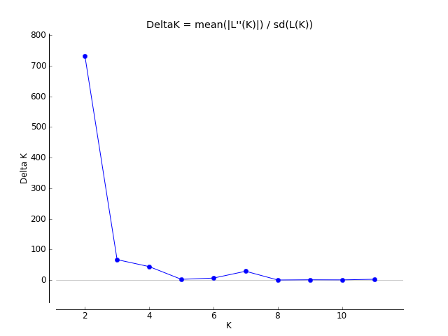
Figure S2. Putative number of populations and subpopulations. Evanno method plot shows the most likely (highest delta K) cluster number in R. dominica. Secondary peaks are putative substructure.

Table S10. Evanno method table to evaluate the most likely (highest delta K) cluster number in R. dominica.
K | Rep | Mean LnP(K) | Stdev | Ln’(K) | [Ln’’(K)] | Delta K
1 | 10 | -187751.2400 | 1.4323 | - | - | -
2 | 10 | -185294.2300 | 1.2084 | 2457.010000 | 883.810000 | 731.418529
3 | 10 | -183721.0300 | 9.5668 | 1573.200000 | 638.730000 | 66.764946
4 | 10 | -182786.5600 | 13.8387 | 934.470000 | 646.190000 | 46.694450
5 | 10 | -182498.2800 | 23.7988 | 288.280000 | 60.570000 | 2.545089
6 | 10 | -182270.5700 | 28.5986 | 227.710000 | 188.870000 | 6.604178
7 | 10 | -181853.9900 | 19.1334 | 416.580000 | 552.340000 | 28.867817
8 | 10 | -181989.7500 | 540.9750 | -135.760000 | 154.080000 | 0.284819
9 | 10 | -181971.4300 | 975.8394 | 18.320000 | 953.130000 | 0.976728
10 | 10 | -182906.2400 | 3634.1348 | -934.810000 | 2455.560000 | 0.675693
11 | 10 | -181385.4900 | 492.5526 | 1520.750000 | 1305.630000 | 2.650742
12 | 10 | -181170.3700 | 446.9182 | 215.120000 | - | -

Figure S3. Strucutre plot. Model-based clustering of 209 beetles collected in 11 locations in the United States using 1156 SNPs markers. Analysis was performed using the program STRUCTURE, with K representing the assumed number of putative populations (HKS, FKS, and MKS are shown as KS)

PCA

Figure S4. Principal component Analysis (PCA)-based k-means clustering. Calculation are based on 1156 polymorphic single nucleotide polymorphism (SNP) markers and 209 beetles. Different colors indicate predominant crop type.

Figure S5. Principal component Analysis (PCA)-based k-means clustering. Calculation are based on 1156 polymorphic single nucleotide polymorphism (SNP) markers and 209 beetles. Different colors indicate the role as source or sink according to the rail transport system (Nopsa et al. 2015).

DAPC

To estimate the best number of clusters to explain observed variance we used Discriminant Analysis of Principal Components (DAPC) (Jombart 2008; Jombart et al. 2010), which optimizes the variance between groups and minimizes variance within groups (Jombart et al. 2010). To identify optimum number of clusters to describe the data, we used the DAPC algorithm to compare different numbers of k using Bayesian Information Criteria (BIC) to test for the most likely number of clusters to summarize data. First, we transformed the data using Principal Component Analysis (PCA), specifying 200 PCs to be retained; subsequently, a BIC value was calculated for each k value, and number of cluster determined (k) by picking the number of cluster associated with the BIC lowest value (k=6). Clusters were determined without sampling location information, and cluster membership probability was assessed to see if individuals collected at the same place belonged to the same cluster. Further, we analyzed the allele contribution to the PCs. Alleles can contribute differently to the observed variance and therefore might give us additional information about the relative frequency of certain alleles in different locations. All DAPC analyses were performed using adegenet package in R.
DAPC analysis based on allelic variation estimated k=6 as the optimal number of clusters to explain observed allelic variation. Clusters were formed without sample location information, and had high membership, with 89.5% of individuals collected at the same location belonging to the same cluster. The clusters with the highest membership, frequency of individuals collected at the same location and belonging to the same DPCA cluster, were TX, CA, ND, AR, and OK. We also analyzed the contribution of the alleles to PCA variance and the loading plot indicates that four SNPs reflect most of the variation observed among populations.

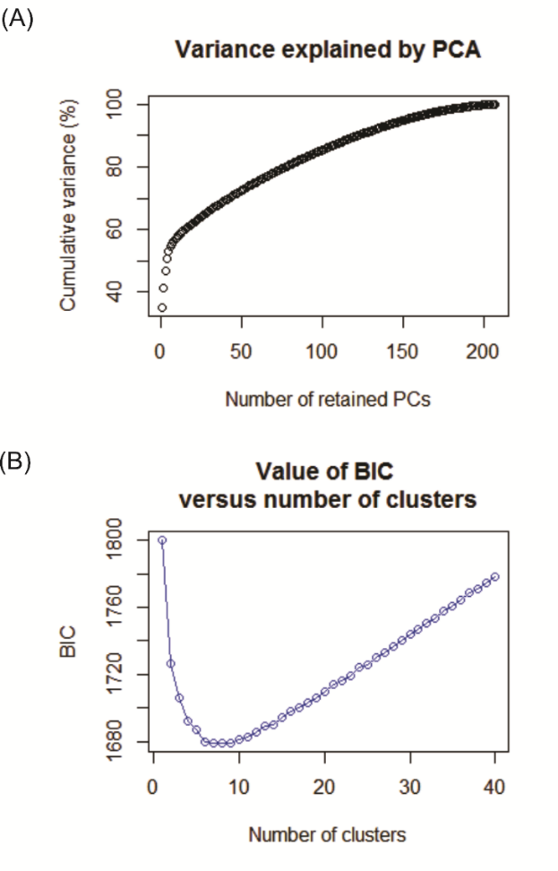
Figure S6. Genetic diversity using multivariate DAPC analysis. (A) The function shows cumulated variance explained by the eigenvalues of the PCA. (B) The function shows BIC values for increasing k value. Lower BIC value (k=6) indicates clusters should be retained.

Figure S7. DAPC clustering of 209 individuals from 11 locations in the United States using 5,379 SNPs markers (K=6). (A) The plot of the two components combination revealing of differentiation between clusters (colors represented) without sampling location information. (B) Plotting the densities of individuals on the discriminant function with different colors for DAPC clusters.

Geographic distances

Table S11. Distance matrix showing the straight-line distance (Km)—accounting for curvature of the earth—between locations calculated using R. Calculation used GeoDistanceInMetresMatrix function available in https://github.com/clipo/Seriation/blob/master/R/distanceCalculations.R.
 | LA | TX | MKS | HKS | FKS | CA | AR | OK | ND | SC | WA
LA | 0 | 209 | 953 | 902 | 993 | 2561 | 529 | 684 | 1770 | 1117 | 2791
TX | 209 | 0 | 1036 | 952 | 1093 | 2464 | 714 | 723 | 1879 | 1311 | 2789
MKS | 953 | 1036 | 0 | 171 | 103 | 2032 | 641 | 344 | 854 | 1544 | 1923
HKS | 902 | 952 | 171 | 0 | 275 | 1916 | 690 | 229 | 984 | 1621 | 1909
FKS | 993 | 1093 | 103 | 275 | 0 | 2108 | 628 | 430 | 787 | 1501 | 1943
CA | 2561 | 2464 | 2032 | 1916 | 2108 | 0 | 2584 | 2013 | 2196 | 3520 | 1239
AR | 529 | 714 | 641 | 690 | 628 | 2584 | 0 | 575 | 1328 | 937 | 2563
OK | 684 | 723 | 344 | 229 | 430 | 2013 | 575 | 0 | 1195 | 1508 | 2111
ND | 1770 | 1879 | 854 | 984 | 787 | 2196 | 1328 | 1195 | 0 | 2004 | 1559
SC | 1117 | 1311 | 1544 | 1621 | 1501 | 3520 | 937 | 1508 | 2004 | 0 | 3429
WA | 2791 | 2789 | 1923 | 1909 | 1943 | 1239 | 2563 | 2111 | 1559 | 3429 | 0

Bioclimatic variables

Table S12. Nineteen bioclimatic predictions and the altitude (m) for each sample location. Variables were calculated according to Hijmans et al. 2005 and the maps used to extract bioclimatic information are available at the Bioclim website; (http://www.worldclim.org/bioclim).
POP | m | WC01 | WC02 | WC03 | WC04 | WC05 | WC06 | WC07 | WC08 | WC09 | WC10 | WC11 | WC12 | WC13 | WC14 | WC15 | WC16 | WC17 | WC18 | WC19
LA | 27 | 188 | 123 | 40 | 6787 | 335 | 29 | 306 | 109 | 238 | 272 | 97 | 1463 | 165 | 98 | 15 | 422 | 304 | 328 | 422
TX | 9 | 198 | 115 | 39 | 6318 | 334 | 46 | 288 | 261 | 159 | 275 | 113 | 1430 | 152 | 88 | 17 | 414 | 273 | 393 | 340
MKS | 356 | 120 | 131 | 31 | 10071 | 326 | -96 | 422 | 222 | -16 | 246 | -16 | 857 | 136 | 19 | 52 | 354 | 68 | 327 | 68
HKS | 480 | 129 | 133 | 31 | 9890 | 339 | -80 | 419 | 229 | -3 | 254 | -3 | 744 | 110 | 15 | 48 | 297 | 62 | 277 | 62
FKS | 361 | 114 | 129 | 30 | 10195 | 321 | -101 | 422 | 220 | -24 | 241 | -24 | 885 | 122 | 22 | 49 | 342 | 75 | 336 | 75
CA | 99 | 169 | 152 | 44 | 6825 | 364 | 23 | 341 | 100 | 256 | 256 | 82 | 282 | 55 | 0 | 83 | 151 | 3 | 3 | 143
AR | 85 | 158 | 118 | 32 | 8524 | 336 | -22 | 358 | 159 | 264 | 264 | 43 | 1216 | 130 | 78 | 19 | 379 | 241 | 241 | 299
OK | 291 | 153 | 131 | 33 | 8948 | 345 | -45 | 390 | 242 | 34 | 266 | 34 | 876 | 133 | 28 | 40 | 316 | 104 | 255 | 104
ND | 273 | 51 | 121 | 25 | 12450 | 283 | -199 | 482 | 202 | -119 | 202 | -119 | 531 | 87 | 11 | 57 | 235 | 42 | 235 | 42
SC | 63 | 178 | 134 | 42 | 6804 | 333 | 15 | 318 | 263 | 134 | 263 | 88 | 1207 | 137 | 63 | 23 | 402 | 220 | 402 | 287
WA | 676 | 84 | 118 | 34 | 7799 | 285 | -59 | 344 | -8 | 182 | 186 | -13 | 467 | 64 | 17 | 39 | 185 | 60 | 72 | 169

Train rail and crops variables

Table S13. State grain rail and crop production statistical summary. Shipments and receipts were compiled by the U.S. Department of Agriculture, Agriculture Marketing Service and authored by Prater et al. 2013 available at http://dx.doi.org/10.9752/TS066.06-2013. Data is presented as volume of grain x 10⁶ tons. Wheat and rice acreage data were extracted from 50 km buffer using ArcGIS 10.3.1 (https://www.nass.usda.gov/Charts_and_Maps/Crops_County/).
STATE | SHIPMENTS | RECEIPTS | WHEAT | RICE | CROP
WA | 7.381341 | 27.564503 | 1884660.389 | 0 | Wheat
TX | 10.462916 | 55.590223 | 0 | 745478.6836 | Rice
CA | 2.2154043 | 10.590569 | 231129.5767 | 0 | Wheat
LA | 0.172832 | 4.431420 | 254053.2649 | 740190.1715 | Rice
AR | 0.356 | 0.166 | 185328.6326 | 796881.8453 | Rice
OK | 12.053613 | 2.637918 | 1845491.138 | 0 | Wheat
SC | 0 | 1.172296 | 0 | 0 | Wheat
KS | 35.298760 | 3.314456 | 1909107.531 | 0 | Wheat
ND | 47.047967 | 3.683122 | 364691.9368 | 0 | Wheat

Modeling parameters and variables

Table S14. Modeling parameters and variables. Model selection was performed in R using glmuli and leaps packages.
Model parameters |  |  |  | Reference
Response variable | M
Explanatory variables | Climate (PCA scores) | WC01 "Annual Mean Temperature"  WC02 "Mean Diurnal Range"  WC03 "Isothermality"  WC04 "Temperature Seasonality"  WC05 "Max Temperature of Warmest Month"  WC06 "Min Temperature of Coldest Month"  WC07 "Temperature Annual Range"  WC08 "Mean Temperature of Wettest Quarter"  WC09 "Mean Temperature of Driest Quarter"  WC10 "Mean Temperature of Warmest Quarter"  WC11 "Mean Temperature of Coldest Quarter"  WC12 "Annual Precipitation"  WC13 "Precipitation of Wettest Month"  WC14 "Precipitation of Driest Month"  WC15 "Precipitation Seasonality"  WC16 "Precipitation of Wettest Quarter"  WC17 "Precipitation of Driest Quarter"  WC18 "Precipitation of Warmest Quarter"  WC19 "Precipitation of Coldest Quarter” |  | Hijmans et al. 2005
 | Agriculture/production | RICE “rice production ‘acreages’ in a 50 Km buffer”  WHEAT “wheat production ‘acreage’ in a 50 Km buffer” |  | Prater et al. 2013
 | Transportation | SHIPMENTS “Volume of grain ship from that location”  RECEIPTS “volume of grain received from other locations  CEN “centrality” |  | Nopsa et al. 2015
 | Geographical | DIST “Geographic distance” |  | Hijmans et al. 2005
level | 1 | “no interactions allowed”
method | “h” | Exhaustive screening
maxsize | 6 | “maximum 6 terms to be included in candidate models”
crit | “aicc” | Corrected Akaike IC
confsetsize | 100 | Number of model to be looked for (confidence set)
fitfunction | “glm”

Model selection, most important variables and best models for M

Figure S8. AICc values for the 200 top models for the number of effective migrants (M) of Rhyzopertha dominica. Horizontal red line separates models with AICc less than 2 units away from the “best” model. Five models were selected according to this criterium.

Figure S9. Relative importance of predictors for the average M, considering all models. Vertical red line indicates the 0.8 cutoff used to separate important variables. Most important variables were the “geographical distance” and “volume of grain received”.

