Supplementary Figures
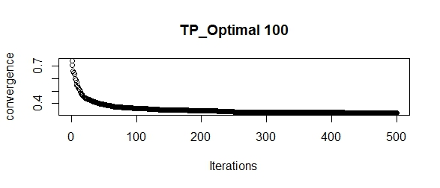
Figure S1: STPGA model convergence for optimized training population of 100 clones
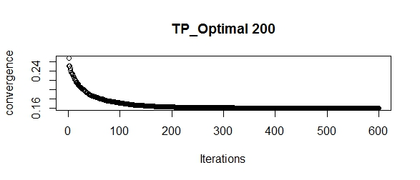
Figure S2: STPGA model convergence for optimized training population of 200 clones

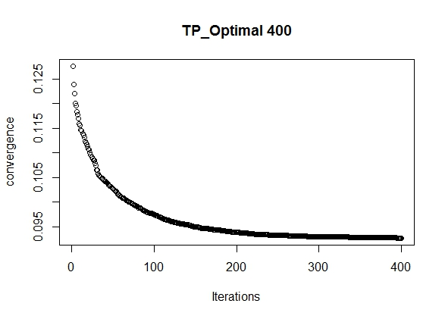
Figure S3: STPGA model convergence for optimized training population of 400 clones

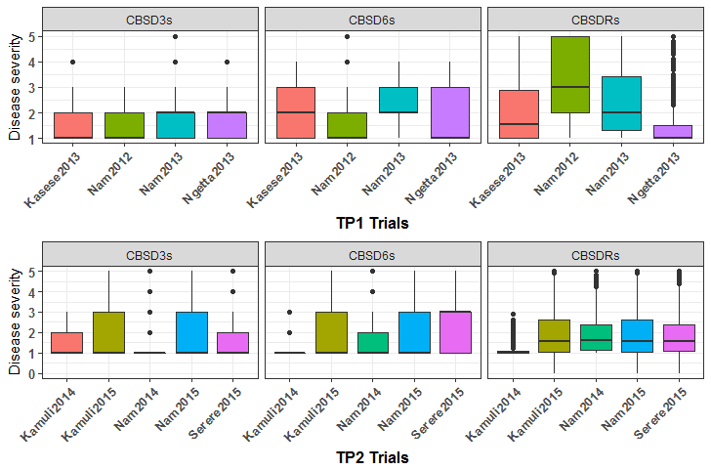

Figure S4: Boxplot showing the phenotypic distribution for two training sets (TP1 and TP2) for the three disease traits
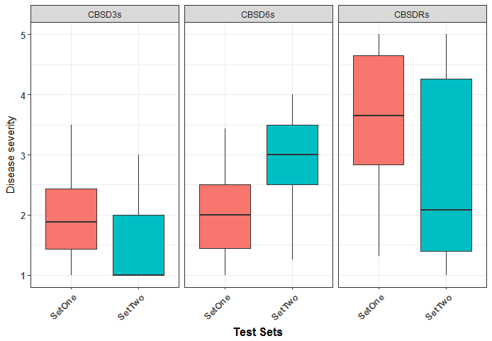
Figure S5: Boxplot showing the phenotypic distribution for the two sets of W. African clones for the three disease traits.
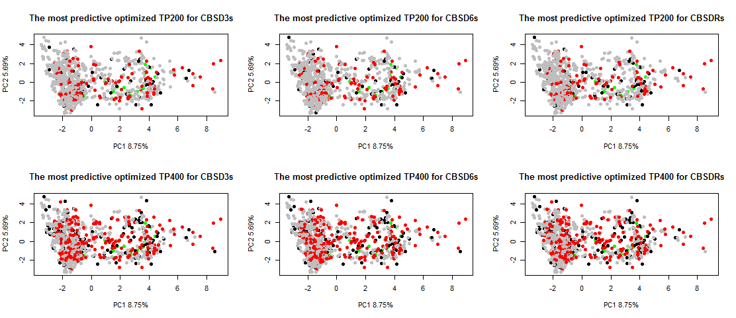
Figure S6: Plot of PC1 against PC2 for the most predictive optimized training size of 200 and 400 for TP1 (Black) and TP2 (Red) as well as the unselected TP1+TP2 (Grey) and the IITA test set (Green) for the CBSD3s, CBSD6s and CBSDRs.

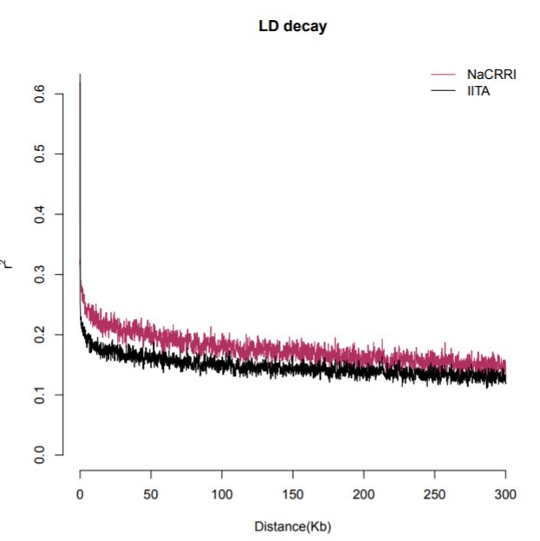
Figure S7: Linkage disequilibrium (LD) decay rate measured as the r² values of pair-wise relationship among the markers along the chromosomes.

Supplementary Tables
Table S1: Prediction accuracies for optimized training population size of 100 for combined TPs (TP1 and TP2)
Training  Size of 100 | G-BLUP |  |  | Bayes-A |  |  | Bayes -B |  |  | Bayesian Lasso
 | CBSD3s  Pre.acc | CBSD6s  Pre.acc | CBSDRs  Pre.acc | CBSD3s  Pre.acc | CBSD6s  Pre.acc | CBSDRs  Pre.acc | CBSD3s  Pre.acc | CBSD6s  Pre.acc | CBSDRs  Pre.acc | CBSD3s  Pre.acc | CBSD6s  Pre.acc | CBSDRs  Pre.acc
TP_1 | 0.21 | 0.21 | -0.09 | 0.22 | 0.23 | 0.03 | 0.27 | 0.24 | -0.13 | 0.31 | 0.21 | -0.15
TP_2 | 0.36 | 0.22 | -0.04 | 0.42 | 0.20 | -0.30 | 0.43 | 0.18 | -0.04 | 0.36 | 0.15 | 0.15
TP_3 | 0.09 | 0.12 | 0.00 | 0.09 | 0.11 | -0.28 | 0.07 | 0.15 | 0.02 | 0.18 | 0.15 | -0.06
TP_4 | 0.15 | 0.16 | -0.16 | 0.14 | 0.13 | -0.43 | 0.20 | 0.17 | 0.03 | 0.14 | 0.14 | -0.01
TP_5 | 0.21 | 0.22 | -0.07 | 0.23 | 0.19 | -0.11 | 0.24 | 0.21 | -0.05 | 0.29 | 0.16 | 0.04
TP_6 | 0.22 | 0.23 | -0.05 | 0.19 | 0.20 | -0.22 | 0.22 | 0.16 | 0.02 | 0.27 | 0.16 | -0.07
TP_7 | 0.44 | 0.29 | -0.19 | 0.38 | 0.25 | -0.18 | 0.43 | 0.35 | 0.09 | 0.41 | 0.27 | -0.07
TP_8 | 0.43 | 0.16 | -0.29 | 0.38 | 0.15 | -0.06 | 0.41 | 0.16 | -0.20 | 0.45 | 0.13 | -0.22
TP_9 | 0.27 | 0.28 | -0.17 | 0.31 | 0.33 | -0.31 | 0.31 | 0.32 | 0.06 | 0.39 | 0.23 | -0.06
TP_10 | 0.11 | 0.19 | -0.16 | 0.13 | 0.20 | -0.24 | 0.18 | 0.20 | -0.08 | 0.17 | 0.14 | -0.19
TP_11 | 0.37 | 0.31 | 0.10 | 0.38 | 0.24 | -0.24 | 0.49 | 0.32 | 0.08 | 0.39 | 0.19 | -0.05
TP_12 | 0.27 | 0.19 | 0.03 | 0.32 | 0.15 | -0.17 | 0.32 | 0.18 | -0.01 | 0.31 | 0.17 | -0.02
TP_13 | 0.15 | 0.28 | -0.07 | 0.23 | 0.29 | -0.32 | 0.23 | 0.27 | -0.01 | 0.28 | 0.18 | -0.08
TP_14 | 0.35 | 0.36 | -0.11 | 0.34 | 0.38 | -0.22 | 0.33 | 0.38 | 0.09 | 0.35 | 0.35 | -0.03
TP_15 | 0.08 | 0.27 | -0.07 | 0.05 | 0.28 | -0.24 | 0.15 | 0.27 | -0.11 | 0.24 | 0.22 | -0.19
TP_16 | 0.23 | 0.27 | -0.18 | 0.24 | 0.26 | -0.07 | 0.27 | 0.25 | 0.06 | 0.40 | 0.19 | -0.03
TP_17 | 0.33 | 0.20 | -0.01 | 0.33 | 0.18 | -0.21 | 0.31 | 0.18 | -0.18 | 0.40 | 0.17 | -0.14
TP_18 | 0.45 | 0.30 | -0.08 | 0.37 | 0.29 | -0.18 | 0.43 | 0.22 | -0.13 | 0.50 | 0.23 | -0.18
TP_19 | 0.23 | 0.24 | -0.18 | 0.10 | 0.27 | -0.20 | 0.26 | 0.26 | -0.05 | 0.28 | 0.19 | -0.05
TP_20 | 0.37 | 0.14 | -0.29 | 0.31 | 0.14 | 0.16 | 0.39 | 0.09 | -0.08 | 0.43 | 0.11 | 0.00
Mean Pre.acc | 0.27 | 0.23 | -0.10 | 0.26 | 0.22 | -0.19 | 0.30 | 0.23 | -0.03 | 0.33 | 0.19 | -0.07
Table S2: Prediction accuracies for optimized training population size of 200 for combined TPs (TP1 and TP2)
 |  |  |  | G-BLUP |  |  |  |  |  |  |  | Bayes-A |  |  |  |  |  |  | Bayes-B |  |  |  |  |  | Bayesian Lasso
 | Train. Pop size 200 |  |  | M3CBSDs |  | M6CBSDs |  |  | CBSDRs |  |  | M3CBSDs |  |  | M6CBSDs |  | CBSDRs |  | M3CBSDs |  | M6CBSDs |  | CBSDRs |  | M3CBSDs |  |  |  | M6CBSDs |  | CBSDRs
 |  |  |  | Pre.acc (r) |  | Pre.acc (r) |  |  | Pre.acc (r) |  |  | Pre.acc(r) |  |  | Pre.acc(r) |  | Pre.acc (r) |  | Pre.acc (r) |  | Pre.acc (r) |  | Pre.acc (r) |  | Pre.acc (r) |  |  |  | Pre.acc (r) |  | Pre.acc (r)
 | TP_1 |  |  | 0.18 |  | 0.33 |  |  | -0.02 |  |  | 0.20 |  |  | 0.31 |  | -0.29 |  | 0.37 |  | 0.32 |  | 0.18 |  | 0.31 |  |  |  | 0.28 |  | 0.14
 | TP_2 |  |  | 0.27 |  | 0.38 |  |  | 0.06 |  |  | 0.33 |  |  | 0.36 |  | -0.28 |  | 0.30 |  | 0.43 |  | 0.13 |  | 0.36 |  |  |  | 0.34 |  | 0.13
 | TP_3 |  |  | 0.09 |  | 0.34 |  |  | -0.03 |  |  | 0.10 |  |  | 0.34 |  | -0.20 |  | 0.09 |  | 0.39 |  | 0.10 |  | 0.21 |  |  |  | 0.20 |  | 0.12
 | TP_4 |  |  | 0.39 |  | 0.29 |  |  | -0.05 |  |  | 0.40 |  |  | 0.32 |  | -0.29 |  | 0.38 |  | 0.29 |  | 0.14 |  | 0.42 |  |  |  | 0.27 |  | 0.12
 | TP_5 |  |  | 0.40 |  | 0.25 |  |  | -0.04 |  |  | 0.24 |  |  | 0.27 |  | -0.37 |  | 0.42 |  | 0.18 |  | -0.10 |  | 0.41 |  |  |  | 0.21 |  | -0.09
 | TP_6 |  |  | 0.36 |  | 0.27 |  |  | -0.08 |  |  | 0.36 |  |  | 0.24 |  | -0.08 |  | 0.43 |  | 0.30 |  | -0.03 |  | 0.38 |  |  |  | 0.18 |  | -0.05
 | TP_7 |  |  | 0.28 |  | 0.29 |  |  | -0.03 |  |  | 0.24 |  |  | 0.25 |  | -0.43 |  | 0.30 |  | 0.25 |  | 0.15 |  | 0.36 |  |  |  | 0.21 |  | 0.18
 | TP_8 |  |  | 0.29 |  | 0.20 |  |  | 0.01 |  |  | 0.29 |  |  | 0.16 |  | -0.47 |  | 0.42 |  | 0.22 |  | -0.03 |  | 0.39 |  |  |  | 0.22 |  | 0.01
 | TP_9 |  |  | 0.26 |  | 0.36 |  |  | -0.12 |  |  | 0.29 |  |  | 0.36 |  | -0.22 |  | 0.20 |  | 0.31 |  | 0.13 |  | 0.35 |  |  |  | 0.29 |  | 0.11
 | TP_10 |  |  | 0.38 |  | 0.37 |  |  | 0.07 |  |  | 0.42 |  |  | 0.35 |  | -0.16 |  | 0.33 |  | 0.34 |  | 0.00 |  | 0.43 |  |  |  | 0.22 |  | -0.03
 | TP_11 |  |  | 0.26 |  | 0.29 |  |  | 0.11 |  |  | 0.21 |  |  | 0.27 |  | -0.35 |  | 0.27 |  | 0.28 |  | 0.12 |  | 0.30 |  |  |  | 0.23 |  | 0.09
 | TP_12 |  |  | 0.20 |  | 0.31 |  |  | -0.05 |  |  | 0.27 |  |  | 0.31 |  | -0.46 |  | 0.22 |  | 0.30 |  | 0.22 |  | 0.24 |  |  |  | 0.22 |  | 0.23
 | TP_13 |  |  | 0.15 |  | 0.14 |  |  | 0.00 |  |  | 0.23 |  |  | 0.15 |  | -0.35 |  | 0.12 |  | 0.13 |  | -0.12 |  | 0.29 |  |  |  | 0.13 |  | -0.07
 | TP_14 |  |  | 0.22 |  | 0.22 |  |  | -0.02 |  |  | 0.23 |  |  | 0.21 |  | -0.22 |  | 0.28 |  | 0.24 |  | 0.10 |  | 0.23 |  |  |  | 0.21 |  | 0.12
 | TP_15 |  |  | 0.28 |  | 0.31 |  |  | -0.09 |  |  | 0.23 |  |  | 0.23 |  | -0.39 |  | 0.29 |  | 0.17 |  | 0.10 |  | 0.31 |  |  |  | 0.23 |  | 0.12
 | TP_16 |  |  | 0.25 |  | 0.17 |  |  | -0.09 |  |  | 0.27 |  |  | 0.09 |  | -0.11 |  | 0.11 |  | 0.12 |  | -0.09 |  | 0.29 |  |  |  | 0.13 |  | -0.07
 | TP_17 |  |  | 0.11 |  | 0.19 |  |  | -0.12 |  |  | 0.07 |  |  | 0.18 |  | -0.25 |  | 0.08 |  | 0.14 |  | -0.02 |  | 0.27 |  |  |  | 0.15 |  | -0.07
 | TP_18 |  |  | 0.25 |  | 0.23 |  |  | -0.09 |  |  | 0.27 |  |  | 0.19 |  | -0.30 |  | 0.19 |  | 0.27 |  | 0.13 |  | 0.32 |  |  |  | 0.19 |  | 0.08
 | TP_19 |  |  | 0.27 |  | 0.21 |  |  | -0.09 |  |  | 0.30 |  |  | 0.19 |  | -0.31 |  | 0.33 |  | 0.20 |  | 0.10 |  | 0.36 |  |  |  | 0.21 |  | 0.05
 | TP_20 |  |  | 0.38 |  | 0.27 |  |  | 0.02 |  |  | 0.25 |  |  | 0.33 |  | -0.26 |  | 0.37 |  | 0.35 |  | 0.13 |  | 0.31 |  |  |  | 0.26 |  | 0.15
 | Mean Pre.acc |  |  | 0.27 |  | 0.28 |  |  | -0.03 |  |  | 0.26 |  |  | 0.26 |  | -0.29 |  | 0.27 |  | 0.26 |  | 0.07 |  | 0.34 |  |  |  | 0.22 |  | 0.06
Table S3: Prediction accuracies for optimized training population size of 400 for combined TPs

Training pop 400 |  | G-BLUP |  |  |  |  |  |  |  |  |  |  | Bayes-A |  |  |  |  |  |  | Bayes-B |  |  |  |  |  |  | Bayesian Lasso
 |  | CBSD3s  Pred.acc |  |  |  |  | CBSD6s  Pred.acc |  |  | CBSDRs  Pred.acc |  |  | CBSD3s  Pred.acc |  |  | CBSD6s  Pred.acc |  | CBSDRs  Pred.acc |  | CBSD3s  Pred.acc |  | CBSD6s  Pred.acc |  | CBSDRs  Pred.acc |  |  | CBSD3s  Pred.acc |  |  | CBSD6s  Pred.acc |  | CBSDRs  Pred.acc
TP_1 |  | 0.40 |  |  |  |  | 0.18 |  |  | 0.01 |  |  | 0.40 |  |  | 0.18 |  | -0.30 |  | 0.42 |  | 0.14 |  | -0.12 |  |  | 0.46 |  |  | 0.13 |  | -0.11
TP_2 |  | 0.28 |  |  |  |  | 0.19 |  |  | 0.06 |  |  | 0.26 |  |  | 0.21 |  | -0.11 |  | 0.32 |  | 0.16 |  | -0.05 |  |  | 0.34 |  |  | 0.12 |  | -0.07
TP_3 |  | 0.32 |  |  |  |  | 0.16 |  |  | 0.01 |  |  | 0.32 |  |  | 0.16 |  | -0.10 |  | 0.33 |  | 0.12 |  | -0.11 |  |  | 0.38 |  |  | 0.12 |  | -0.10
TP_4 |  | 0.34 |  |  |  |  | 0.21 |  |  | -0.05 |  |  | 0.33 |  |  | 0.18 |  | -0.10 |  | 0.31 |  | 0.24 |  | -0.08 |  |  | 0.33 |  |  | 0.12 |  | -0.16
TP_5 |  | 0.32 |  |  |  |  | 0.19 |  |  | -0.03 |  |  | 0.30 |  |  | 0.18 |  | -0.20 |  | 0.37 |  | 0.19 |  | -0.12 |  |  | 0.39 |  |  | 0.14 |  | -0.12
TP_6 |  | 0.19 |  |  |  |  | 0.21 |  |  | -0.02 |  |  | 0.10 |  |  | 0.22 |  | -0.23 |  | 0.23 |  | 0.17 |  | -0.04 |  |  | 0.25 |  |  | 0.13 |  | -0.05
TP_7 |  | 0.34 |  |  |  |  | 0.18 |  |  | 0.04 |  |  | 0.38 |  |  | 0.19 |  | -0.25 |  | 0.35 |  | 0.22 |  | -0.09 |  |  | 0.37 |  |  | 0.20 |  | -0.04
TP_8 |  | 0.26 |  |  |  |  | 0.17 |  |  | -0.04 |  |  | 0.30 |  |  | 0.22 |  | -0.17 |  | 0.26 |  | 0.22 |  | 0.01 |  |  | 0.35 |  |  | 0.16 |  | -0.02
TP_9 |  | 0.34 |  |  |  |  | 0.19 |  |  | 0.00 |  |  | 0.36 |  |  | 0.15 |  | -0.16 |  | 0.30 |  | 0.13 |  | -0.08 |  |  | 0.40 |  |  | 0.13 |  | -0.08
TP_10 |  | 0.35 |  |  |  |  | 0.23 |  |  | -0.05 |  |  | 0.33 |  |  | 0.20 |  | -0.28 |  | 0.34 |  | 0.23 |  | -0.11 |  |  | 0.36 |  |  | 0.16 |  | -0.15
TP_11 |  | 0.38 |  |  |  |  | 0.17 |  |  | -0.04 |  |  | 0.37 |  |  | 0.16 |  | -0.22 |  | 0.36 |  | 0.17 |  | -0.13 |  |  | 0.38 |  |  | 0.14 |  | -0.13
TP_12 |  | 0.26 |  |  |  |  | 0.14 |  |  | 0.01 |  |  | 0.33 |  |  | 0.13 |  | -0.11 |  | 0.22 |  | 0.10 |  | -0.08 |  |  | 0.32 |  |  | 0.10 |  | -0.05
TP_13 |  | 0.39 |  |  |  |  | 0.23 |  |  | 0.00 |  |  | 0.43 |  |  | 0.20 |  | -0.32 |  | 0.43 |  | 0.19 |  | -0.12 |  |  | 0.43 |  |  | 0.13 |  | -0.11
TP_14 |  | 0.24 |  |  |  |  | 0.19 |  |  | 0.02 |  |  | 0.27 |  |  | 0.18 |  | -0.23 |  | 0.27 |  | 0.18 |  | -0.11 |  |  | 0.35 |  |  | 0.14 |  | -0.08
TP_15 |  | 0.31 |  |  |  |  | 0.21 |  |  | -0.06 |  |  | 0.30 |  |  | 0.23 |  | -0.11 |  | 0.34 |  | 0.13 |  | -0.13 |  |  | 0.32 |  |  | 0.13 |  | -0.04
TP_16 |  | 0.31 |  |  |  |  | 0.20 |  |  | 0.00 |  |  | 0.32 |  |  | 0.21 |  | -0.24 |  | 0.34 |  | 0.20 |  | -0.08 |  |  | 0.34 |  |  | 0.15 |  | -0.02
TP_17 |  | 0.24 |  |  |  |  | 0.20 |  |  | 0.01 |  |  | 0.26 |  |  | 0.17 |  | -0.08 |  | 0.22 |  | 0.17 |  | -0.01 |  |  | 0.31 |  |  | 0.18 |  | -0.05
TP_18 |  | 0.37 |  |  |  |  | 0.20 |  |  | 0.01 |  |  | 0.42 |  |  | 0.19 |  | -0.20 |  | 0.41 |  | 0.18 |  | -0.06 |  |  | 0.41 |  |  | 0.13 |  | -0.09
TP_19 |  | 0.34 |  |  |  |  | 0.17 |  |  | -0.08 |  |  | 0.26 |  |  | 0.17 |  | -0.13 |  | 0.26 |  | 0.16 |  | -0.15 |  |  | 0.37 |  |  | 0.12 |  | -0.11
TP_20 |  | 0.25 |  |  |  |  | 0.16 |  |  | -0.04 |  |  | 0.30 |  |  | 0.14 |  | -0.25 |  | 0.26 |  | 0.16 |  | -0.11 |  |  | 0.30 |  |  | 0.12 |  | -0.07
Mean |  | 0.32 |  |  |  |  | 0.19 |  |  | -0.01 |  |  | 0.32 |  |  | 0.18 |  | -0.19 |  | 0.32 |  | 0.17 |  | -0.09 |  |  | 0.36 |  |  | 0.14 |  | -0.08

Table S4: Prediction accuracies for optimized training population size of 800 for TP1 and TP2
 | G-BLUP |  |  | Bayes-A |  |  | Bayes-B |  |  | Bayesian Lasso
Train. Pop size 800 | M3CBSDs | M6CBSDs | CBSDRs | M3CBSDs | M6CBSDs | CBSDRs | M3CBSDs | M6CBSDs | CBSDRs | M3CBSDs | M6CBSDs | CBSDRs
 | Pre.acc (r) | Pre.acc (r) | Pre.acc (r) | Pre.acc(r) | Pre.acc(r) | Pre.acc (r) | Pre.acc (r) | Pre.acc (r) | Pre.acc (r) | Pre.acc (r) | Pre.acc (r) | Pre.acc (r)
TP_1 | 0.30 | 0.25 | 0.05 | 0.30 | 0.21 | -0.13 | 0.27 | 0.21 | -0.09 | 0.29 | 0.19 | -0.01
TP_2 | 0.29 | 0.25 | 0.07 | 0.31 | 0.25 | -0.09 | 0.27 | 0.25 | -0.05 | 0.29 | 0.17 | 0.02
TP_3 | 0.31 | 0.26 | 0.06 | 0.34 | 0.26 | -0.10 | 0.27 | 0.20 | -0.05 | 0.33 | 0.15 | 0.00
TP_4 | 0.31 | 0.26 | 0.07 | 0.28 | 0.25 | -0.14 | 0.30 | 0.25 | 0.03 | 0.30 | 0.17 | 0.03
TP_5 | 0.30 | 0.27 | 0.07 | 0.12 | 0.21 | -0.13 | 0.28 | 0.27 | -0.04 | 0.29 | 0.13 | 0.00
TP_6 | 0.30 | 0.27 | 0.06 | 0.33 | 0.26 | -0.17 | 0.12 | 0.26 | -0.05 | 0.29 | 0.18 | -0.04
TP_7 | 0.30 | 0.27 | 0.07 | 0.35 | 0.22 | -0.18 | 0.27 | 0.25 | -0.01 | 0.27 | 0.17 | 0.00
TP_8 | 0.29 | 0.27 | 0.06 | 0.32 | 0.24 | -0.15 | 0.30 | 0.28 | -0.02 | 0.30 | 0.21 | 0.00
TP_9 | 0.30 | 0.26 | 0.07 | 0.33 | 0.27 | -0.11 | 0.21 | 0.14 | -0.05 | 0.28 | 0.16 | 0.00
TP_10 | 0.31 | 0.26 | 0.07 | 0.34 | 0.25 | -0.20 | 0.38 | 0.26 | -0.07 | 0.34 | 0.19 | -0.05
TP_11 | 0.30 | 0.28 | 0.05 | 0.32 | 0.29 | -0.13 | 0.35 | 0.33 | 0.01 | 0.32 | 0.16 | -0.01
TP_12 | 0.30 | 0.26 | 0.07 | 0.34 | 0.27 | -0.11 | 0.37 | 0.23 | -0.03 | 0.34 | 0.18 | 0.01
TP_13 | 0.30 | 0.26 | 0.07 | 0.16 | 0.25 | -0.12 | 0.34 | 0.13 | -0.05 | 0.28 | 0.17 | -0.03
TP_14 | 0.30 | 0.28 | 0.07 | 0.16 | 0.23 | -0.20 | 0.33 | 0.21 | -0.05 | 0.36 | 0.20 | -0.03
TP_15 | 0.30 | 0.26 | 0.07 | 0.30 | 0.27 | 0.12 | 0.24 | 0.24 | 0.04 | 0.30 | 0.12 | -0.01
TP_16 | 0.30 | 0.27 | 0.06 | 0.26 | 0.26 | -0.18 | 0.30 | 0.30 | -0.04 | 0.30 | 0.20 | 0.00
TP_17 | 0.30 | 0.26 | 0.06 | 0.31 | 0.25 | -0.19 | 0.32 | 0.18 | -0.10 | 0.37 | 0.16 | -0.01
TP_18 | 0.30 | 0.27 | 0.06 | 0.34 | 0.26 | -0.11 | 0.25 | 0.33 | -0.05 | 0.30 | 0.19 | -0.01
TP_19 | 0.29 | 0.25 | 0.05 | 0.29 | 0.25 | -0.07 | 0.28 | 0.15 | -0.07 | 0.30 | 0.13 | -0.02
TP_20 | 0.28 | 0.25 | 0.06 | 0.26 | 0.23 | -0.18 | 0.26 | 0.18 | -0.05 | 0.29 | 0.11 | -0.01
Mean Pre.acc | 0.31 | 0.26 | 0.06 | 0.29 | 0.25 | -0.13 | 0.29 | 0.23 | -0.04 | 0.31 | 0.17 | -0.01

Table S5: Prediction accuracies for full set (922) of clones (TP1 and TP2)
 | G-BLUP |  |  | Bayes-A |  |  | Bayes-B |  |  | Bayesian Lasso
Train. Pop size 922 | M3CBSDs | M6CBSDs | CBSDRs | M3CBSDs | M6CBSDs | CBSDRs | M3CBSDs | M6CBSDs | CBSDRs | M3CBSDs | M6CBSDs | CBSDRs
 | Pre.acc (r) | Pre.acc (r) | Pre.acc (r) | Pre.acc(r) | Pre.acc(r) | Pre.acc (r) | Pre.acc (r) | Pre.acc (r) | Pre.acc (r) | Pre.acc (r) | Pre.acc (r) | Pre.acc (r)
Pre.acc | 0.30 | 0.25 | 0.05 | 0.24 | 0.21 | -0.11 | 0.30 | 0.26 | -0.09 | 0.31 | 0.15 | -0.04

Table S6: Comparing prediction accuracies for optimized and random subset of training population of size 200

 |  | Optimized |  |  | Random sub  Set of TP
 |  | Subset of TP
Train. Pop size 200 | CBSD3s | CBSD6s | CBSDRs | CBSD3s | CBSD6s | CBSDRs
TP_1 | 0.18 | 0.33 | -0.42 | 0.30 | 0.01 | -0.02
TP_2 | 0.27 | 0.38 | -0.33 | 0.06 | 0.00 | 0.06
TP_3 | 0.09 | 0.34 | 0.08 | 0.40 | 0.15 | -0.03
TP_4 | 0.39 | 0.29 | 0.33 | 0.25 | 0.06 | -0.05
TP_5 | 0.40 | 0.25 | 0.16 | 0.36 | -0.04 | -0.04
TP_6 | 0.36 | 0.27 | 0.16 | 0.16 | -0.03 | -0.08
TP_7 | 0.28 | 0.29 | 0.30 | 0.50 | 0.04 | -0.03
TP_8 | 0.29 | 0.20 | 0.05 | 0.15 | -0.23 | 0.01
TP_9 | 0.26 | 0.36 | -0.17 | -0.18 | -0.06 | -0.12
TP_10 | 0.38 | 0.37 | -0.17 | 0.07 | -0.07 | 0.07
TP_11 | 0.26 | 0.29 | -0.11 | -0.07 | 0.07 | 0.11
TP_12 | 0.20 | 0.31 | -0.12 | -0.11 | 0.01 | -0.05
TP_13 | 0.15 | 0.14 | -0.16 | 0.06 | -0.17 | 0.00
TP_14 | 0.22 | 0.22 | -0.13 | 0.34 | -0.04 | -0.02
TP_15 | 0.28 | 0.31 | -0.15 | -0.13 | 0.03 | -0.09
TP_16 | 0.25 | 0.17 | 0.18 | -0.12 | 0.01 | -0.09
TP_17 | 0.11 | 0.19 | 0.02 | -0.07 | -0.19 | -0.12
TP_18 | 0.25 | 0.23 | -0.18 | -0.13 | 0.06 | -0.09
TP_19 | 0.27 | 0.21 | -0.19 | 0.23 | 0.09 | -0.09
TP_20 | 0.38 | 0.27 | 0.12 | 0.21 | 0.11 | 0.02
Mean Pre.acc | 0.27 | 0.28 | -0.04 | 0.11 | -0.01 | -0.03
Table S7: Comparing prediction accuracies for optimized and random subset of training population of size 400
 |  | Optimized |  |  | Random sub
 |  | Subset of TP |  |  | Set of TP
Train. Pop size 400 | CBSD3s | CBSD6s | CBSDRs | CBSD3s | CBSD6s | CBSDRs
TP_1 | 0.40 | 0.18 | 0.01 | 0.17 | -0.04 | -0.03
TP_2 | 0.28 | 0.19 | 0.06 | 0.05 | 0.05 | 0.03
TP_3 | 0.32 | 0.16 | 0.01 | 0.15 | 0.14 | -0.02
TP_4 | 0.34 | 0.21 | -0.05 | 0.02 | 0.00 | 0.04
TP_5 | 0.32 | 0.19 | -0.03 | 0.07 | 0.06 | 0.17
TP_6 | 0.19 | 0.21 | -0.02 | -0.02 | 0.16 | -0.21
TP_7 | 0.34 | 0.18 | 0.04 | 0.19 | -0.01 | 0.22
TP_8 | 0.26 | 0.17 | -0.04 | 0.29 | 0.01 | -0.01
TP_9 | 0.34 | 0.19 | 0.00 | -0.10 | 0.10 | -0.21
TP_10 | 0.35 | 0.23 | -0.05 | 0.26 | 0.12 | -0.12
TP_11 | 0.38 | 0.17 | -0.04 | 0.38 | 0.11 | 0.07
TP_12 | 0.26 | 0.14 | 0.01 | 0.08 | -0.08 | -0.03
TP_13 | 0.39 | 0.23 | 0.00 | -0.04 | -0.12 | 0.11
TP_14 | 0.24 | 0.19 | 0.02 | 0.24 | 0.20 | -0.02
TP_15 | 0.31 | 0.21 | -0.06 | 0.17 | 0.09 | 0.04
TP_16 | 0.31 | 0.20 | 0.00 | 0.02 | -0.05 | 0.08
TP_17 | 0.24 | 0.20 | 0.01 | 0.02 | 0.01 | -0.02
TP_18 | 0.37 | 0.20 | 0.01 | 0.03 | 0.07 | -0.28
TP_19 | 0.34 | 0.17 | -0.08 | 0.23 | 0.01 | 0.08
TP_20 | 0.25 | 0.16 | -0.04 | -0.14 | -0.11 | 0.01
Mean Pre.acc | 0.32 | 0.19 | -0.01 | 0.10 | 0.04 | -0.01
Table S8: Prediction accuracies for single and multi-kernel G-BLUP models for optimized training population size of 200 clones, where K_1, K_2 and K_3 represent single kernel, two kernels, and three kernels G-BLUP models respectively. K_1 is fitted with one genomic relationship matrix, K_2 with two genomic relationship matrix is characterized by the first genomic relationship matrix arising from combined CBSD QTL markers on chromosomes 4 and 11, and second kernel being the rest of the genomic markers, while K_3 with 3 genomic relationship matrices is characterized by the first two genomic relationship matrices arising from CBSD QTL markers on chromosomes 4 and 11, and third kernel being the rest of the genomic markers
Training set 200 | CBSD3s |  |  | CBSD6s |  |  |  | CBSDRs
 | K_1 | K_2 | K_3 | K_1 | K_2 | K_3 |  | K_1 | K_2 | K_3
TP1 | 0.18 | 0.27 | 0.30 | 0.34 | 0.44 | 0.45 |  | -0.02 | -0.01 | 0.09
TP2 | 0.27 | 0.29 | 0.32 | 0.39 | 0.46 | 0.42 |  | 0.06 | 0.07 | -0.02
TP3 | 0.09 | 0.47 | 0.42 | 0.35 | 0.19 | 0.47 |  | -0.03 | -0.07 | -0.06
TP4 | 0.38 | 0.42 | 0.43 | 0.29 | 0.45 | 0.38 |  | -0.05 | -0.06 | -0.09
TP5 | 0.40 | 0.45 | 0.46 | 0.26 | 0.34 | 0.36 |  | -0.04 | -0.07 | -0.15
TP6 | 0.35 | 0.31 | 0.33 | 0.29 | 0.34 | 0.41 |  | -0.08 | -0.21 | -0.02
TP7 | 0.37 | 0.32 | 0.27 | 0.20 | 0.40 | 0.29 |  | -0.03 | -0.01 | -0.03
TP8 | 0.29 | 0.30 | 0.35 | 0.37 | 0.30 | 0.50 |  | 0.01 | -0.02 | -0.12
TP9 | 0.26 | 0.35 | 0.26 | 0.37 | 0.49 | 0.47 |  | -0.12 | 0.11 | -0.04
TP10 | 0.37 | 0.30 | 0.21 | 0.30 | 0.47 | 0.43 |  | 0.07 | -0.06 | 0.13
TP11 | 0.26 | 0.23 | 0.25 | 0.31 | 0.42 | 0.44 |  | 0.11 | 0.12 | -0.05
TP12 | 0.20 | 0.19 | 0.22 | 0.15 | 0.27 | 0.28 |  | -0.05 | -0.02 | -0.03
TP13 | 0.15 | 0.22 | 0.23 | 0.23 | 0.32 | 0.28 |  | 0.00 | 0.00 | 0.02
TP14 | 0.22 | 0.31 | 0.32 | 0.31 | 0.43 | 0.41 |  | -0.02 | -0.12 | -0.11
TP15 | 0.28 | 0.27 | 0.22 | 0.17 | 0.17 | 0.17 |  | -0.09 | -0.15 | -0.11
TP16 | 0.24 | 0.43 | 0.39 | 0.20 | 0.14 | 0.30 |  | -0.09 | -0.13 | -0.12
TP17 | 0.11 | 0.34 | 0.34 | 0.23 | 0.33 | 0.26 |  | -0.12 | -0.15 | -0.15
TP18 | 0.25 | 0.29 | 0.41 | 0.21 | 0.50 | 0.30 |  | -0.09 | -0.13 | -0.12
TP19 | 0.26 | 0.20 | 0.26 | 0.38 | 0.25 | 0.33 |  | -0.09 | -0.13 | -0.12
TP20 | 0.27 | 0.25 | 0.30 | 0.22 | 0.31 | 0.51 |  | 0.02 | -0.01 | 0.24
Mean Pred | 0.27 | 0.31 | 0.32 | 0.28 | 0.35 | 0.37 |  | -0.03 | -0.05 | -0.04
Table S9: Prediction accuracies for single and multi-kernel G-BLUP models for optimized training population of size 400, K_1, K_2 and K_3 represent single kernel, two kernels, and three kernels G-BLUP models respectively. K_1 was fitted with one genomic relationship matrix, K_2 with two genomic relationship matrix was characterized by the first genomic relationship matrix arising from combined CBSD QTL markers on chromosomes 4 and 11, and second kernel being the rest of the genomic markers, while K_3 with 3 genomic relationship matrices was characterized by the first two genomic relationship matrices arising from CBSD QTL markers on chromosomes 4 and 11, and third kernel being the rest of the genomic markers
Training set 400 | CBSD3s |  |  | CBSD6s |  |  | CBSDRs
 | K_1 | K_2 | K_3 | K_1 | K_2 | K_3 | K_1 | K_2 | K_3
TP1 | 0.40 | 0.42 | 0.41 | 0.17 | 0.24 | 0.26 | 0.00 | 0.01 | 0.02
TP2 | 0.28 | 0.24 | 0.23 | 0.19 | 0.34 | 0.26 | 0.06 | -0.12 | -0.10
TP3 | 0.32 | 0.39 | 0.34 | 0.16 | 0.23 | 0.25 | 0.01 | 0.00 | 0.01
TP4 | 0.34 | 0.31 | 0.34 | 0.21 | 0.27 | 0.29 | -0.01 | -0.09 | -0.04
TP5 | 0.32 | 0.27 | 0.29 | 0.19 | 0.25 | 0.27 | -0.05 | -0.05 | -0.03
TP6 | 0.19 | 0.43 | 0.43 | 0.21 | 0.30 | 0.30 | -0.03 | -0.04 | -0.03
TP7 | 0.34 | 0.31 | 0.37 | 0.17 | 0.23 | 0.26 | -0.02 | 0.03 | 0.04
TP8 | 0.26 | 0.24 | 0.28 | 0.17 | 0.27 | 0.28 | 0.04 | -0.07 | -0.08
TP9 | 0.34 | 0.29 | 0.36 | 0.19 | -0.24 | 0.29 | -0.04 | -0.01 | 0.00
TP10 | 0.35 | 0.32 | 0.36 | 0.23 | 0.28 | 0.30 | 0.00 | -0.05 | -0.03
TP11 | 0.38 | 0.28 | 0.36 | 0.24 | 0.23 | 0.27 | -0.05 | -0.07 | -0.04
TP12 | 0.26 | 0.27 | 0.28 | 0.14 | 0.20 | 0.23 | -0.04 | 0.00 | 0.01
TP13 | 0.39 | 0.34 | 0.42 | 0.22 | 0.29 | 0.31 | 0.01 | 0.00 | 0.01
TP14 | 0.24 | 0.34 | 0.24 | 0.19 | 0.25 | 0.31 | 0.00 | 0.01 | 0.01
TP15 | 0.31 | 0.32 | 0.33 | 0.21 | 0.28 | 0.29 | 0.02 | -0.01 | -0.05
TP16 | 0.31 | 0.29 | 0.32 | 0.20 | 0.26 | 0.28 | -0.06 | 0.00 | 0.01
TP17 | 0.24 | 0.29 | 0.28 | 0.20 | 0.23 | 0.29 | 0.00 | 0.02 | 0.04
TP18 | 0.37 | 0.39 | 0.40 | 0.20 | 0.24 | 0.26 | 0.01 | 0.00 | 0.01
TP19 | 0.34 | 0.29 | 0.30 | 0.17 | 0.20 | 0.27 | 0.01 | -0.08 | -0.06
TP20 | 0.25 | 0.34 | 0.49 | 0.16 | 0.25 | 0.23 | -0.08 | -0.01 | -0.01
Mean Pred. | 0.32 | 0.32 | 0.34 | 0.19 | 0.23 | 0.27 | -0.01 | -0.03 | -0.02

Table S10: Five-fold cross validation, replicated 10 times for IITA clones G-BLUP model
Replications | CBSD3s | CBSD6s | CBSDRs
1 | 0.39 | 0.23 | 0.08
2 | 0.45 | 0.24 | 0.04
3 | 0.41 | 0.42 | 0.22
4 | 0.37 | 0.21 | 0.20
5 | 0.46 | 0.34 | -0.03
6 | 0.37 | -0.29 | 0.13
7 | 0.48 | 0.27 | 0.07
8 | 0.45 | 0.27 | -0.20
9 | 0.36 | 0.22 | 0.13
10 | 0.33 | 0.14 | 0.18
Mean Pred. | 0.40 | 0.21 | 0.08

Table S11: Prediction accuracies of CBSD-traits for single and multi-kernel G-BLUP models under high density, whole genome sequence imputed markers (WGS) and low density genotyping-by sequencing markers (GBS) markers for optimized training population size of 200 clones.
Traits | Single Kernel model (K1) |  | Multi-Kernel (K2) |  | Multi-Kernel (K3)
 | GBS markers | WGS Markers | GBS markers | WGS Markers | GBS markers | WGS Markers
CBSD3s | 0.27 | 0.35 | 0.31 | 0.26 | 0.32 | 0.32
CBSD6s | 0.28 | 0.15 | 0.35 | 0.24 | 0.37 | 0.22
CBSDRs | -0.03 | 0.18 | -0.05 | 0.19 | -0.04 | 0.14

Table S12: Prediction accuracies for CBSD related traits for single and multi-kernel G-BLUP models under high density, whole genome sequence imputed markers (WGS) and low density genotyping-by sequencing markers (GBS) markers for optimized training population size of 400 clones
Traits | Single Kernel model (K1) |  | Multi-Kernel (K2) |  | Multi-Kernel (K3)
 | GBS markers | WGS Markers | GBS markers | WGS Markers | GBS markers | WGS Markers
CBSD3s | 0.32 | 0.39 | 0.34 | 0.41 | 0.44 | 0.32
CBSD6s | 0.19 | 0.15 | 0.23 | 0.16 | 0.20 | 0.27
CBSDRs | -0.01 | 0.16 | -0.03 | 0.15 | 0.17 | -0.02

Table S13: Variance component and heritability estimates of TP1 and TP2 for CBSD-traits.
Datasets |  |  | TP1 |  |  |  |  | TP2
Sources Variations |  | CBSD3s | CBSD6s | CBSDRs |  | Sources Variations | CBSD3s | CBSD6s | CBSDRs
Rep/Loc | 0.127 |  | 0.013 | 0.017 |  | Block/Loc | 0.017 | 0.059 | 0.009
Clones | 0.132 |  | 0.228 | 0.453 |  | Clones | 0.173 | 0.213 | 0.318
Clones x Loc | 0.025 |  | 0.056 | 0.42 |  | Clones x Loc | 0.008 | 0.119 | 0.096
Residual | 0.34 |  | 0.446 | 0.64 |  | Residual | 0.385 | 0.529 | 0.471
H2 | 0.28 |  | 0.34 | 0.42 |  | H2 | 0.31 | 0.29 | 0.40

