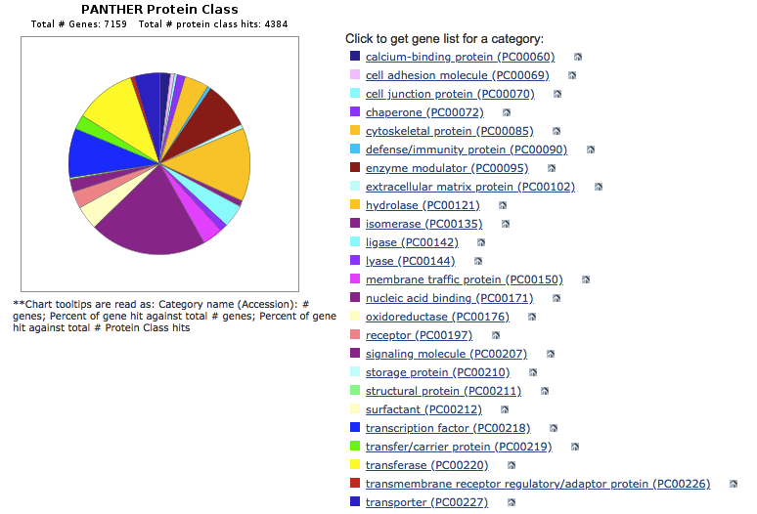
Figure S1. Pie plot of “dosage sensitive” genes categorized by protein functions. The top three are nucleic acid binding, cytoskeletal proteins, and transferases.

