Splice site strength | Degree of retention (expressed as PSI)
A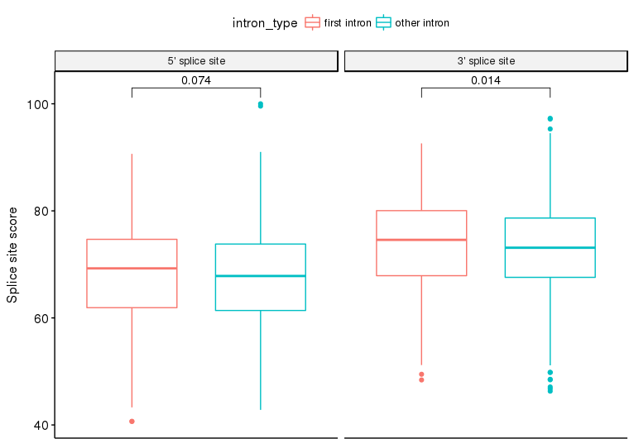 | B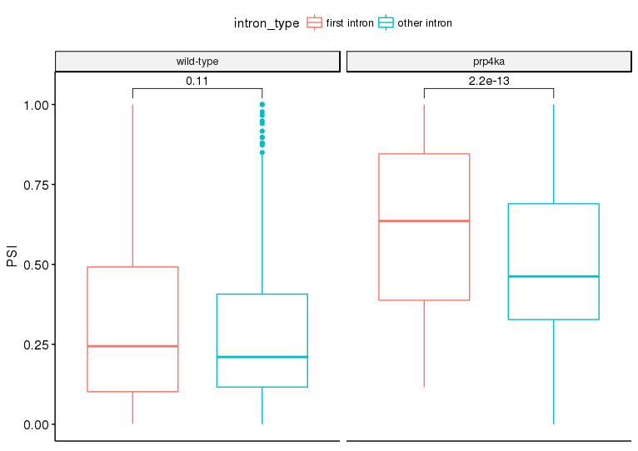
C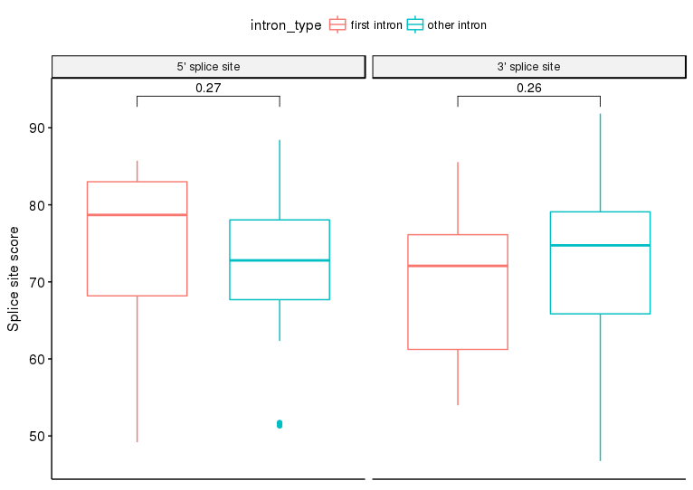 | D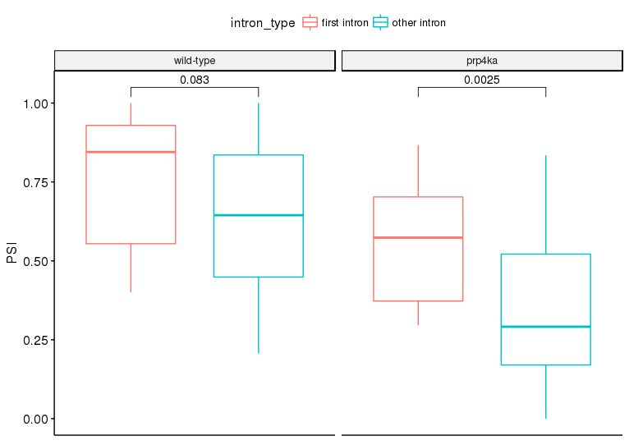
E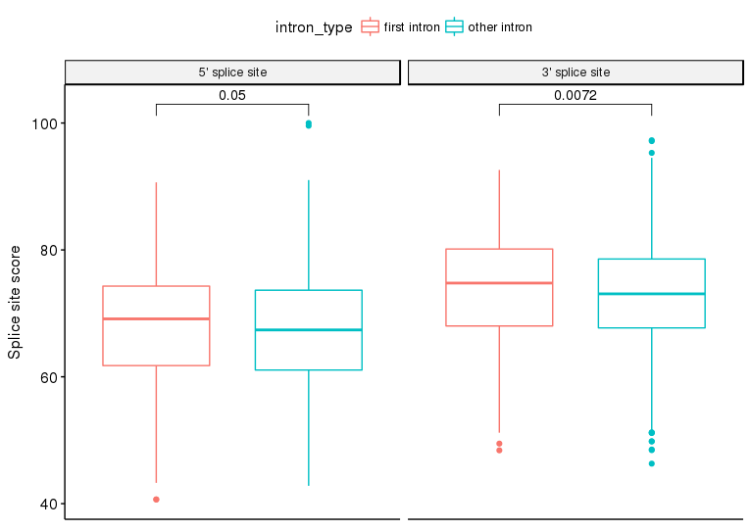 | F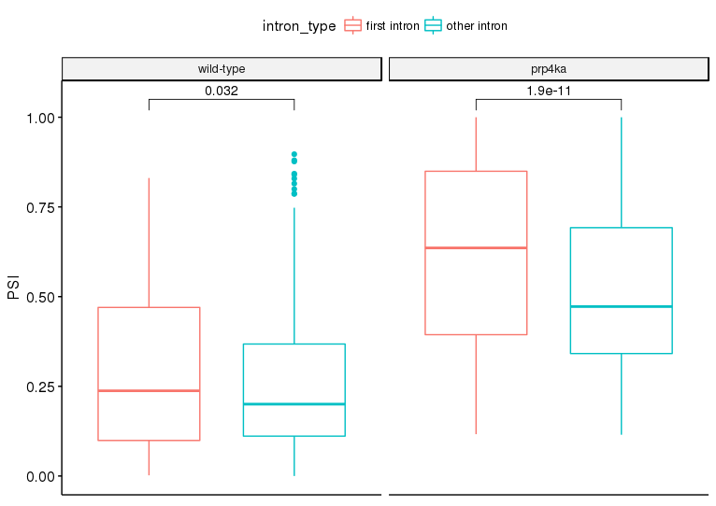
Figure S9: First intron splicing in wild-type and the prp4ka mutant. The splice site scores of both the 5’ and 3’ splice sites (left column) and the degree of retention (represented by PSI, Percent Spliced In, values; right column) were compared for the first introns versus all other retained introns (A and B). Additionally, comparisons were made for introns less retained in prp4ka (C and D) and introns more retained in prp4ka (E and F). Significance values were derived from applying Wilcoxon tests to the different groups.

