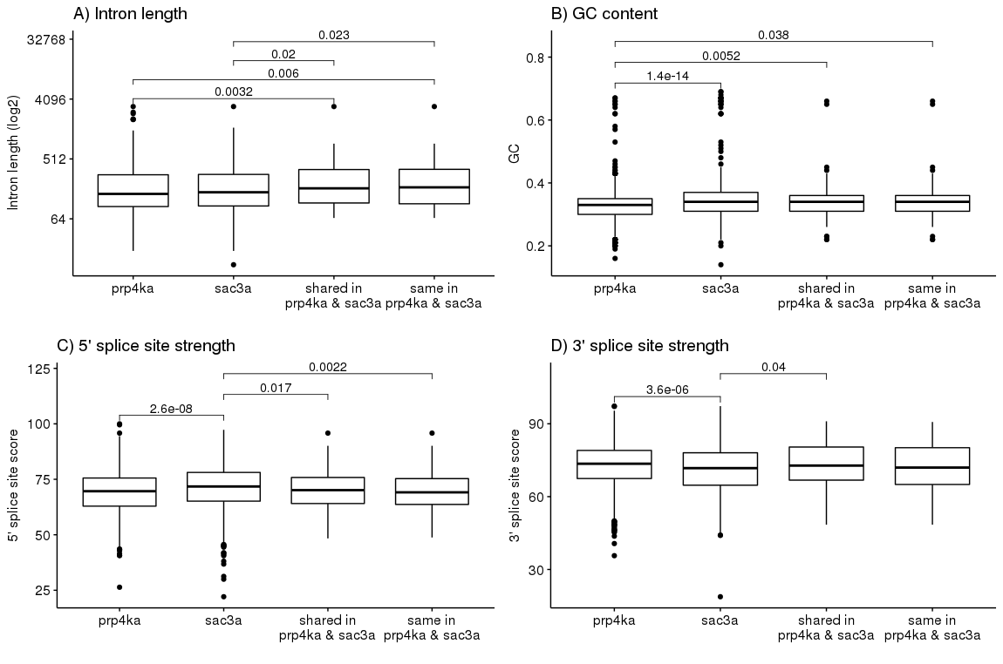
Figure S8: Analysis of alternative introns differentially regulated in both prp4ka and sac3a mutants. The intron length, guanine-cytosine (GC) content, and the 5’ and 3’ splice site scores of the alternative introns of prp4ka, sac3a, and of the events regulated in both mutants (shared and same) were compared. The “shared”-subgroup describes the evens regulated In both mutants and the “same”-subgroup describes the event regulated in the same manner in both mutants.

