Figure S7: Supplemental Note 2 - Statistical analysis of features of introns affected by differential alternative splicing in the sac3a mutant
The 5’ splice site strength, 3’ splice site strength, guanine-cytosine (GC) content and length were compared for “non-changing-events” and the “up and down” regulated events. The “const. introns” group represents all the constitutive introns in the Arabidopsis AtRTD2 transcriptome, for which no SUPPA events have been annotated. The “No change” category always describes the intron(s), the features of intron(s), of the particular alternative splicing event type which is not changing in the prp4ka mutant, relative to wild-type. The significance of the differences between groups were tested using t-tests. Significant findings (p-value < 0.01) are marked in red.

Intron retention
Included less, the intron is included less relative to wild-type
Included more, the intron is included more (more retained) relative to wild-type

5’ splice site strength |  |  |  |  | 3’ splice site strength
 | CSI | No change | Included less | Included more |  | CSI | No change | Included less | Included more
mean | 75.002 | 72.805 | 71.683 | 69.967 | mean | 73.275 | 71.586 | 73.649 | 70.444
median | 75.808 | 73.696 | 72.671 | 71.294 | median | 73.654 | 72.187 | 74.060 | 70.450
CSI x no change |  |  | 2.275e-200 |  | CSI x no change |  |  | 2.485e-149
CSI x included less |  |  | 6.557e-05 |  | CSI x included less |  |  | 0.598
CSI x included more |  |  | 9.325e-19 |  | CSI x included more |  |  | 2.541e-07
No change x included less |  |  | 0.170 |  | No change x included less |  |  | 0.00407
No change x included more |  |  | 2.322e-07 |  | No change x included more |  |  | 0.035
Included less x included more |  |  | 0.078 |  | Included less x included more |  |  | 0.00034
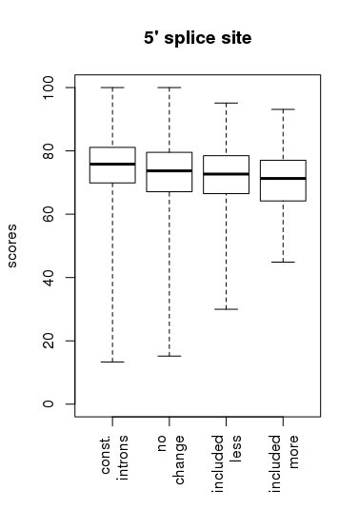 |  |  |  |  | 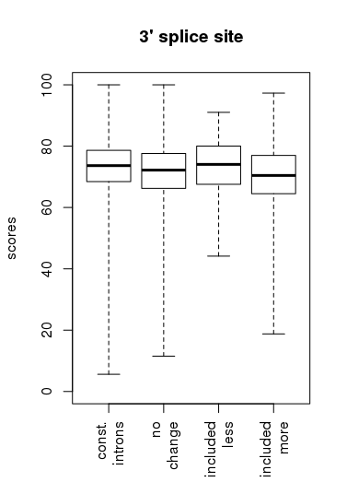

GC content |  |  |  |  | Intron size
 | CSI | No change | Included less | Included more |  | CSI | No change | Included less | Included more
min | 0.070 | 0.120 | 0.210 | 0.140 | min | 4 | 8 | 42 | 13
5% | 0.240 | 0.260 | 0.270 | 0.260 | 5% | 75 | 73 | 77 | 74
25% | 0.300 | 0.310 | 0.310 | 0.310 | 25% | 86 | 88 | 99 | 97
median | 0.330 | 0.330 | 0.340 | 0.340 | median | 99 | 117 | 145 | 139
75% | 0.350 | 0.360 | 0.360 | 0.370 | 75% | 162 | 243 | 231 | 281
95% | 0.400 | 0.410 | 0.400 | 0.410 | 95% | 474 | 552 | 513 | 575
max | 0.820 | 0.750 | 0.670 | 0.620 | max | 57631 | 5480 | 909 | 1090
CSI x no change |  |  | 8.327e-175 |  | CSI x no change |  |  | 1.770e-76
CSI x included less |  |  | 0.00011 |  | CSI x included less |  |  | 0.021
CSI x included more |  |  | 1.997e-10 |  | CSI x included more |  |  | 3.608e-06
No change x included less |  |  | 0.331 |  | No change x included less |  |  | 0.754
No change x included more |  |  | 0.00591 |  | No change x included more |  |  | 0.070
Included less x included more |  |  | 0.343 |  | Included less x included more |  |  | 0.142
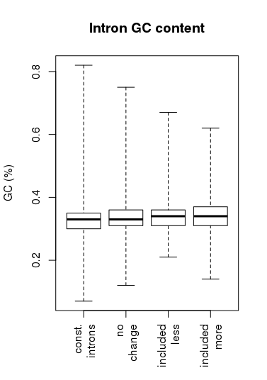 |  |  |  |  | 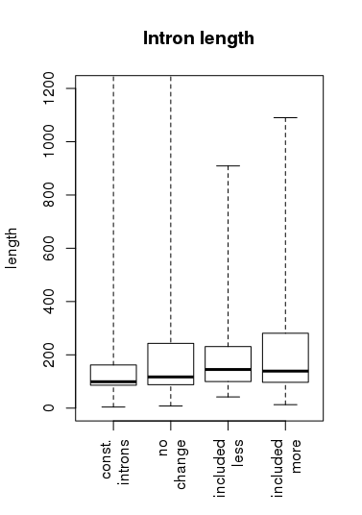

Exitron
Included less, the exitron is included less relative to wild-type
Included more, the exitron is included more (more retained) relative to wild-type

5’ splice site strength |  |  |  |  | 3’ splice site strength
 | CSI | No change | Included less | Included more |  | CSI | No change | Included less | Included more
mean | 75.002 | 65.268 | 58.410 | 63.903 | mean | 73.275 | 63.095 | 59.640 | 63.243
median | 75.808 | 67.950 | 62.515 | 67.981 | median | 73.654 | 64.342 | 62.444 | 64.843
CSI x no change |  |  | 1.934e-204 |  | CSI x no change |  |  | 2.196e-305
CSI x included less |  |  | 0.016 |  | CSI x included less |  |  | 0.00298
CSI x included more |  |  | 7.291e-05 |  | CSI x included more |  |  | 7.326e-06
No change x included less |  |  | 0.259 |  | No change x included less |  |  | 0.347
No change x included more |  |  | 0.579 |  | No change x included more |  |  | 0.938
Included less x included more |  |  | 0.392 |  | Included less x included more |  |  | 0.376
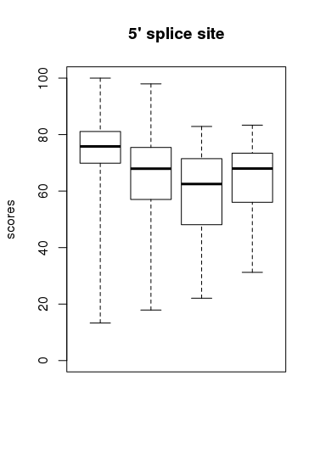 |  |  |  |  | 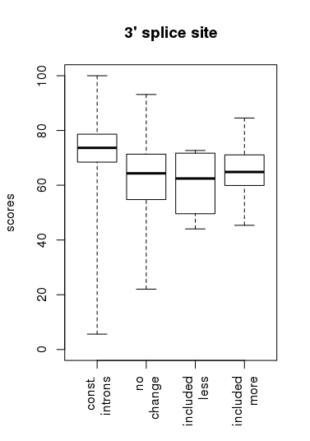

GC content |  |  |  |  | Intron size
 | CSI | No change | Included less | Included more |  | CSI | No change | Included less | Included more
min | 0.070 | 0.180 | 0.350 | 0.320 | min | 4 | 16 | 69 | 21
5% | 0.240 | 0.320 | 0.355 | 0.330 | 5% | 75 | 63 | 72 | 42
25% | 0.300 | 0.370 | 0.390 | 0.355 | 25% | 86 | 81 | 79 | 78
median | 0.330 | 0.410 | 0.440 | 0.420 | median | 99 | 98 | 89 | 90
75% | 0.350 | 0.460 | 0.645 | 0.495 | 75% | 162 | 114 | 183 | 122
95% | 0.400 | 0.640 | 0.660 | 0.660 | 95% | 474 | 462 | 331 | 247
max | 0.820 | 0.740 | 0.660 | 0.690 | max | 57631 | 2847 | 432 | 289
CSI x no change |  |  | 0.0 |  | CSI x no change |  |  | 0.00793
CSI x included less |  |  | 0.00136 |  | CSI x included less |  |  | 0.576
CSI x included more |  |  | 8.514e-07 |  | CSI x included more |  |  | 1.222e-05
No change x included less |  |  | 0.116 |  | No change x included less |  |  | 0.807
No change x included more |  |  | 0.432 |  | No change x included more |  |  | 0.00026
Included less x included more |  |  | 0.252 |  | Included less x included more |  |  | 0.277
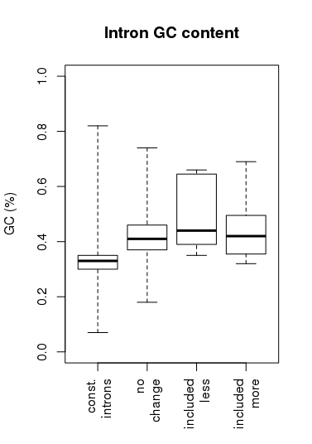 |  |  |  |  | 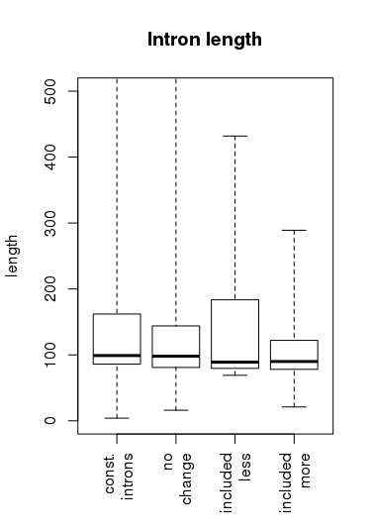

Alternative 5’ splice sites
Used more, the 5’ splice site used more compared to the other 5’ splice site defining the event
Used less, the 5’ splice site used less compared to the other 3’ splice site defining the event

5’ splice site strength
 | CSI | No change | Used less | Used more
mean | 75.002 | 69.265 | 67.085 | 69.235
median | 75.808 | 70.037 | 67.995 | 70.449
CSI x no change |  |  | 0.0
CSI x used less |  |  | 1.407e-13
CSI x used more |  |  | 9.860e08
No change x used less |  |  | 0.022
No change x used more |  |  | 0.976
Used less x used more |  |  | 0.120
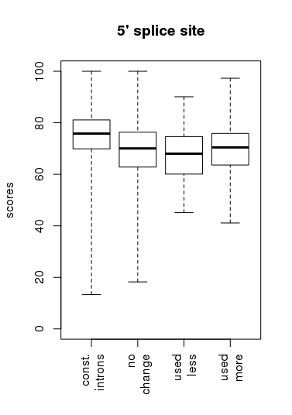

GC content |  |  |  |  | Intron size
 | CSI | No change | Used less | Used more |  | CSI | No change | Used less | Used more
min | 0.070 | 0.140 | 0.250 | 0.220 | min | 4 | 14 | 73 | 67
5% | 0.240 | 0.270 | 0.290 | 0.290 | 5% | 75 | 77 | 94 | 86
25% | 0.300 | 0.310 | 0.330 | 0.320 | 25% | 86 | 96 | 162 | 113
median | 0.330 | 0.330 | 0.350 | 0.330 | median | 99 | 144 | 285 | 173
75% | 0.350 | 0.360 | 0.370 | 0.360 | 75% | 162 | 304 | 526 | 336
95% | 0.400 | 0.400 | 0.416 | 0.400 | 95% | 474 | 666 | 865 | 742
max | 0.820 | 0.710 | 0.660 | 0.670 | max | 57631 | 5016 | 1403 | 1064
CSI x no change |  |  | 1.602e-127 |  | CSI x no change |  |  | 1.649e-192
CSI x used less |  |  | 1.066e-06 |  | CSI x used less |  |  | 5.628e-12
CSI x used more |  |  | 0.00049 |  | CSI x used more |  |  | 1.834e-05
No change x used less |  |  | 0.00115 |  | No change x used less |  |  | 2.940e-06
No change x used more |  |  | 0.084 |  | No change x used more |  |  | 0.471
Used less x used more |  |  | 0.251 |  | Used less x used more |  |  | 0.00052
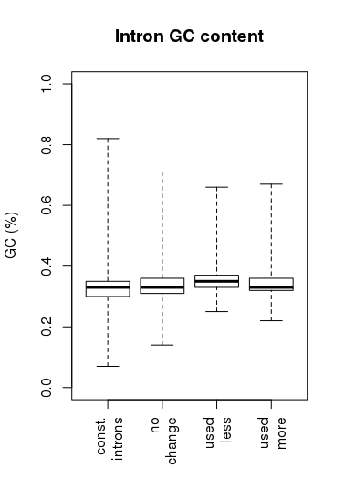 |  |  |  |  | 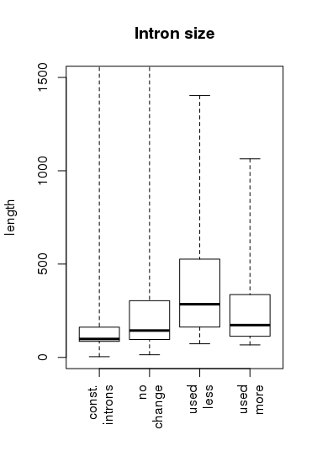

Alternative 3’ splice sites
Used more, the 3’ splice site used more compared to the other 3’ splice site defining the event
Used less, the 3’ splice site used less compared to the other 3’ splice site defining the event

3’ splice site strength
 | CSI | No change | Used less | Used more
mean | 73.275 | 69.011 | 68.146 | 68.416
median | 73.654 | 69.434 | 68.454 | 68.613
CSI x no change |  |  | 0.0
CSI x used less |  |  | 1.068e-07
CSI x used more |  |  | 7.385e-07
No change x used less |  |  | 0.342
No change x used more |  |  | 0.522
Used less x used more |  |  | 0.834
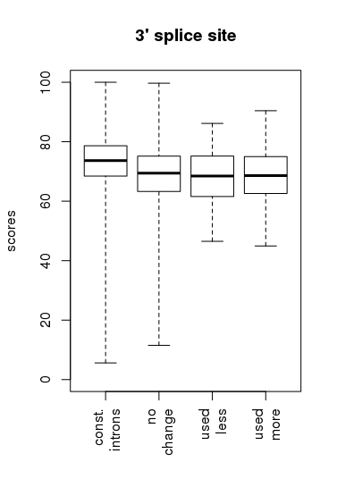

GC content |  |  |  |  | Intron size
 | CSI | No change | Used less | Used more |  | CSI | No change | Used less | Used more
min | 0.070 | 0.100 | 0.220 | 0.240 | min | 4 | 21 | 51 | 69
5% | 0.240 | 0.260 | 0.270 | 0.273 | 5% | 75 | 74 | 83 | 78
25% | 0.300 | 0.310 | 0.310 | 0.310 | 25% | 86 | 90 | 110 | 101
median | 0.330 | 0.330 | 0.340 | 0.330 | median | 99 | 119 | 198 | 159
75% | 0.350 | 0.360 | 0.370 | 0.355 | 75% | 162 | 244 | 334 | 317
95% | 0.400 | 0.400 | 0.420 | 0.407 | 95% | 474 | 558 | 684 | 700
max | 0.820 | 0.710 | 0.690 | 0.680 | max | 57631 | 5673 | 1500 | 1515
CSI x no change |  |  | 1.744e-114 |  | CSI x no change |  |  | 2.311e-108
CSI x used less |  |  | 0.00083 |  | CSI x used less |  |  | 5.883e-06
CSI x used more |  |  | 0.00878 |  | CSI x used more |  |  | 0.00037
No change x used less |  |  | 0.023 |  | No change x used less |  |  | 0.00427
No change x used more |  |  | 0.114 |  | No change x used more |  |  | 0.054
Used less x used more |  |  | 0.674 |  | Used less x used more |  |  | 0.559
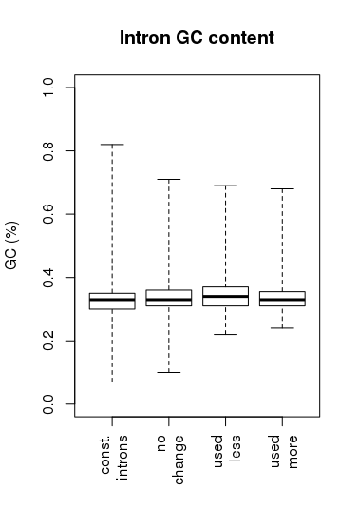 |  |  |  |  | 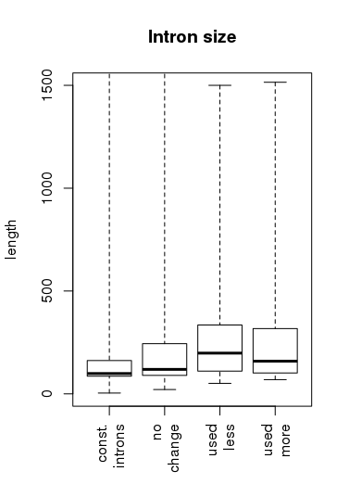

Exon skipping
Skipped more, the exon is less often included.
Skipped less, the exon is more often included.

upstream
5’ss
downstream
3’ss
3’ss
5’ss

Upstream 5’ss strength |  |  |  | Downstream 3’ss strength
 | No change | Skipped more | Skipped less |  | No change | Skipped more | Skipped less
mean | 74.262 | 76.244 | 69.305 | mean | 72.752 | 77.244 | 71.626
median | 74.818 | 73.350 | 68.553 | median | 72.886 | 77.264 | 70.211
No change x skipped more |  |  | 0.495 | No change x skipped more |  |  | 0.033
No change x skipped less |  |  | 0.041 | No change x skipped less |  |  | 0.503
Skipped more x skipped less |  |  | 0.067 | Skipped more x skipped less |  |  | 0.029
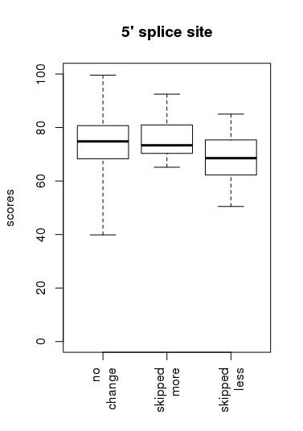 |  |  |  | 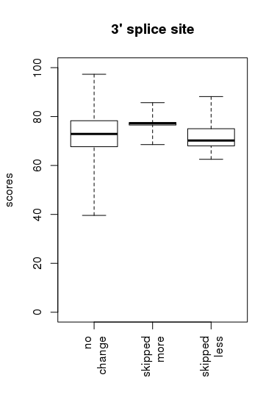

3’ss strength |  |  |  | 5’ss strength
 | No change | Skipped more | Skipped less |  | No change | Skipped more | Skipped less
mean | 72.521 | 74.272 | 73.614 | mean | 73.626 | 74.421 | 73.414
median | 73.153 | 75.969 | 75.208 | median | 74.271 | 74.453 | 72.815
No change x skipped more |  |  | 0.418 | No change x skipped more |  |  | 0.755
No change x skipped less |  |  | 0.467 | No change x skipped less |  |  | 0.890
Skipped more x skipped less |  |  | 0.797 | Skipped more x skipped less |  |  | 0.738
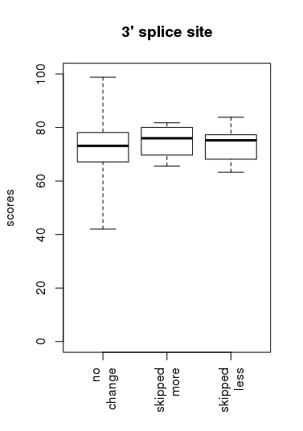 |  |  |  | 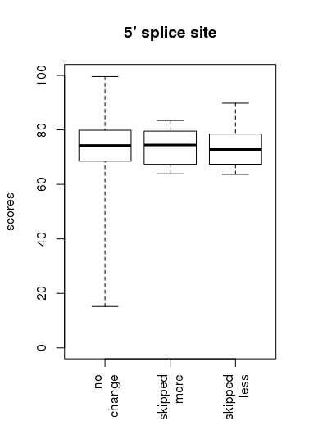

5’ss strength |  | 3’ss strength
No change - Upstream 5’ss x 5’ss | 0.00872 | No change - Upstream 3’ss x 3’ss | 0.291
Skipped less - Upstream 5’ss x 5’ss | 0.149 | Skipped less - Upstream 3’ss x 3’ss | 0.371
Skipped more - Upstream 5’ss x 5’ss | 0.629 | Skipped more - Upstream 3’ss x 3’ss | 0.285

Upstream intron GC content |  |  |  | Downstream intron GC content
 | No change | Skipped more | Skipped less |  | No change | Skipped more | Skipped less
min | 0.14 | 0.3 | 0.29 | min | 0.15 | 0.23 | 0.3
5% | 0.26 | 0.312 | 0.29 | 5% | 0.25 | 0.262 | 0.316
25% | 0.3 | 0.33 | 0.3 | 25% | 0.3 | 0.33 | 0.33
median | 0.33 | 0.34 | 0.35 | median | 0.33 | 0.34 | 0.34
75% | 0.35 | 0.36 | 0.36 | 75% | 0.35 | 0.34 | 0.35
95% | 0.39 | 0.36 | 0.382 | 95% | 0.39 | 0.376 | 0.384
max | 0.67 | 0.36 | 0.39 | max | 0.69 | 0.4 | 0.4
No change x skipped more |  |  | 0.079 | No change x skipped more |  |  | 0.923
No change x skipped less |  |  | 0.177 | No change x skipped less |  |  | 0.00898
Skipped more x skipped less |  |  | 0.823 | Skipped more x skipped less |  |  | 0.311
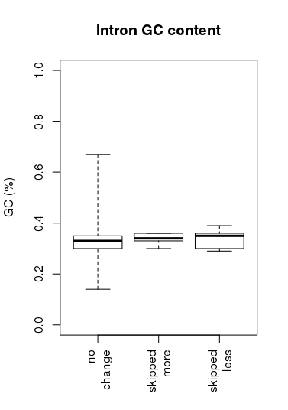 |  |  |  | 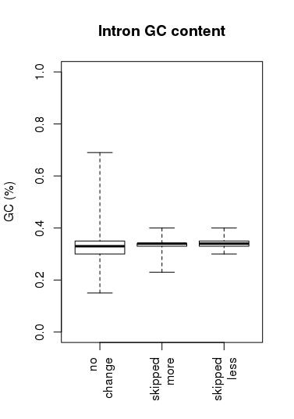

Upstream intron size |  |  |  | Downstream intron size
 | No change | Skipped more | Skipped less |  | No change | Skipped more | Skipped less
min | 36 | 85 | 79 | min | 40 | 73 | 83
5% | 74 | 87 | 88 | 5% | 76 | 79 | 91
25% | 95 | 98 | 142 | 25% | 94 | 90 | 117
median | 150 | 163 | 186 | median | 143 | 92 | 147
75% | 297 | 183 | 200 | 75% | 290 | 168 | 160
95% | 654 | 351 | 415 | 95% | 636 | 1997 | 319
max | 3929 | 422 | 442 | max | 2713 | 3158 | 388
No change x skipped more |  |  | 0.093 | No change x skipped more |  |  | 0.525
No change x skipped less |  |  | 0.093 | No change x skipped less |  |  | 0.00275
Skipped more x skipped less |  |  | 0.582 | Skipped more x skipped less |  |  | 0.412
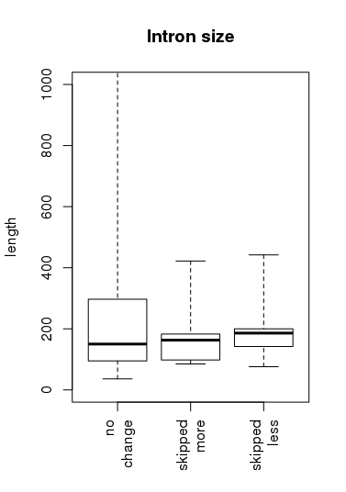 |  |  |  | 