Figure S6: Supplemental Note 1 - Statistical analysis of features of introns affected by differential alternative splicing in the prp4ka mutant
The 5’ splice site strength, 3’ splice site strength, guanine-cytosine (GC) content and length were compared for “non-changing-events” and the “up and down” regulated events. The “const. introns” group represents all the constitutive introns in the Arabidopsis AtRTD2 transcriptome, for which no SUPPA events have been annotated. The “No change” category always describes the intron(s), the features of intron(s), of the particular alternative splicing event type which is not changing in the prp4ka mutant, relative to wild-type. The significance of the differences between groups were tested using t-tests. Significant findings (p-value < 0.01) are marked in red.

Intron retention
Included less, the intron is included less relative to wild-type
Included more, the intron is included more (more retained) relative to wild-type

5’ splice site strength |  |  |  |  | 3’ splice site strength
 | const. introns | No change | Included less | Included more |  | const. introns | No change | Included less | Included more
mean | 75.002 | 73.088 | 73.125 | 67.566 | mean | 73.275 | 71.475 | 71.927 | 73.309
median | 75.808 | 74.021 | 74.840 | 68.188 | median | 73.654 | 72.074 | 74.413 | 73.668
const. introns x no change |  |  | 1.123e-148 |  | const. introns x no change |  |  | 1.547e-162
const. introns x included less |  |  | 0.135 |  | const. introns x included less |  |  | 0.313
const. introns x included more |  |  | 2.412e-152 |  | const. introns x included more |  |  | 0.884
No change x included less |  |  | 0.976 |  | No change x included less |  |  | 0.735
No change x included more |  |  | 1.131e-90 |  | No change x included more |  |  | 5.124e-14
Included less x included more |  |  | 4.118e-05 |  | Included less x included more |  |  | 0.308
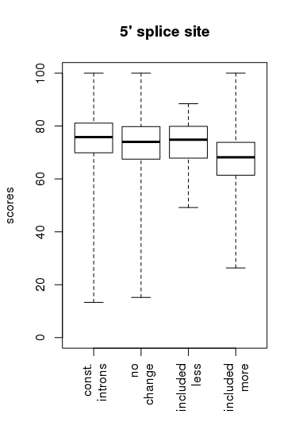 |  |  |  |  | 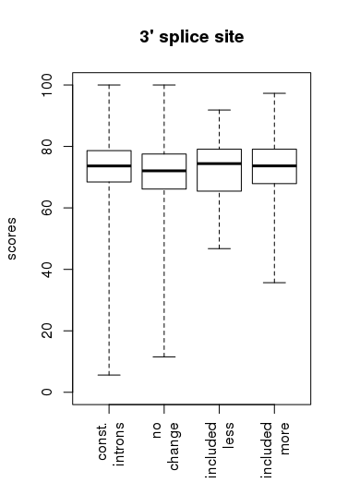

GC content |  |  |  |  | Intron size
 | const. introns | No change | Included less | Included more |  | const. introns | No change | Included less | Included more
min | 0.070 | 0.120 | 0.210 | 0.160 | min | 4 | 8 | 72 | 34
5% | 0.240 | 0.260 | 0.240 | 0.250 | 5% | 75 | 72 | 77 | 79
25% | 0.300 | 0.310 | 0.300 | 0.300 | 25% | 86 | 88 | 95 | 97
median | 0.330 | 0.330 | 0.340 | 0.330 | median | 99 | 116 | 115 | 145
75% | 0.350 | 0.360 | 0.360 | 0.350 | 75% | 162 | 241 | 211 | 275
95% | 0.400 | 0.410 | 0.400 | 0.390 | 95% | 474 | 553 | 436 | 554
max | 0.820 | 0.750 | 0.430 | 0.580 | max | 57631 | 5480 | 1094 | 1236
const. introns x no change |  |  | 1.714e-191 |  | const. introns x no change |  |  | 4.192e-70
const. introns x included less |  |  | 0.292 |  | const. introns x included less |  |  | 0.339
const. introns x included more |  |  | 0.481 |  | const. introns x included more |  |  | 1.076e-21
No change x included less |  |  | 0.449 |  | No change x included less |  |  | 0.693
No change x included more |  |  | 8.525e-18 |  | No change x included more |  |  | 0.000549
Included less x included more |  |  | 0.363 |  | Included less x included more |  |  | 0.252
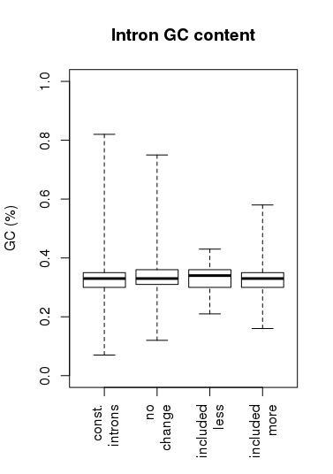 |  |  |  |  | 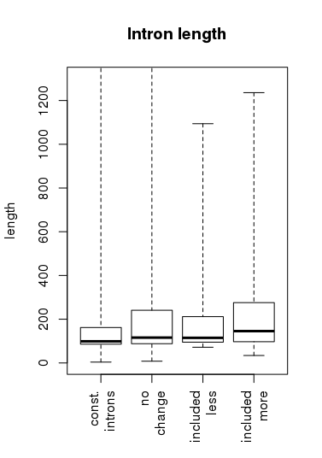

Exitron
Included less, the exitron is included less relative to wild-type
Included more, the exitron is included more (more retained) relative to wild-type

5’ splice site strength |  |  |  |  | 3’ splice site strength
 | const. introns | No change | Included less | Included more |  | const. introns | No change | Included less | Included more
mean | 75.002 | 65.183 | 67.018 | 67.314 | mean | 73.275 | 63.022 | 60.876 | 67.771
median | 75.808 | 67.883 | 72.701 | 69.228 | median | 73.654 | 64.323 | 59.356 | 67.262
const. introns x no change |  |  | 1.553e-205 |  | const. introns x no change |  |  | 1.547e-310
const. introns x included less |  |  | 0.174 |  | const. introns x included less |  |  | 0.030
const. introns x included more |  |  | 2.212e-05 |  | const. introns x included more |  |  | 0.014
No change x included less |  |  | 0.741 |  | No change x included less |  |  | 0.660
No change x included more |  |  | 0.189 |  | No change x included more |  |  | 0.032
Included less x included more |  |  | 0.989 |  | Included less x included more |  |  | 0.207
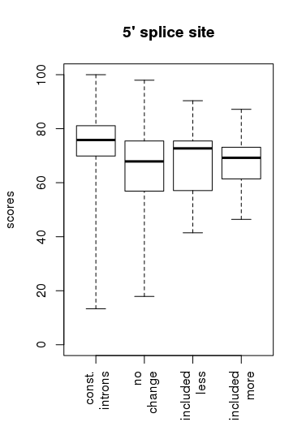 |  |  |  |  | 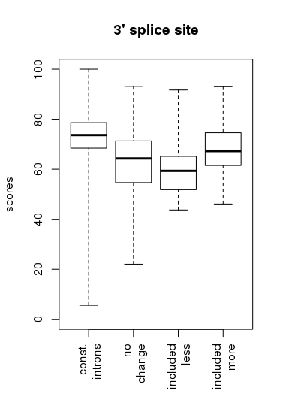

GC content |  |  |  |  | Intron size
 | const. introns | No change | Included less | Included more |  | const. introns | No change | Included less | Included more
min | 0.070 | 0.180 | 0.280 | 0.260 | min | 4 | 16 | 72 | 60
5% | 0.240 | 0.320 | 0.296 | 0.270 | 5% | 75 | 63 | 75 | 75
25% | 0.300 | 0.370 | 0.370 | 0.335 | 25% | 86 | 81 | 81 | 83
median | 0.330 | 0.410 | 0.400 | 0.360 | median | 99 | 98 | 89 | 96
75% | 0.350 | 0.470 | 0.400 | 0.425 | 75% | 162 | 145 | 106 | 104
95% | 0.400 | 0.640 | 0.670 | 0.594 | 95% | 474 | 462 | 189 | 220
max | 0.820 | 0.740 | 0.670 | 0.660 | max | 57631 | 2847 | 222 | 396
const. introns x no change |  |  | 0.0 |  | const. introns x no change |  |  | 0.00928
const. introns x included less |  |  | 0.048 |  | const. introns x included less |  |  | 0.00505
const. introns x included more |  |  | 0.00088 |  | const. introns x included more |  |  | 5.626e-06
No change x included less |  |  | 0.942 |  | No change x included less |  |  | 0.014
No change x included more |  |  | 0.00550 |  | No change x included more |  |  | 0.00017
Included less x included more |  |  | 0.326 |  | Included less x included more |  |  | 0.924
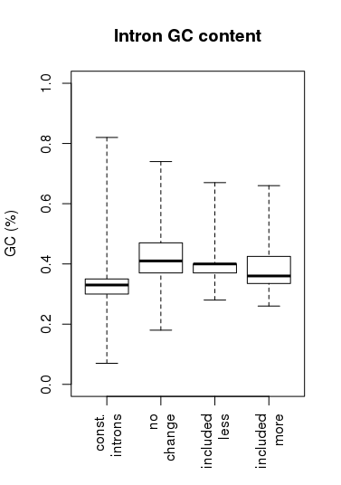 |  |  |  |  | 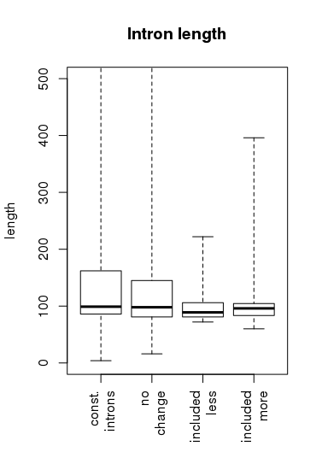

Alternative 5’ splice sites
Used more, the 5’ splice site used more compared to the other 5’ splice site defining the event
Used less, the 5’ splice site used less compared to the other 3’ splice site defining the event

5’ splice site strength
 | const. introns | No change | Used less | used more
mean | 75.002 | 69.260 | 68.228 | 69.639
median | 75.808 | 70.037 | 67.928 | 70.740
const. introns x no change |  |  | 0.0
const. introns x used less |  |  | 8.433e-29
const. introns x used more |  |  | 3.304e-15
No change x used less |  |  | 0.058
No change x used more |  |  | 0.556
Used less x used more |  |  | 0.090
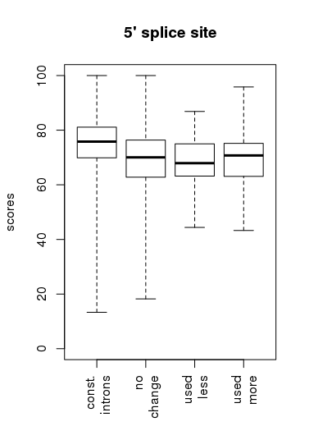

GC content |  |  |  |  | Intron size
 | const. introns | No change | used less | used more |  | const. introns | No change | Used less | Used more
min | 0.070 | 0.140 | 0.200 | 0.210 | min | 4 | 14 | 72 | 66
5% | 0.240 | 0.270 | 0.260 | 0.280 | 5% | 75 | 77 | 88 | 79
25% | 0.300 | 0.310 | 0.310 | 0.310 | 25% | 86 | 96 | 108 | 116
median | 0.330 | 0.330 | 0.330 | 0.330 | median | 99 | 144 | 202 | 205
75% | 0.350 | 0.360 | 0.350 | 0.360 | 75% | 162 | 303 | 395 | 377
95% | 0.400 | 0.400 | 0.390 | 0.398 | 95% | 474 | 670 | 774 | 681
max | 0.820 | 0.710 | 0.640 | 0.670 | max | 57631 | 5016 | 2045 | 1372
const. introns x no change |  |  | 4.689e-130 |  | const. introns x no change |  |  | 5.204e-186
const. introns x used less |  |  | 0.037 |  | const. introns x used less |  |  | 5.088e-13
const. introns x used more |  |  | 3.591e-06 |  | const. introns x used more |  |  | 1.848e-13
No change x used less |  |  | 0.047 |  | No change x used less |  |  | 0.00276
No change x used more |  |  | 0.557 |  | No change x used more |  |  | 0.012
Used less x used more |  |  | 0.064 |  | Used less x used more |  |  | 0.545
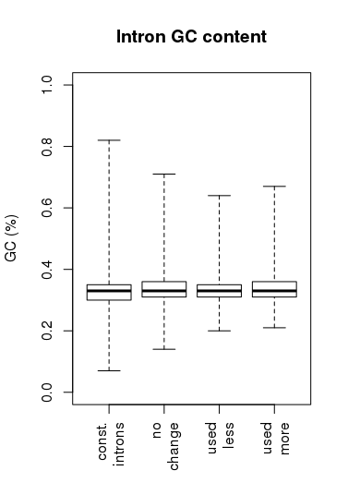 |  |  |  |  | 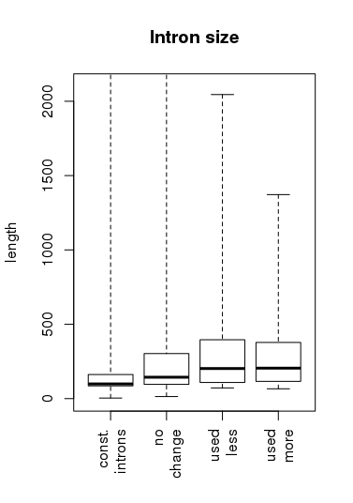

Alternative 3’ splice sites
Used more, the 3’ splice site used more compared to the other 3’ splice site defining the event
Used less, the 3’ splice site used less compared to the other 3’ splice site defining the event

3’ splice site strength
 | const. introns | No change | Used less | Used more
mean | 73.275 | 68.986 | 70.839 | 69.767
median | 73.654 | 69.405 | 72.752 | 70.067
const. introns x no change |  |  | 0.0
const. introns x used less |  |  | 0.00157
const. introns x used more |  |  | 1.830e-06
No change x used less |  |  | 0.016
No change x used more |  |  | 0.272
Used less x used more |  |  | 0.301
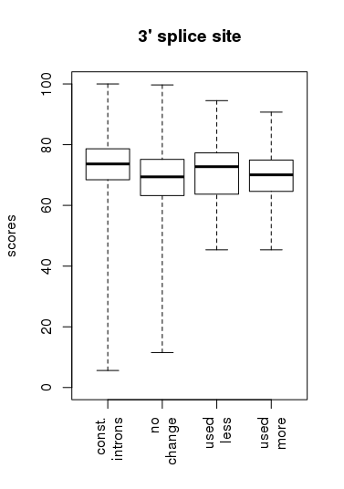

GC content |  |  |  |  | Intron size
 | const. introns | No change | Used less | Used more |  | const. introns | No change | Used less | Used more
min | 0.070 | 0.100 | 0.210 | 0.200 | min | 4 | 21 | 63 | 21
5% | 0.240 | 0.260 | 0.260 | 0.260 | 5% | 75 | 74 | 82 | 75
25% | 0.300 | 0.310 | 0.310 | 0.300 | 25% | 86 | 90 | 105 | 94
median | 0.330 | 0.330 | 0.330 | 0.330 | median | 99 | 119 | 189 | 153
75% | 0.350 | 0.360 | 0.350 | 0.350 | 75% | 162 | 224 | 337 | 287
95% | 0.400 | 0.400 | 0.380 | 0.380 | 95% | 474 | 586 | 840 | 785
max | 0.820 | 0.710 | 0.660 | 0.650 | max | 57631 | 5673 | 2592 | 2470
const. introns x no change |  |  | 3.548e-117 |  | const. introns x no change |  |  | 9.670e-107
const. introns x used less |  |  | 0.051 |  | const. introns x used less |  |  | 1.353e-06
const. introns x used more |  |  | 0.181 |  | const. introns x used more |  |  | 0.00071
No change x used less |  |  | 0.998 |  | No change x used less |  |  | 0.00049
No change x used more |  |  | 0.561 |  | No change x used more |  |  | 0.057
Used less x used more |  |  | 0.677 |  | Used less x used more |  |  | 0.211
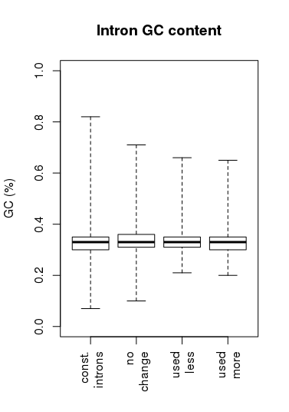 |  |  |  |  | 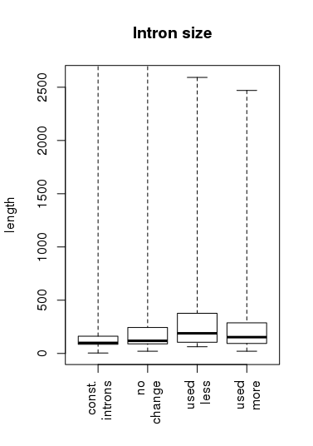

Exon skipping
Skipped more, the exon is less often included.
Skipped less, the exon is more often included.

upstream
5’ss
downstream
3’ss
3’ss
5’ss

Upstream 5’ss strength |  |  |  | Downstream 3’ss strength
 | No change | Skipped more | Skipped less |  | No change | Skipped more | Skipped less
mean | 74.245 | 75.060 | 70.945 | mean | 72.781 | 70.079 | 73.522
median | 74.796 | 73.362 | 75.615 | median | 72.915 | 69.588 | 71.672
No change x skipped more |  |  | 0.649 | No change x skipped more |  |  | 0.091
No change x skipped less |  |  | 0.341 | No change x skipped less |  |  | 0.706
Skipped more x skipped less |  |  | 0.287 | Skipped more x skipped less |  |  | 0.172
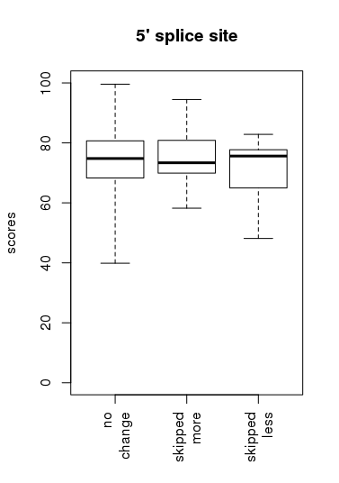 |  |  |  | 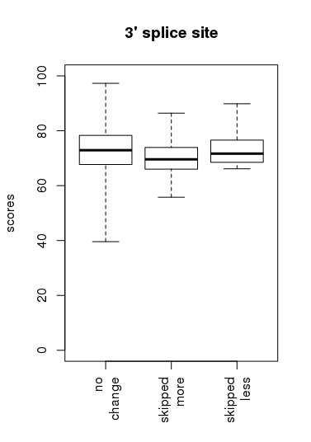

3’ss strength |  |  |  | 5’ss strength
 | No change | Skipped more | Skipped less |  | No change | Skipped more | Skipped less
mean | 72.514 | 74.927 | 71.875 | mean | 73.648 | 73.745 | 68.666
median | 73.159 | 75.024 | 70.354 | median | 74.271 | 74.164 | 72.991
No change x skipped more |  |  | 0.183 | No change x skipped more |  |  | 0.945
No change x skipped less |  |  | 0.723 | No change x skipped less |  |  | 0.112
Skipped more x skipped less |  |  | 0.228 | Skipped more x skipped less |  |  | 0.132
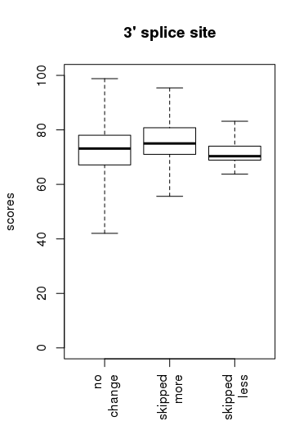 |  |  |  | 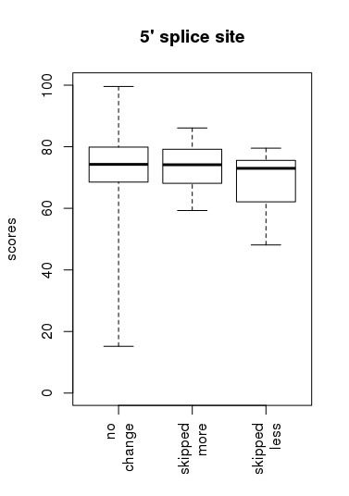

5’ss strength |  | 3’ss strength
No change - Upstream 5’ss x 5’ss | 0.014 | No change - Upstream 3’ss x 3’ss | 0.222
Skipped less - Upstream 5’ss x 5’ss | 0.609 | Skipped less - Upstream 3’ss x 3’ss | 0.531
Skipped more - Upstream 5’ss x 5’ss | 0.561 | Skipped more - Upstream 3’ss x 3’ss | 0.043

Upstream intron GC content |  |  |  | Downstream intron GC content
 | No change | Skipped more | Skipped less |  | No change | Skipped more | Skipped less
min | 0.14 | 0.27 | 0.28 | min | 0.15 | 0.23 | 0.25
5% | 0.26 | 0.285 | 0.2855 | 5% | 0.25 | 0.285 | 0.261
25% | 0.3 | 0.305 | 0.31 | 25% | 0.3 | 0.295 | 0.295
median | 0.33 | 0.335 | 0.33 | median | 0.33 | 0.34 | 0.345
75% | 0.35 | 0.35 | 0.3525 | 75% | 0.35 | 0.3575 | 0.355
95% | 0.39 | 0.3775 | 0.37 | 95% | 0.39 | 0.39 | 0.3925
max | 0.67 | 0.38 | 0.37 | max | 0.69 | 0.4 | 0.42
No change x skipped more |  |  | 0.435 | No change x skipped more |  |  | 0.138
No change x skipped less |  |  | 0.814 | No change x skipped less |  |  | 0.768
Skipped more x skipped less |  |  | 0.798 | Skipped more x skipped less |  |  | 0.672
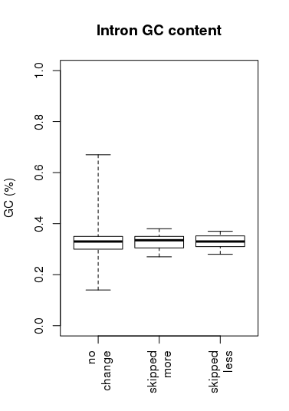 |  |  |  | 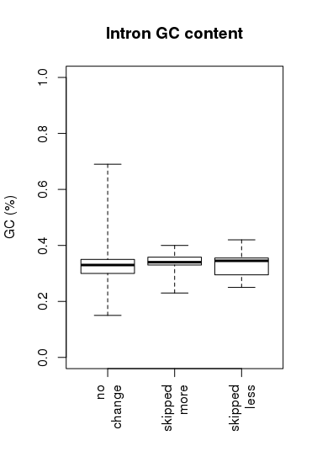

Upstream intron size |  |  |  | Downstream intron size
 | No change | Skipped more | Skipped less |  | No change | Skipped more | Skipped less
min | 36 | 82 | 76 | min | 40 | 83 | 79
5% | 74 | 93 | 79.3 | 5% | 76 | 88.25 | 85.05
25% | 95 | 128.25 | 130.5 | 25% | 94 | 126.5 | 113
median | 150 | 183.5 | 183.5 | median | 142 | 259.5 | 140.5
75% | 295 | 335.75 | 292.25 | 75% | 288 | 369.25 | 191
95% | 645.5 | 797.75 | 580.65 | 95% | 634.7 | 744 | 689.25
max | 3929 | 852 | 832 | max | 2713 | 3158 | 758
No change x skipped more |  |  | 0.388 | No change x skipped more |  |  | 0.180
No change x skipped less |  |  | 0.873 | No change x skipped less |  |  | 0.974
Skipped more x skipped less |  |  | 0.696 | Skipped more x skipped less |  |  | 0.230
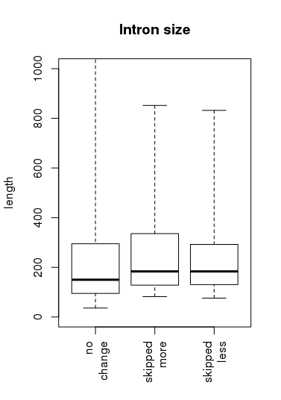 |  |  |  | 