**Supplemental Material**

**Table S1** SNP density and number of SNPs by chromosome: for each chromosome the number of polymorphic SNPs per Mbp, the total number of genotyped SNPs per Mbp, and the absolute numbers of polymorphic and genotyped SNPs are given.

|  |  |  |  |  |
| --- | --- | --- | --- | --- |
| Chromosome | Polymorphic SNP  (per Mbp) | SNP loci  (per Mbp) | Polymorphic SNP | SNP loci |
| Chr1 | 69.9 | 262.8 | 13,633 | 51,251 |
| Chr2 | 53.0 | 232.1 | 9,641 | 42,248 |
| Chr3 | 62.2 | 243.0 | 9,948 | 38,865 |
| Chr4 | 54.2 | 234.1 | 8,517 | 36,748 |
| Chr5 | 54.0 | 246.8 | 8,201 | 37,506 |
| Chr6 | 59.1 | 247.6 | 8,870 | 37,137 |
| Chr7 | 55.0 | 241.2 | 7,973 | 34,980 |
| Chr8 | 50.0 | 248.5 | 6,393 | 32,059 |
| Chr9 | 70.4 | 249.2 | 8,796 | 31,154 |
| Chr10 | 34.0 | 224.1 | 4,446 | 29,356 |
| Chr11 | 62.0 | 233.8 | 7,543 | 28,520 |
| Chr12 | 56.3 | 254.2 | 6,750 | 30,507 |
| Chr13 | 56.5 | 247.1 | 6,783 | 29,652 |
| Chr14 | 58.0 | 211.5 | 7,254 | 26,441 |
| Chr15 | 58.6 | 252.7 | 6,092 | 26,279 |
| Chr16 | 54.5 | 254.6 | 4,960 | 23,170 |
| Chr17 | 68.2 | 268.1 | 6,480 | 25,474 |
| Chr18 | 46.4 | 259.3 | 4,224 | 23,599 |
| Chr19 | 65.8 | 265.2 | 4,015 | 16,179 |
| ChrX | 11.8 | 127.9 | 2,022 | 21,870 |
| Overall | 54.3 | 237.2 | 142,541 | 622,995 |

**Table S2** Estimates of genetic parameters for all traits obtained by three different kinds of relationship matrices.

|  |  |  |  |  |  |  |  |
| --- | --- | --- | --- | --- | --- | --- | --- |
| Trait | Rela-tionship |  |  |  |  |  |  |
| LS0 | Aa+x | 1.10 (0.48) | 0.18 (0.27) | 0.30 (0.16) | 2.12 (0.34) | 7.79 (0.27) | .11 (0.03) |
|  | Ga+x | 1.95 (0.64) | 0.13 (0.23) | 0.29 (0.16) | 1.82 (0.36) | 7.80 (0.27) | .17 (0.04) |
|  | Ha+x | 2.14 (0.69) | 0.15 (0.28) | 0.29 (0.16) | 1.76 (0.36) | 7.81 (0.27) | .19 (0.04) |
|  |  |  |  |  |  |  |  |
| LW0 | Aa+x | 5.70 (1.20) | 0.04 (0.62) | 0.53 (0.33) | 3.87 (0.73) | 14.5 (0.5) | .23 (0.03) |
|  | Ga+x | 8.44 (1.54) | 0.01 (0.52) | 0.49 (0.33) | 3.15 (0.75) | 14.5 (0.5) | .32 (0.04) |
|  | Ha+x | 8.97 (1.65) | 0.06 (0.62) | 0.49 (0.33) | 3.04 (0.75) | 14.6 (0.5) | .33 (0.04) |
|  |  |  |  |  |  |  |  |
| BM21 | Aa | 0.55 (0.07) |  | 2.14 (0.06) |  | 0.61 (0.03) | .17 (0.02) |
|  | Ga | 0.75 (0.09) |  | 2.12 (0.06) |  | 0.59 (0.03) | .22 (0.02) |
|  | Ha | 0.80 (0.10) |  | 2.12 (0.06) |  | 0.59 (0.03) | .23 (0.03) |
|  |  |  |  |  |  |  |  |
| BM42 | Aa | 2.64 (0.22) |  | 1.69 (0.10) | 2.90 (0.11) | 0.68 (0.04) | .33 (0.02) |
|  | Ga | 3.32 (0.28) |  | 1.68 (0.10) | 2.90 (0.11) | 0.68 (0.04) | .39 (0.03) |
|  | Ha | 3.52 (0.29) |  | 1.68 (0.10) | 2.90 (0.11) | 0.68 (0.04) | .40 (0.03) |
|  |  |  |  |  |  |  |  |
| BM63 | Aa | 4.26 (0.31) |  | 1.16 (0.10) | 4.90 (0.16) | 0.80 (0.05) | .38 (0.02) |
|  | Ga | 5.36 (0.40) |  | 1.16 (0.10) | 4.90 (0.16) | 0.80 (0.05) | .44 (0.02) |
|  | Ha | 5.67 (0.42) |  | 1.16 (0.10) | 4.90 (0.16) | 0.80 (0.05) | .45 (0.02) |
|  |  |  |  |  |  |  |  |
| BMM | Aa+x | 5.59 (0.46) | 0.00 (0.00) | 1.24 (0.16) |  | 5.73 (0.24) | .45 (0.03) |
|  | Ga+x | 7.01 (0.57) | 0.00 (0.00) | 1.23 (0.16) |  | 5.75 (0.24) | .50 (0.03) |
|  | Ha+x | 7.42 (0.61) | 0.00 (0.00) | 1.23 (0.16) |  | 5.75 (0.24) | .52 (0.03) |

Traits: litter size (LS0), litter weight (LW0), body weights at ages of 21, 42, 63 days and at mating (BM21, BM42, BM63, BMM). Kinds of relationship matrices: pedigree-derived numerator relationship matrix (A), gene-drop derived (G), combined expected and observed genomic relationships (H); subscripts indicate that autosomal relationships only (a) or both autosomal and X-chromosomal relationships (a+x) were part of the model. Genetic parameters: : autosomal additive genetic variance, : X-chromosomal additive genetic variance, : heritability, : common litter common litter environmental effect, : permanent environmental effect, : residual, standard errors in brackets.

**Table S3** Details for the restricted likelihood ratio tests of the null hypothesis of no significant X-chromosomal genetic variance by trait and kind of relationship matrix. Traits are litter size (LS0), litter weight (LW0) and body mass at ages of 21, 42, 63 days and at mating (BM21, BM42, BM63, BMM). Kinds of relationship matrices were pedigree-derived (A), computed by gene-drop (G) and combined expected and observed genomic relationships (H). The full (a+x) and the reduced (a) model were identical except of the X-chromosomal genetic variance and were compared by their respective log-likelihoods (LogL), resulting in the RLRT test-statistics and error probabilities (P-value).

|  |  |  |  |  |  |
| --- | --- | --- | --- | --- | --- |
| Trait | Relationship | LogL (a) | LogL (a+x) | RLRT | P-value |
| LS0 | Aa / Aa+x | -9918.92 | -9918.69 | 0.46 | 0.4976 |
|  | Ga / Ga+x | -9919.05 | -9918.88 | 0.34 | 0.5598 |
|  | Ha / Ha+x | -9918.45 | -9918.30 | 0.30 | 0.5839 |
|  |  |  |  |  |  |
| LW0 | Aa / Aa+x | -1908.37 | -1908.36 | 0.02 | 0.8875 |
|  | Ga / Ga+x | -1905.99 | -1905.99 | 0.00 | 1.0000 |
|  | Ha / Ha+x | -1904.94 | -1904.93 | 0.02 | 0.8875 |
|  |  |  |  |  |  |
| BM21 | Aa / Aa+x | -1549.06 | -1546.66 | 4.80 | 0.0285 |
|  | Ga / Ga+x | -1548.70 | -1546.36 | 4.68 | 0.0305 |
|  | Ha / Ha+x | -1549.22 | -1546.63 | 5.18 | 0.0228 |
|  |  |  |  |  |  |
| BM42 | Aa / Aa+x | -8038.47 | -8031.09 | 14.76 | 0.0001 |
|  | Ga / Ga+x | -8037.29 | -8030.61 | 13.36 | 0.0003 |
|  | Ha / Ha+x | -8036.76 | -8030.06 | 13.40 | 0.0003 |
|  |  |  |  |  |  |
| BM63 | Aa / Aa+x | 483.76 | 494.77 | 22.02 | 2.687E-06 |
|  | Ga / Ga+x | 483.89 | 494.86 | 21.94 | 2.836E-06 |
|  | Ha / Ha+x | 484.07 | 495.04 | 21.94 | 2.830E-06 |
|  |  |  |  |  |  |
| BMM | Aa / Aa+x | -10663.10 | -10663.10 | 0.00 | 1.0000 |
|  | Ga / Ga+x | -10663.00 | -10663.00 | 0.00 | 1.0000 |
|  | Ha / Ha+x | -10663.10 | -10663.10 | 0.00 | 1.0000 |

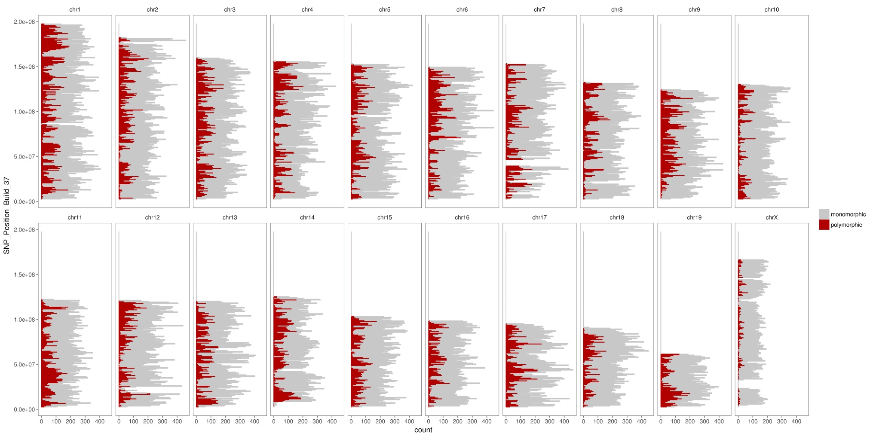**Figure S1** SNP distribution on the whole genome  
The range of each bar is 1Mbp, bars colored in red are the counts of polymorphic SNP in each 1Mbp-long genomic segment and bas colored in grey are the counts of monomorphic SNP in each 1Mbp-long genomic segment. So the height of each bar (polymorphic SNP plus monomorphic SNP) represents the overall number of all SNP markers in the 1Mbp-long genomic segment

**Figure S2** Comparison of the genetic trends for six important traits

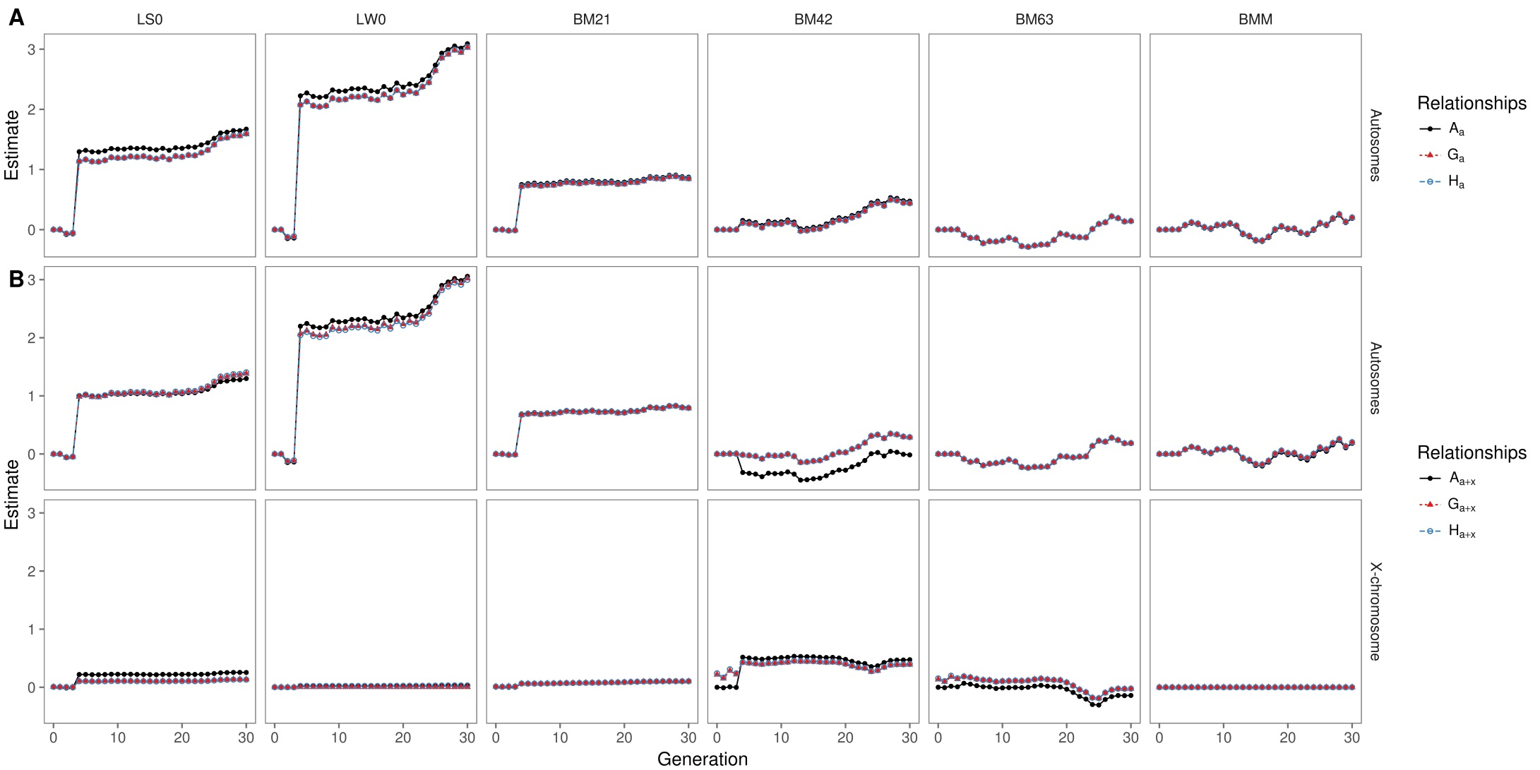

## S1: and

In the article we demonstrate



With  and  we can get



This indicates that for autosomes the sum of the gametic self-relationships inherited from parents is equal to 1. So the inbreeding coefficient can be derived by expected self-relationship subtracting 1 which follows the same rule with the calculation of the pedigree-derived inbreeding coefficient.

It should be noted that  doesn’t have to be equal to  especially when the inbreeding degrees of these two lines are different.

## S2: Direct inversion of

The inverse of the relationship matrix  can be set up directly, starting with the inverse expected relationship matrix for all founders, which usually will be small and therefore is easy to invert. Then for each other individual in the pedigree an additional column and row is added, as known for the inverse of the numerator relationship matrix (Henderson 1976). For this step we need to know the Mendelian sampling variance among full-sibs of the candidate.

**For autosomes:** The Mendelian Sampling term (MS) refers to the random within-family deviation of a candidate’s breeding value from parent average. For autosomes we have



where  is the breeding value of candidate ,  and  are the breeding values of parents  and  of individual  and  is the Mendelian Sampling term. The variance  of  can then be computed from the 3x3 relationship matrix of the candidate and its parents

 ,

which simplifies to

.

In the particular case of a population bred from only two founder lines, as in our case, the term  will be equal to  as soon as allele frequencies reach their equilibrium, which is from generation F2 on in our case. Then the above equation can be further simplified to



for the later generations. Thus the variance of the Mendelian sampling term can be calculated from the diagonal elements of  and the pedigree, provided that values for  are also known for early generations. Note that in crosses of more than two lines it may take more generations until equilibrium of allele frequencies is reached.

Thus, for any non-founder candidate with index an additional row and column with zeroes is appended to the inverse and multiples of  are added to the expanded matrix at nine different positions. Indices and multiples are given by



where  is the Mendelian Sampling value of individual ,  and  are the parents of individual . In order to get all nine-positions indices of off-diagonal elements have to be exchanged.

**For X-chromosome:** With some modifications similar rules can also be applied to the X-chromosome. First, X-chromosomal Mendelian sampling terms for female and male individuals can be derived from the following equations:

, if  is female

, if  is male

where  is the breeding value of individual ,  and are the breeding value of the parents of individual  and the term is the Mendelian Sampling term of individual . Then we can calculate variances of the Mendelian sampling terms by adopting (S4) and (S5)

, if  is female

, if  is male

which simplifies to

, if  is female

, if  is male.

Allele frequencies of X-chromosomal alleles will fluctuate around their equilibrium frequencies for a series of generations. In case all founder lines have equal genetic contributions through males and females and equilibrium frequencies have been reached  will eventually stabilize at a value of 0.5. This was, however, not the case in our application example. Likewise  will be affected by these fluctuations. Under the same conditions as diagonal elements for males reach 0.5 the elements  for females will ultimately equal to .

The rules (S3) for autosomes are modified to



Except from the computation of the Mendelian sampling variances the rule (S8) are identical to those given by Fernando and Grossman (1990) for a pedigree-derived relationship matrix of a single population that has allele frequencies at their equilibrium already in the founder generation.

## S3: conversion between gametic and individual genomic founder relationships

In the case of a two-line cross the expected gametic and individual genomic founder relationships can be transformed back and forth by



and

.

For X-chromosome the expected gametic and individual genomic founder relationships have conversion equations

 .

## Literature cited

Fernando, R. L., and M. Grossman, 1990 Genetic evaluation with autosomal and X-chromosomal inheritance. Theor. Appl. Genet. 80: 75–80.

Henderson, C. R., 1976 A Simple Method for Computing the Inverse of a Numerator Relationship Matrix Used in Prediction of Breeding Values. Biometrics 32: 69–83.