Genomic analysis to identify signatures of artificial selection and loci associated with important economic traits in Duroc pigs
Yunlong Ma¹, Saixian Zhang¹, Kaili Zhang, Chengchi Fang, Shengsong Xie, Xiaoyong Du, Xinyun Li, Debin Ni & Shuhong Zhao
Key Laboratory of Agricultural Animal Genetics, Breeding, and Reproduction of the Ministry of Education & Key Laboratory of Swine Genetics and Breeding of the Ministry of Agriculture, Huazhong Agricultural University, Wuhan 430070, P. R. China
Correspondence and requests for materials should be addressed to: Shuhong Zhao or Debin Ni (shzhao@mail.hzau.edu.cn, nidebin@mail.hzau.edu.cn)
¹These authors contributed equally to this work.

Figure S1 The principal component analysis of 3 pig populations using the SNPs data after joint genotyping.
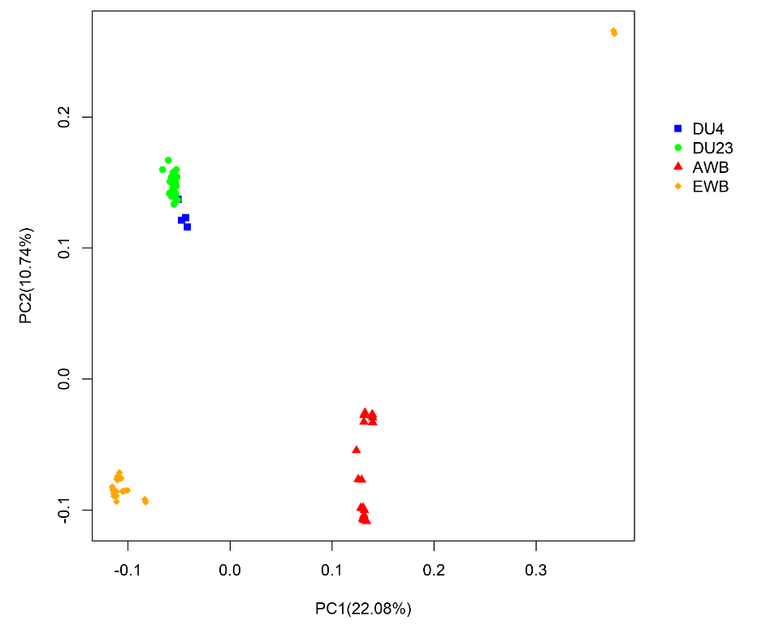

Figure S2 Linkage disequilibrium (LD) patterns of 3 pig populations.
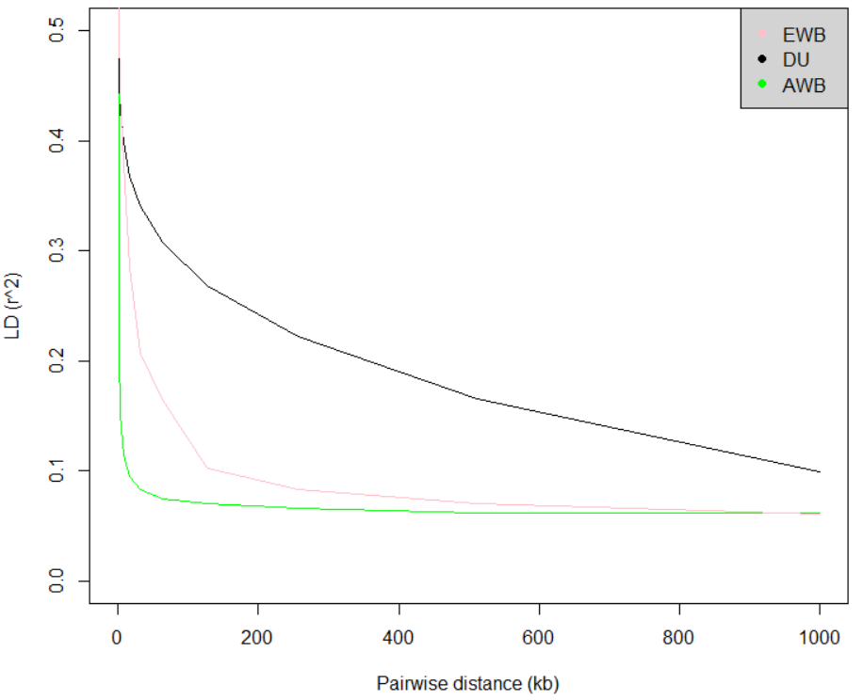

Figure S3 Venn diagrams showing the distribution of shared and unique SNPs.
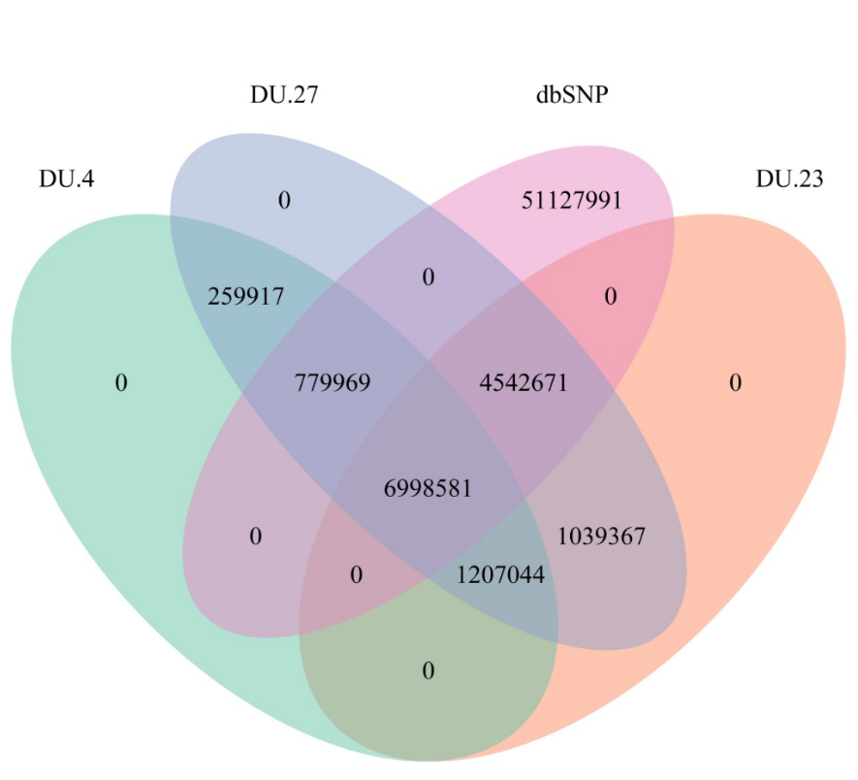

Figure S4 Genome-wide distribution of SNPs on basis of 282 individuals genotyped by sequencing. The number of SNPs was calculated for non-overlapping 250 kb windows across the pig genome. The diversities were illustrated by colors, with red indicating higher numbers and white indicating lower numbers.
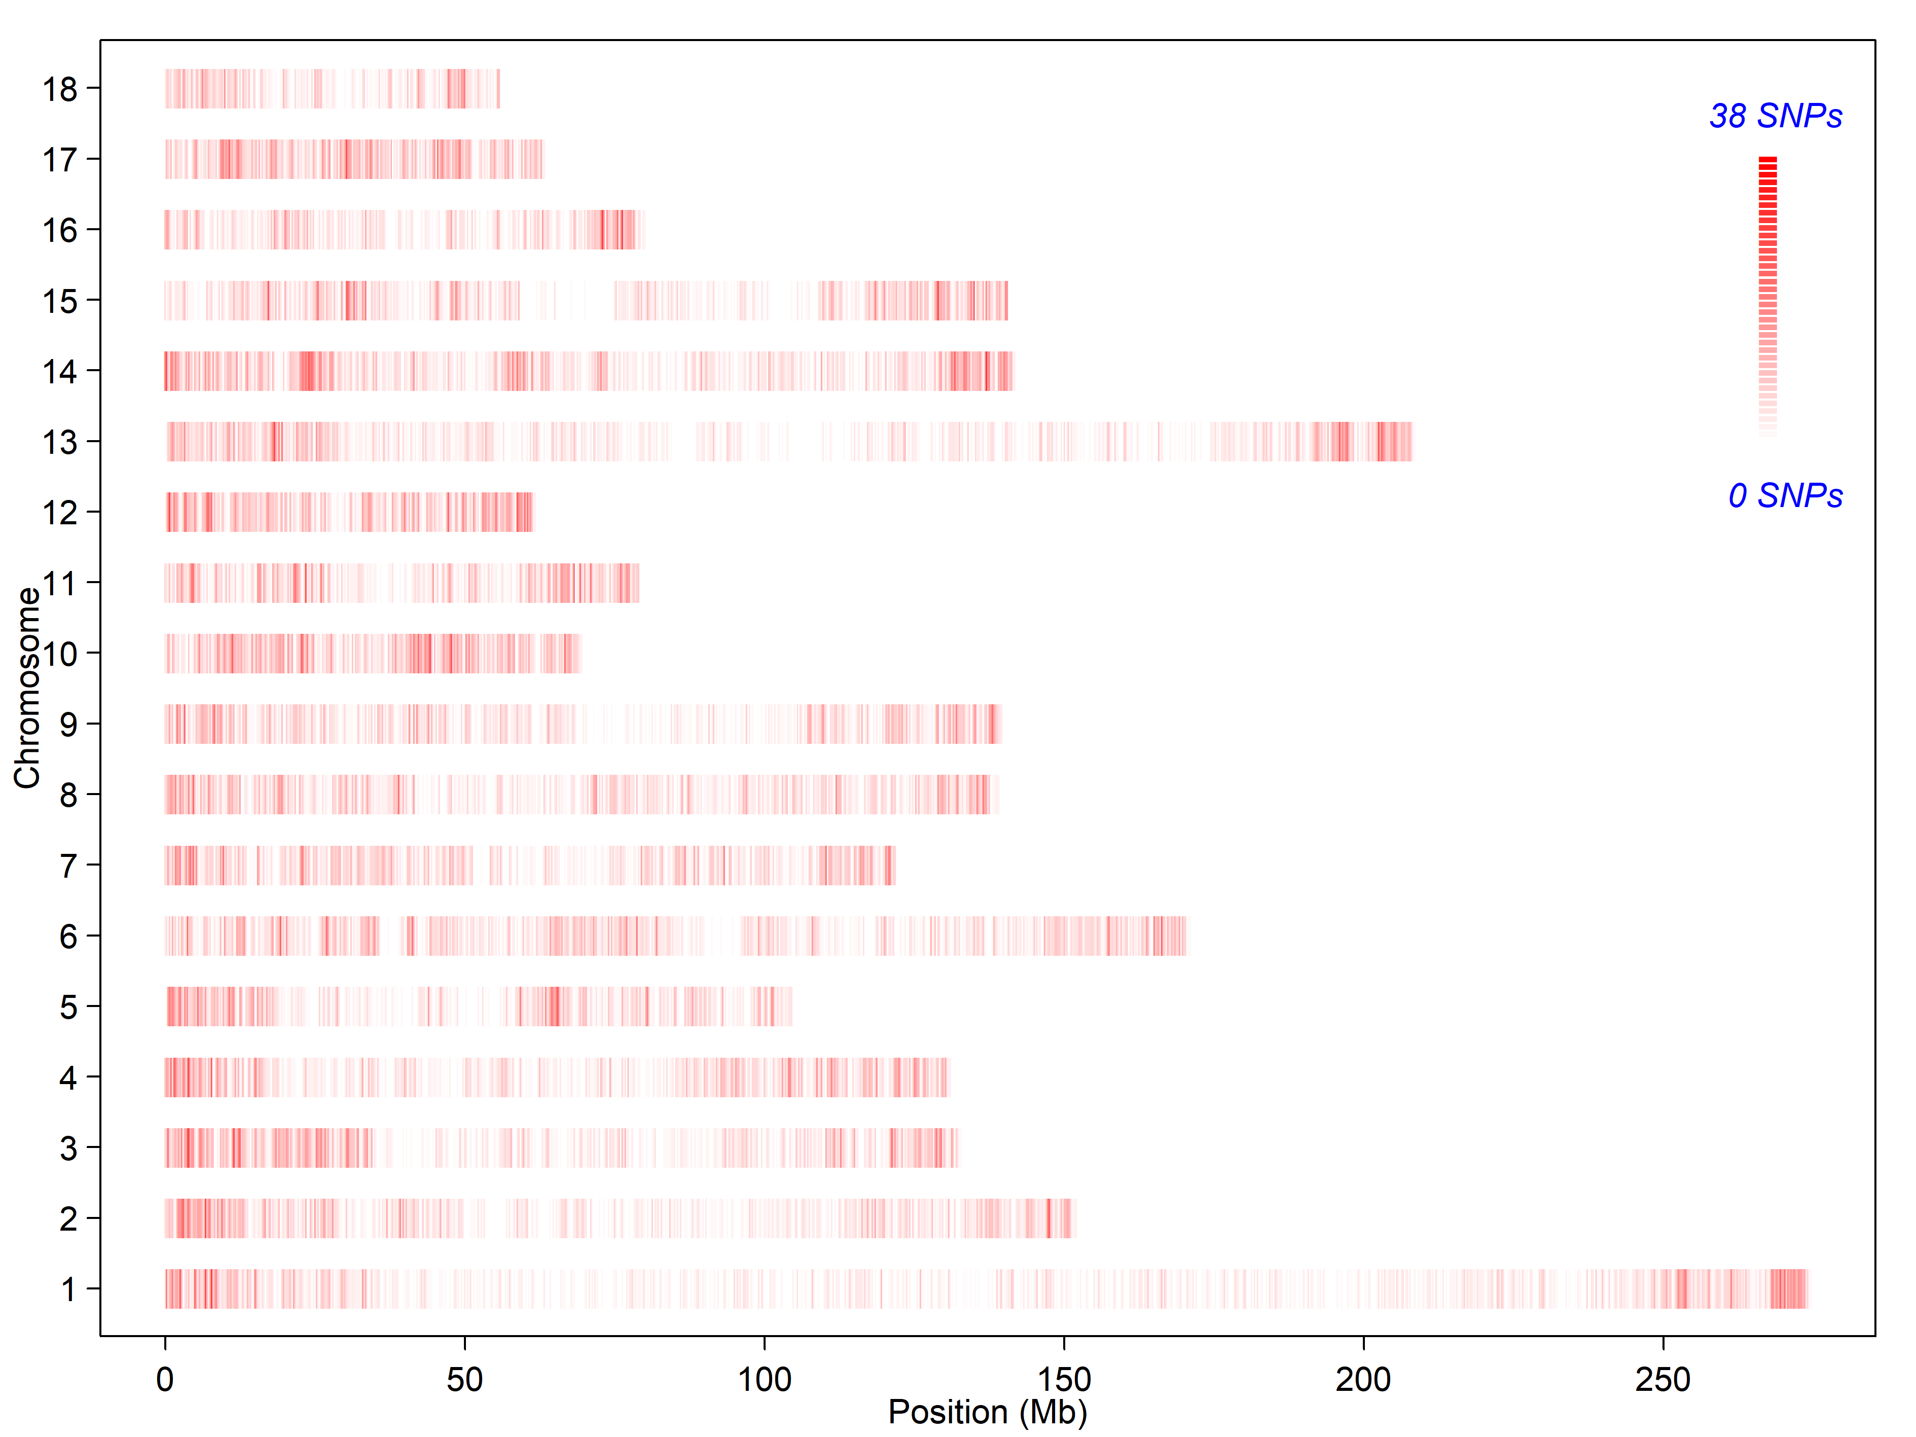

Figure S5 Genome-wide visualization of selection signatures identified by the composite likelihood ratio (CLR) tests for 3 pig populations.
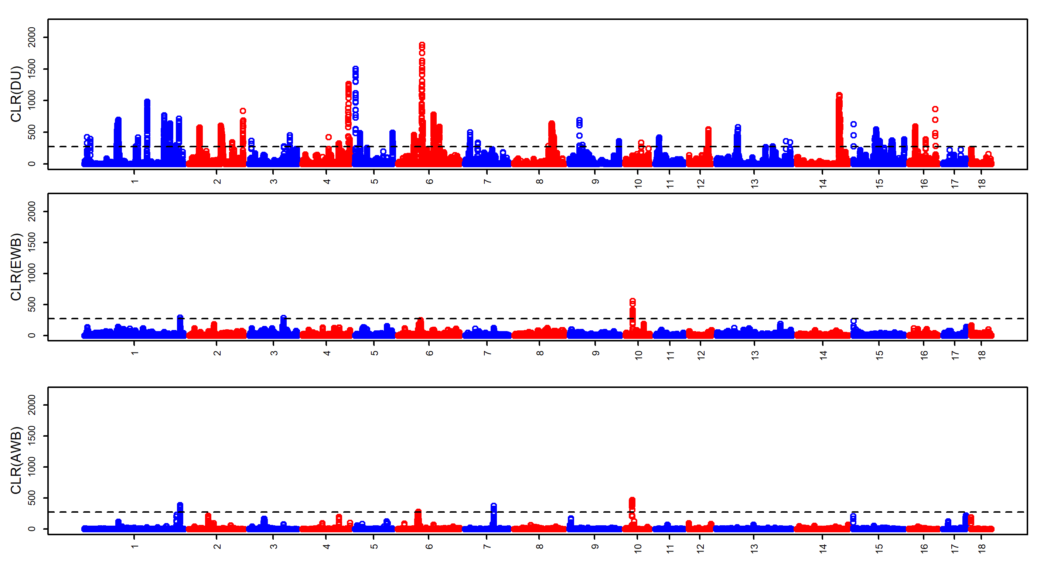

Figure S6 10 replicated visualizations of GWAS for intramuscular fat (IMF) trait using a random sampling of 250 individuals. The left Manhattan plots present the association of the imputed SNPs with the IMF trait in 250 Duroc individuals, respectively. The right is the corresponding quantile-quantile plots.
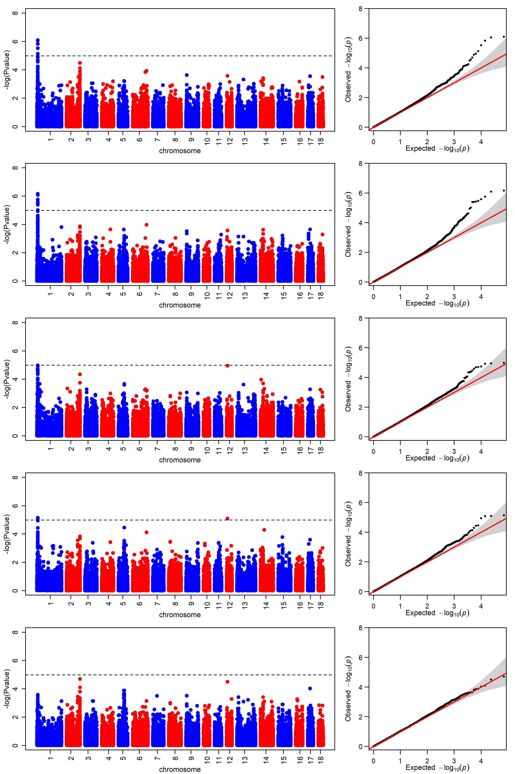
Figure S6 cont.
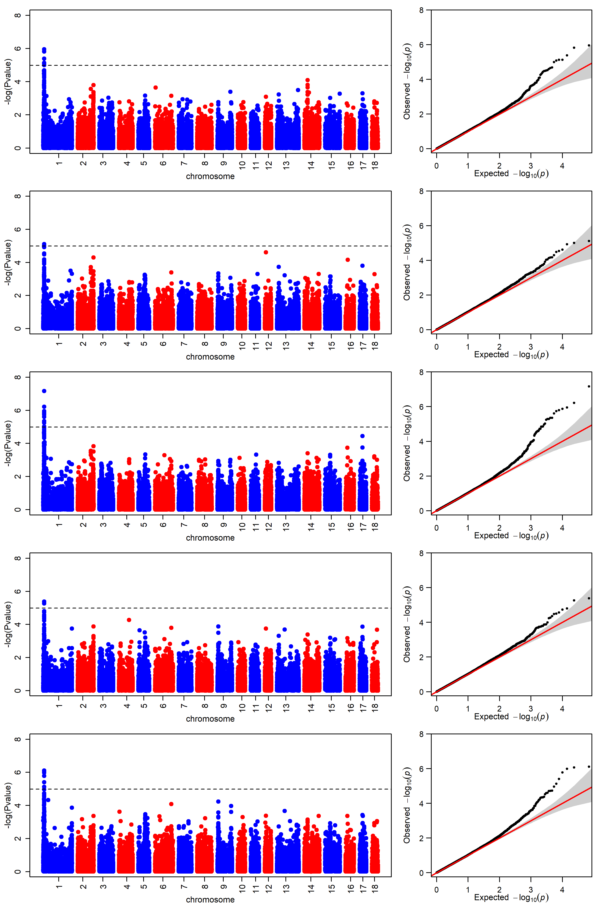

Figure S7 10 replicated visualizations of GWAS for feed conversion ratio (FCR) trait using a random sampling of 250 individuals. The left Manhattan plots present the association of the imputed SNPs with the FCR trait in 250 Duroc individuals, respectively. The right is the corresponding quantile-quantile plots.
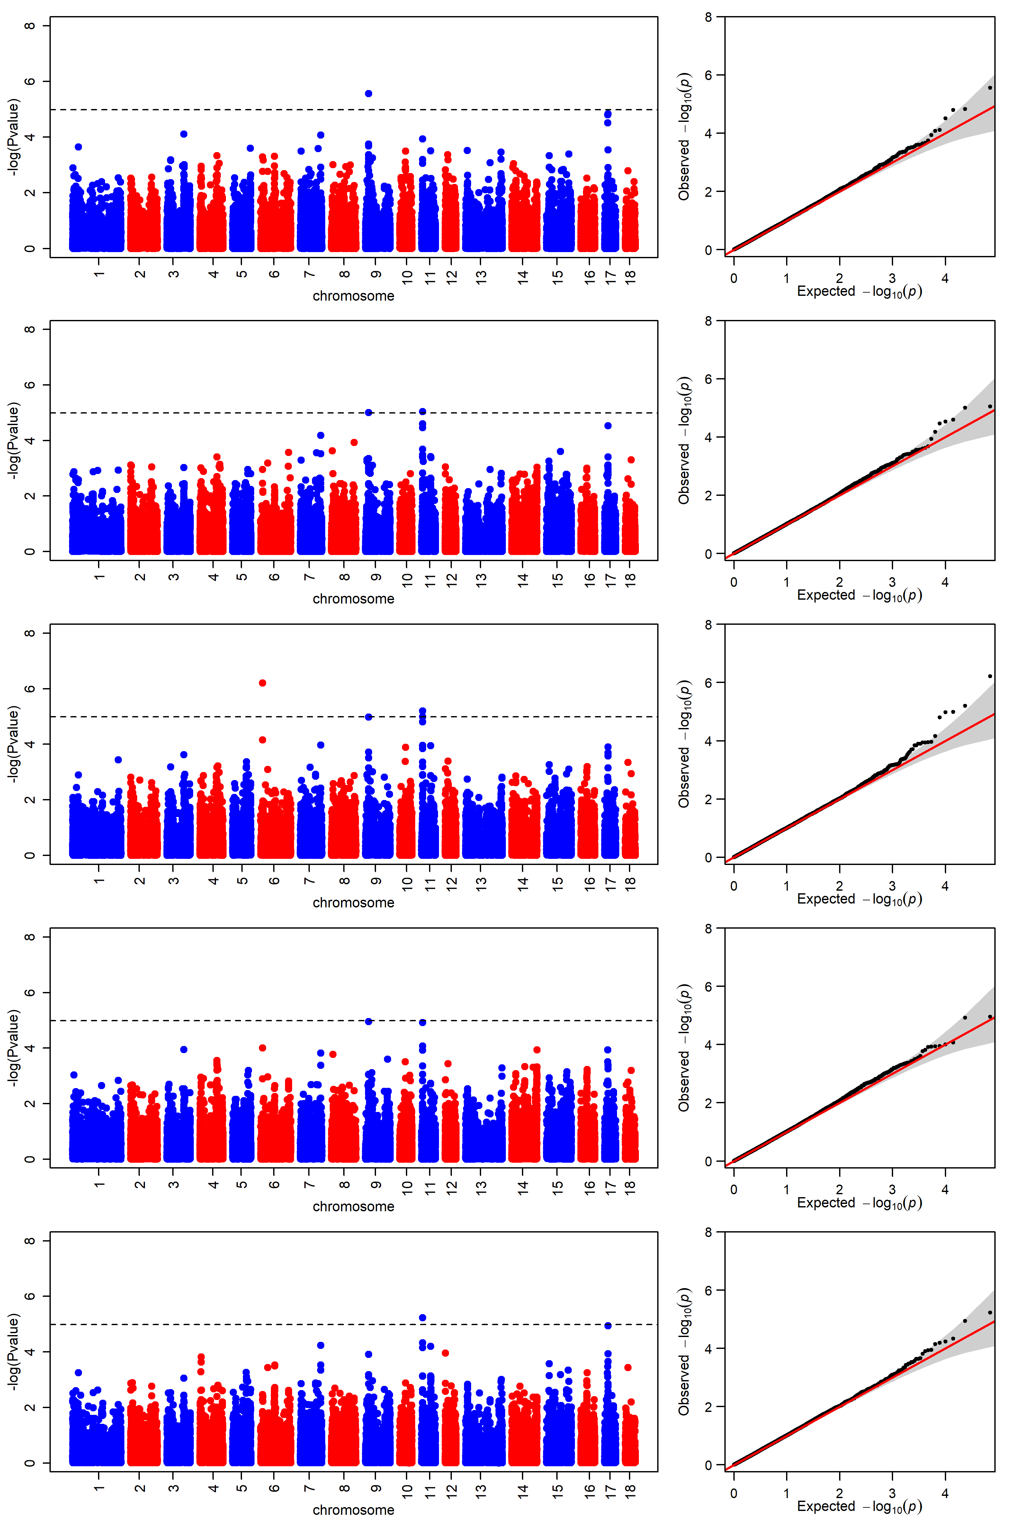
Figure S7 cont.
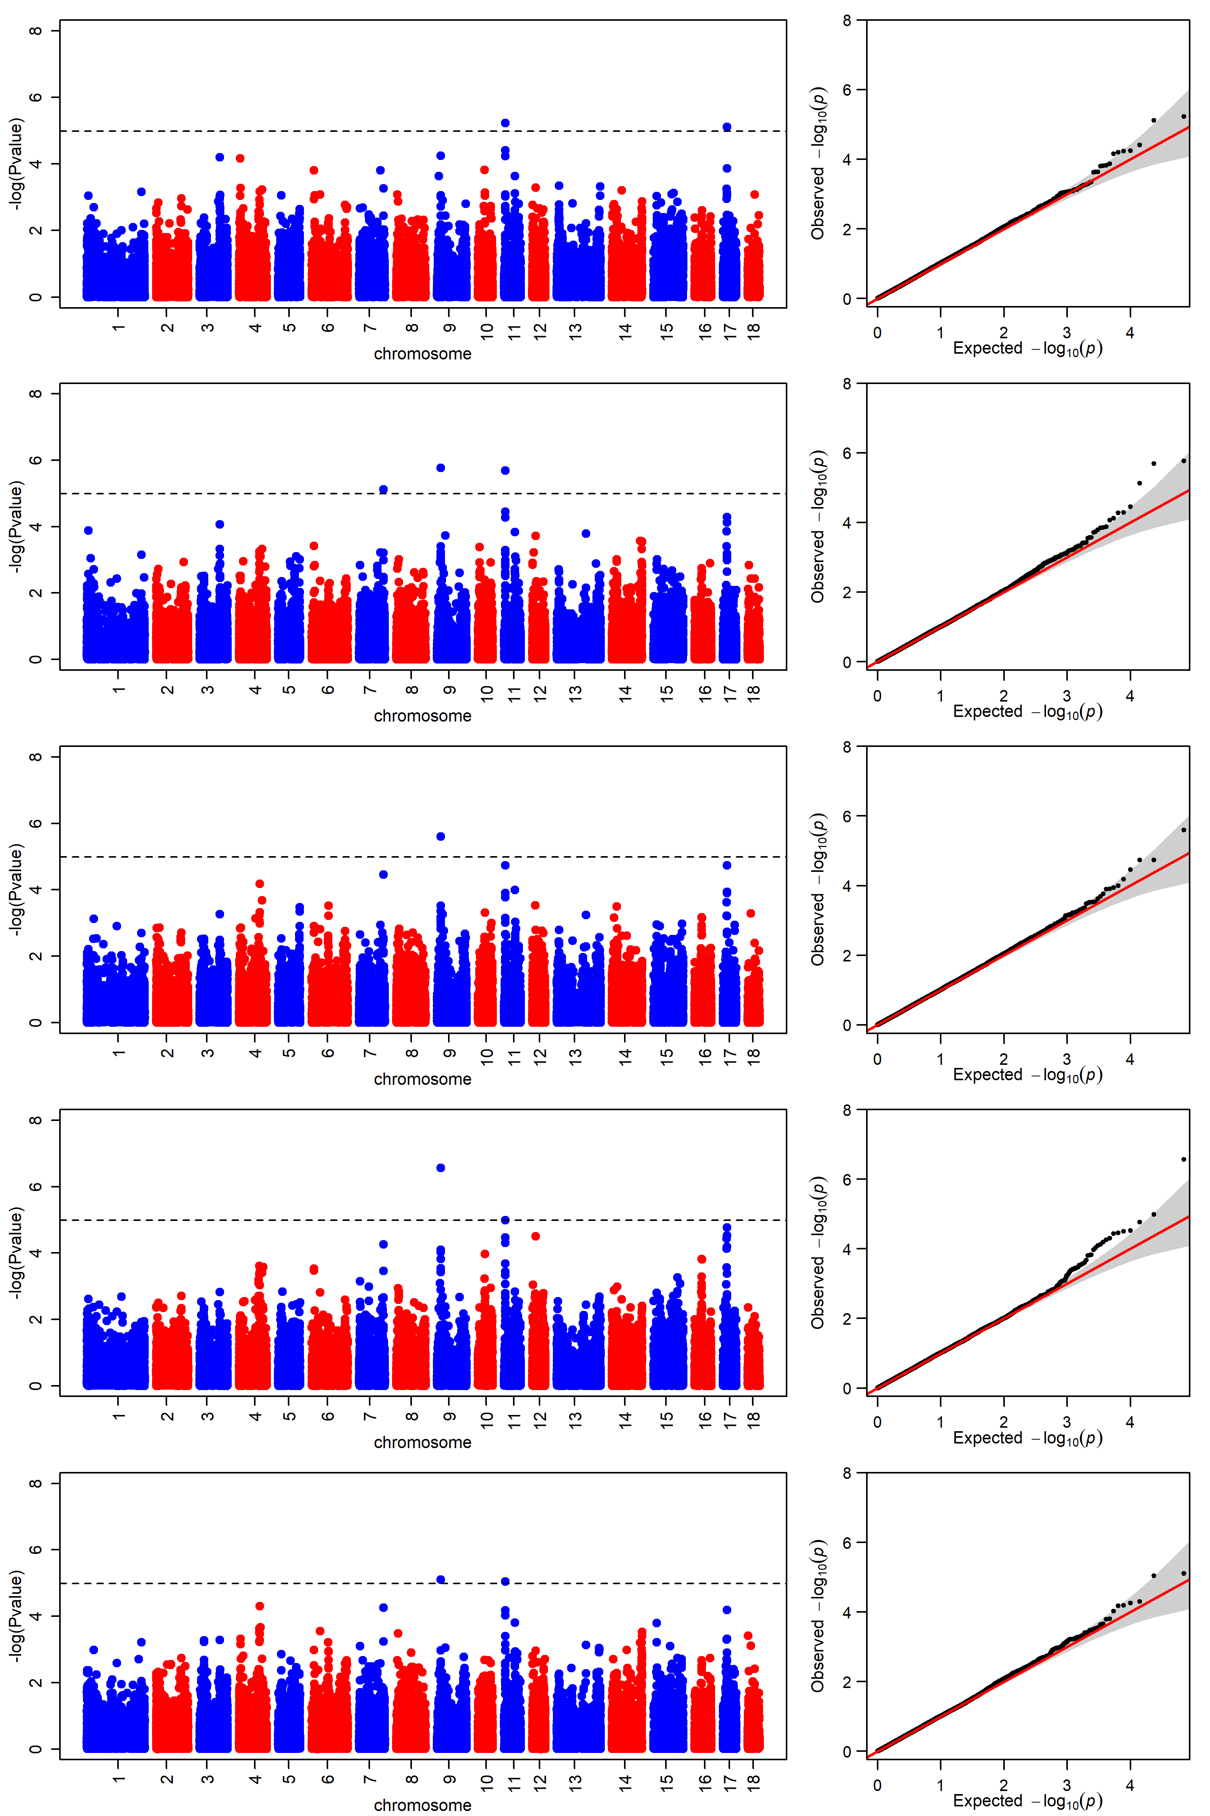

Table S1: The accession number of 69 whole genome sequence pigs from the EMBL-EBI (https://www.ebi.ac.uk/).
Population¹ | the accession number
AWB | SAMEA1557396; SAMEA1557421; SAMEA2612519; SAMEA2612520; SAMEA2612521; SAMN02298082; SAMN02298083; SAMN02298084; SAMN02298085; SAMN02298086; SAMEA1557411; SAMN03031171; SAMN03031172; SAMN03031173; SAMN03031174; SAMN03031175; SAMN03031176; SAMN03031177; SAMN03031178; SAMN03031179; SAMN03031180
EWB | SAMEA2612524; SAMEA2612525; SAMEA2612526; SAMEA2612522; SAMEA2612523; SAMEA1557403; SAMEA1557401; SAMEA2612513; SAMEA2612514; SAMEA2612515; SAMEA2612516; SAMEA2612517; SAMEA2612518; SAMEA1557424; SAMEA1557433; SAMEA1557387; SAMEA1557414 ;SAMEA1557417; SAMN02904855; SAMEA3497882; SAMEA3497883; SAMEA3497874; SAMEA3497878; SAMEA3497880; SAMEA3497881
DU | SAMN03031126; SAMN03031127; SAMN03031128; SAMN03031129; SAMN03031130; SAMN03031131; SAMN03031132; SAMN03031133; SAMN03031134; SAMN03031135; SAMN03031136; SAMN03031137; SAMN03031138; SAMN03031139; SAMN03031140; SAMN03031141; SAMN03031142; SAMN03031143; SAMN03031144; SAMN03031145; SAMEA1557407; SAMEA1557419; SAMEA1557434
¹ AWB is Asian wild boars, EWB is European wild boars and DU is Durocs.

Table S2: The summary of phenotypes and fixed effect in this study.
See Supplementary Table S2.xls
NOTE: phenotype = observed value – the mean of observed value

Table S3: Summary and annotation of SNPs in Asian wild boars (AWB) and European wild boars (EWB).
Breed |  | AWB | EWB
Sample size |  | 21 | 25
Average depth (X) |  | 12.84 | 9.34
Average genome coverage (%) |  | 91.92 | 86.23
Average Mapping rate (%) |  | 99.71 | 99.78
High-quality base (Gb) |  | 674.69 | 583.99
Q20 (%) |  | 96.7 | 97.84
Q30 (%) |  | 89.84 | 91.08
Number of total SNP |  | 35,875,566 | 21,995,903
Upstream |  | 211,258 | 126,781
UTR5 |  | 65,049 | 38,850
Exonic | Stopgain | 1,419 | 873
Exonic | Stoploss | 214 | 135
Exonic | Synonymous | 149,746 | 87,455
Exonic | Nonsynonymous | 97,142 | 61,553
Exonic | Unknown | 204 | 158
Splicing |  | 1,354 | 909
Intronic |  | 13,452,014 | 8,198,395
UTR3 |  | 330,903 | 200,449
UTR5/UTR3 |  | 1,969 | 1,185
Downstream |  | 227,557 | 137,666
Upstream/downstream |  | 5,484 | 3,191
Intergenic |  | 21,331,253 | 13,138,303

Table S4: A summary of artificial selection regions in Duroc pigs.
Chr. | Begin Pos.(Mb) | End Pos.(Mb) | P-value.¹
1 | 6.90 | 7.35 | 0.011;0.001(AWB);0.008(EWB);
1 | 15.65 | 16.20 | 0.011;-;0.007(EWB);
1 | 172.05 | 173.20 | 0.001;0.010(AWB);0.012(EWB);
1 | 251.45 | 251.975 | 0.018;0.006(AWB);0.017(EWB);
1 | 259.55 | 260.55 | 0.001;0.003(AWB);-;
2 | 86.55 | 92.75 | 0.003;0.001(AWB);-;
2 | 147.875 | 148.925 | 0.001;0.007(AWB);0.016(EWB);
3 | 109.90 | 110.325 | 0.020;0.010(AWB);0.005(EWB);
3 | 111.60 | 112.375 | 0.009;0.006(AWB);-;
4 | 99.475 | 100.525 | 0.016;-;0.018(EWB);
4 | 100.60 | 101.20 | 0.017;-;0.003(EWB);
4 | 126.075 | 126.975 | <0.001;-;0.005(EWB);
5 | 1.425 | 2.375 | <0.001;0.002(AWB);0.015(EWB);
5 | 13.175 | 13.85 | 0.007;-;0.005(EWB);
5 | 103.075 | 104.60 | 0.007;0.019(AWB);0.018(EWB);
6 | 43.725 | 44.575 | 0.008;0.015(AWB);-;
6 | 44.575 | 45.825 | 0.011;0.015(AWB);-;
6 | 102.00 | 104.275 | 0.006;0.008(AWB);0.014(EWB);
6 | 104.325 | 104.80 | 0.014;0.001(AWB);0.015(EWB);
7 | 13.275 | 14.20 | 0.015;0.010(AWB);0.017(EWB);
7 | 14.225 | 14.90 | 0.007;0.010(AWB);-;
7 | 34.95 | 35.425 | 0.015;0.003(AWB);0.009(EWB);
8 | 107.275 | 108.875 | 0.009;-;0.008(EWB);
8 | 108.95 | 109.85 | 0.010;0.013(AWB);-;
9 | 26.825 | 27.35 | 0.001;0.015(AWB);-;
9 | 34.85 | 35.30 | 0.018;<0.001(AWB);-;
9 | 135.80 | 136.65 | 0.014;0.016(AWB);-;
11 | 9.725 | 10.725 | 0.010;0.004(AWB);0.013(EWB);
12 | 53.00 | 53.95 | 0.005;-;0.20(EWB);
13 | 55.850 | 57.40 | 0.009;-;0.001(EWB);
13 | 58.475 | 59.75 | 0.004;-;0.002(EWB);
13 | 155.30 | 155.725 | 0.020;0.015(AWB);-;
13 | 191.25 | 191.675 | 0.014;0.004(AWB);-;
13 | 203.10 | 203.525 | 0.015;0.013(AWB);-;
14 | 114.625 | 118.325 | <0.001;0.004(AWB);0.007(EWB);
15 | 0 | 0.40 | 0.003;0.011(AWB);0.014(EWB);
15 | 58.675 | 59.325 | 0.010;0.010(AWB);-;
16 | 44.475 | 45.075 | 0.011;0.017(AWB);-;
¹This column presents the genome-wide P-values of sweep statistics that are listed in this order: CLR, F_{ST}(AWB), F_{ST}(EWB).
Table S5: Comparison of SNPs in whole genome and in selection regions based on the whole genome sequencing data of Duroc pigs.
Category |  | Whole genome | Artificial selection region
Upstream |  | 92,785  (0.6258%) | 1,190  (0.4787%)
UTR5 |  | 28,436  (0.1918%) | 523  (0.2104%)
Exonic | Stopgain | 545  (0.0037%) | 10  (0.0041%)
Exonic | Stoploss | 117  (0.0008%) | 3  （0.0012%）
Exonic | Synonymous | 66,285  (0.4470%) | 1228  (0.4974%)
Exonic | Nonsynonymous | 44,660  (0.3012%) | 683  (0.2767%)
Exonic | Unknown | 152  (0.0010%) | 0
Splicing |  | 614  (0.0041%) | 13  (0.0052%)
Intronic |  | 5,496,375  (37.069%) | 97,287  (39.136%)
UTR3 |  | 133,194  (0.8983%) | 2,500  (1.0057%)
UTR5/UTR3 |  | 702  (0.0047%) | 43  (0.0173%)
Downstream |  | 98,207  (0.6623%) | 1,281  (0.5153%)
Upstream/downstream |  | 2,328  (0.0157%) | 53  (0.0213%)
Intergenic |  | 8,863,149  (59.775%) | 143,978  (57.918%)
Number of total SNP |  | 14,827,549  (100%) | 246,868  (100%)

Table S6: A summary of GWAS for intramuscular fat (IMF) and feed conversion ratio (FCR) traits variation in Duroc pigs.
Chr. | Pos.(bp) | -log(P-value) | Nearby Sweep Region | Nearby Genes/QTLs
1 | 8430665;  8575536;  8575556;  8845023; | 5.46 (IMF) | 7125000-7150000,0.01(CLR);  8200000-8225000,0.017(F_{ST,AWB})  8150000-8975000, 0.006(F_{ST,EWB}); | IGF2R; TMEM181;  SOD2;  TAGAP;  Drip loss QTL; Stearic acid content QTL;
9 | 17505393 | 5.56 (FCR) | 17200000-17225000,0.017(F_{ST,AWB})  17725000-17750000,0.01(F_{ST,EWB}) | PCF11; ANKRD42; CCDC90B; DLG2; Time spent feeding QTL;
11 | 5620047 | 5.16 (FCR) | 4800000-4825000,0.033(CLR)  5825000-5850000,0.006(F_{ST,AWB})  4900000-4925000,0.005(F_{ST,EWB}) | FLT3; PAN3; FLT1
17 | 18651444 | 5.16 (FCR) | 18375000-18400000,0.048(CLR)  16775000-16800000,0.014(F_{ST,AWB})  17050000-17075000,0.001(F_{ST,EWB}) | LAMP5; PAK5

Table S7: The genotype-class frequencies and phenotypic means for 7 particular SNPs.
IMF |  |  |  | FCR
rs340788032 | CC | AC | AA | rs330638537 | GG | GC | CC
Freq. | 0.45 | 0.29 | 0.26 | Freq. | 0.45 | 0.25 | 0.30
M_phe | 1.83 | 2.07 | 2.25 | M_phe | 2.19 | 2.05 | 2.04
rs707781124 | CC | TC | TT | rs329888489 | TT | TC | CC
Freq. | 0.41 | 0.33 | 0.26 | Freq. | 0.04 | 0.07 | 0.89
M_phe | 1.86 | 1.95 | 2.31 | M_phe | 2.40 | 2.24 | 2.09
rs711970670 | GG | AG | AA | rs320554563 | GG | AG | AA
Freq. | 0.41 | 0.33 | 0.26 | Freq. | 0.49 | 0.39 | 0.12
M_phe | 1.87 | 1.94 | 2.33 | M_phe | 2.18 | 2.07 | 1.99
rs320531432 | CC | TC | TT
Freq. | 0.47 | 0.28 | 0.25
M_phe | 1.85 | 2.07 | 2.25
IMF: intramuscular fat, FCR: feed conversion ratio.

Table S8: The genes overlap with the 7.00-10.00Mb selection regions on SSC1 in Duroc pigs.
Chr. | Pos. (Mb)¹ | P-value. (method)² | Gene | Gene function
1 | 6891751..7050374;-1 | 0.01;0.002(AWB);0.008(EWB); | MAP3K4 | sex determination
1 | 7108101..7207402;-1 | 0.01;0.002(AWB);0.008(EWB); | SLC22A3 | -
1 | 7339285..7365520;-1 | 0.01;0.002(AWB);0.008(EWB); | SLC22A1 | -
1 | 7368103..7472548;-1 | 0.01; 0.04(AWB);0.05(EWB) | IGF2R | growth and development
1 | 7527861..7528838;-1 | 0.028; 0.04(AWB); | MAS1 | -
1 | 7560416..7578687;-1 | 0.028; 0.04(AWB); | PNLDC1 | -
1 | 7579238..7590015;-1 | 0.028; 0.04(AWB); | MRPL18 | -
1 | 7597333..7612910;-1 | 0.028; 0.04(AWB); | ACAT2 | -
1 | 7622547..7651613;-1 | 0.028; 0.04(AWB); | WTAP | -
1 | 8007994..8085558;-1 | 0.046; 0.04(AWB);0.008(EWB) | FNDC1 | muscle and bone development
1 | 8453508..8536381;-1 | 0.046; 0.026(AWB);0.017(EWB) | SYTL3 | -
1 | 8566751..8635729;-1 | 0.046;0.026(AWB);0.017(EWB) | TMEM181 | -
1 | 8655450..8823128;-1 | 0.046;0.026(AWB);0.017(EWB) | TULP4 | -
1 | 8928300..8934989;-1 | -;0.034(AWB); 0.01(EWB) | GTF2H5 | -
1 | 9014209..9109066;-1 | -;0.034(AWB); 0.01(EWB) | SYNJ2 | -
1 | 9130336..9238992;-1 | -;0.034(AWB); 0.01(EWB) | SNX9 | -
1 | 9350255..9619672;-1 | -;0.034(AWB); 0.01(EWB) | ZDHHC14 | -
1 | 9791634..10227947;-1 | -;<0.023(EWB) 0.023(EWB) | ARID1B | growth
1 | 7061969..7109531;+1 | 0.01;0.002(AWB);0.008(EWB); | PLG | -
1 | 7230644..7230770;+1 | 0.01;0.002(AWB);0.008(EWB); | RF00425 | -
1 | 7289170..7323644;+1 | 0.01;0.002(AWB);0.008(EWB); | SLC22A2 | -
1 | 7590140..7601795;+1 | 0.028; 0.04(AWB); | TCP1 | -
1 | 7593176..7593315;+1 | 0.028; 0.04(AWB); | RF00429 | -
1 | 7599025..7599157;+1 | 0.028; 0.04(AWB); | RF00401 | -
1 | 7679352..7691724;+1 | 0.028; 0.04(AWB);0.008(EWB) | SOD2 | fertility
1 | 8208084..8218717;+1 | 0.046;0.017(AWB);0.008(EWB) | TAGAP | -
1 | 8243300..8265639;+1 | 0.046;0.017(AWB);0.005(EWB) | RSPH3 | -
1 | 8403355..8452747;+1 | 0.046;0.025(AWB);0.005(EWB) | EZR | -
1 | 8765339..8767283;+1 | 0.046;0.025(AWB);0.005(EWB) | NDUFA3 | -
1 | 8555745..8567087;+1 | 0.046;0.025(AWB);0.017(EWB) | DYNLT1 | fertility
1 | 8935073..9001474;+1 | -;0.034(AWB); 0.01(EWB) | SERAC1 | -
1 | 9667885..9719230;+1 | -; 0.23(EWB) | TMEM242 | -
¹ ‘-1’ represents minus-strand, ‘+1’ represents positive-strand.
² This column presents the genome-wide P-values of sweep statistics.

Table S9: A partial list of enrichment analysis terms based on the candidate artificial selection regions in Duroc pigs.
Category | Term | Count | P_value
GOTERM_BP_DIRECT | GO:0042267~natural killer cell mediated cytotoxicity | 6 | <0.001
GOTERM_BP_DIRECT | GO:0019882~antigen processing and presentation | 6 | 0.002
GOTERM_BP_DIRECT | GO:0043651~linoleic acid metabolic process | 6 | 0.030
GOTERM_BP_DIRECT | GO:0019372~lipoxygenase pathway | 3 | 0.018
GOTERM_BP_DIRECT | GO:0006855~drug transmembrane transport | 3 | 0.037
GOTERM_CC_DIRECT | GO:0072557~IPAF inflammasome complex | 4 | <0.001
GOTERM_CC_DIRECT | GO:0097169~AIM2 inflammasome complex | 4 | <0.001
GOTERM_MF_DIRECT | GO:0046703~natural killer cell lectin-like receptor bindin | 6 | <0.001
GOTERM_MF_DIRECT | GO:0015101~organic cation transmembrane transporter activity | 4 | 0.005
GOTERM_MF_DIRECT | GO:0005329~dopamine transmembrane transporter activity | 3 | 0.001
KEGG_PATHWAY | hsa00790:Folate biosynthesis | 4 | 0.019
KEGG_PATHWAY | hsa04650:Natural killer cell mediated cytotoxicity | 6 | 0.003

References
Bogani, D., P. Siggers, R. Brixey, N. Warr, S. Beddow et al., 2009 Loss of Mitogen-Activated Protein Kinase Kinase Kinase 4 (MAP3K4) Reveals a Requirement for MAPK Signalling in Mouse Sex Determination. Plos Biology 7.
Indu, S., S. C. Sekhar, J. Sengottaiyan, A. Kumar, S. M. Pillai et al., 2015 Aberrant Expression of Dynein light chain 1 (DYNLT1) is Associated with Human Male Factor Infertility. Molecular & Cellular Proteomics 14: 3185-3195.
Kano, Y., M. Konno, K. Ohta, N. Haraguchi, S. Nishikawa et al., 2013 Jumonji/Arid1b (Jarid1b) protein modulates human esophageal cancer cell growth. Molecular & Clinical Oncology 1: 753-757.
Kwiatkowska, J., B. Wąsowska and P. Gilun, 2017 Expression of hypoxia inducible factor 1α and antioxidant enzymes: Superoxide dismutases-1 and -2 in ischemic porcine endometrium. Reproductive Biology.
Tanaka, K., E. Matsumoto, Y. Higashimaki, T. Katagiri, T. Sugimoto et al., 2012 Role of Osteoglycin in the Linkage between Muscle and Bone. Journal of Biological Chemistry 287: 11616-11628.
Wang, K., P. X. Wu, Q. Yang, D. J. Chen, J. Zhou et al., 2018 Detection of Selection Signatures in Chinese Landrace and Yorkshire Pigs Based on Genotyping-by-Sequencing Data. Frontiers in Genetics 9.

